How to Generate the Census Rules Report in Infinite Campus

Make sure your context switcher is reflecting the correct calendar. The report will generate for data in your building only.

Path: Reporting > Data Validation > Data Validation Report

Report Options:
- Data Validation Group: Select Census Rules
  - It is located toward the bottom of the list under the State Owned area.

Report Data Source: Local Dataset (this should automatically be selected for you).

Output Options:
Generate Now (this should automatically be selected for you).

- Select Excel

- Bottom of screen click the blue Generate button:

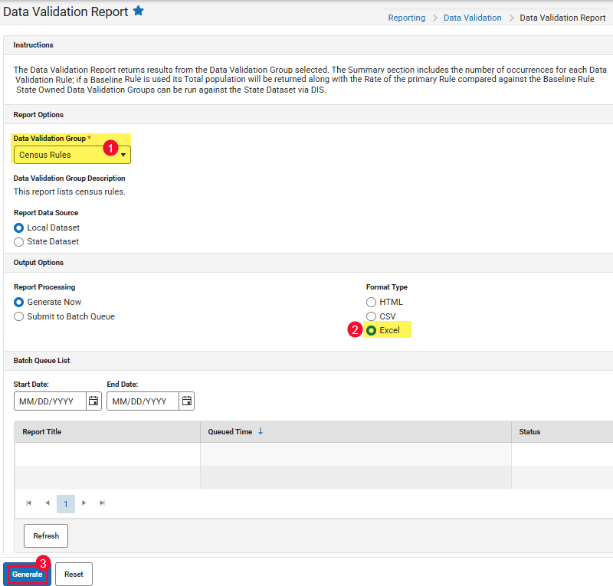

Within the report there are many different areas student data may need to be updated.

For the purpose of mailing marking period 4 report cards, your attention should be focused on the following four priority areas:
- Priority 1: Active students not in a household
- Priority 2: Active students who do not have a mailing address
- Priority 3: Household with more than 1 primary mailing address
- Priority 4: Households with more than 2 addresses

Below pages will walk you through how to update each of these priority areas.

Priority 1: Active Students Not in a Household
These students will need to have a household created.

Search using the following options:
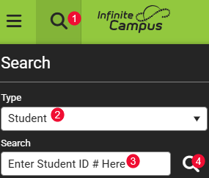

Go to Census > People > Add Person (page 9-11 of Census Manual)
- To avoid duplication, be sure to search every combination of the name.
  - If the name appears in the box and it is a match, select it.
  - If the name does not appear in the box click the Create New Person button (bottom right).
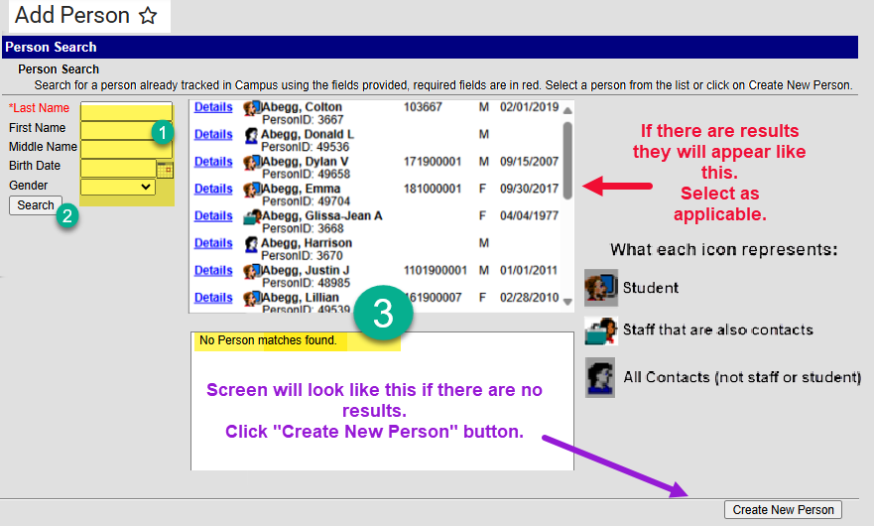

Go to Census > Address > Add Address (page 12-13 of Census Manual)
- Identify the students’ address
  - Be sure to identify applicable information in each of the specific address fields
- Search
  - If the address appears select the address identified in the Address box.
    - Remember if the address is not (V) send it to DSC Help Desk.
  - If the address does not appear, select the Create New button (bottom right).
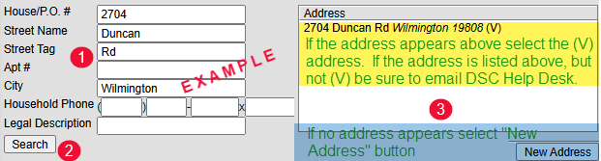

Go to Census > Household > Census Wizard (page 14-16 of Census Manual):
Remember this is a 3-step process:

Step 1:
- In the Person Search area search for each member of the household (student, mom, dad…).
- Select the person’s name, from the “People Not in Households” to add them to the Assembling a New Household box.
- Repeat until all people that reside in the household are listed in the box.
- Click the “Clear Search Fields” button (next to the search button).
- In the Address Search area, search for the address to be identified to all the people you selected.
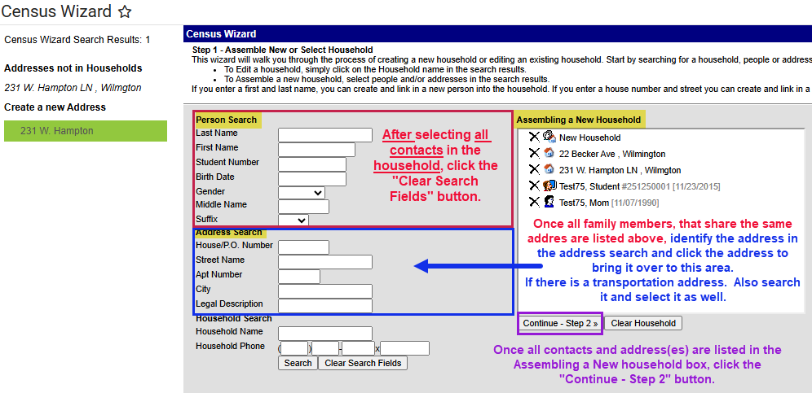

Step 2: Identify information about the household
- Identify the household phone
- Identify Start Date for each person listed
- For each address listed, select boxes as applicable: Mailing and/or Physical
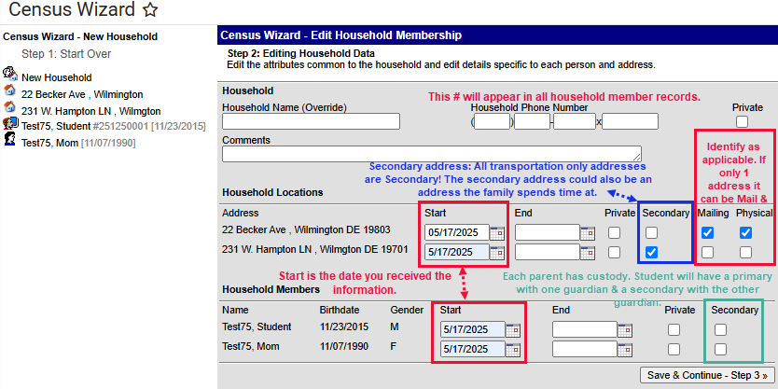

Step 3: Edit Relationships between Students and Household Members
- Relationship: ALWAYS start with the student identifying the relationship of the person to the student. As you identify the relationship, if there are siblings the information will auto fill for the siblings as well. Starting with the student helps prevent confusion.
- Start Date: Is the date you received the information.
- Sequence (Seq): The order in which contact(s) are called in case of emergency.
- Check Boxes: Check as applicable to the relationship of the person to the student:
  - Guardian: check the box if the contact is a guardian to the student.
  - Mailing: If the address is a mailing address for a guardian, check the box.
  - Portal: check for all guardian contacts grades EC – 12.
  - Messenger: check for guardian contacts to receive messages about the student.
- Click Save & Done. Screen will flash and information will be saved.
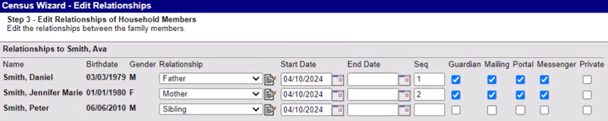

Priority 2: Active students who do not have a mailing address
These students will need to have the appropriate mailing and physical address identified where missing.

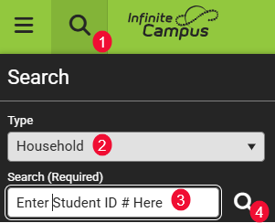

- Select the house icon from the search results:
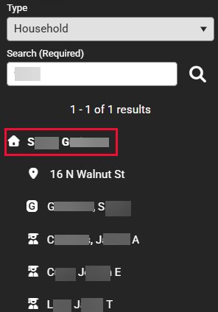

- Use the Related Tools menu on the right-side of the screen select “Household Addresses”:
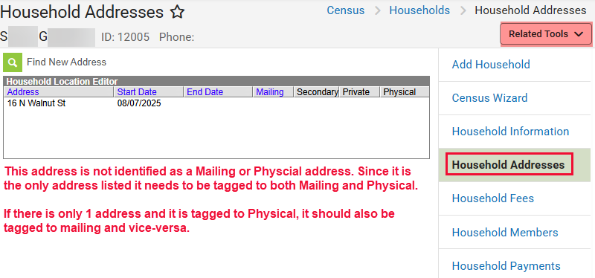

- Every student should have one Mailing and one Physical address!
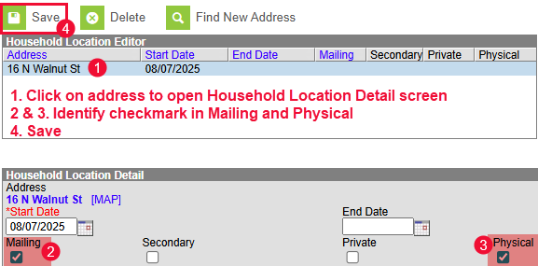

ALERT: if all addresses are ended (“This household has no current primary address.”), contact the guardian for two proofs of address to update the household address by following steps 1 & 2 then select Find New Address to add the correct address.

Priority 3: Household with more than 1 primary mailing address
School will need to make a determination based on reaching out to guardian to determine which address school correspondence should be identified as the mailing address and what to tag the other address.

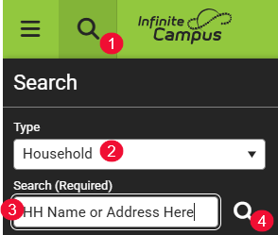

Select the House Icon from the search results:
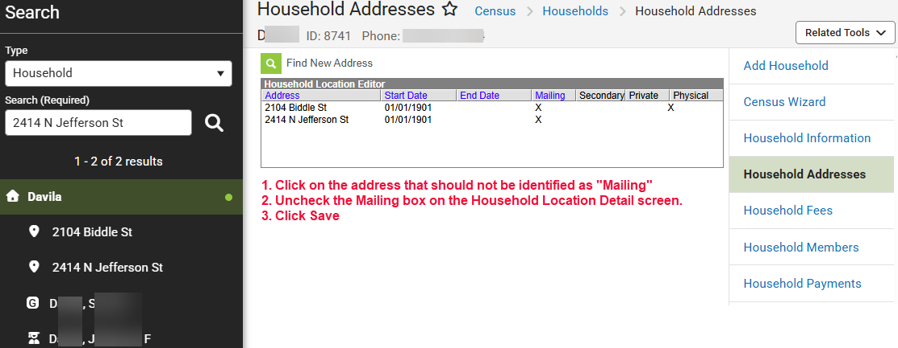

- Click on the address that should not be identified as “Mailing”.
  - Uncheck the Mailing box on the Household Location Detail screen.
    - If the address is only identified as Mailing and should not be used to mail school correspondence, school will need to determine if the address should remain in the student’s record and vice versa if the address is a physical address.
- Click Save

Priority 4: Households with more than 2 addresses
If there is more than one address in the household, one address may be the mailing address and one may be the physical address, one may be a secondary address for transportation – all of that is okay as in the example below.
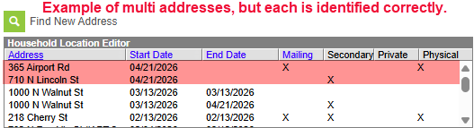

To find the household with more than 2 addresses:

However, if two of the same exact address is listed, you will need to inactivate one of the duplicate addresses:
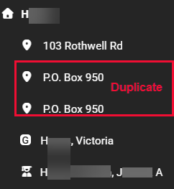

- Click on the house icon to open the address information
- If the address is not showing, use the related tools to select Household Address
- Verify which of the duplicate addresses should be kept in the student’s record
- Once the address is highlighted use the Delete button at the top of the screen to remove the duplicate address from the record.
