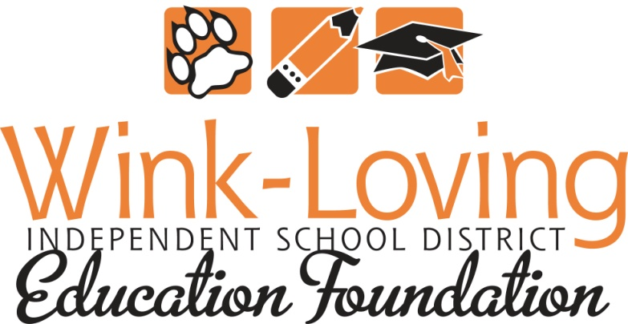
Scholarship Program

Founded in 2009, the Wink-Loving ISD Education Foundation (WLEF) will present scholarships to graduating seniors from the Wink-Loving ISD high school. All scholarship awards are restricted to furthering the student’s education including tuition, housing and such related expenses as are at the discretion of the WLEF board. All awards are made on a one-time, non-renewable basis and are made without regard to race, creed, color, sex, relation or national origin. Award funds must be used within a one year period.
Scholarship Eligibility
To be eligible for the Wink-Loving ISD Education Foundation Scholarship, a student must:
- Have been enrolled in and maintained enrollment throughout the final two years of his/her education at the Wink-Loving Independent School District high school.
- Meet all graduation requirements as specified by Wink-Loving ISD policy and as set forth by the State of Texas by May of their graduation year. (i.e. credits, TAKS, etc.)
- They must verify that they are continuing their education, either at a college or university, technical school, or certification program.
- If enlisted into the military, must have completed boot camp and submit a copy of his/her orders for future service.
Scholarship Selection Process
All students that meet the scholarship eligibility requirements and have completed the Request for Scholarship Application will be awarded a scholarship from the Wink-Loving ISD Education Foundation.

This application must be filled out completely.

Full Name___________________________________________________________________________

Address_____________________________________________________________________________

Phone #____________________________ Social Security #__________________________________

College, University or vocational school you plan to attend:

____________________________________________________________________________________

Please briefly describe your short and long range plans or goals after graduating from Wink High School.
______________________________________________________________________________________________________________________________________________________________________________________________________________________________________________________________________________________________________________________________________________________________________________________________________________________________________________________________________________________________________________________________
I certify that I have completed my last two years as a Wink High School student and therefore qualify for this scholarship.

___________________________________________ ________________________________
Student Date

Verification obtained by:

___________________________________________ ________________________________
Wink High School Counselor Date

