2026 Calculus Summer Assignment

New Users:
If you do not have a Deltamath account, click Create Account and use my teacher code: 820626 and then enroll yourself in the Summer Assignment Class.

Returning Users:
Go to Deltamath.com and Log In to your account.
Click the Tools Dropdown menu and choose Manage Login and Teachers option.
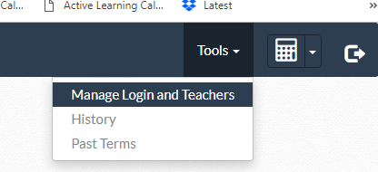

Click the Add Teacher Button, Enter my Code 820626 and then enroll yourself in the Summer Assignment Class.
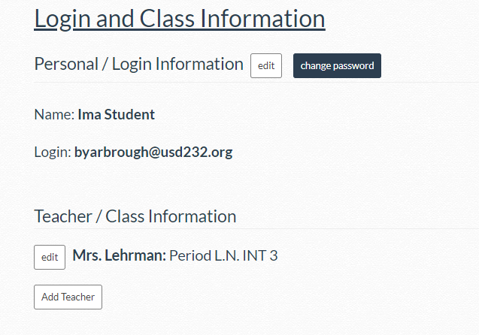

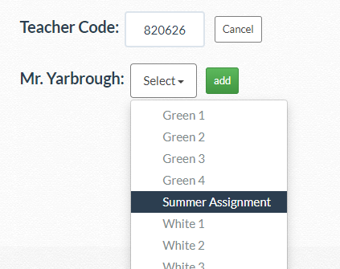

You will see 5 Homework Modules. The Deltamath assignments have staggered due dates with the first module due by 11:59pm on June 12th, 2026. Due dates will then be every two weeks, so do not procrastinate.
