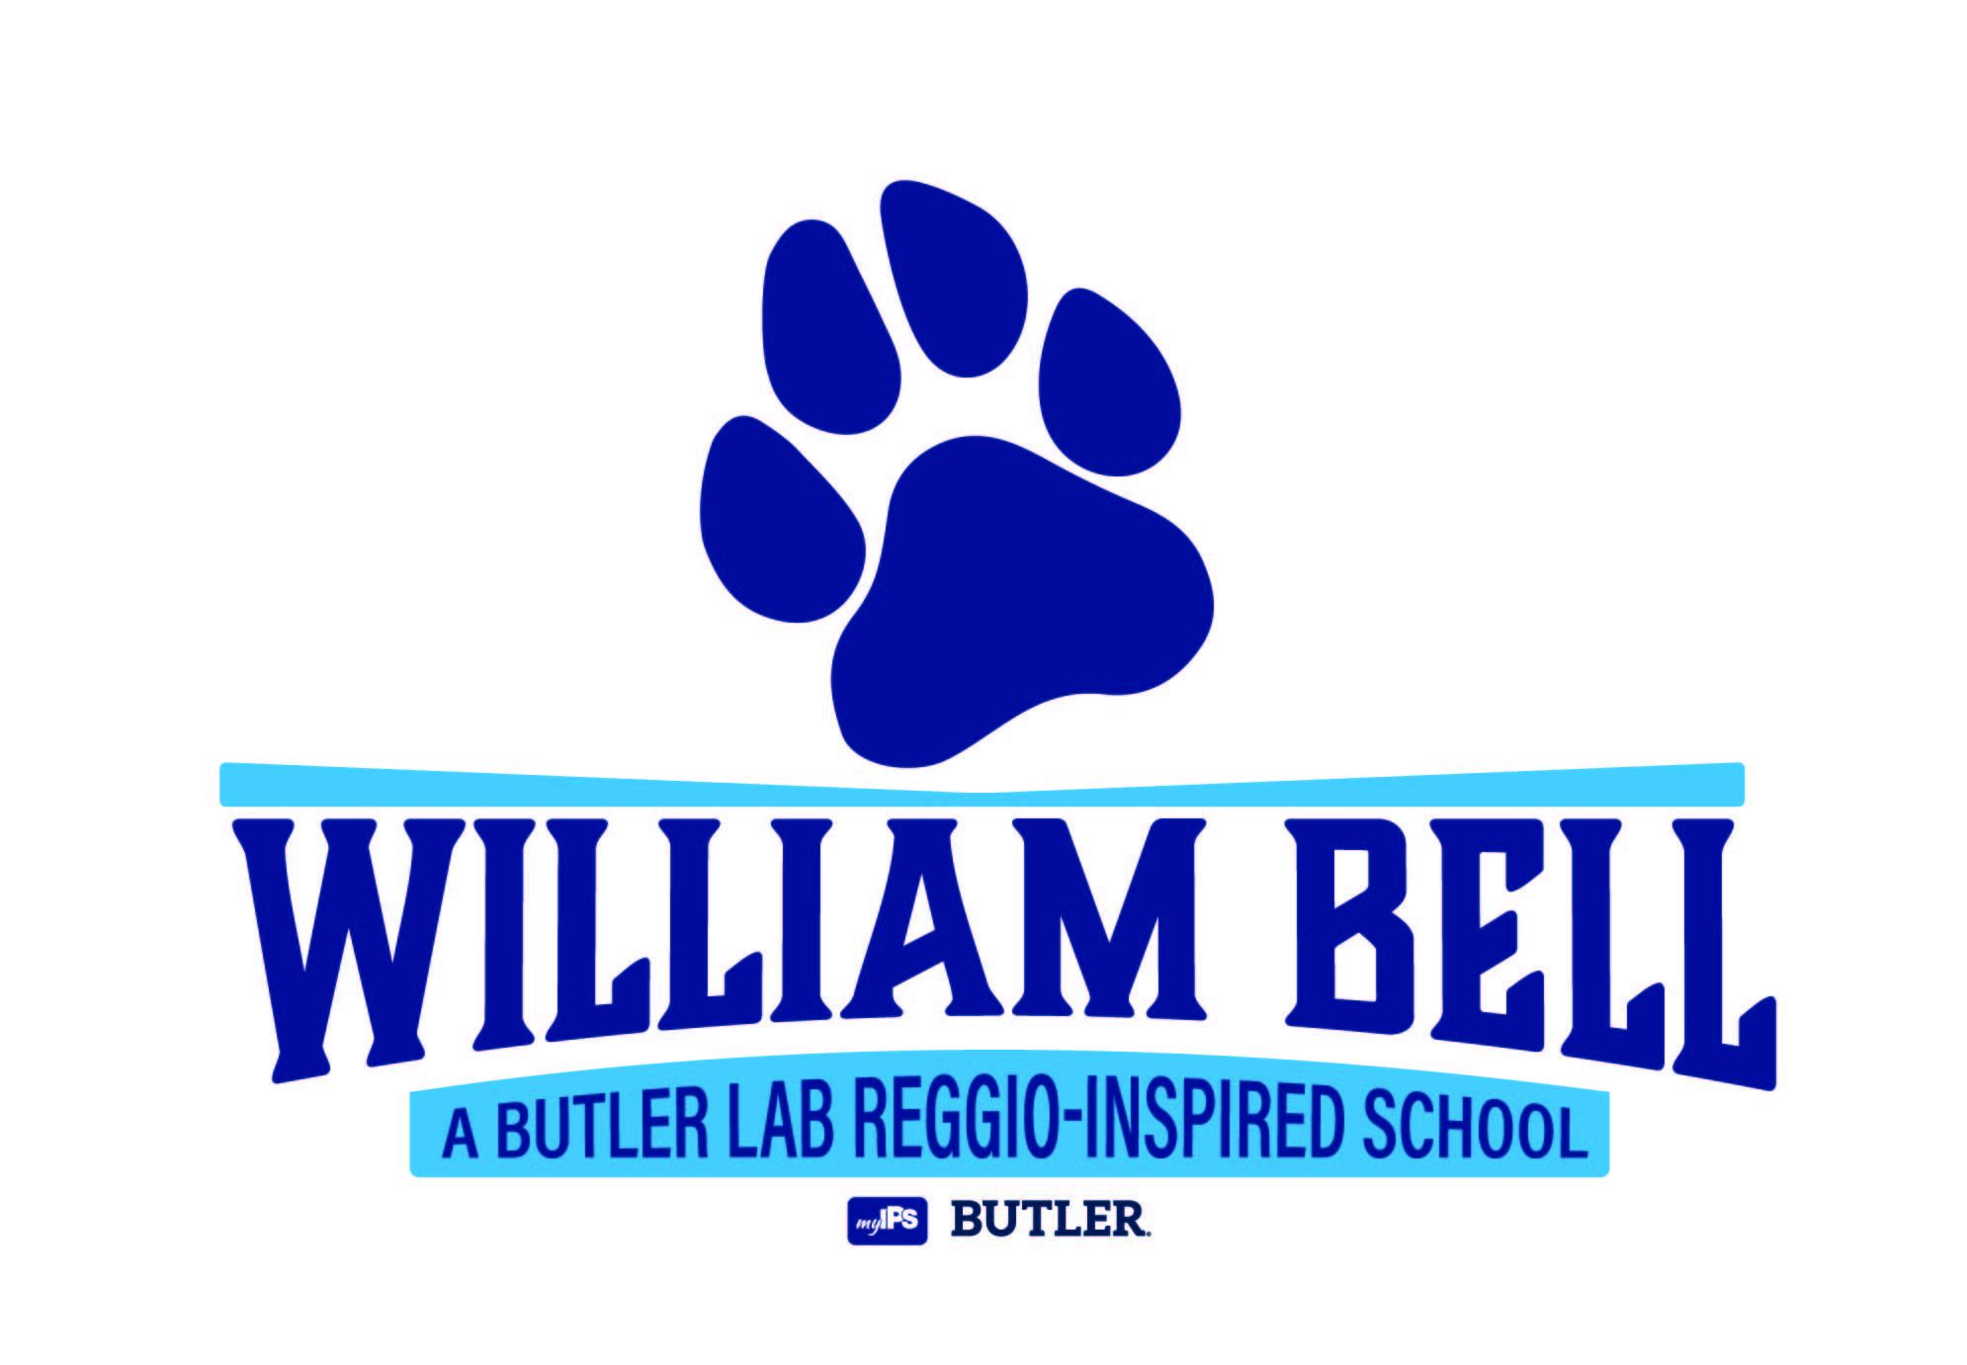
William Bell School 60
A Butler Lab
Reggio-Inspired School
Inspiring children to transform the world

Title 1 Parent/Guardian Involvement Policy

Because education is a shared responsibility of students, parents/guardians, community, and staff members at William Bell School 60, we value the input of all stakeholders in the development and implementation of this partnership. As a Title 1 school, this parent/guardian involvement policy has been jointly created and will be reviewed/revised annually to support parents/guardians and the school community in their efforts of establishing academic success for all students.

The purpose of this policy is to inform and empower all parents/guardians who have children attending William Bell School 60 so they may actively participate in their child’s education and maximize academic achievement. It not only applies to parents and guardians, but also to the teachers, administrators, staff members, and the greater community. We are dedicated to providing parents/guardians with the communications and resources needed to ensure that they are involved in the academic and cultural upbringing of their children.

During the 2026-2027 school year, William Bell School 60, along with the parents/guardians, will uphold this policy by:

- Involving parents/guardians in an organized, ongoing, and timely way in the planning, review, and improvement of programs and policies, such as the:
    - Title 1 School-Parent/Guardian Compact
    - Title 1 Parent/Guardian Involvement Policy
    - School curriculum and integration of Indiana Academic Standards
    - School academic status as determined by the Indiana Department of Education
    - School implementation of academic assessments and desired proficiency levels appropriate for each grade level
    - Lab Collaborative activities

- Providing parents/guardians with:
    - Timely information about Title 1 programs
    - A description and explanation of the curriculum used at the school
    - Opportunities for regular meetings to formulate suggestions and to participate, as appropriate, in decisions relating to the education of their children
    - A response to parent/guardian suggestions and input in a timely manner

- Allowing parents/guardians to submit comments concerning their satisfaction with the school-wide program as a part of the Title 1 plan in a variety of ways (emailing the leadership team or principal, or calling the school, etc)

- Integrating a Title 1 School-Parent/Guardian Compact that has been jointly developed with parents/guardians and reviewed annually to ensure the shared responsibilities for improved student academic achievement and the means by which a partnership will be cultivated

- Strengthening the ability of parents/guardians and the school to have excellent parent/guardian involvement by:
    - Providing the current copy of the School Improvement Plan to all parent/guardians
    - Making literature available in both English and Spanish (when possible)
    - Providing parent/guardian meetings and workshop meetings that integrate existing programs such as IPS Preschool Program.
    - Providing regular communication between home and school including electronic and paper versions
    - Making visits to homes of children as needed
    - Calling families weekly to inform of school events, student achievement and upcoming meetings as well as letting parents/guardians know in a timely manner of special events at the school
    - Creating a warm and welcoming environment for all families regardless of family structure or background

- Assisting parents/guardians in their understanding of the Indiana Academic Standards/Common Core Standards, student’s progress reports, and how to effectively work with the school staff for enhanced achievement

- Developing appropriate roles for community- based organizations and businesses and creating partnerships with neighboring schools

- Employing school staff who are responsible for:
    - Holding parent/guardian meetings and events
    - Attending district workshops and meetings
    - Conducting phone calls and home visits with parents/guardians
    - Providing materials to parents/guardians through workshops conducted through The Indiana Partnership and other organizations
    - Providing a variety of academic workshops that will give all parents/guardians training in how to help children’s achievement, including providing resources for families with preschool aged children
    - Meeting all other requirements listed in the job description

- Conducting meetings at different times for parents/guardians and families including morning, afternoon and/or evening times, assisting with transportation to and from the meetings, and offering child care services

- Preparing educators to work jointly with parents for their child’s development by requiring teachers to communicate and work with parents/guardians as an equal partner to help build ties between home and school

- Providing other reasonable support for parent/guardian involvement activities as they may request, including suggestions about how parents/guardians can help their children transition into or from our school

- Holding regular activities for families including but not limited to:
- Informational packets for all incoming families
- Welcome phone calls to all incoming families
- Back to School Night meeting and information sharing
- Title 1 Annual Meeting where the following information is given to parents:
    - Assessment Process- Local and State
    - Discipline Policy
    - Attendance Policy
    - Uniform Policy
    - Description and Explanation of Curriculum
    - Parent Involvement Policy
    - Parental Contact Information
    - Description of Title I Services
    - Student Proficiency Levels and Expectations
- Student Progress Conferences
- Lab Collab Meetings and Recap Meetings at least quarterly
- Principal Chats
- Education Workshops addressing topics selected by parents/guardians
- Lab School Carnival
- African American/Diversity/Multicultural studies
- IREAD Informational Parent/Guardian Meeting
- Bingo Night
- Night of 100 Languages & Open House
- Lab School Bulldog Bash
- Bike to School Day
- End of the Year Celebration and Picnic

This policy will be our joint road map to ensure
that academic success is being achieved by all our students.

Rev 4/09/2026

