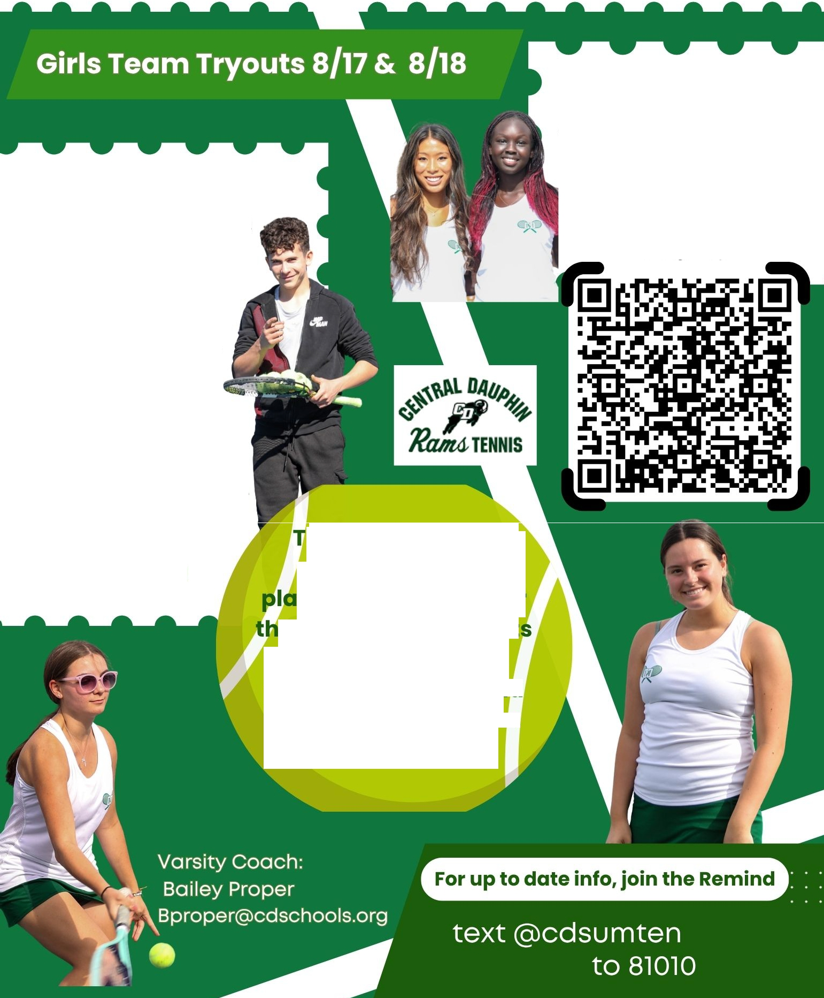

OPEN COURTS
for high school players interested in playing on the CD High teams
Join the Remind to see the weekly schedule

Always Bring:
- Raquet
- Proper Athletic Attire
- Water
- Sunscreen
- Good Attitude!

hese options are opportunities for yers to get ready for
e school team try out by improving skills, practicing games, and meeting other playe s on the team.

SUMMER CAMPS
offered to 7th - 12th grade students interested in improving their skills
Scan QR code below to sign up

