A.P. Literature and Composition
Summer Reading 2026-2027
Welcome to AP Literature!

AP English Literature and Composition is equivalent to an introductory college-level literary analysis course. As such, you must be willing to read the assigned novels and plays. In this course, you can expect to read, discuss, and analyze fictional works, as well as improve your writing skills.
Why Summer Reading? At the end the school year, you will take the AP English Literature and Composition exam. We will read several books/plays over the course of the school year. This summer, you will read and annotate a long work of fiction that will study the first quarter, and aquire a copy of The Awakening so you’re prepared for your first reading assignments. It is recommended that you purchase your own personal copy of each book so you can write/annotate directly in the book. Library books are acceptable, however you will need to annote using sticky notes.

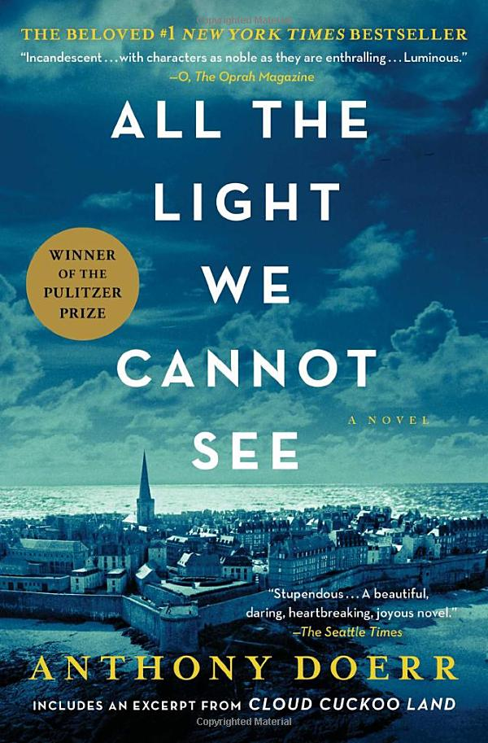
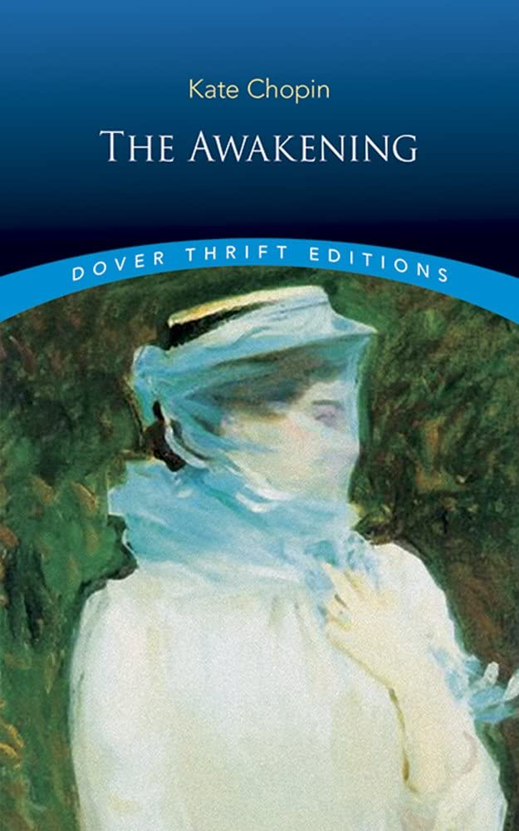
Books:
All the Light We Cannot See by Anthony Doerr
The Awakening by Kate Chopin
Assignments:

- All the Light We Cannot See by Anthony Doerr
- There will be a test and in-class timed-write on this book within the first few weeks of school.

Assignment: Read/annotate your book.
Annotating consists of both marking passages in the book and writing comments. You can do this in a variety of ways including using sticky notes, color coding with highlighters, or underlining/circling. Please have your annotations available for teacher review on the first day of school.
- Suggestions for annotations:
- Plot: a pivotal event that supports a theme) or structural shifts or turns in the plot
- Characterization: showing how a character is developed/changed
- Setting: showing the significance of setting to the theme
- Patterns: recurring images, ideas, colors, symbols or motifs
- Irony: (Verbal, Dramatic, or Situational)
- Tone: identify tone in commentary using a tone adjective
- Theme: include a one-sentence thematic statement in your commentary
- Figurative language such as metaphors, similes, personification, etc; effective &/or creative use of stylistic or literary devices
- Meaningful or striking quotations or events you find surprising or confusing
- Passages that remind you of your own life or something you’ve heard about it in our society
- Passages with confusing language or unfamiliar vocabulary

Also: The Awakening by Kate Chopin: Grab a copy: Amazon: Dover Thrift Edition
This will be our first text. You will receive a reading assignment the first week of school.

*Please be aware that students will be held responsible for the assignments on the first day of the fall semester. If a student chooses to change the level of course or class or program over the summer, the student will be held responsible for the summer assignments for the courses reflected on the schedule for the first day of school. If you have questions regarding which course you are enrolled in for the fall, please contact your guidance counselor. If you have questions regarding the above assignment, please reach out to our ELA department head at vanettenr@pcsb.org

Have a wonderful summer!

