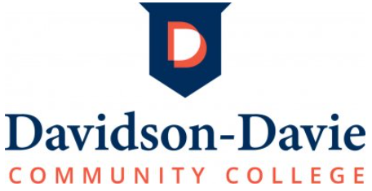

ACHIEVEMENT SCHOLARSHIP APPLICATION 2026-2027
(to be completed by the student)
Instructions

The Davidson-Davie Community College Foundation offers a limited number of scholarships to graduating high school seniors who enroll at Davidson-Davie Community College. Some scholarships reward merit while others take financial need into consideration. Each student applying for an achievement scholarship must complete the following:

(1) Achievement Scholarship Application (with transcript attached)
(2) Application for admission to Davidson-Davie Community College
(3) NC Residency Determination Service (RDS)
(4) 2026-2027 Free Application for Federal Student Aid (FAFSA)

Students who have not completed all four of the above applications at the time this scholarship review takes place will be dropped from consideration.

This completed Achievement Scholarship Application (with transcript attached) must be submitted to your high school counselor by the deadline they provide in order to be considered for a scholarship!

Selection Process

A selection committee at Davidson-Davie Community College will review completed applications and make final decisions. Students selected for scholarships will be notified by July.

Student Information
SSN or Davidson-Davie Comm. College Student ID Number: ______

Name
First Middle Last

Mailing Address
P.O. Box or Street Address

City State Zip Code County (Ex. Davidson, Davie)

Phone ( ) ____ Personal (not high school) Email ______

High School
Are you a current CCP student? _______________________ Birth date: ________________________
Is your parent/guardian a customer of Davidson Water? ____ Yes ____ No

If you selected yes, what is your parent/guardian’s name? ___________________________________
College Plans
1. Have you submitted your application for admission to Davidson-Davie Community College for 2026-2027?
Yes No __ (if not completed you will be dropped from consideration, please complete
it ASAP at davidsondavie.edu/admissions/how-to-apply/ )
2. Have you completed the NC Residency Determination Service (RDS) for 2026-2027?
Yes No __ (if not completed you will be dropped from consideration, please complete
it ASAP at ncresidency.cfnc.org/residency )

3. Have you submitted your 2026-2027 Free Application for Federal Student Aid (FAFSA)?
Yes No (if not completed you will be dropped from consideration, please complete
it ASAP at studentaid.gov/h/apply-for-aid & be sure to add DDCC’s Federal School Code 002919 to the “Colleges” section)
If yes, what is your SAI (Student Aid Index) found in your FAFSA Submission Summary (select the “Eligibility Overview” tab)? $________________
4. Intended Program of Study:

5. Do you plan to enroll full-time (12 or more semester/credit hours) in a two-year degree program?
Yes No __ Unsure ______
Volunteer and Community Activities
List below any volunteer and community activities in which you have been involved, any leadership positions held, and the years of your participation (you can attach a separate page if needed).

Awards and Honors
List below any awards or honors you have received (you can attach a separate page if needed).

Essay
On a separate sheet of paper, please write an essay of no more than 350 words that addresses your educational and career goals and how Davidson-Davie Community College can assist you in pursuing your goals. The essay should be typed and attached to this application.

Please Sign Below
I certify that the information given on this application is complete, accurate, and true to the best of my knowledge. I understand my signature gives the Davie-Davidson Community College Financial Aid Office and the Davidson-Davie Foundation permission to release any appropriate information in correspondence with donors and the scholarship committee.

Signature Date
Remember to attach your transcript to this application!

