Generating the Roll In or Out Report for End of Year
Purpose: The report shows your current student with their next year grade and building they will be attending next year.

Path: Reporting > Data Validation > Data Validation Report

Select the following options:

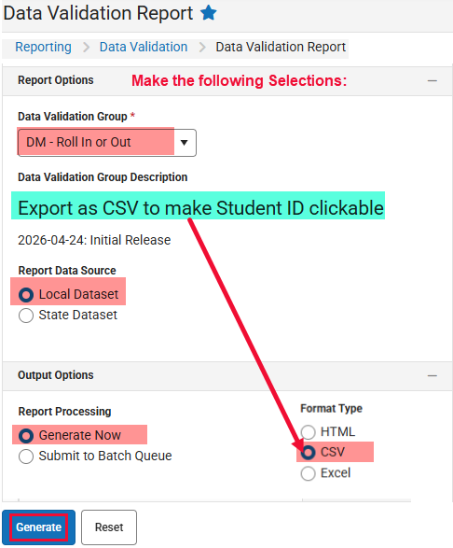

The report will have your current and incoming students registered in your building and their status:

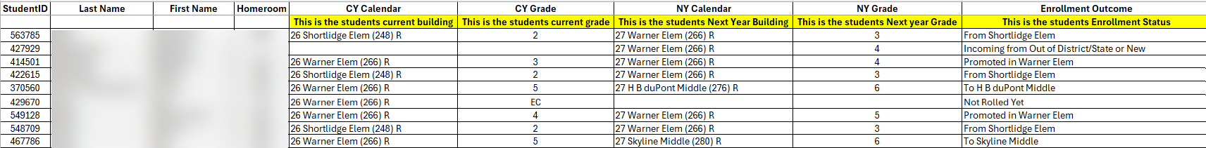

Run this report often as the end of year approaches. This report will change as the school year ends and End of Year status is updated.

