Dear Incoming Kindergarten Families,
Welcome to Ladd K-8 School! We are excited to partner with you to educate your student(s) and begin this exciting journey together! Kindergarten is such a special year filled with learning, growth, and new friendships, and we are thrilled to welcome your family to our school community.

Important School Information
- School Hours: 9:15 AM – 3:45 PM
- Office Hours: 8:15 AM – 4:45 PM
- Office Phone Number: (907) 451-1700
  - Dial 0 to speak with someone in the office
  - Dial 1 to report a student absence
Student supervision outside begins at 9:00 AM each morning. Breakfast is available beginning at 8:50 AM.

Breakfast & Lunch Information
Breakfast and lunch are served daily at school. Free and reduced lunch applications for the 2026–2027 school year will be published in August.
Student lunch accounts can be set up through School Cafe. In School Cafe, families can:
- Add money to student meal accounts
- Indicate student food allergies
- Monitor account balances and purchases

School Supplies
Student school supply lists are dependent on your student’s grade level. Please find your student’s supply list here:
Ladd Elementary School Supply Lists

Every year, World's Biggest Backpack provides free school supplies to students while supplies last.
This year’s event:
- Date: August 8, 2026
- Time: 10:00 AM – 2:00 PM
- Location: 3340 Badger Road, North Pole, AK 99705
As kindergarten students are learning how to navigate being a big kid in school, sometimes they have spills, accidents, or just get wet at recess and need a change of clothing. Please include a gallon size baggie with an extra pair of socks, underpants, pants, and a t-shirt to ensure that we have clothing to offer your student in the event that they need to change. Please clearly label your student’s extra clothing with their name in sharpie on the tag.

Winter Gear Expectations
Living in Alaska means students need appropriate winter clothing to stay warm and safe during outdoor recess. We go outside for recess in temperatures as low as -20 degrees. A picture of the minimum required winter gear is included below to help you prepare your student for the Alaskan cold.


Student Health Information
Our health assistant has prepared forms for families to complete in order to set up your student’s SchoolCare account. In SchoolCare, families can:
- Indicate student health needs
- Provide medication information
- Give permission for administration of over-the-counter medications such as acetaminophen

Drop-Off & Pick-Up Procedures
A graphic explaining our “Stop, Drop & Go” procedures for drop-off and pick-up is included below. These procedures help keep students safe while also streamlining arrival and dismissal because we know your time is valuable.
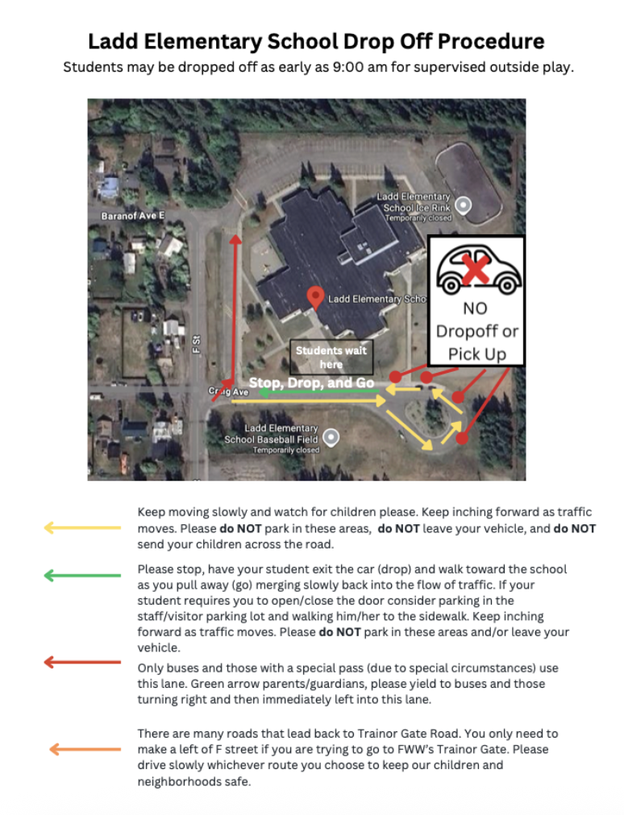
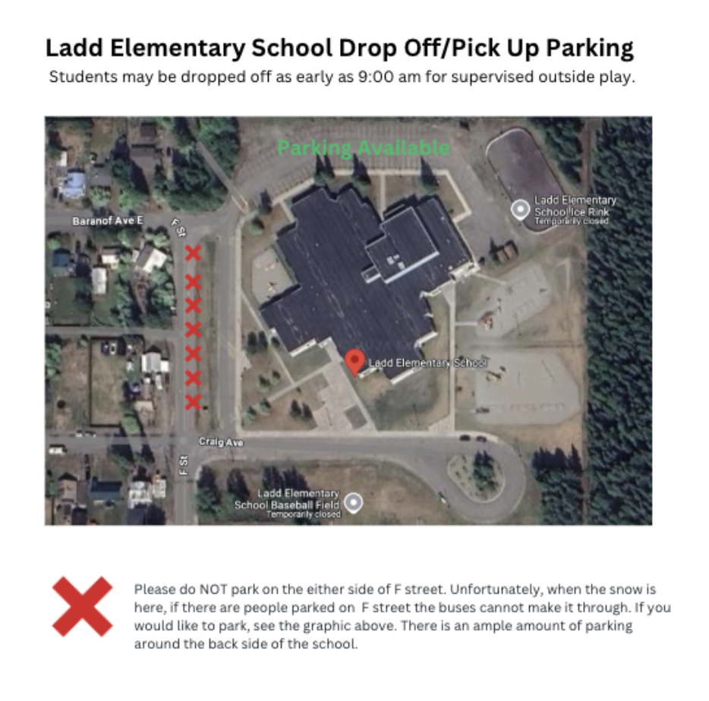

Transportation Information
If your student needs bus transportation, please visit the transportation page on our website to find:
- Bus route numbers
- Pick-up and drop-off locations
- Transportation times
Ladd Elementary School Website

Stay Connected
Please download the ParentSquare app to access the Fairbanks North Star Borough School District communication platform. Teachers, administrators, and the school district communicate important information through ParentSquare.
We also encourage families to follow us on Facebook to receive updates about upcoming events and to see pictures celebrating learning and activities happening at school.

Student & Family Support
We are fortunate to have caring staff members available to support students and families:
- Jennifer Frymark — School Counselor (907) 451-1700 (dial option 4)
- Jill Murray — Military Family Life Counselor
- Georgia Sandgren — Military Support Coordinator for military families navigating Alaska
Military family support information can be found here:
Military Student Support Information
Please reach out to the office if you would like information about:
- Employment opportunities
- Volunteering opportunities
- General questions or concerns
You can contact us anytime at (907) 451-1700.
We look forward to working with you and welcoming your family to our Ladd Elementary community!
Sincerely,
Michelle Heminger
Michelle Heminger
Ladd K-8 Principal
(907) 451-1700
Michelle.heminger@k12northstar.org

