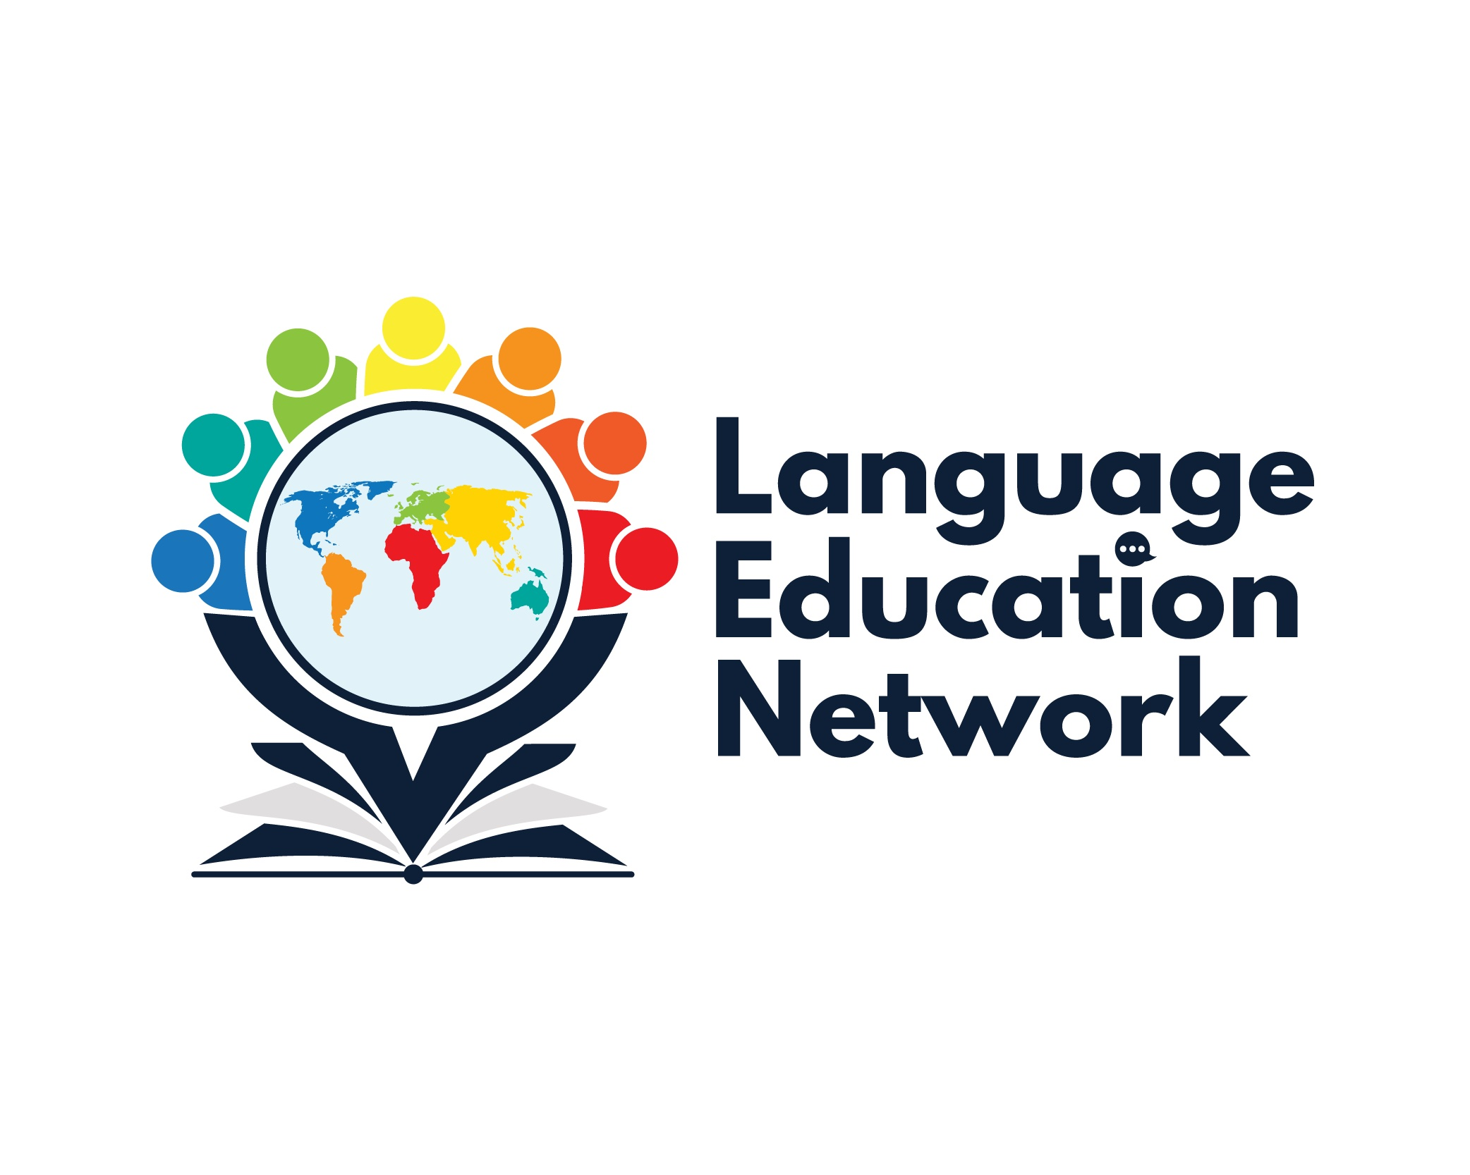

May 8, 2026
12:30 – 3:00 pm
AGENDA
PURPOSE: The purpose of our network is to come together to align current research and policy with the work that is required to prepare our English Learners and Multilingual Students for college and career.
¡BIENVENIDOS!  2025-2026 Meeting Dates | PRESENTATION SLIDES  Facilitators:  Carlos Pagán: cpagan@sbceo.org  Melissa Garcia: mgarcia@sbceo.org
  September 26, 2025  December 5, 2025 | March 20, 2026  May 8, 2026

SECTION | TOPIC | LINKS & RESOURCES
1: (12:30 – 12:45) | LUNCH (12:15-12:45)  Introductions & Grounding Activity | Language Education Network (LEN) Webpage
2: (12:45 – 1:30) | - Assembly Bill 2555 Patel (AB-2555): English Learners: reclassification (2025-2026) | AB 2555 (Patel)
3: (1:30-2:00) | - TK Language Screeners  - IPT Early Childhood (Ballard & Tighe)  - preLAS (Data Recognition Corporation) | TK Multilingual Learner Screeners
BREAK 2:00-2:10
4: (2:10– 2:40) | - Unpacking the Literacy Content Blocks for TK-5  - CAASPP-ELPAC Website  - Mentimeter Poll  - BCN Updates  - Accountability (LTELs)  - Assessments  - Legislative | Literacy Content Blocks  Upcoming and On-Demand Trainings
5: (2:40-3:00) | - Professional Learning Opportunities  - DLI Institute (June 15-16, 2026; 8:00am-3:00pm- VCOE & SBCEO)  - AI & Language Development  - ELPAC 101 for Teachers  Student Events in Spanish  - Batalla de los libros (May 14, 2026) | DLI Topics:  - June 15th: GLAD en español Strategies – ALAS (VCOE)  - June 16th: Dr. Tara Yosso – Cultural Wealth Model (DLI Pillar- Sociocultural Competence) (SBCEO)  AI & Language Development  ELPAC 101 for Teachers (K-5)  ELPAC 101 for Teachers (6-12)

2026-2027 LEN DATES:
September 25, 2026
December 4, 2026
March 12, 2027
May 14, 2027
(12:30-3:00 pm)

