Blood Loss/ Traumatic Injury
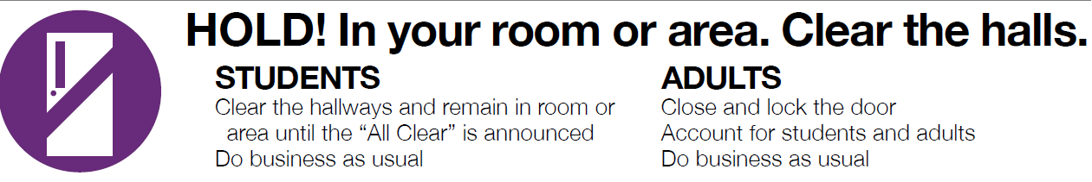
The North Kansas City School District will follow the protocols set forth by DESE and the “Stop the Bleed Act” RSMO 160.485
Classroom Staff:
- If able, don PPE and begin direct pressure to the wound.
- Notify the office/ building administrator
Administrators:
- Place the building in security protocol: “Hold”
- Activate the Medical Emergency Response Team
- Notify a School Resource Deputy/ Officer
- Notify Emergency Medical Services
Medical Emergency Response Team:
Respond and follow training procedures as set forth by American Red Cross and/or American College of Surgeons
