

LSRRE 2025 PROGRAMS

We Love Books
Wednesday, February 19, 2025 – 12:30 pm
Erika’s Kitchen – 1630 3rd Ave S, Payette
*Bring a book you enjoy and share why the rest of us should read it!

LSRRE Scholarship Presentation
Wednesday, March 26, 2025 – 12:30 pm
Idaho Pizza, 1255 State St, Weiser
Presenter: Heather Hoffman, 2024 Scholarship Recipient
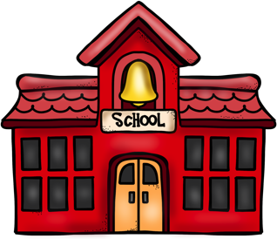
*NOTE: This event falls on the fourth Wednesday of the month

Payette School District’s Vision for
Technical Career Classes
Wednesday, April 16, 2025 – 12:30 pm
Ericka’s Kitchen – 1630 3rd Ave S, Payette
Presenter: Barbara Wilson, Payette School Board

LSRRE Final Fling: Bring on Summer
Wednesday, May 21, 2025 – 1:00 pm
Warzyn Residence – 832 Beverly Hills Dr, Payette
*Bring your favorite salad or desert.

