Scholar’s Showcase- April edition

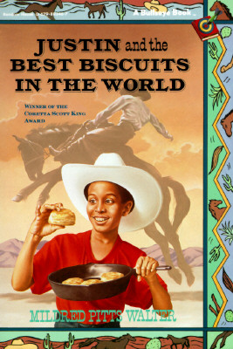

Fourth grade GATE students completed a novel study of the Coretta Scott King award winning novel Justin and the Best Biscuits in the World. Students explored the history of African American cowboys as well as the impact a grandfather can have on his grandson. All students enjoyed a hands-on baking activity that involved using a biscuit recipe from the novel. The biscuits did not last long once they were taken out of the oven! Yum!



Fourth grade GATE students formed collaborative groups with the goal of building a bridge out of 150 popsicle sticks that could hold weight. Students studied bridge design and structural integrity. All groups were surprised by the amount of weight their bridges could hold!

