
School Achievements
Council Members

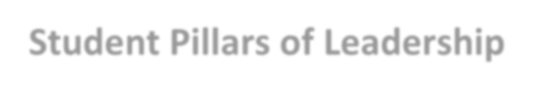
- Only National Association for the Education of Young Children (NAEYC)- accredited school in Richland One
- Arts in Basic Curriculum (ABC) grant recipient
- Distinguished Arts Program grant recipient
- Palmetto Gold Award recipient
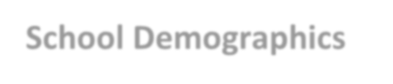
- CarolinaCAP Partner School

School Demographics
- 225 students in Pre-K through Grade 5
- 33% African American, 4% Asian,
15% Hispanic, 44% White, 4% Other

Student Pillars of Leadership
Pre K – 2nd grades Respect Cooperation Community Responsible Self-Control Caring
Trustworthy
3rd – 5th grades
Respect Collaboration Citizenship Responsible Self-Discipline Empathy Integrity
The School Improvement Council of A.C. Moore Elementary prepared this annual report to share information about the school’s progress in meeting its goals and objectives during the school year. If you have questions about the information summarized here, please contact SIC Chair Erin Linden or Principal John Allen at (803) 343-2910.
Chair: Erin Linden, Parent erinholscher@hotmail.com

Vice Chair: Katie Rankin, Parent katiewrankin@gmail.com

Secretary: Ariel Asouzu, Parent ariel.asouzu@richlandone.org
John Allen, Principal john.allen@richlandone.org

Sherri Burgess, Assistant Principal sherri.burgess@richlandone.org

Sylvia Rogers, Parent Engagement Specialist sylvia.rogers@richlandone.org

Anna Kate Twitty, Parent / PTO Co-President annakate918@gmail.com

David King, Teacher
david.king@richlandone.org
Samantha Martin, Teacher samantha.martin@richlandone.org


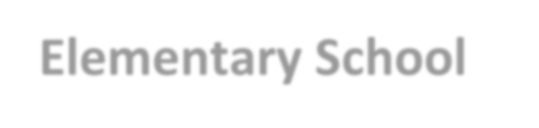
Report to the Parents
A.C. Moore
Elementary School
School Improvement Council

2025-2026
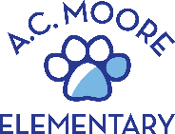
333 Etiwan Drive, Columbia, SC 29205
(803) 343-2910

Vision Statement
A.C. Moore Elementary School is committed to fostering productive citizens by ensuring all learners achieve their personal best in a supportive, creative, intellectual, and culturally diverse learning environment.
Mission Statement
A.C. Moore Elementary School stakeholders will collaboratively use research-based, data-driven, and arts-infused instructional practices to empower and encourage all students to achieve their personal best.


SIC Annual Goals
The School Improvement Council established goals for the school year, as derived from the five-year School Improvement Plan, and employed the following strategies to address them.


Core Values
Passion: Embracing and nurturing our school community
Intentionality: Purposeful, present, and prepared
Accountability: Growth over ego

Increase Communication within School Community
- Weekly homeroom teacher newsletters
- Monthly PTO newsletter and parent grade level liaisons
- Active school social media accounts on X & Facebook
- Bobcat Beat daily morning news show

Enhance Involvement in the Arts
- Koger Center Field Experiences
- Spring Fling
- District Honor Choir
- District Arts Show
- Onsite Artist in Residence experiences

Boost Community Engagement & Student Enrollment
- Fall Fest
- Literacy Publishing Party
- Horace Mann Perfect Attendance Program

School Goals
By May 2026, 70% of students in grades K- 5 will meet their growth goal on STAR Reading.
By May 2026, 70% of students in grades K- 5 will meet their growth goal on iReady Math.
By May 2026, 70% of students in Grade 3- 5 will score meets or exceeds in ELA & Math as measured by the SC READY assessment.
Student Achievement

Extracurricular Activities

Clubs and Activities
Bobcat Chorus Fitness Team Running Club Principal’s Council News Crew Safety Patrol Modern Band
Superintendent’s Book Club Challenge

Special Programs and Community Involvement
- Arts in Basic Curriculum (ABC) School
- Creative Arts Alliance
- Healthier Generation Wellness Team
- St. Patrick’s Day Parade & Festival
- PTO Clothing Closet
- Special Olympics Unified Champion School
- Radius Southside Hope Program
- United Way Fundraiser
- ArtNow
- Tiny Taste Nutrition Program (4K)
- Book of the Month

