Student Achievement
In the spring of 2023, Willow Drive Elementary 3rd -5th grade students participated in SC Ready State assessments in ELA and Math. 4th-grade students also participated in the SC Ready Science assessment.
A comparison for growth from the previous year along with an absolute overall rating was sent in the Fall of 2023.
Another assessment utilized is the MAP test, which is administered three times a year (fall, winter, and spring). In comparing fall to spring growth, Willow Drive students can see where they will score on state testing.

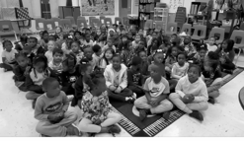

School Improvement Council (SIC) Members
Jackie Thomas
Principal
jackie.thomas@sumterschools.net

Stephanie Beckley Assistant Principal
stephanie.beckley@sumterschools.net

Shawn Rearden
Chair, Instructional Coach
shawn.rearden@sumterschools.net

Tammy Adams Kelly Community
Larisa Rhodes
Community
Catherine Hallman Community
Allison Tyner
Staff
Shemaka Veasey
Parent

Purpose of the Report
This report is issued by the Willow Drive Elementary School Improvement Council in accordance with South Carolina law to share information on the school’s progress in meeting various goals and objectives, the work of the SIC, and other accomplishments during the school year.

Willow Drive Elementary
Where Eagles Soar with Pride!

2023-2024 Annual Report To Parents

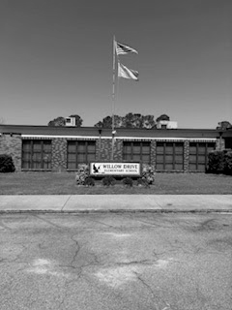

Mission
“The mission of Willow Drive Elementary is to develop competent, lifelong learners by providing a thorough and effective educational program that prepares students to meet the challenges of an ever-changing society.”

26 Willow Drive Sumter. SC 29150
(803) 773-5796

https://wde.sumterschools.net

Principal
Jackie Thomas
Assistant Principal
Stephanie Beckley


Strategic Plan Goals

Goal 1
Increase the percentage of students who meet or exceed the standard in ELA and Math by 5% over 5 years.

Goal 2
Maintain teacher attendance rates at quality professional development at 95%.

Goal 3
100% of teachers will be endorsed through the Read to Succeed Initiative.

Goal 4
Increase parental involvement by 5%.

Goal 5
Increase the percentages of stakeholders satisfied with the school environment and home-school relations by 5%.

Goals are developed on a 5-year cycle. The current plan is for 2022-2027. Please visit our website to view more detailed strategies for current goals.

Activities to Support Strategies for Improvement

- Service Learning
projects
- Reading Interventionist
- Reading Workshop
- Raz Kids, IXL, ExactPath
- Expanded leveled bookroom
- Continue to expand business and community partnerships
- On-going professional development in Math, ELA, and Social-Emotional learning
- Organize special school and community events
- Social media, website, digital, and hard copy communication with parents and school stakeholders
- Parent Conference Nights
- Monthly school calendar
- Small Group Instruction
- Quarterly newsletters

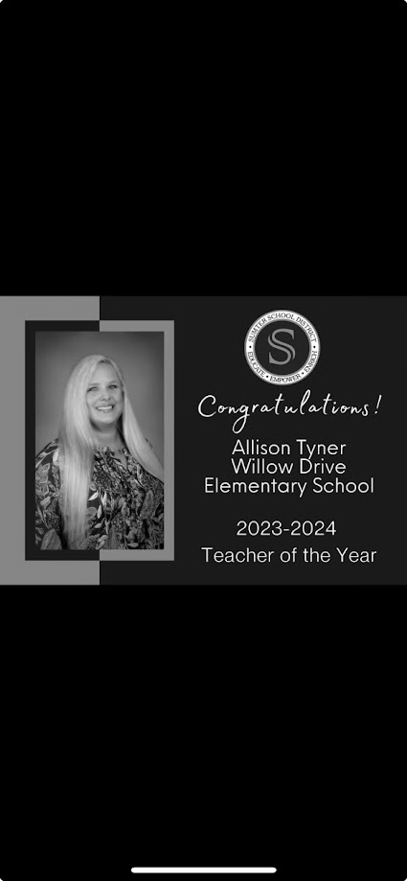

2023-2024 School Highlights

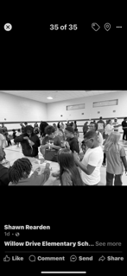

- Fundraising for Relay for Life
- Fundraising for the American Heart Association
- Kids Heart Challenge
- Canned Food Drive for Local charities
- Exact Path Skill Mastery Awards
- Read Across America Week
- Random Acts of Kindness Initiative
- Exact Path High Flyer Recognition
- Red Ribbon Week
- LETRS Training for all teachers
- 2 students in SC Honors Choir
- Spring Fling at the Drive (STEAM Night)
- Participated in the Christmas Parade
- Military Child Month
_________________________

Sumter School District does not discriminate on the basis of race, color, religion, national origin, sex, disability, or age in admission to, treatment in, or employment in its programs and activities. For inquiries regarding the policy, contact the Assistant Superintendent of Human Resources or Director of Specialized Programs, Sumter School District 1345 Wilson Hall Road Sumter Sc 29150, or call 803-463-6900.

