To our Wickliffe Schools’ family,
I want to take a moment today to provide a clear update on the significant changes that will impact our students and families in the upcoming school year. As most of you know, voters in Wickliffe have rejected our recent levy requests, and as a result we are obligated to provide a ‘reduction plan’ to the State of Ohio. After hundreds of hours of work and consideration, we have built and the State has approved this plan.

As Superintendent, these decisions were very hard and not made lightly. These have been stressful to consider, and I am grateful for the hard work of our Board, Administration, and Staff as we’ve pieced together the best path forward for our schools and community. This reflects the financial realities we face paired with our commitment to essential education with reduced funding. These reductions will trim our budget by over $2.5 million per year, and put us on a much more stable financial footing for the future.

Here are the BIG PICTURE CHANGES we will make in the 2026-27 school year:

- Reduction of staff positions: including 3 Full-Time Administrators, 13 Full-Time Teaching positions, and 15 Building Monitor positions.
- Reduction of 5 Bussing Routes and increasing of the “walk zone” to 2 miles.
- Transition to a Half-Day Kindergarten program.
- Transition to a Full Cost, Pay-to-Participate model for all athletic and extracurricular programs.
- Streamlining High School Electives offerings, and removal of low-enrollment and non-essential courses.

As you may also know, there is an Earned Income Tax levy being placed on May 5th ballot. If passed, we will evaluate which of these can be adjusted – however, even if passed the funds would not be accessible until 2027, meaning few of these would be restored within a year.

We recognize that this will have a real impact on our students, families, staff, and community. We are committed to being transparent, communicative, and supportive as we move through this together. More details will come with time – like changes to campus start/end times, schedules, and fee structures.

Thank you for your understanding, trust, and partnership as we work to provide the best possible educational experience within our capacity.

Sincerely, Mike Chokshi
Superintendent, Wickliffe City Schools

FURTHER DETAILS:

Kindergarten Program Changes
- Kindergarten will transition to a half-day program for all students.
- Placement in AM or PM Kindergarten will be based on classroom capacity and need to maintain a balanced enrollment across sessions.

K-6 Electives
- Only Physical Education will continue on a regular basis.
- Band will be offered in Grade 5 and Grade 6, but on a limited basis.

HS Course Offerings
- Overall, high school electives will be streamlined, with low-enrollment and non-essential courses removed from the master schedule. Students requiring resources will be provided time in a different capacity than a separate period.
- Each grade will have one period for electives, with the following options:
  - Band – offered in Grade 7-12, but in a different capacity than the traditional ‘class period’.
  - 9th Grade – 4 content areas and Health, 1 semester elective choice
  - 10th Grade – 4 content areas and Financial Literacy, 1 semester elective choice
  - 11th Grade – 4 content areas, CTE, CCP, or 1 elective
  - 12th Grade – Remaining Graduation Requirements, CTE, or CCP
- Advanced Placement (AP) and honors offerings will be reduced to only courses with consistently high enrollment.
- Career-technical education partnerships will continue with Mentor and Willoughby-Eastlake
- CCP courses at Lakeland CC and Cuyahoga Community College (Tri-C) will remain available.
- ‘Learn, Leader, Serve’ will have only one section.
- Extracurricular clubs will operate IF they are self-funded or supported by outside boosters.

Pay-to-Participate Fees
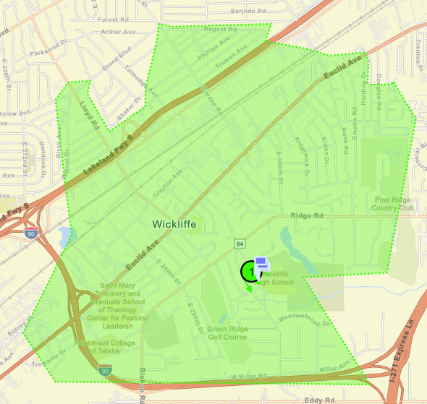
- All athletic and extracurricular programs will move to a full cost ‘pay-to-participate’ model.
- Fees will reflect the actual ‘true’ cost of running each program.

Transportation
- Beginning in 2026/2027, bussing/ transportation will be provided ONLY to K-8 students living over 2 miles from their school building.
- Families living within the 2-mile “walk zone” will be responsible for arranging their own transportation.
- Map (on right) highlights the “walk zone” in green. Bussing will only be available for those outside the highlighted green area.

