
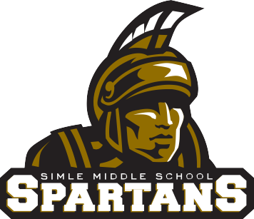
4

RUSS RIEHL
Principal
Jeremy Burgard
Assistant Principal
RANDY LAMBERTH
Assistant Principal

2026 SMS Football Important Dates

May 14th: Coach/Athlete Informational Meeting in the cafeteria (this will happen during homebase in the am)
June 2 – July 23rd: Spartan Training @ Simle Middle School
- Registration form can be found online at:
  - Spartan Training
  - Please see Mr. Woeste for a registration form
July 7-8th: Simle Middle School Central City Football Camp
- We strongly encourage all athletes to attend this camp!
- Registration form can be found here: https://docs.google.com/document/d/1VfbxW0VfLqF99SMrmz1XYkyY0GKLktH1Yx79hoD0bk8/edit?tab=t.0
- Please see Coach Lemar with any questions
July 27-29th: Legacy O&D Camp for Middle School Athletes
- Registration form can be found online at the following link: https://legacysabersfootball.com/
- Contact Coach Clements for more information:
    - chris_clements@bismarckschools.org
August 12th: Parent Meeting/Gear Handout/ SWAY Testing (Bring Phone)
- Schedule for this night will look like this (times are subject to change):
  - 5:00-5:30: Parent Meeting in the Auditorium
  - 5:30-6:30: 7th grade athletes SWAY Testing
  - 5:30-6:30: 8th grade athletes Gear Handout
  - 6:30-7:30: 7th grade athletes Gear Handout
August 17th: First day of Practice/SWAY Testing (Bring Phone)
- Great day to be a Spartan and future Saber
- Practice will start at 4:30 and will end by 6:00 pm (make sure you have a ride and that it is here on time)

