

2026 RANGER VOLLEYBALL CAMP
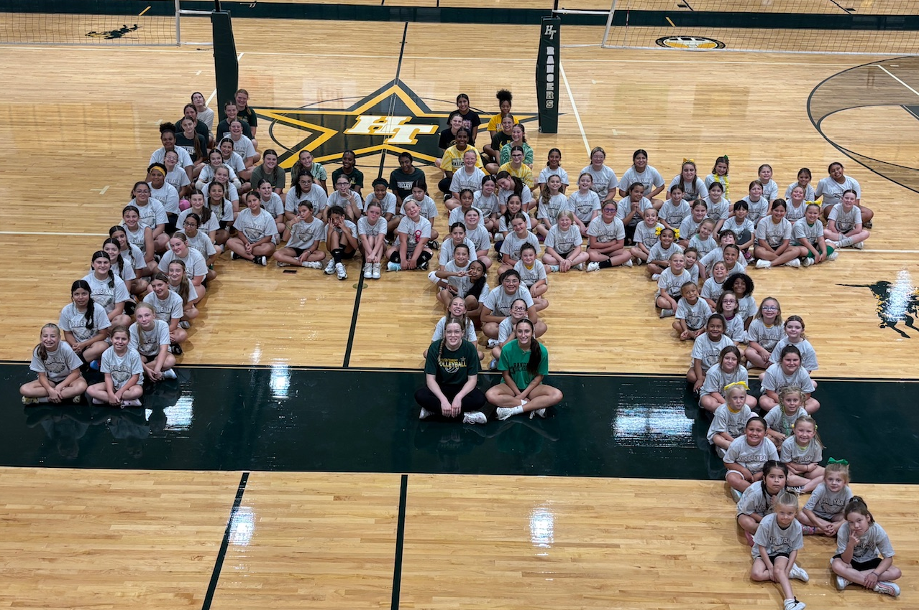
Once a Ranger, Always a Ranger
Grades:
K-8th (based on the 26-27 school year)

Dates:
Tuesday, July 21st
Wednesday, July 22nd
Thursday, July 23rd

Times:
12:00 - 2:00 pm - (5th - 8th)
2:15 - 3:45 pm - (K - 4th)
Location:
Hamilton Township High School Gym

Cost: $40

*T-Shirt Included - Registration received by July 10th for guaranteed shirt size.

Cash or Check Made out to: Hamilton Township High School
Mail payment and registration to:
Chelsea Snider - HT Volleyball
1105 Rathmell Road Columbus, OH 43207
OUR RANGER VOLLEYBALL CAMP WILL GIVE YOUR DAUGHTER A CHANCE TO WORK WITH YOUR HIGH SCHOOL AND MIDDLE SCHOOL COACHING STAFF, AS WELL AS A CHANCE TO WORK WITH HIGH SCHOOL PLAYERS AND WATCH THEM DEMONSTRATE SPECIFIC SKILLS. THE CAMP WILL FEATURE FUNDAMENTALS, COMPETITIONS, AND DRILLS USED AT ALL LEVELS IN OUR VOLLEYBALL PROGRAM. YOUR CHILD SHOULD WEAR ATHLETIC SHOES, CLOTHING, AND BRING A WATER BOTTLE.
Student Name___________________________________________________ Grade (2026/2027 School Year) _________________
Phone Number ________________________________ Parent Email Address_____________________________________________
Street Address________________________________________________________________________________________________
City ________________________________________________ Zip _____________________________
T-Shirt Size (Circle One) Youth Sizes: Youth Small Youth Medium Youth Large Adult Sizes: Small Medium Large X-Large
Emergency Contact & Phone Number__________________________________________________________
PERMISSION/MEDICAL RELEASE:The above student has my permission to attend the Ranger Volleyball Camp. I hereby agree that the participant above has been examined and found to be in good physical health. I have no knowledge of any physical impairment that would affect or be affected by this child participating in the camp. In addition, I agree that the participant is physically fit and able to take part in vigorous activity and should any illness or injury occur, I give consent to allow medical treatment for the participant. I am aware that injuries may occur during the camp and I waive, release, and forever discharge Hamilton Local Schools, the Board of Education, the employees, and the camp authorities from any and all injuries. In addition, I understand that the camp authorities are not responsible for any accidents, medical or dental, incurred during the course of instruction given by staff, and said staff is to be held blameless. I also understand that cooperation and behavior are important and should the participant behave in any way deemed inappropriate, the camp coordinator may expel her from the camp and the fee will not be refunded. Once a fee is paid, there will be no refunds.
SIGNATURE_____________________________________________________________
(Parent or Guardian)

