SIC Meeting
November 13, 2023

AGENDA
2:45 PM
Welcome/Introductions

Members in Attendance:

Reading and Approval of Minutes From Last Meeting

Updates
- ATSI Tutoring
- 2023 School Report Card
- Red Ribbon Week
- Veterans Day Assembly
- Kona Ice
- Food Drive for Sumter United Ministries
- ESSER Tutoring

Upcoming
- 2nd Quarter Interims 11/15
- World Kindness Week 11/13-11/17
- Club day 11/17
- Thanksgiving holiday 11/20-24
- MAP testing 12/4-12/8
- Second quarter ends 12/20
- WINTER BREAK 12/21-1/5
- 2nd semester begins 1/8

District Updates

- Wednesday, November 15 – This is the statutory deadline by which the current year’s membership of local SICs must be reported to the online SC-SIC Member Network. Principals or their school staff designee should have by this date obtained a user account and password to input this data on the Member Network (more information available here).
- Friday, December 8 – This is the application deadline for the 2024 Dick and Tunky Riley Award for SIC Excellence. This year’s Level One application process is entirely online. More information on the application process is available here and here. Information regarding previous Riley Award honorees can be found here.

Items to Share
- Dick and Tunky Riley Award (Deadline 12/8)
- Shower Shaw with Goodies (dropoff is 12/9)

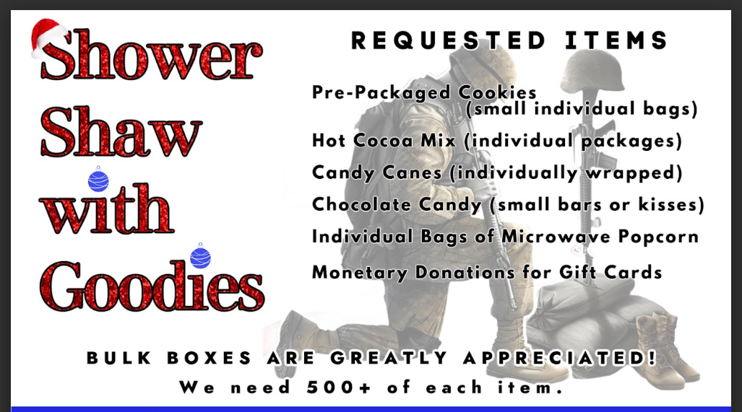

Questions/Concerns:

Meeting Adjourned at:

