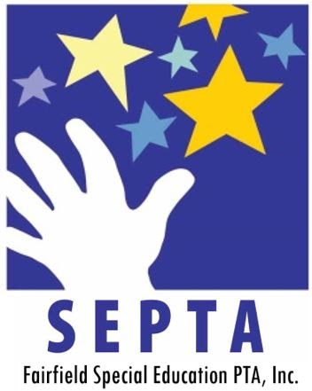
Fairfield SEPTA Scholarship Fund

Grant Application
2025-2026

Name: _________________________________________________________

Address: _______________________________________________________

Phone Number:__________________________________________________
Email Address where you or someone else can be reached:_______________
_______________________________________________________________

Current School: _________________________________________________

School Activities, Athletics, Clubs: ___________________________________

_______________________________________________________________

_______________________________________________________________

After School and Weekend Activities, Jobs, Volunteering: _________________

_______________________________________________________________

_______________________________________________________________

Awards, Achievements: ____________________________________________

_______________________________________________________________

________________________________________________________________

Academic Performance, GPA: _______________________________________

_______________________________________________________________

**Please follow the below instructions very carefully so that the selection committee has all appropriate information:

Instructions: Only circle one of the Scholarships below you are applying for. If you do not identify which scholarship you are applying for by circling it, you will not be eligible for either one.

Sandy-View Scholarship: $2,500.00 award.

This is a new scholarship. One person will be awarded this from Warde and one from Ludlowe. The person must describe how their disability has impacted them but has allowed them to fulfill their high school dreams and also allow them to follow their dreams after high school.

- Student must have a set plan for post-secondary education
- Student must within their essay describe in detail how their disability has impacted them and their high school experience.
- Student must receive a letter from their School Counselor with the School Counselor recommendation letter attached specifically for this scholarship. The School Counselor must write why the student should receive it.
- Economic need will “strongly” be taken into consideration and should be reflected in your essay.

Student signature: ________________________Parent Signature: _______________________

School Counselor Signature: __________________________

SEPTA Scholarship: $500 - $1,500 depending on need.

The Review Committee would like you to reflect on and describe for us the following 5 areas in an attached essay:

- How has your disability affected your high school experience?
- What actions have you taken to overcome its impacts?
- Describe your plans for this Scholarship.
- How will this money help with your future education?
- Why do you believe the committee should award you this scholarship?

[Please attach your Essay to your application.
Essay should be approximately 250-500 words]

Completed Application Deadline
May 8, 2026

Completed Application and appropriate supporting documentation needs to be turned into:

- Mr. Michael Sanzaro/Transition Coordinator - (msanzaro@fairfieldschools.org)

**Do not use .net email.

There will be a short, (10-minute) interview with the Selection Committee in May to review your application and to give the committee a chance to meet you and for you to present any further information.

For the Sandy-View Scholarship there will be a 15–20-minute interview.

Failure to keep your appointment with the review committee is an automatic disqualification.

____________________________ __________________________
Signature Date

