
Kingsbury Elementary School

School Renewal Plan

2022-2027
Updated March 17, 2023
Updated March 15, 2024
Updated December 12, 2024
Updated March 27, 2025

SCHOOL RENEWAL PLAN

TABLE OF CONTENTS

Stakeholders Involvement for School Renewal Plan………………………………..……. 4

Needs Assessment Data ……………………………………………….……………………… 6

Executive Summary of Needs Assessment Data Findings ……………………………… 12

Performance Goals and Action Plans ……………………………….…………………….. 15

College & Career Ready Goals ……………………………….……………...…….. 15

High Performing Workforce Goals …………………………….…………………….. 23

Safe & Supportive Schools Goals ……………………………….…………………… 27

Strong Stakeholders Partnership Goals ……………………………….….……..….. 30

Effective & Efficient Operations Goals ……………………………….….……..….. 34
Read to Succeed .………………………………………………..…….……………………… 38

NOTE: The items above are linked to the listed pages for ease of navigation through the Strategic Plan. This Table of Contents page is bookmarked in the bottom right corner of each page for navigation purposes, as well.

STAKEHOLDER INVOLVEMENT FOR SCHOOL PLAN

List the names of persons who were involved in the development of the school renewal plan. A participant for each numbered category is required.

POSITION NAME

1. PRINCIPAL Phillip W. Jackson

2. TEACHER Sheila Pack

3. PARENT/GUARDIAN Amanda Hines

4. COMMUNITY MEMBER LaCharlie Sharrod

5. SCHOOL IMPROVEMENT COUNCIL Kendra Tysinger

6. READ TO SUCCEED COACH & Team Lead Dr. Jonnell Atkins

7. STEAM Lead Teacher Erin Bradford

8. Assistant Principal Dr. Stephanie Cooper

9. Assistant Principal Courtney Geddings

10. School Counselor Akeila Brailsford
11. School Counselor Ashley Cook

12. Instructional Coach Kara Gaertner

13. PTO President Amanda Craven

(May include school board members, administrators, School Improvement Council members, students, PTO members, agency representatives, university partners, etc.)
** Must include the School Read to Succeed Literacy Leadership Team.

*REMINDER: If state or federal grant applications require representation by other stakeholder groups, it is appropriate to include additional stakeholders to meet those requirements and to ensure that the plans are aligned.


College & Career Readiness | Safe & Supportive Environment | Strong Stakeholder Partnerships | High Performing Workforce | Math &  Reading | Effective & Efficient Operations
Beth Ann Young | Kala McCall | Allison Stanfield | Sheila Pack | Leslie Cribb | Adrienne Love
Kayla Miller | Jannette Murdoch | Shelby McHaney | Alyssa Gibbs | Jodi Lucas | Abigail Harrell
Rakeshia Raby | Nina Clark | Ashlee Kennedy | Shayntay Alston | Serena McCoy | Hope Jackson
Lee Anna Harding | Amy Robbins | Ellie Holladay | Theresa Witherspoon | Emily Masaitis | Penny Aylward
Ann Parrish | Alyssa Lemke | Ashley Cook | Michael McCaffrey | Megan Drummond | Tracy Spigner
Michelle Blassengale | Annette McCaffrey | Alison Brunson | Rebekah Crolley | Stephanie McCormick | Marlene Woodard
Phillip Jackson | Akeila Brailsford | Erin McCaffrey | Stephanie Cooper | Barbara Hale | Sheri McDowell
 |  | Jami Coker | Kara Gaertner | Jonnell Atkins | Courtney Geddings

NEEDS ASSESSMENT DATA

Provide the link to your school’s most recent School Report Card:
Kingsbury Elementary School Report Card

Directions: Provide additional school’s needs assessment data including both formative and summative assessments used to gauge student learning. (Charts, graphs, or other formats of data may be used.)

Data Source: Teaching Strategies: GOLD
Report Type: Performance Snapshot by Area
Term Tested: Fall 2021
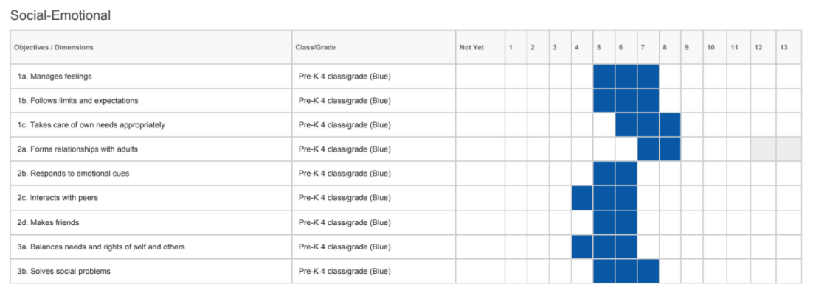
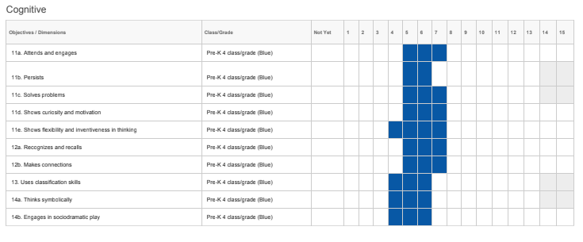

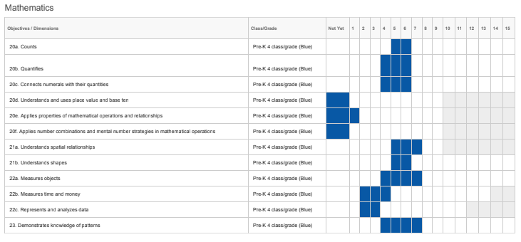

Data Source: South Carolina Kindergarten Readiness Assessment
Report Type: Percent Met, Approaching, or Emerging
Term Tested: Fall 2020
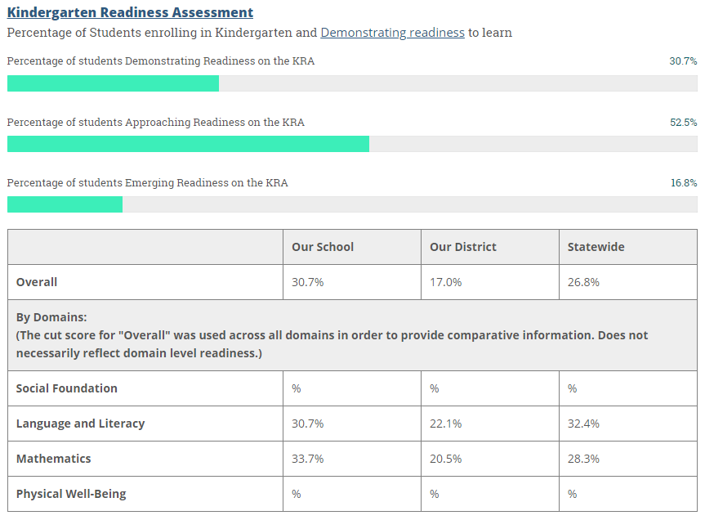

Data Source: NWEA MAP Growth Assessment
Report Type: Grade Level Summary Report
Term Tested: Fall 2021

Kindergarten:

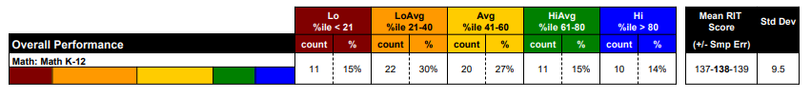

1st Grade:

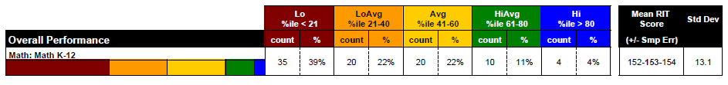
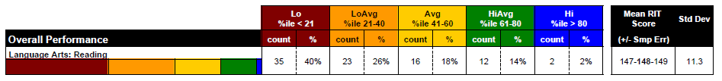

2nd Grade:

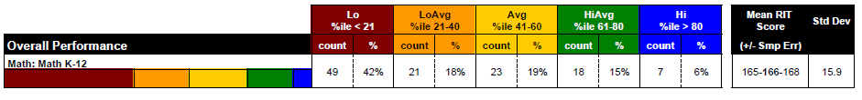
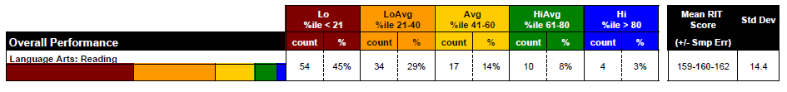

Data Source: NWEA MAP Growth Assessment
Report Type: Projected Proficiency Summary Report
Term Tested: Fall 2021

Language Arts: Reading (2-5)

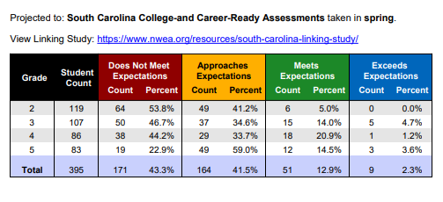

Math: Math (2-5)
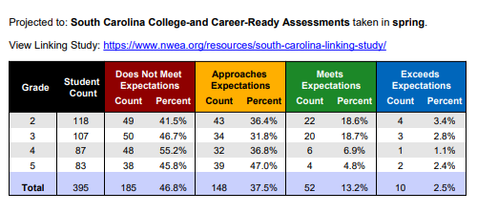
Data Source: South Carolina Ready Assessment
Report Type: Percent Met or Exceeding
Term Tested: Spring 2021

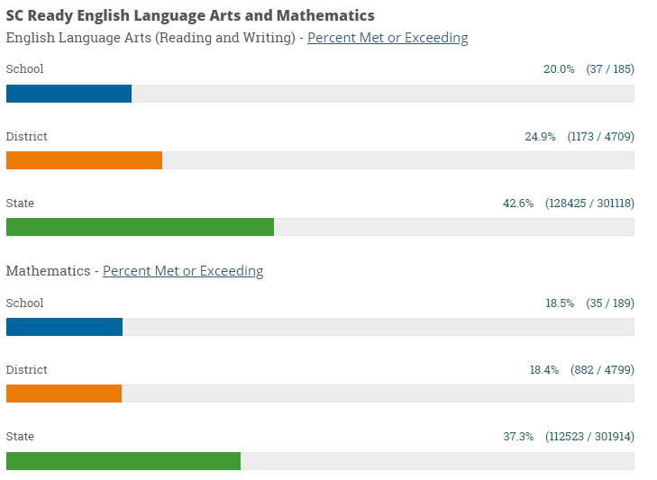

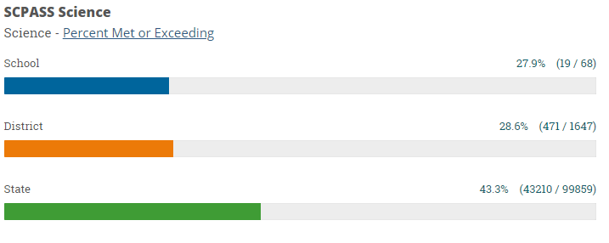

Data Source: South Carolina School Report Card
Report Type: Teacher, Student & Parent Survey
Term Tested: Spring 2021

Results of Teacher, Student and Parent Surveys:
 | Teachers | Students | Parents
Percent satisfied with learning environment | 90.3% | 91.0% | 83.3%
Percent satisfied with social and physical environment | 92.7% | 88.1% | 87.7%
Percent satisfied with school-home relations | 80.5% | 81.9% | 80.0%

EXECUTIVE SUMMARY OF NEEDS ASSESSMENT DATA FINDINGS

Per SBE Regulation 43-261, the annual needs assessment will provide focus for planning teams to set priorities for the plan. The comprehensive needs assessment must identify targeted areas of discrepancy between the desired performance levels and the current status as indicated by available data. Any discrepancies in the following areas identified by the school and district report cards must be included in the plan: (1) achievement, (2) achievement by subgroups, (3) graduation rates, (4) attendance, (5) discipline, (6) teacher/administrator quality and professional growth, and (7) other priority areas.

Measurable performance goals, written in five-year increments, shall be developed to address the major areas of discrepancy found in the needs assessment in key areas reported in the district and school report cards.

State Report Card for districts and schools data: http://ed.sc.gov/data/report-cards/state-report-cards/

Directions: In the appropriate boxes, use school data to identify areas in need of improvement. Required areas to be addressed: Student Achievement, Teacher/Administrator Quality, and School Climate.

College and Career Readiness
Early Childhood/Primary (PK–2):
The Teaching Strategies GOLD assessment was given to approximately 51 students who were enrolled in Kingsbury Elementary’s four-year-old PreKindergarten classes during the first quarter of the 2021-2022 school year. This assessment measured students in the areas of Language and Literacy. In the area of Language, 27% of the students scored Below Expectations and 73% of the students scored Meeting Expectations or Exceeding Expectations. In the area of Literacy, 40% of the students scored Below Expectations 60% of the students scored Meeting Expectations or Exceeding Expectations.
The Kindergarten Readiness assessment was given to all Kindergarten students at Kingsbury Elementary School who were enrolled during the first quarter of the 2020-2021 school year. This assessment measured students in the area of Language/Literacy and Mathematics. In the area of Language/Literacy, 30.7% demonstrated readiness to learn compared to 22.1% at the district level and 32.4% at the state level. In the area of Mathematics, 33.7% demonstrated readiness to learn compared to 20.5% at the district level and 28.3% at the state level.
Our kindergarten, first, and second graders took MAP Growth testing in the Fall of 2021. Kindergarteners only took the Math Growth test; 74 students tested and 56% tested average or above average proficiency. 88 first-grade students took Fall MAP Growth; 34% scored average or above average proficiency in Language Arts (Reading) and 37% scored average or above average proficiency in Mathematics. 119 second-grade students took Fall MAP Growth; 25% scored average or above average proficiency in Language Arts (Reading) and 40% scored average or above average proficiency in Mathematics.

Elementary/Middle (3–8):
Students in 3rd - 5th grade took MAP testing this school year in the Fall Testing window. Students were assessed in the subject areas of Language Arts (Reading) and Mathematics. 107 Kingsbury 3rd graders were tested in Language Arts and 18.7% were projected to score meets or exceeds expectations, while 21.5% were projected to score meets or exceeds expectations in Math. 87 Kingsbury 4th graders were tested in Language Arts and 22.1% were projected to score meets or exceeds expectations, while 8.0% were projected to score meets or exceeds expectations in Math. 83 Kingsbury 5th graders were tested in Language Arts and 18.1% were projected to score meet or exceed expectations, while 7.2% were projected to score meet or exceed expectations in Math.
The South Carolina College and Career Ready (SC Ready) assessment was given to students in grades 3-5 during the spring of 2021; only students who attended school in person were given the assessments; virtual students were given the option to come to school and test on the dates SC Ready was administered. Students were assessed in the subject areas of English Language Arts (Reading and Writing), and Mathematics. Kingsbury had 20.0% of students' score meet and exceed expectations in English Language Arts and 18.5% of students score meet or exceed expectations in Mathematics. Students across the state performed “meets or exceeds expectations” at 42.6% for English Language Arts and 37.3% for Math under the state averages.

High School (9–12):
n/a

High-Performing Workforce
The recruitment and retention of highly qualified, certified teachers and administrators continue to be a challenge across the state of South Carolina. The statistics across the nation of vacancies that remained unfilled are staggering. In addition, the number of educators who have walked away from the field to begin careers in other areas is a constant source of national news. Currently, 100% of teachers at Kingsbury are certified in their area of duty, and 80% of teachers at Kingsbury have their master's or above level of education. Additionally, 100% of our administrators are certified.
At Kingsbury, we have worked to build a strong sense of community and collaboration. Our staff worked through the SWOT process to report areas of strength, weakness, opportunities, and threats across our campus. We developed teams to address the data gathered through the SWOT process: Student and Achievement, Math and Reading, High Performing Workforce, Safe and Supportive Schools, Strong Stakeholder Partnerships, and Effective and Efficient Operations.
The High Performing Workforce team identified several areas in the school and district work to make changes that would positively impact staff.
Safe and Supportive Schools
Kingsbury Elementary is committed to providing a safe, nurturing, research-based environment that supports diversity and equips students for future success. Utilizing the MTSS process for implementing interventions, targeting intensive intervention as needed, and collaborating with a team as part of our pre-referral process will help increase student success and decrease student frustration in the classroom. Focusing on social-emotional strategies, self-regulation techniques, and implementing a school initiative for training students and staff in de-escalation techniques were a few of the identified areas by the Safe and Supportive Schools Team. Continuing our PBIS system of reinforcing positive behaviors through Kings Coins, the Ransom Table Store, and Purple Notes are also important aspects of continuing to develop community within our classrooms and school. Finally, our school counselors will continue to support classroom teachers, implement grade-level focus lessons, and provide behavior support check-ins with students who need it.

Other (such as district and/or school priorities)


Performance Goal Area: ☐ College and Career Readiness* ☐High Performing WorkForce* ☐Safe and Supportive Schools*
☐Strong Stakeholder Partnerships ☐Effective and Efficient Operations (* required)
PERFORMANCE GOAL:  Per SBE Regulation 43-261, measurable performance goals, written in five-year increments, shall be developed to address the major areas of discrepancy found in the needs assessment in key areas reported in the district and school report cards.  SMART goal must include:  WHO will do WHAT, as measured by HOW and WHEN. | We will increase the number of students in 2nd through 5th grades projected to meet grade level proficiency on SCReady as measured by Fall MAP Reading Growth data by 2% each year.
INTERIM PERFORMANCE GOAL: Meet annual targets below.

 | AVERAGE BASELINE |  | 2022-2023 | 2023-2024 | 2024-2025 | 2025-26 | 2026-2027
DATA SOURCE(s):  Data & Graph from 2021 FALL NWEA Projected Proficiency Summary Report.  Test Date: September 21, 2021 | 2021 Fall MAP Reading Data  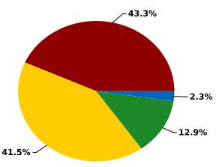  15.2%  2021-2022 | Projected Data | 17.2% | 19.2% | 21.2% | 23.2% | 25.2%
 |  | Actual Data | 17.6%  09/21/2022 | 26.0%  09/01/2023 | 31.8%  08/30/2024

ACTION PLAN FOR FOCUS AREA #1: Teachers/Instruction |  |  |  |  | EVALUATION
ACTIVITY  (Action Steps) | TIMELINE  (Start and End Dates) | PERSON RESPONSIBLE | ESTIMATED COST | FUNDING SOURCE | INDICATORS OF IMPLEMENTATION
1. Weekly LETRS Professional Learning Communities. | 2022-2025 | Reading Coach, Instructional Coach and Classroom Teachers | n/a | n/a | PLC Agendas, PLC Sign-In Sheets & Data Collection Ongoing for new teachers; completed for Group 1Completed for all required staff.
2. Weekly grade level planning to deep dive standards, data, and collaborate best practices. | 2022-2027 | Reading Coach, Instructional Coach and Classroom Teachers | n/a | n/a | Data collection Ongoing Continuing
3. NSGRA data to guide instructional decisions and student grouping. | 2022-2027 | Classroom Teachers | n/a | n/a | Data collection Ongoing Completed
4. Utilize a leveled library for small group reading instruction. Shifted resource room to Decodable Readers and Science of Reading approved resources | 2022-2027 | Reading Coach and Classroom Teachers | $2,500.00 | Title 1 | Data collection Ongoing Continuing
5. Utilize Science of Reading instruction in all grades. | 2022-2027 | Classroom Teachers | $250.00 per teacher | Title 1 | Data collection Ongoing Continuing
6. Use explicit, strategic comprehension instruction in a Science of Reading framework. | 2022-2027 | Reading Coach and Classroom Teachers | n/a | n/a | Lesson Plans & Observations Ongoing Continuing
7. Continue NSGRA (K-5), MAP Growth Testing (K-5), Fluency, and GOLD (Pre-K) to screen, progress monitor, and drive instruction. | 2022-2027 | Classroom Teachers | n/a | n/a | Data reports from these platforms Ongoing Continuing
8. Increase the use of non-fiction text all genres of text. | 2022-2027 | Classroom Teachers | $2,000.00 | Title 1 & General | Lesson Plans & Observations  Ongoing Continuing
9. Teacher collaboration for classroom strategies. | 2022-2027 | Classroom Teachers | n/a | n/a | PLC, PD, and Meeting Sign-in Sheets. Ongoing Continuing
10. Quarterly vertical planning meetings. | 2022-2027 | Classroom Teachers | n/a | n/a | PD Sign-in Sheets and meeting notes Ongoing Continuing
11. FEV Tutoring for the identified subpopulation of students | 2023-2024 | Instructional Coach | $17,000 | ATSI | Weekly reports from FEV Tutoring, Student Standards-Based Exit Tickets, MAP Growth Completed
To add a row, go to the last box and press the tab button.

ACTION PLAN FOR FOCUS AREA #2: Student-focused |  |  |  |  | EVALUATION
ACTIVITY  (Action Steps) | TIMELINE  (Start and End Dates) | PERSON RESPONSIBLE | ESTIMATED COST | FUNDING SOURCE | INDICATORS OF IMPLEMENTATION
1. Literacy Intervention | 2022-2027 | Reading Coach & Reading Interventionists | TBD | Title 1 | Lesson Plans & Observations Ongoing Continuing
2. Science of Reading data to guide instruction and student goals (Reading Horizons) | 2022-2027 | Reading Coach and Classroom Teachers | n/a | n/a | PLC notes, Lesson Plans & Observations Ongoing Continuing
3. Leveled library for self-selected text. | 2022-2027 | Reading Coach and Classroom Teachers | $2,000.00 | Title 1 | Lesson Plans, book invoices, Student Reflections Ongoing Continuing
4. Edmentum individualized plans | 2022-2027 | Reading Coach and Classroom Teachers | n/a | n/a | Edmentum Reports & Guided Reading records Ongoing Continuing
5. Online reading resources/supports: Exact Path, Reading Eggs, Learning A to Z, iXL, and Raz Kids. | 2022-2027 | Instructional Coach, Reading Coach and Classroom Teachers | $5,000.00 | Title 1 | Program usage reports, student performance reports, Guided Reading records. Ongoing Continuing
6. Student periodicals to increase exposure to nonfiction text. (Purchase for 1st - 5th grades resources like Scholastic News, USA Test Prep) | 2022-2027 | Reading Coach and Classroom Teachers | $10,000.00 | Title 1 | Lesson Plans, subscription invoices, Student Reflections Ongoing Continuing
7.
To add a row, go to the last box and press the tab button.

ACTION PLAN FOR STRATEGY: Improve MAP Reading Scores |  |  |  |  | EVALUATION
ACTIVITY | TIMELINE  (Start and End Dates) | PERSON RESPONSIBLE | ESTIMATED COST | FUNDING SOURCE | INDICATORS OF IMPLEMENTATION
1. Student-centered goal setting | 2022-2027 | Instructional Coach & Classroom Teachers | $200.00 | Title 1 | Lesson Plans, book invoices, Student Reflections Ongoing Continuing
2. Goal cards for every student. | 2022-2027 | Instructional Coach & Classroom Teachers | $500.00 | Title 1 | Lesson Plans, print shop invoice, & Student Reflections Ongoing Continuing
3. Grade-level bulletin board displays of progress. | 2022-2027 | Classroom Teachers | $100.00 | Title 1 | Lesson Plans, print shop invoice, & Student Reflections Ongoing Continuing
4. Knightly News Recognition | 2022-2027 | Media Specialist & Classroom Teachers | $500.00 | Title 1 | Print shop invoice, invoice for prizes & Student Reflections Ongoing Continuing
5. Celebrations of met goals/achievement | 2022-2027 | Admin Team & Parent Volunteers | $500.00 | Title 1 | Print shop invoice, invoice for prizes & Student Reflections Ongoing Continuing
6. Implementation of LETRS framework with fidelity. | 2022-2027 | Reading Coach & Classroom Teachers | n/a | n/a | LETRS Training Unit Field Study Documentation, Lesson Plans, & Guided Reading Notes Ongoing Continuing
7. Reading intervention groups with a targeted focus. | 2022-2027 | Reading Coach & Interventionists | TBD | Title 1 | Running Records, Lesson Plans, Progress Monitoring & NSGRA data Ongoing Continuing
8. Continue to grow the science of reading resources available to teachers and students. | 2022-2027 | Reading Coach | TBD | Title 1 | Running Records, Lesson Plans, Progress Monitoring & NSGRA data Ongoing Continuing
9. Utilize Edmentum/Exact (independent learning/small group) | 2022-2027 | Classroom Teachers | n/a | District Purchased | MAP Data;” Pathway” progress data from the program Ongoing Continuing
11. Daily reading and writing cycled skill review with Drops In the Bucket. | 2022-2027 | Classroom Teachers | $400 | Title 1 | Data on standard mastery Ongoing Continuing

To add a row, go to the last box and press the tab button.
Performance Goal Area: ☐ College and Career Readiness* ☐High Performing WorkForce* ☐Safe and Supportive Schools*
☐Strong Stakeholder Partnerships ☐Effective and Efficient Operation (* required)
PERFORMANCE GOAL:  Per SBE Regulation 43-261, measurable performance goals, written in five-year increments, shall be developed to address the major areas of discrepancy found in the needs assessment in key areas reported in the district and school report cards.  SMART goal must include:  WHO will do WHAT, as measured by HOW and WHEN. | We will increase the number of students in 2nd through 5th grades projected to meet grade level proficiency on SCReady as measured by Fall MAP Math Growth data by 2% each year.
INTERIM PERFORMANCE GOAL: Meet annual targets below.

 | AVERAGE BASELINE |  | 2022-2023 | 2023-2024 | 2024-2025 | 2025-26 | 2026-2027
DATA SOURCE(s):  Data & Graph from 2021 FALL NWEA Projected Proficiency Summary Report.  Test Date: September 21, 2021 | Fall 2021 Data  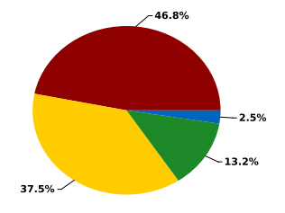  15.7%  2021-2022 | Projected Data | 17.7% | 19.7% | 21.7% | 23.7% | 25.7%
 |  | Actual Data | 18.1%  09/21/2022 | 23.0%  09/01/2023 | 26.5%  08/30/2024

ACTION PLAN FOR STRATEGY #1: Improve student MAP Math Scores |  |  |  |  | EVALUATION
ACTIVITY | TIMELINE  (Start and End Dates) | PERSON RESPONSIBLE | ESTIMATED COST | FUNDING SOURCE | INDICATORS OF IMPLEMENTATION
1. Student-centered goal setting | 2022-2027 | Instructional Coach & Classroom Teachers | $200.00 | Title 1 | Lesson Plans, book invoices, Student Reflections Ongoing Continuing
2. Goal cards for every student. | 2022-2027 | Instructional Coach & Classroom Teachers | $500.00 | Title 1 | Lesson Plans, print shop invoice, & Student Reflections Ongoing Continuing
3. Grade-level bulletin board displays of progress. | 2022-2027 | Classroom Teachers | $100.00 | Title 1 | Lesson Plans, print shop invoice, & Student Reflection Ongoing Continuing
4. Knightly News Recognition | 2022-2027 | Media Specialist & Classroom Teachers | $500.00 | Title 1 | Print shop invoice, invoice for prizes & Student Reflections Ongoing Continuing
5. Celebrations of met goals/achievement | 2022-2027 | Admin Team & Parent Volunteers | $500.00 | Title 1 | Print shop invoice, invoice for prizes & Student Reflection. Ongoing Continuing
6. Utilize Hands-On-Math curriculum to support guided math instruction across grade levels | 2022-2027 | Instructional Coach & Classroom Teachers | $15,000 | Title 1 | Order needed kits to have 1 set in every classroom K-5; invoice for this order; lesson plans, guided math plans, observations Ongoing Continuing
7. Create student manipulative/tool kits in grades 3 thru 5 | 2022-2027 | Instructional Coach & Classroom Teachers | $1,000.00 | Title 1 | Invoice for containers; utilize manipulatives already on campus. Ongoing Continuing
8. Intervention Groups with math interventionists with a targeted focus for all grade levels. | 2022-2027 | Interventionists | TBD | Title 1 | Running Records, Lesson Plans, & Progress Monitoring Ongoing Continuing
9. Continue use of technology to support math instruction and student understanding of standards, skills, and applications. | 2022-2027 | Instructional Coach & Classroom Teachers | $5,000.00 | Title 1 | Program usage reports, student performance reports, Guided Reading records. Ongoing Continuing
10. Relaunch parent workshops to support building confidence in parents engaging in math with their children. | 2022-2027 | Instructional Coach, Parent Facilitator & Classroom Teachers | $1,000.00 | Title 1 | Invoices for incentives, print shop invoices, documentation of invites and participants sign-in. Ongoing Continuing
11. Daily math cycled review (like Drops In the Bucket and Math 4 Today). | 2022-2027 | Classroom Teachers | Title 1 | $400 | Data on standard mastery Ongoing Continuing
11. FEV Tutoring for the identified subpopulation of students | 2023-2024 | Instructional Coach | $17,000 | ATSI | Weekly reports from FEV Tutoring, Student Standards-Based Exit Tickets, MAP Growth Completed
To add a row, go to the last box and press the tab button.

ACTION PLAN FOR FOCUS AREA #2: Teacher & Student Focused Initiatives |  |  |  |  | EVALUATION
ACTIVITY  (Action Steps) | TIMELINE  (Start and End Dates) | PERSON RESPONSIBLE | ESTIMATED COST | FUNDING SOURCE | INDICATORS OF IMPLEMENTATION
1. PD for Hands-On-Learning Guided Math and continued coaching. | 2022-2027 | Instructional Coach, District Instructional Coach and Classroom Teachers | n/a | Title 1 | Lesson Plans, Observations, & Progress Monitoring Ongoing Continuing
2. Guided Math small group instruction | 2022-2027 | Classroom Teachers | n/a | Title 1 | Lesson Plans, Observations, & Progress Monitoring Ongoing Continuing
3. Online math resources and supports such as Exact Path, DreamBox, iXL, and others | 2022-2027 | Classroom Teachers | $5,000.00 | Title 1 | Program usage reports & student performance reports Ongoing Continuing
4. Weekly grade-level professional learning communities | 2022-2027 | Classroom Teachers | n/a | Title 1 | PLC sign-in sheets & PLC agendas Ongoing Continuing
5. Guided Math instruction | 2022-2027 | Classroom Teachers | n/a | Title 1 | Lesson Plans, Observations, & Progress Monitoring Ongoing Continuing
6. Math Intervention | 2022-2027 | Classroom Teachers | TBD | Title 1 | Running Records, Lesson Plans, & Progress Monitoring. Ongoing Continuing
8. Edmentum Intervention | 2022-2027 | Classroom Teachers | n/a | Title 1 | Program usage reports & student performance reports. Ongoing Continuing
9. Incorporate “Number of the Day” & “Number Talks” in the Knightly News daily. | 2022-2027 | Administration, Media Specialist, & School Counselors | n/a | n/a | Knightly News scripts Ongoing Continuing
To add a row, go to the last box and press the tab button.

Performance Goal Area: ☐College and Career Readiness* ☐High Performing WorkForce* ☐Safe and Supportive Schools*
☐Strong Stakeholder Partnerships ☐Effective and Efficient Operations (* required)
PERFORMANCE GOAL:  Per SBE Regulation 43-261, measurable performance goals, written in five-year increments, shall be developed to address the major areas of discrepancy found in the needs assessment in key areas reported in the district and school report cards.  SMART goal must include:  WHO will do WHAT, as measured by HOW and WHEN. | By the year 2027 Kingsbury Elementary will increase the retention of professional teachers by 10% from 83% to 93%.
INTERIM PERFORMANCE GOAL: Meet annual targets below.

 | AVERAGE BASELINE |  | 2022-2023 | 2023-2024 | 2024-2025 | 2025-2026 | 2026-2027
DATA SOURCE(s):  Professional Staff Directory; retention percentage from SY21-SY22  June 3, 2022 | 83%  2021-2022 | Projected Data | 100% | 100% | 100% | 100% | 100%
 | 83%  2021-2022 | Actual Data | 89%  06/01/2023 | 81%  05/31/2024 | 88% expected as of 3/27/2025

ACTION PLAN FOR STRATEGY: Teacher Supportive Practices |  |  |  |  | EVALUATION
ACTIVITY | TIMELINE  (Start and End Dates) | PERSON RESPONSIBLE | ESTIMATED COST | FUNDING SOURCE | INDICATORS OF IMPLEMENTATION
1. Professional Development opportunities from reputable companies to enhance/encourage best practices. | 2022-2027 | Collaborative Team with building leaders and district-level coaches | $10,000.00 | Title 1 | Sign-in Sheets, participation reports; handouts Ongoing Continuing
2. Incentives to keep 100% certified staff | 2022-2027 | Leadership Team | $500.00 | General | The renewal rate for contracts Ongoing Continuing
3. Partnerships with universities to further education for teachers to earn graduate-level credits. | 2022-2027 | District Personnel Department | TBD | TBD | Transcripts Ongoing Continuing
4. Weekly Professional Learning Communities for collaboration with other professionals | 2022-2027 | Instructional Coach | n/a | n/a | PLC sign-in sheets & PLC Agendas Ongoing Continuing
5. Provide literacy and math coach/specialist to support and demonstrate lesson | 2022-2027 | Instructional Coach, Reading Coach, District Level Coaches | TBD | Title 1 & District level funding | Lesson Plans, Observations, & Teacher Reflections. Ongoing Continuing
6. Vertical Team collaboration | 2022-2027 | Leadership Team | n/a | n/a | Lesson Plans, Observations, & meeting agendas. Ongoing Continuing
7.
To add a row, go to the last box and press the tab button.

Performance Goal Area: ☐College and Career Readiness* ☐High Performing WorkForce* ☐Safe and Supportive Schools*
☐Strong Stakeholder Partnerships ☐Effective and Efficient Operations (* required)
PERFORMANCE GOAL:  Per SBE Regulation 43-261, measurable performance goals, written in five-year increments, shall be developed to address the major areas of discrepancy found in the needs assessment in key areas reported in the district and school report cards.  SMART goal must include:  WHO will do WHAT, as measured by HOW and WHEN. | By the year 2027 the percentage of positive staff morale reported through the yearly survey will increase to reach 95%.
INTERIM PERFORMANCE GOAL: Meet annual targets below.

 | AVERAGE BASELINE |  | 2022-2023 | 2023-2024 | 2024-2025 | 2025-2026 | 2026-2027
DATA SOURCE(s):  Reported from satisfaction surveys on the South Carolina Report Card from 2021-2022  April 2022 | 92.7%  2021-2022 | Projected Data | 93.16% | 93.62% | 94.08% | 94.54% | 95%
 | 92.7%  2021-2022 | Actual Data | 97.7%  06/01/2023 | 97.6%  05/31/2024 | Surveys are currently ongoing for this school year  TBD

ACTION PLAN FOR STRATEGY: Staff Moral Supports |  |  |  |  | EVALUATION
ACTIVITY | TIMELINE  (Start and End Dates) | PERSON RESPONSIBLE | ESTIMATED COST | FUNDING SOURCE | INDICATORS OF IMPLEMENTATION
1. Duty-free lunches | 2022-2027 | PTA | Free | n/a | Increased number of staff reporting job satisfaction in survey Ongoing Continuing
2. Planning time pass to leave campus | 2022-2027 | Admin Team | Free | n/a | Increased number of staff reporting job satisfaction in survey Ongoing Continuing
3. Spa Day on campus | 2022-2027 | Admin/  Leadership Team | Free | n/a; connection with local career center | Increased number of staff reporting job satisfaction in survey Ongoing Continuing
4. Monthly Celebrations of staff | 2022-2027 | Admin/  Leadership Team | $500 | General | Increased number of staff reporting job satisfaction in survey Ongoing Continuing
5. Monthly Treat Cart for staff | 2022-2027 | Admin/  Leadership Team | $500 | General | Increased number of staff reporting job satisfaction in survey Ongoing Continuing
6. Send teachers to national Professional Development opportunities | 2022-2027 | Administrative Team & Instructional Coach | TBD | Title 1 | Handout and participation reports; sharing new learning in staff PD or PLC Ongoing Continuing
7. Snacks & Coffee carts | 2022-2027 | Administrative Team & Instructional Coach | TBD | Donations from our business partners | Increased number of staff reporting job satisfaction in survey Ongoing Continuing
To add a row, go to the last box and press the tab button.

Performance Goal Area: ☐ College and Career Readiness* ☐High Performing WorkForce* ☐Safe and Supportive Schools*
☐Strong Stakeholder Partnerships ☐Effective and Efficient Operations (* required)
PERFORMANCE GOAL:  Per SBE Regulation 43-261, measurable performance goals, written in five-year increments, shall be developed to address the major areas of discrepancy found in the needs assessment in key areas reported in the district and school report cards.  SMART goal must include:  WHO will do WHAT, as measured by HOW and WHEN. | By the year 2027, the number of discipline referrals will decrease by 10% from the 2021-2022 school year.
INTERIM PERFORMANCE GOAL: Meet annual targets below.

 | AVERAGE BASELINE |  | 2022-2023 | 2023-2024 | 2024-2025 | 2025-26 | 2026-2027
DATA SOURCE(s):  total referrals from ABE system for 2018-2019 The last complete school year prior to the pandemic  June 6, 2019 | 433  2021-2022 | Projected Data | 424.34 | 415.68 | 407.05 | 398.36 | 389.7
 | 433  2021-2022 | Actual Data | as of 3/14/23 283  EOY: 446  06/01/2023 | 266  as if 3/15/23  EOY: 382  05/31/2024 | 290 as of 03/27/2025

ACTION PLAN FOR FOCUS AREA: Behavior-Focused Supports for Students |  |  |  |  | EVALUATION
ACTIVITY  (Action Steps) | TIMELINE  (Start and End Dates) | PERSON RESPONSIBLE | ESTIMATED COST | FUNDING SOURCE | INDICATORS OF IMPLEMENTATION
1. Implement PBIS “Purple Notes” with prizes; shift to align with Leader In Me “Knightly Notes” | 2022-2027 | Media Specialist & School Counselors | $500.00 | General | Data sheets; invoice from print shop Ongoing Continuing
2. Implement PBIS “Kings Coins” with Ransom Table shopping weekly | 2022-2027 | Parent Volunteers | $500.00 | General | Data sheets; invoices for incentives Ongoing Continuing
3. Character Values: focus of Knightly News, Guidance Lessons, and Celebrations; Use LiM Curriculum in all classes with all students | 2022-2027 | Media Specialist & School Counselors Counselors | $500.00 | General | Lesson notes & student reflections Ongoing Continuing
4. Guidance Lessons | 2022-2027 | School Counselors | n/a | n/a | Lesson notes & student reflections Ongoing Continuing
5. Daily Morning Meetings with Responsive Classroom strategies and a more student-centered approach | 2022-2027 | Instructional Coach & School Counselors | $500.00 | Title 1 | Lesson notes & student reflections Ongoing Continuing
6. Community Member “spotlight” weekly who exhibits the character trait at their workplace | 2022-2027 | Instructional Coach, Parent Facilitator & School Counselors | n/a | n/a | Presentation notes & student reflections Ongoing Ongoing
7. Implementation of Zones of Regulation | 2022-2027 | Special Education Team | $500.00 | Special Education | Observations, PLC check-ins, & student reflections Ongoing Continuing
8. Visual Supports and Visual Cues around the school to reinforce positive behavior. | 2022-2027 | Special Education Team | $1,000.00 | Special Education | Posters throughout the school Ongoing Continuing
9. Sensory, redirection, or reset activities and training | 2022-2027 | Special Education Team | $500.00 | Special Education | PD Sign-in Sheets, PD Agenda, & PD presentation documentation Ongoing Continuing
10. Staff training on de-escalation & further training on the Zones of Regulation | 2022-2027 | Special Education Team & District Special Education Staff | $500.00 | Special Education | PD Sign-in Sheets, PD Agenda, & PD presentation documentation Ongoing Continuing
11, Extra Recess, Dances, Movie, Bounce House Incentives for behavior to increase motivation. (Not during related arts) | 2022-2027 | Instructional Coach, Parent Facilitator & School Counselors | n/a | n/a | Presentation notes & student reflections Ongoing Continuing
12. Implement the Leader In Me program with all staff and students. | 2022-2027 | Instructional Coach & School Counselors | $45,000 | Title 1 | Goal Data Trackers, professional development presentations, sign-in sheets, and artifacts Ongoing Continuing
To add a row, go to the last box and press the tab button.

Performance Goal Area: ☐ College and Career Readiness* ☐High Performing WorkForce* ☐Safe and Supportive Schools*
☐Strong Stakeholder Partnerships ☐Effective and Efficient Operations (* required)
PERFORMANCE GOAL:  Per SBE Regulation 43-261, measurable performance goals, written in five-year increments, shall be developed to address the major areas of discrepancy found in the needs assessment in key areas reported in the district and school report cards.  SMART goal must include:  WHO will do WHAT, as measured by HOW and WHEN. | By the year 2027, our school’s number of business partners will increase by 25%.
INTERIM PERFORMANCE GOAL: Meet annual targets below.

 | AVERAGE BASELINE |  | 2022-2023 | 2023-2024 | 2024-2025 | 2025-26 | 2026-2027
DATA SOURCE(s):  Site Council Report from 2021-2022  April 2022 | 3  2021-2022 | Projected Data | n/a | n/a | n/a | n/a | 4
 | 3  2021-2022 | Actual Data | 7  06/01/2023 | 9  05/31/2024 | 12  as of 03/27/2025

ACTION PLAN FOR FOCUS AREA: Community outreach initiatives |  |  |  |  | EVALUATION
ACTIVITY  (Action Steps) | TIMELINE  (Start and End Dates) | PERSON RESPONSIBLE | ESTIMATED COST | FUNDING SOURCE | INDICATORS OF IMPLEMENTATION
1. Career Day | 2022-2027 | Instructional Coach | n/a | n/a | Participant sign-in, student reflections, & pictures. Ongoing Continuing
2. Spirit Nights at local restaurants and ice cream shops | 2022-2027 | Teachers & Admin Team | n/a | n/a | Participant sign-in, student reflections, & pictures. Ongoing Continuing
3. Mentors | 2022-2027 | Instructional Coach | n/a | n/a | Participant sign-in, observations, logs, & student reflections. Ongoing Continuing
4. Read Across America readers | 2022-2027 | Reading Coach | n/a | n/a | Participant sign-in, student reflections, & pictures. Ongoing Completed
5. Business Partners character spotlight | 2022-2027 | School Counselors | n/a | n/a | Printed documentation and student reflections Ongoing Continuing
6. Backpacks with Snacks for the weekend from a community partner. | 2022-2027 | School Counselors | n/a | n/a | Printed documentation Ongoing Continuing
7.
8.
To add a row, go to the last box and press the tab button.

Performance Goal Area: ☐ College and Career Readiness* ☐High Performing WorkForce* ☐Safe and Supportive Schools*
☐Strong Stakeholder Partnerships ☐Effective and Efficient Operations (* required)
PERFORMANCE GOAL:  Per SBE Regulation 43-261, measurable performance goals, written in five-year increments, shall be developed to address the major areas of discrepancy found in the needs assessment in key areas reported in the district and school report cards.  SMART goal must include:  WHO will do WHAT, as measured by HOW and WHEN. | By 2027, the number of parents reporting satisfaction with school communication will increase to 90%
INTERIM PERFORMANCE GOAL: Meet annual targets below.

 | AVERAGE BASELINE |  | 2022-2023 | 2023-2024 | 2024-2025 | 2025-26 | 2026-2027
DATA SOURCE(s):  Reported from satisfaction surveys on the South Carolina Report Card from 2021-2022  April 2022 | 83.3%  2021-2022 | Projected Data | 84.64% | 85.98% | 87.32% | 88.66% | 90%
 | 83.3%  2021-2022 | Actual Data | 95.3%  06/01/2023 | 90%  05/31/2024 | Surveys are currently ongoing for this school year  TBD

ACTION PLAN FOR FOCUS AREA: Home-School initiatives |  |  |  |  | EVALUATION
ACTIVITY  (Action Steps) | TIMELINE  (Start and End Dates) | PERSON RESPONSIBLE | ESTIMATED COST | FUNDING SOURCE | INDICATORS OF IMPLEMENTATION
1. Parent Workshops | 2022-2027 | Teachers, Parent Facilitator & Instructional Coach | $200.00 | Title 1 | Sign-in sheets and parent questionnaire at the end of each workshop session Ongoing Continuing
2. Communication Apps: schoolwide use of Class Dojo | 2022-2027 | Teachers | n/a | n/a | parent survey results Ongoing Continuing
3. Shining Knight Spotlights | 2022-2027 | School Counselors | n/a | n/a | Documentation of knights chosen and write-up of spotlight. Ongoing Continuing
4. Curriculum Nights | 2022-2027 | Teachers & Instructional Coach | $500 | Title 1 | Sign-in sheets and parent questionnaire at the end of each session Ongoing Continuing
5. Newsletters (school and classroom) | 2022-2027 | Teachers | n/a | n/a | Documentation of communication Ongoing Continuing
6. Effective communication with parents through a variety of ways including but not limited to conferences, posting on social media, and notes home. | 2022-2027 | Administrative Team and teachers | $500 | General | Documentation of communication, public postings, and survey results Ongoing Continuing
7.
To add a row, go to the last box and press the tab button.

Performance Goal Area: ☐College and Career Readiness* ☐High Performing WorkForce* ☐Safe and Supportive Schools*
☐Strong Stakeholder Partnerships ☐Effective and Efficient Operations (* required)
PERFORMANCE GOAL:  Per SBE Regulation 43-261, measurable performance goals, written in five-year increments, shall be developed to address the major areas of discrepancy found in the needs assessment in key areas reported in the district and school report cards.  SMART goal must include:  WHO will do WHAT, as measured by HOW and WHEN. | By 2027 we will implement “tech talks” at Kingsbury Elementary School for parents and students to solve frequently asked technology questions via an online video database by creating a minimum of four videos a year to have at least twenty “tech talk” videos by the year 2027.
INTERIM PERFORMANCE GOAL: Meet annual targets below.

 | AVERAGE BASELINE |  | 2022-2023 | 2023-2024 | 2024-25 | 2025-2026 | 2026-2027
DATA SOURCE(s):  New initiative on campus  August 2022 | 0  2021-2022 | Projected Data | 4 | 8 | 12 | 16 | 20
DATA SOURCE(s):  New initiative on campus  August 2022 | 0  2021-2022 | Actual Data | 2  06/01/2023 | 8  05/31/2024 | 10  03/27/2025

ACTION PLAN FOR STRATEGY: Technology supports for families and students |  |  |  |  | EVALUATION
ACTIVITY | TIMELINE  (Start and End Dates) | PERSON RESPONSIBLE | ESTIMATED COST | FUNDING SOURCE | INDICATORS OF IMPLEMENTATION
1. Connect parents to Kingsbury YouTube channel as a resource for support. | 2022-2027 | Media Specialist | n/a | n/a | Uploads to the website, Schoology, and other platforms Ongoing Continuing
2. Survey parents regarding their comfort level with technology utilized by Kingsbury so training can be tailored to meet needs. | 2022-2027 | Instructional Coach & Parent Facilitator | n/a | n/a | Survey results Ongoing Continuing
3. Grade Level teams create monthly submissions for the school's YouTube channel to support connection between school and home. | 2022-2027 | Teachers | n/a | n/a | Uploads to the website, Schoology, and other platforms Ongoing Continuing
4. Relaunch parent workshops to include technology component | 2022-2027 | Instructional Coach & Parent Facilitator | $500.00 | Title 1 | Workshop invitation, Workshop Sign-in Sheets, Workshop Agenda, Workshop Presentation. Ongoing Continuing
5. Utilize district technology coach to create videos | 2022-2027 | Technology Coach | n/a | n/a | Uploads to the website, Schoology, and other platforms Ongoing Continuing
6. Utilize technology coaches at the district level for parent training sessions on Schoology. | 2022-2027 | Technology Coach | n/a | n/a | Uploads to the website, Schoology, and other platforms Ongoing Continuing
To add a row, go to the last box and press the tab button.

Performance Goal Area: ☐College and Career Readiness* ☐High Performing WorkForce* ☐Safe and Supportive Schools*
☐Strong Stakeholder Partnerships ☐Effective and Efficient Operations (* required)
PERFORMANCE GOAL:  Per SBE Regulation 43-261, measurable performance goals, written in five-year increments, shall be developed to address the major areas of discrepancy found in the needs assessment in key areas reported in the district and school report cards.  SMART goal must include:  WHO will do WHAT, as measured by HOW and WHEN. | By 2027 the number of technology “help” requests will be reduced by 5% by implementation of a shared Google Drive that includes support for frequently asked questions and frequent issues that arise.
INTERIM PERFORMANCE GOAL: Meet annual targets below.

 | AVERAGE BASELINE |  | 2022-2023 | 2023-2024 | 2024-25 | 2025-2026 | 2026-2027
DATA SOURCE(s):  Report run by Kingsbury Media Specialist 06/18/2022 | 204  2021-2022 | Projected Data | 201.96 | 199.92 | 197.88 | 195.84 | 193.8
 | 204  2021-2022 | Actual Data | 126  06/01/2023 | 64  03/15/24 | 58  03/27/2025

ACTION PLAN FOR STRATEGY: Technology support for teachers focused on curriculum & training |  |  |  |  | EVALUATION
ACTIVITY | TIMELINE  (Start and End Dates) | PERSON RESPONSIBLE | ESTIMATED COST | FUNDING SOURCE | INDICATORS OF IMPLEMENTATION
1. Create Google Shared Drive with videos on how to solve common technology issues. | 2022-2027 | Media Specialist & Instructional Coach | n/a | n/a | Documentation log of content of Google Drive Ongoing Continuing
2. Devote in-person PD towards basic application training, data gathering, and implementation in the classroom. | 2022-2027 | Media Specialist & Instructional Coach | n/a | n/a | PD sign-in, PD agenda, & PD Presentation Ongoing Continuing
3. Create videos to address the frequently asked questions for both students and teachers. | 2022-2027 | Media Specialist & Instructional Coach | n/a | n/a | Documentation log of videos Ongoing Continuing
4. Offer student-based training so students can help with supporting other students in the classroom. | 2022-2027 | Media Specialist & Instructional Coach | n/a | n/a | Documentation log of videos Ongoing Continuing
5.
6.
To add a row, go to the last box and press the tab button.

Schools will complete and upload the appropriate Exemplary Literacy Classroom Reflection Tool on the SCDE Read to Succeed Web page at
https://ed.sc.gov/instruction/early-learning-and-literacy/read-to-succeed1/reading-plans-state-district-and-school/ .

Refer to the Directions for Completing District and School Reading Plans for additional information on the SCDE Read to Succeed Web page at
https://ed.sc.gov/instruction/early-learning-and-literacy/read-to-succeed1/reading-plans-state-district-and-school/ .

For further Read to Succeed questions, please contact the Office of Early Learning and Literacy at 803-734-2577.

