New Mark Wrestling Information & FAQ’s

When: Practice Starts on Monday October 27th, 2026

Where: Staley High School in the Great Hall

Practice Time: 3-4:40

Coaches: Head Coach- Clinton Minnick (Teaches at New Mark)
Assistant Coach- Zach Sherman (Teaches at Gateway 6th Grade Center)
Assistant Coach- Scot Holm (Teaches at Staley High School)
Assistant Coach- We will add more coaches as we increase in numbers.

As you see above, we only have one coach in the building. Please communicate with Coach Minnick if your athlete has any unique situations that we need to be aware of.

FAQ’s

How does my athlete get to Practice at Staley?
Fill out Final Forms information, they will use those names/ID numbers to get kids on their High School Connections Buses for practice. Some students will get on that same bus(as they rode to school) and ride on the bus until it arrives at Staley. When they get off the bus, at Staley they will enter the building for practice.
What if my athlete doesn’t ride a bus?
Have your student ask for a bus to ride over to Staley and I can get them a bus ticket.

How does my athlete get home from practice?
Athletes that would like to use school transportation home (only for practice) will get onto a connection bus that will take them to New Mark and from there they will get onto a bus that will take them home.
Athletes’ parents are always allowed to pick them up. However, if a student’s ride is late (more than 3 times) the student will be asked to start riding the bus home.
If your student lives to close to New Mark for transportation, to and from school, they will be brought back to New Mark and then will walk home. A bus home will not be provided home from New Mark.

What does my athlete need for practice?
- Physical Uploaded to Final Forms, which can be found on New Mark’s website.
- Athletic Clothes/Change of Clothes (Shorts, Sweats/Joggers, shirts, long sleeves). The more skin covered the better. See below for more info why.
- Wrestling Shoes(You can buy these brand new or sometimes you can find them at a thrift store) I do have some for athletes to check out. However, if they get lost the athlete will need to replace them at cost(brand new $$)

What does Green and Black Groups mean?
I will divide athletes into 2 different groups a]er the first 2 weeks of the season. I will look at each weight and experience of each wrestler and place them in a group. Why do this? In the past 2 years, at New Mark, we’ve had really good numbers (80+). 3 years ago, we use to take every athlete to the meets and if I had four athletes around 180 pounds, each one would only get 1 match. Your athlete will get more out of practice than just wrestling one match for the evening.

What does my athlete do on the day in which their Group doesn’t go to a meet?
On those days that your athlete does not have a match they will still go to practice (No practices on Saturday).

How long does a Weeknight Meet last?
This is an estimated guess. If they are running 2 mats generally 3.5 hours. If they are running 3 mats 2.5 hours.

How long does a Tournament last?
This is an estimated guess and is once again dependent on how many mats the tournament is ran on. Most tournaments should be completed by 2pm, but we were at some last year that didn’t get done un+l 4:45pm in past years.

What to bring to a meet or tournament?
- School Issued Equipment
- Wrestling Shoes
- Food and Drinks (Try to bring healthy food and not have your athletes go to the Concession Stands)

What happens if my athlete forgets their equipment for a meet or tournament?
If your athlete forgets their equipment, hopefully they catch this before we get on the bus to leave to the meet. If we have practice that day, they will be dropped off at practice. If they inform us at a meet, we will have to scratch them from competition. We have athletes of all different sizes so I can’t carry a wardrobe of clothes for athletes. I do not want athletes sharing shoes, because they will have to switch and sometimes, they might be wrestling at the same +me and slow down the tournament.

Can I check my athlete out after they are done wrestling?
When we are at an away competition you are welcome to sign your athlete out on our sign out sheet. Please make sure that you sign them out, so we know who is on our bus for the ride home. Only Guardians can sign out athletes.
At home meets students must stay until the meet is over, because we are responsible for rolling up the mats and putting them up. If your athlete needs to leave early for a home match, please communicate before the day of the competition.

What if my athlete has braces?
Athletes with braces must have and always wear a mouthpiece that covers their upper and lower braces. If they do not have this they will be disqualified from their match.

I don’t want my athlete to wrestle against someone who is not their gender?
That is completely fine. Missouri currently combines boys and girls for middle school wrestling. When they get into high school they will start splitting them. Please notify Coach Minnick by email if you do not want your athlete wrestling against someone who is not their gender.

What happens when my athlete gets a skin infection?
In wrestling athletes can get several different skin infections if they do not keep up on their hygiene. With proper hygiene and routines your athlete should be fine. Earlier I mentioned covering more parts of the body the better off you are. When practicing on the mats, with more skin covered, your athlete will have less skin contact with the mat and contact with others skin. It is also important that your athlete takes a shower(with a antibacterial soap) as soon as they get home, whether that is practice or a competition. If they do ever get a skin infection, please let us know. Your athlete will need to be treated for the skin infection and can return to practice once it is cleared up. Please share the doctors note with us.

What happens if my athlete gets in trouble on the bus?
Every year we have athletes that get in trouble on the bus. Whether that is going to and from a competition or riding the bus home from practice. Your athlete will have one friendly reminder, extra conditioning and as a
parent you will receive an email stating that they have been warned. On the second time that your athlete gets in trouble on the bus they will not be allowed to ride the bus home. Parents will need to make arrangements to pick students up from practice.

What equipment will my athlete receive?
Option A | Option B
Singlet, Fight Shorts and Crewneck, Wrestling Bag | Fight Shorts, Compression Top and Crew Neck, Wrestling Bag
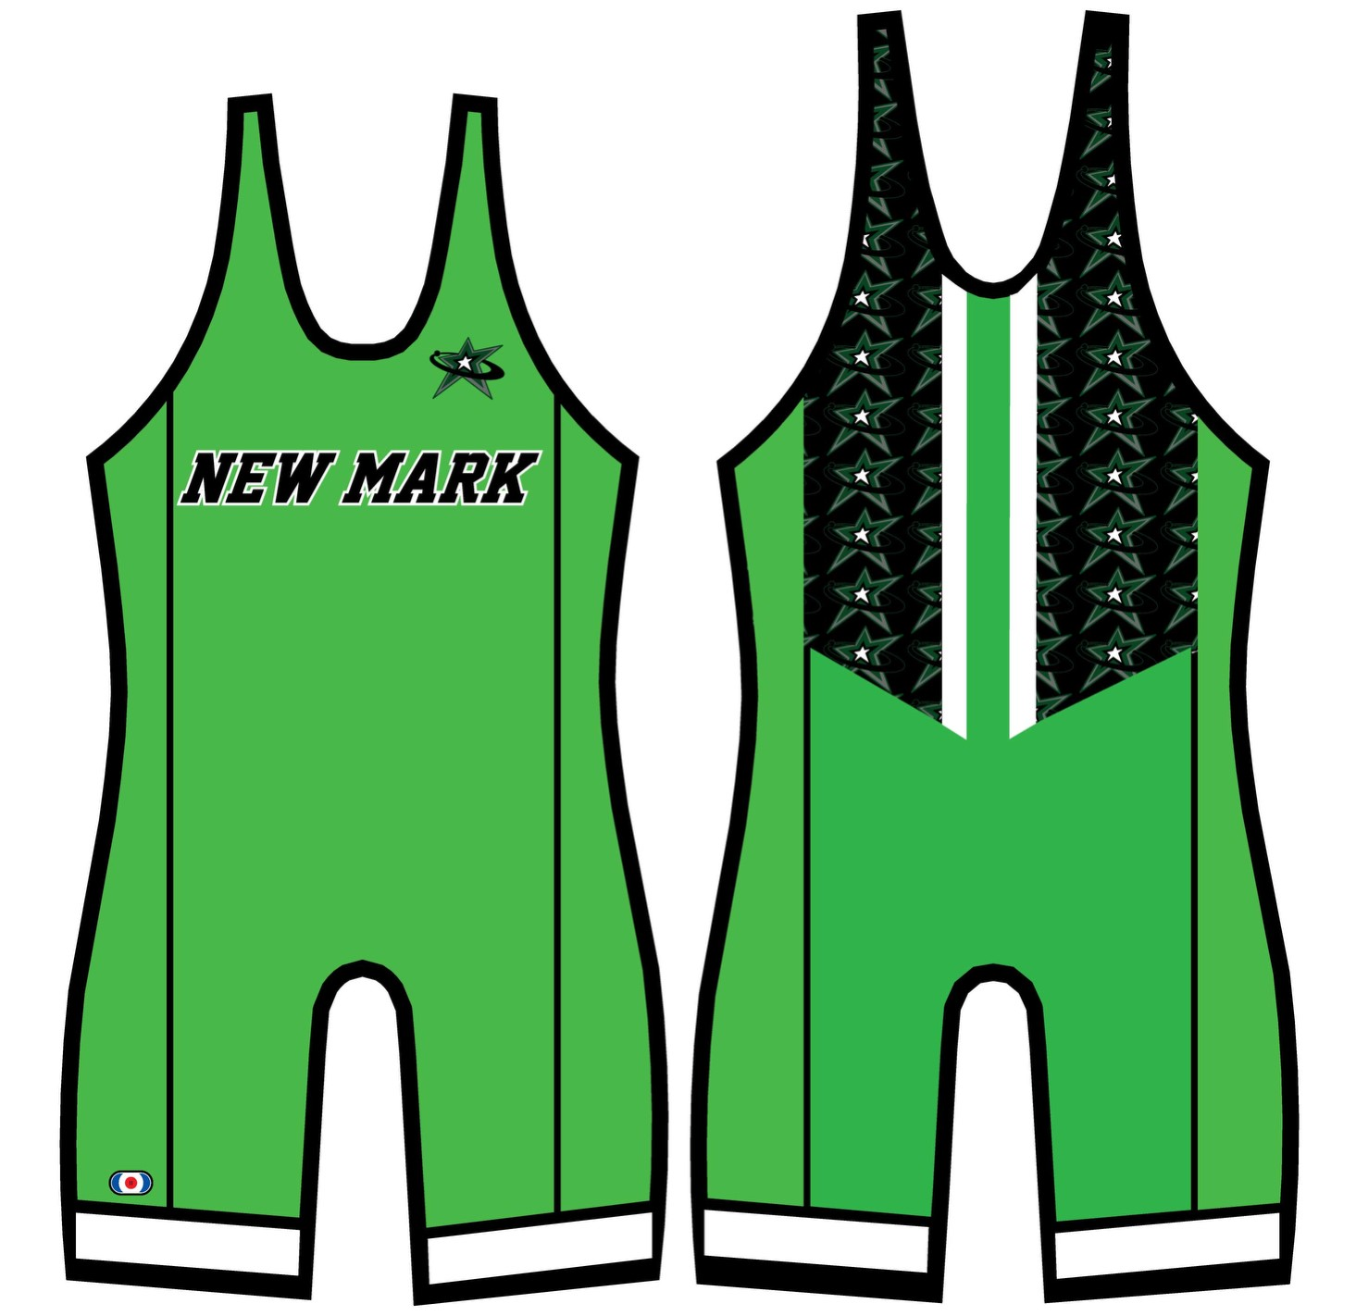 | 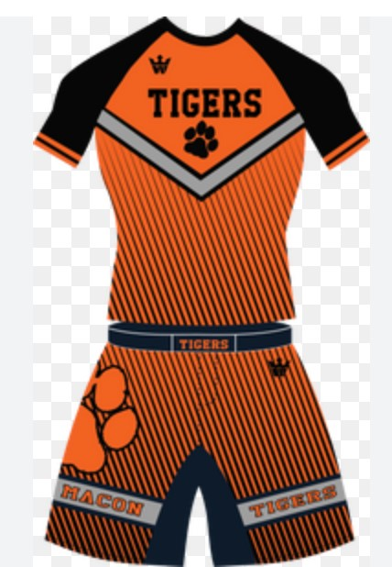
The choice of these two options is up to you as a parent. If a female athlete does want to wear a singlet, they will need to wear the correct bras as describe below to follow MSHSAA bylaws.

Female Wrestlers do have additional requirements:

