Mustang High School
Summer School

Location: Mustang High School
Session 1: June 1 - June 18 Session 2: June 29 - Jul 16, 2026

Attendance: Staffed Hours ( Monday - Thursday 8:00 a.m. - 12:00 p.m)
- All Students must attend on the first day of each session and will receive their Edgenuity log-in and instruction for using the Edgenuity platform.
- After the first day, students are able to attend on campus each day if they choose to, but not required except for exams.
- Teachers will be available during staffed hours for tutoring or assistance.
- All exams are required to be completed on campus and will be locked until the student is on campus.

Available Courses:
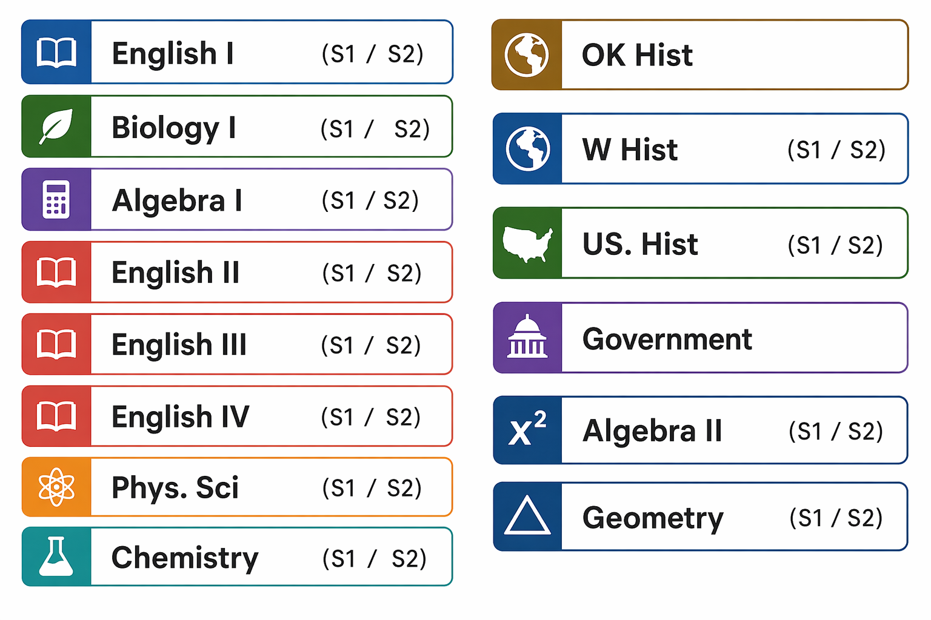
Enrollment Procedure:
*Fill out the enrollment form and indicate the class in which you want to enroll.
*Return enrollment form and Student Behavior Contract with payment to Mrs. George in the media center.
*Payment may be made in person with a Credit Card, Cashier's Check, Money Order, personal check or cash.
*Please make checks payable to: Mustang Public Schools.
*If you have questions, please contact your student's counselor.

Guidelines and Expectations
Students will be enrolled in a session that is equal to .5 credit. Students have the opportunity to complete this class and enroll in a 2nd class, if time permits. Any student not completing the course by the deadline will receive an "F" recorded on their transcript.

Enrollment is on a first come, first served basis. If the class fills, students will be put on a wait list. Your enrollment is NOT COMPLETE until tuition fees are paid.

 All courses are taught online through the Edgenuity Online Education Curriculum under the direction of a highly qualified instructor.

Students attending Summer School must abide by the rules and regulations listed in the Mustang High School Student Handbook. The MHS Student Handbook can be found at www.mustangps.org Students not abiding by the rules can be removed from Summer School with no refund given.

Log In Information:
Students will receive their Edgenuity log-in and receive instruction for using the Edgenuity platform on the first day. Students will use their clever account to access Edgenuity and log in using their Mustang Public Schools credentials.

Technology:
Students will be permitted to work from home using their own technology with the exception of unit exams which will be required to be completed on campus. Students who don’t have access to their own device or internet access will be permitted to attend campus during the staffed hours and use campus provided devices.

Cost:
The cost of each class will be $100.00 (Reduced Lunch Student - $50.00, Free Lunch Student - $25.00).
**Please note that payment is accepted on a per-class basis. Each class must be paid for individually, and payment for the next class can be made once the previous class has been completed.
No Refunds will be issued

MUSTANG SUMMER SCHOOL ENROLLMENT FORM

SUMMER 2026

Session 1: June 1 - June 18 Session 2: June 29 - July 16
In District: $100.00 (Reduced Lunch Student - $50.00, Free Lunch Student - $25.00)
**Please note that payment is accepted on a per-class basis. Each class must be paid for individually, and payment for the next class can be made once the previous class has been completed.
Class Hours: 8:00 a.m. - 12:00 p.m. Monday - Thursday in B-Hall
*Complete and return to Veronica George in the media center.

Circle which course you would like to enroll in:
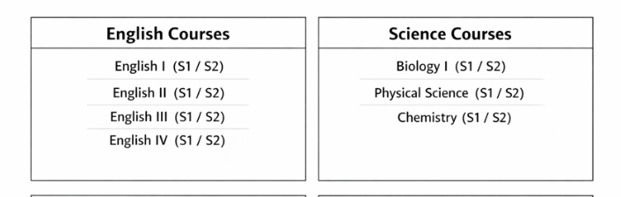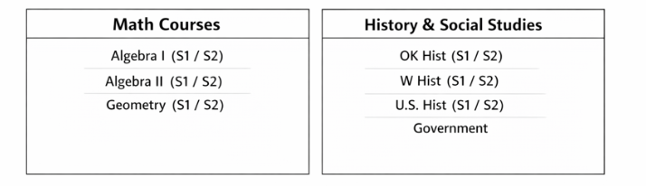
- Original Credit Course ____________________Counselor Signature_______________________________

Student Number: _____________________________________

Student's Name: _______________________________________________________________
Student's Cell #: _______________________________________________________________
Parent's/Guardian's Name: _____________________________________________________
Parent's Address: _____________________________________________________________
Home Phone Number: _________________ Parent's Work Number: __________________
Parent’s Cell Phone Number: ___________________________________________________
Parent’s Email: ________________________________________________________________
Emergency Name & Phone #: ___________________________________________________
____ I qualify for Reduced School Lunches _____ I qualify for Free school lunches
METHOD OF PAYMENT: **Please note that payment is accepted on a per-class basis. Each class must be paid for individually, and payment for the next class can be made once the previous class has been completed. No Refunds.
______Credit Card _____Cashier’s Check _____ Money Order _____Check _____ Cash
Receipt #: _______________________________________________
*I have read the Summer School Guidelines and agree to the terms.
Student Signature __________________________________ Date ________________
Parent/Guardian Signature ___________________________ Date _______________
***Enrollment is complete only after the tuition is paid.
Mustang High School Summer School Behavior Contract

I, ________________________________________________, agree to:
(Student Name)

Initial the following statements: I will:
_________ Conduct myself in an appropriate manner during summer school

________ Follow the rules and guidelines in the MHS handbook

_________ Set myself up for success by attending campus for all exams.

_________ Utilize my time wisely

**I realize that if I fail to fulfill my commitment to summer school, I can be released from the program with no refund and could lose credit in the class or classes I am taking.
Student Signature ______________________________________________ Date ________________

Student Cell# _______________________________________________________________________

Parent/Guardian SIgnature ____________________________________________________________

Parent/Guardian Cell # _______________________________________________________________

Parent/Guardian Email _______________________________________________________________
(The email address will allow progress reports to be sent to Parent/Guardian)

