



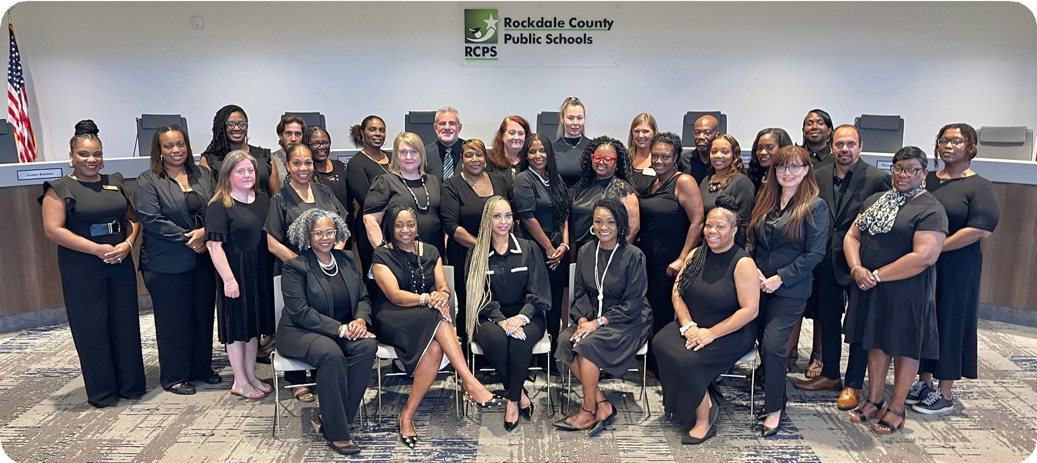
The Office of Exceptional Children Services

NEWSLETTER

BBAACCKK TTOO SSCCHHOOOOLL
August/September 2025

WELCOME BACK TO SCHOOL!
The Exceptional Children Services Department, formerly the Learning Support Department, at Rockdale County Public Schools, is excited to welcome students and families back to a new school year! We are committed to supporting every student with exceptional needs by providing high-quality services, resources, and collaboration with families and educators. In this issue, you’ll find information about who we are, how to contact us, helpful resources, and details about upcoming events designed to support our students and families. We look forward to partnering with you this year to ensure success for all of our exceptional learners!

ECS Parent Mentor
adyer@rockdale.k12.ga.us https://www.rockdaleschools.org/ 770-918-6187

WHO WE ARE, HOW TO CONTACT US

Dr. Tyra Simon, Director 770-860-4231.

Kachelle Davis, Secondary Coordinator 770-860-4238.

Jessica Francis, Elementary Coordinator 770-860-4212.

Sasceria White, Elementary Coordinator/Related Services 770-761-1454.

Tracey Thomas, Secondary Coordinator 770-860-4229.

Deana Cain, Data Specialist 770-860-4244.

Angela Dyer, Parent Mentor 770-918-6187.

Avis Gayle, Secretary / Special Ed Records 770-860-4231.

Jackeline Perez, Learning Support Bookkeeper 770-860-4245.

RESOURCES
REGISTRATION
WWW.ROCKDALESCHOOLS.ORG
UNDERSTOOD.ORG P2PGA.ORG
APPLY FOR MEDICAID
MEDICAID.GEORGIA.GOV
MYRER.ORG
(Rockdale Emergency Relief)
WANDER ALERT PROGRAM
www.rockdalesheriff.com

UPCOMING EVENTS

ECS FLAG FOOTBALL AND CHEERLEADING
MIDDLE AND HIGH SCHOOL STUDENTS SEPTEMBER 3,2025-OCTOBER 20,2025 CONTACT ANGELA DYER ADYER@ROCKDALE.K12.GA.US

VIRTUAL PARENT TAKEAWAY
- INFORMATIONAL SESSION TO GET TO KNOW AND MEET ROCKDALE COUNTY PUBLIC SCHOOLS EXCEPTIONAL CHILDREN SERVICES DEPARTMENT AND RELATED SERVICES.
Teams link
- https://tinyurl.com/2t8tpsfb
- ECS Parent Mentor
- adyer@rockdale.k12.ga.us https://www.rockdaleschools.org/ 770-918-6187
SEPTEMBER 23,202 6 PM

