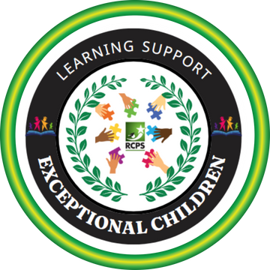

The Office of Exceptional Children Services

NEWSLETTER
October/November 2025

Fall is here, and this issue focused on safety, behavior and caregiver information. October is National Fire Safety awareness month and November is national caregiver awareness month.
Did you know that Rockdale Fire Rescue will help you develop a plan specific to your family’s needs? Rockdale has a Special Needs Fire Safety Program! Millions of Americans live with physical, mental, or cognitive disabilities, impairments, or special needs. These individuals are at the highest risk of injury or death in residential fires. It is important to know their specific risks and build a fire prevention and evacuation plan around their abilities.
Click Here For Request Form You may also call 470-840-7877 to speak with an instructor.

HOME SAFETY SURVEY PROGRAM:
This program has proven to reduce the number and severity of home fires by providing critical life-saving equipment to those who may not otherwise have it. During the home visit our department’s Fire and Life Safety Educators will check existing smoke alarms for functionality and proper placement.
They will install new alarms (single station alarms only) or replace batteries, if needed. If the home has gas appliances, a carbon monoxide alarm will be installed. The home will be assessed for any common fire risks, such as overloaded outlets or extension cords, improper storage of flammable materials, blocked exits, unattended candles or space heaters. The resident’s Home Escape Plan will be reviewed and/or encouraged. Residents of Conyers and Rockdale County can benefit by this program by contacting our department or completing the Request form to schedule an appointment.
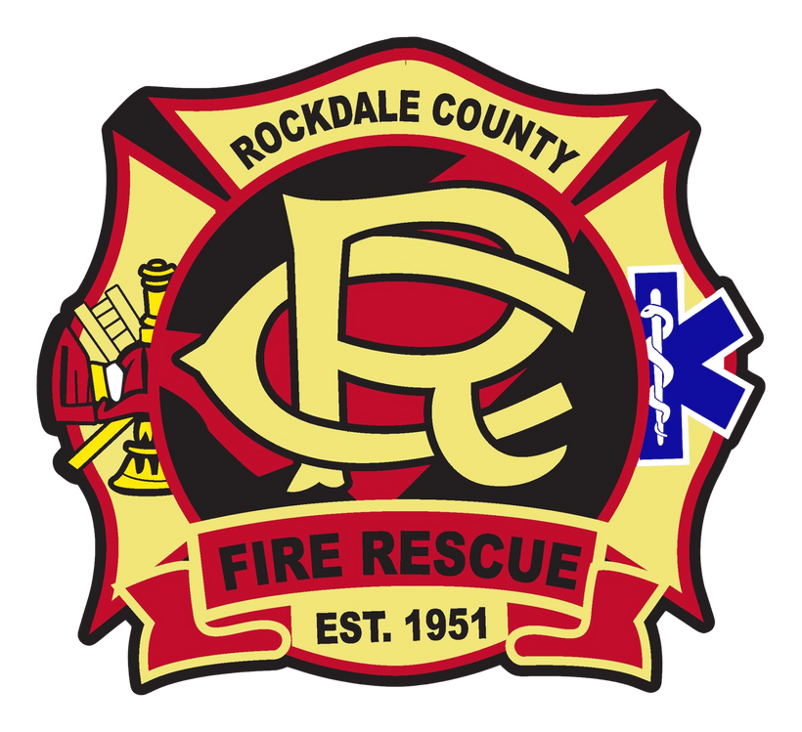

ECS Parent Mentor
adyer@rockdale.k12.ga.us https://www.rockdaleschools.org/ 770-918-6187

BEHAVIOR TIPS FOR FAMILIES
Young children need help from adults to learn how they are expected to behave in social situations. Check out these helpful tips for how families can promote their child’s positive behavior during common routines that can sometimes be challenging

Following Directions
“Help! My child has a hard time following directions when I ask them to do something.”
What you can do:
- Listen to your own instructions — make sure they’re clear, specific, and consistent.
- Make sure directions are positive (i.e., they tell the child to do something rather than to stop doing something).
- When the child follows the instruction correctly, make sure you praise them through encouragement or smiles.
- If your child is having a hard time following directions with more than one step (e.g., put your lunch in your backpack, get your coat on, and tie your shoes), try to present only one step at a time. Give the next step only after they finish the first.
- Here are some examples of good directions — “When you are finished eating, put your bowl in the sink.” “Wash your hands before you come to the table for dinner.” “Put your pajamas on and then brush your teeth.” “Climb into your car seat, please.”
- Make sure to praise your child for each step they complete. Use specific praise — say, “I like how you _.” Kids will repeat behaviors that get attention.

Changing Activities or Making Transitions
"Help! My child yells, cries, and throws things when they have to change activities.” Changing activities is also called making transitions.
What you can do:
- Give your child a warning ahead of time that they’ll have to change activities. Set a timer and tell them when the timer beeps, they need to go to the next activity.
- Give reminder about what comes next — tell the child what he or she can do after they’re finished.
- Just before a transition, give the child a picture or an object representing the activity the child should go to next. The child can even take the picture or object to the next activity.
- Use music and movement to transition. For example, have the child hop or take “giant steps” to the next activity.
- Try to include the child’s favorite activity, toy, or person in a specific activity. For example, if it’s time to go to bed and they love reading books with their dad, you could say, “After you finish your bath time, it will be time to read a book with Daddy!” Or if it’s time to leave a friend’s house and you have their favorite toy, music, or book in the car, say, “In two minutes, it will be time to leave, and when we get to the car, you get to listen to The Wiggles!”
For more information about managing behaviors please click this link https://headstart.gov/children-disabilities/article/challenging-behavior-tips-families

ECS Parent Mentor
adyer@rockdale.k12.ga.us https://www.rockdaleschools.org/ 770-918-6187

Take Care of Yourself
The emotional and physical health of parents has an effect on the family. Parents are the heart of the family and are most often the ones who deal with the issues of the child with a disability, in addition to working, paying bills, shopping, cleaning and taking care of the needs of other children. All of this can be overwhelming and can take a toll on your health.
  - Take some time to take care of yourself by following these simple tips.
  - Accept help. Don’t try to do everything yourself. When someone offers to help you out, gladly accept it.
  - Don’t give in to guilt. Things don’t have to be perfect. Do the best you can.
  - Get informed. Spend time reading about some of the issues you are facing.
  - Seek support from other parents. Support can come in many ways – one-on-one, in a group, or on the internet. Call Parent to Parent of Georgia at 1-800-229-2038 to find the support you need.
  - Stay connected. Keep in touch with family and friends. Make plans to get out of the house and be social.
  - Commit to staying healthy. Make sure you get enough sleep, eat healthy regular meals and get enough exercise. See your doctor on a regular basis.

RESOURCES

REGISTRATION
WWW.ROCKDALESCHOOLS.ORG

UNDERSTOOD.ORG P2PGA.ORG
APPLY FOR MEDICAID
MEDICAID.GEORGIA.GOV

MYRER.ORG
(Rockdale Emergency Relief)

WANDER ALERT PROGRAM
www.rockdalesheriff.com

UPCOMING EVENTS

RCPS & NCS TRANSITION FAIR
NOVEMBER 13, 2025, 5:00-7:00 PM
1110 EMORY ST, OXFORD, GA 30054
CONTACT ANGELA DYER
ADYER@ROCKDALE.K12.GA.US

VIRTUAL PARENT TAKEAWAY
- 10/28 Georgia Vocational Rehab
- 11/04 Attendance, Why does it matter?
- 11/18 Preparing for technical school or college after high school.

All Virtual Parent Takeaways start at 6PM.

TEAMS Link: https://tinyurl.com/2t8tpsfb

ECS Parent Mentor
adyer@rockdale.k12.ga.us https://www.rockdaleschools.org/ 770-918-6187

