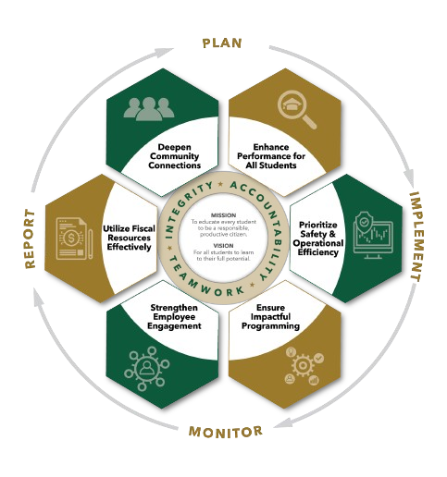


May agenda
Autrey Mill Middle School Governance Council
Date | time May 11, 2026| 7:45 am | Location Room A130

SGC Members: Trey Martin, Principal | Emma Cornwall, Teacher |Maud de Groot, Teacher | Ashley Perry, School Employee | Matthew McNamara, School Employee |Kathleen Newquist, Parent | Jessica Saszi, Parent |Beth Zampieri, Parent| Korina Calbay, Community Member | Jacob Marmer, Community Member
Time | Item | Owner
7:45am | Call to Order | Cornwall
7:46am  7:47am | Action Item: Approve Agenda  Action Item: Approve March Minutes | Cornwall  Cornwall
7:48am  8:20am  8:25am  8:30am | Discussion Item: Parent/Teacher SGC New Members  Informational Item: Principals Update  Discussion Item: SGC Survey Update  Action Item: Meeting Adjournment | All Members  Mr. Martin  All Members  Cornwall

Meeting Norms
Silences Phones | Be Respectful of Others’ Opinions | Work for the Good of All Students

