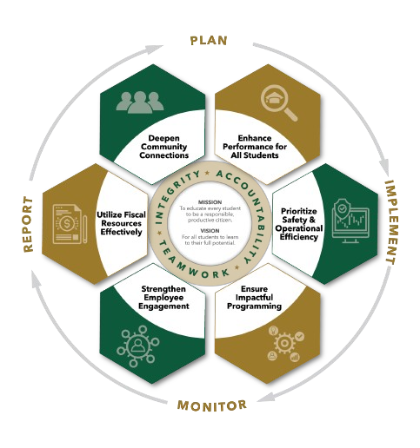


February Minutes
Autrey Mill Middle School Governance Council
Date | time February 25 2026| 7:45 am | Location Room A130

SGC Members: Trey Martin, Principal | Emma Cornwall, Teacher |Maud de Groot, Teacher | Ashley Perry, School Employee | Matthew McNamara, School Employee |Kathleen Newquist, Parent | Jessica Saszi, Parent |Beth Zampieri, Parent| Korina Calbay, Community Member | Jacob Marmer, Community Member
Time | Item
7:47 am | Call to Order
Action Item: Approve Agenda
Motion: Marmer
Second: Perry
All in favor
7:49 am | Action Item: Approve January Minutes  Motion: Newquist  Second: Saszi  All in favor
7:50 am | Action Item: Annual Budget Approval  AMMS budget is stronger than last year; budget allows for an additional teacher salary in reserve as safety net for next year. Review of teacher allocation. Ensuring adequate coverage for connections and reading. Administration is confident that budget is sound and strong.  Motion: Marmer  Second: Saszi  All in favor
8:17 am | Discussion Item: Planning for parent/teacher SGC elections  AMMS will elect 1 teacher and 1 parent this cycle. One new community member will be appointed. Parents and staff asked to contact their network to encourage candidates to submit their names.
8:20 am | Discussion Item: Charter Proposals  - 6th Science – requesting funds for classroom headphones at a total cost of $320; each teacher gets 10 sets (40 total headphones)  - General school fund allocation to support events - $350 benefitting all AMMS students
8:25 am | Action Item: Charter Dollar Proposals  - Declined – teachers may use school owned headphones for this purpose  - Approved – Council approves all remaining funds to be allocated to a general fund prioritizing use for Career Day and STEM Day activities  Motion: Marmer  Second: Saszi  All in favor
8:30 am | Informational Item: Principal’s Update  - District leadership proposed a district wide furlough on 5/21; will be voted on in March (expect a similar furlough for the 27-28 school year)  - All AMMS admin will be housed at JCHS Media Center this summer as extensive renovations occur at AMMS building
8:35 am | Discussion Item: Draft Next Meeting Agenda  - Next meeting will be March 30 and will be open for public comment  - April meeting canceled  - May meeting is TBD
8:38 am | Action Item: Meeting Adjournment  Motion: Newquist  Second: Cornwall  All in favor

Meeting Norms
Silences Phones | Be Respectful of Others’ Opinions | Work for the Good of All Students

