Regional School District No. 12
Bridgewater, Roxbury and Washington, Connecticut

REQUEST FOR PROPOSALS

FOR

CONSTRUCTION SERVICES

Shepaug Valley School Exhaust Fans and HVAC Renovations

______________________________

April 1, 2026

Voluntary Meeting for Opening of Proposals

Time: Thursday, April 30, 2026 at 11:30am Eastern Time (US and Canada)

Offices of the Superintendent, 11A School Street, Washington, CT 06794

REGIONAL SCHOOL DISTRICT NO. 12

INSTRUCTIONS FOR SUBMISSION OF PROPOSAL

1. INTRODUCTION

The Board of Education (the “BOE”) of the Regional School District No. 12 (the “District”) is inviting qualified contractors to submit proposals for all labor and materials for the following improvements at Shepaug Valley School at 159 South Street, Washington, CT 06793:

- Shepaug Valley School Exhaust Fans and HVAC Renovations

All improvements are more particularly described in Exhibit D (the “Project”). The Project is described in more detail in Section 4 of these Instructions for Submission of Proposal (the “Instructions”).

This opportunity has been publicly advertised through the Invitation to Submit Proposals attached as Exhibit E. The Project will be awarded to the Contractor(s) determined and selected by the District in the manner described in Section 7 of these Instructions.

The BOE reserves the right to amend or withdraw this Request for Proposals (RFP) for any reason (including, but not limited to, the failure of the BOE to approve the Project by vote at referendum or the lack of funding for the Project), to accept or reject any or all Proposals, to waive any informalities or non-material deficiencies in any Proposal submission, to award or not award a contract in connection with this RFP, to negotiate with one or more Contractors as permitted by the BOE’s purchasing policies and applicable law, and to award a contract to the Contractor as deemed by the BOE to be in the best interest of the BOE and the District.

2. SCHEDULE

2.01 A mandatory walkthrough of the site will take place at 1:30pm on Monday, April 13, 2026. Contractors should report to the Shepaug Valley School, 159 South Street, Washington, CT 06793 at 1:30pm.

2.02 All Requests for Information must be received no later than 4:00pm on Wednesday, April 22, 2026 by Donald O’Leary, Director of Facilities, at olearyd@region-12.org .

2.03 Addenda will be issued and posted on the BOE’s website no later than 4:00pm on Friday, April 24, 2026.

2.04 Proposals are due at Central Office by 11:30am on Thursday, April 30, 2026 (the “Submission Deadline”) at which time the BOE will open the Proposals publicly at Central Office 11A School Street, Washington, CT 06793.

2.05 The Form of Contract (“Contract”) is available for review on the District’s website here: https://www.region-12.org/central-office/business-office/bids-rfps. By submitting a proposal, contractor agrees generally to the terms of the contract and shall execute a contract prior to the District issuing a Notice to Proceed. Contractor shall note any problematic contract terms in its RFP submission.

2.06 The Board intends to award the Contract(s) by Tuesday, May 26, 2026 and to issue a notice to proceed upon execution of the contract.

2.07 The Completion Dates for the improvements are as follows:
- The completion date for the Shepaug Valley School Exhaust Fans and HVAC Renovations must be coordinated with the Director of Facilities with consideration given to the availability of materials, and restrictions for work days dependent on the school calendar. The District desires to complete the project by Tuesday, August 18, 2026.

3. CONTENTS OF PROPOSALS

3.01 Proposals must include the following:

Completed and fully executed Proposal Form attached hereto as Exhibit A. The Proposal Form must be executed by a duly authorized representative of the Contractor having legal authority to contract on behalf of the Contractor.

The information and documents listed on Exhibit B.

3.02 Please note the Selection Process described in Section 7 of these Instructions.

3.03 The Board is tax exempt. The sales or use tax on materials or supplies exempted by regulations of the Connecticut Department of Revenue Services shall not be included as part of a price proposed by the Contractor for the Project (the “Project Price”).

3.04 The term “Proposal Documents” shall mean and include these Instructions for Submission of Proposal and all exhibits and schedules attached hereto and such other documents and information as may otherwise be incorporated herein by reference.

4. SCOPE OF THE WORK

4.01 The scope of the work for the Project is described on Exhibit D.

5. ADDENDA/INTERPRETATIONS/RFI/SUBSTITUTIONS

5.01 Interpretations/Requests for Information

- Contractors requiring information regarding clarification or interpretation of the Proposal Documents shall make a written request to the BOE by email to Donald O’Leary, Director of Facilities, at olearyd@region-12.org. Responses to such requests shall be provided by way of Addenda posted on the District’s website.

5.02 Substitutions

- The materials, products and equipment described in the Proposal Documents establish a standard of required function, dimension, appearance and quality to be met by any proposed substitution.

- Requests for substitutions shall be made to the BOE by email to Donald O’Leary, Director of Facilities, at olearyd@region-12.org and shall include the name of the material or equipment for which it is to be substituted and a complete description of the proposed substitution including drawings, performance and test data, and other information necessary for an evaluation. A statement setting forth changes in other materials, equipment or other portions of the work, including changes in the work of other contracts that incorporation of the proposed substitution would require, shall be included. The burden of proof of the merit of the proposed substitution is upon the Contractor. The Board will provide notice of any approved substitutions by way of Addenda.

5.03 Addenda

- Addenda will be posted on the District’s website: https://www.region-12.org/central-office/business-office/bids-rfps.

- Interpretations or changes to, or corrections of, the Proposal Documents, or substitutions made in any manner other than by way of an Addendum will not be binding, will be of no force and effect and Contractors shall not rely upon them.

6. DELIVERY OF PROPOSALS

6.01 Proposals will be received at Central Office, 11A School Street Washington, CT 06794 by the Proposal Deadline. The BOE has no responsibility for any delays caused by the delivery process. The subject line of the Proposal delivered shall state: “Response to Shepaug Valley School Exhaust Fans and HVAC Renovations.”

6.02 Proposals must contain the items described in Section 3 of these Instructions.

7. SELECTION PROCESS

7.01 Proposals will be opened on Thursday, April 30, 2026 at 11:30am. The proposal opening will take place at 11A School Street, Washington, CT 06794. No Contractor may withdraw a proposal within 60 days after the date that the proposals are opened.

7.02 The BOE will be responsible for evaluating the proposals and for the selection of the Contract awardee. The evaluation criteria shall include (i) the quality of the Contractor’s references, and (ii) the contents of the Contractor’s Proposal submission. The BOE will award the Contract to the Contractor the BOE believes to offer the best combination of price and quality. The BOE is not required to award the Contract to the Contractor submitting the lowest Proposal Price and this selection process may result in the award of the Contract to other than the lowest Contractor if determined by the BOE to be in the best interests of the District.

7.03 Any Proposal not including the attendant submissions required hereunder shall be considered unresponsive and may be rejected by the BOE.

7.04 The BOE also reserves the right to negotiate further with one or more of the firms as to any features of their Proposals and to accept modifications and clarifications of the Proposal when such action will be in the best interests of the District.

7.05 Contractors whose Proposals are deemed unacceptable will be notified.

8. THE CONTRACT

8.01 The BOE intends to use, and the successful Contractor will be required to execute and deliver, the contract referenced in Section 2.05 hereof. Notwithstanding the foregoing, the BOE reserves the right to further modify the Contract prior to its execution. If a Contractor has objections to any of the terms and conditions of the Contract, such objections should be specifically identified and included in the Proposal submission.

8.02 Please refer to the Contract for important terms and conditions that are applicable to the Project such as markup limitations for changes in the scope of the work, liquidated damages, indemnification obligations and other important rights and obligations.

9. INSURANCE REQUIREMENTS

9.01 The insurance requirements to be met by the successful Contractor are set forth on Exhibit F to this RFP.

10. FURTHER INFORMATION AND REQUIREMENTS

10.01 NONDISCRIMINATION

The BOE prohibits harassment and discrimination on the basis of race, color, religious creed, age, marital status, military or veteran status, national origin, sex, ancestry, sexual orientation, or past or present physical or mental disability in accordance with Titles VI, VII of the Civil Rights Act of 1964, Title IX of the Education Amendments Act of 1973; Section 504 of the Rehabilitation Act of 1973; the Americans with Disabilities Act of 1991; and applicable state laws.

As part of its Proposal submission each Contractor shall submit the signed Statement of Policy attached hereto as Exhibit G confirming the Contractor’s equal opportunity policies.

10.02 BACKGROUND CHECK REQUIREMENTS AND STUDENT SAFETY

The successful Contractor will be required to comply with all applicable laws including, without limitation, the requirements set forth on Exhibit H hereto.

10.03 PREVAILING WAGE LAW AND PAYROLL CERTIFICATION

This Project may be subject to the prevailing wage requirements of the State of Connecticut (CGS §31-52). The applicable Wage Rates are attached hereto as Exhibit I.

If the cost of any Improvement or the Project exceeds $100,000, the wages paid on an hourly basis to any mechanic, laborer or worker employed upon the work herein contracted to be done and the amount of payment or contribution paid or payable on behalf of each such employee to any employee welfare fund, as defined in subsection (h) of Section 31-53 of the General Statutes of Connecticut shall be at a rate equal to the rate customary or prevailing for the same work in the same trade or occupation in the town in which such public works project is being constructed. Any contractor who is not obligated by agreement to make such payment or contribution on behalf of such employees to any such employee welfare fund shall pay to each employee as part of their wages the amount of the payment of contribution for their classification on each pay day.

To the extent required pursuant to Connecticut General Statute Section 31-53b, the contract awardee shall furnish proof, and shall cause its Subcontractors to furnish proof, with the weekly certified payroll form for the first week each employee begins work on such project that any person performing the work of a mechanic, laborer or worker pursuant to the classifications of labor under section 31-53 on such public works project, pursuant to such contract, has completed a course of at least ten hours in duration in construction safety and health approved by the federal Occupational Safety and Health Administration or, has completed a new miner training program approved by the Federal Mine Safety and Health Administration in accordance with 30 CFR 48 or, in the case of telecommunications employees, has completed at least ten hours of training in accordance with 29 CFR 1910.268.

10.04 PERFORMANCE AND PAYMENT (LABOR AND MATERIALS) BONDS

If the contract awarded in connection with this RFP exceeds One Hundred Thousand and 00/100 Dollars ($100,000.00), the successful Contractor will be required to furnish Performance and Payment (Labor and Material) Bonds an amount equal to one hundred percent (100%) of the contract price, as security for the faithful performance and payment of all the contractor’s obligations under the contract documents. Bonds shall be in the forms prescribed by law or regulation and shall be acceptable to the BOE.

Bonds shall meet the requirements of the applicable Connecticut General Statues, including but not limited to Sections 49-41, 49-41a, and 49-42 with regard to the Payment Bond and Section 38a-290 with regard to the Performance and Payment Bonds. The Performance Bond shall meet the three (3) year minimum requirement set forth in Section 38a-290 of the Connecticut General Statues. Surety companies executing Bonds must appear on the United States Treasury Department Circular Number 570, as amended, and be authorized to transact business in the State of Connecticut. All Bonds signed by an agent must be accompanied by a certified copy of the authority to act.

10.05 PROHIBITED INTEREST

No member, officer or employee of the BOE, or member of a local public agency having jurisdiction within the BOE, during his or her tenure or one year thereafter, shall be permitted to share in, have interest in or benefit from, directly or indirectly, any contract or agreement resulting from this RFP.

EXHIBITS TO THESE INSTRUCTIONS:

Exhibit A: Proposal Form
Exhibit B: Submission Requirements
Exhibit C: Intentionally Omitted
Exhibit D: Scope of the Work
Exhibit E: Invitation to Submit Proposal
Exhibit F: Insurance Requirements
Exhibit G: Statement of Policy re: Equal Opportunity
Exhibit H: Background Check Requirements and Student Safety
Exhibit I: Wage Rates
Exhibit J: Non-collusion Affidavit
Exhibit A
Proposal Form

The undersigned hereby proposes and agrees to fully perform the work set forth on in the Scope of Work (Exhibit D), including, without limitation and within the time stated in the Instructions and in accordance with the Proposal Documents for the Base Proposal amount set forth below.

Base Proposal Amount:

Lump sum amount of _____________________________________ Dollars ($_____________)

Unit Prices: Unit Unit Price

Names of Subcontractors to be utilized on the Project:

Receipt of Addenda Acknowledged:
Signature
Addendum No. 1 dated
Addendum No. 2 dated

By its signature below, the undersigned hereby:

- Agrees and warrants that if selected as contract awardee for the Project, undersigned shall, within five days, Saturdays, Sundays and legal holidays excluded, after presentation thereof by the BOE, execute a contract in accordance with the terms of this Request for Proposal and the Instructions;

- Represents that the undersigned has read and understood the Proposal Documents, INCLUDING ALL EXHIBITS, which are Exhibit A through Exhibit J, and any Addenda;

- Certifies that, as (Title/Capacity) of the Contractor, all of the information and material included in the Contractor’s submission is complete, accurate, and true; and

- Understands the terms and conditions of the Proposal Documents, and understands that, if any information submitted by or on behalf of the Contractor is found to be incomplete, inaccurate, or false, or if any attempt to mislead the BOE is discovered, either during the evaluation or subsequent to any award, the same may result in the disqualification of the Contractor and/or the immediate termination of the Contract.
- Acknowledges the Insurance Requirements outlined in Exhibit F and certifies the Contractor maintains or shall purchase the types and limits of insurance required prior to commencement of the project. Contractor shall provide proof of such coverage together with the signed contract (if awarded).

Signed this ____ day of [DATE] by:

Contractor:

By
Its (Title):
Print Name:
Exhibit B

Submission Contents

Proposals should include the following information and documents organized and presented as provided and in the form listed below:

1. Contractor Identity and Contact Information: Provide basic information regarding the identity and contact information of the Contractor.

2. Contractor’s History and General Qualifications: Provide a general statement of the Contractor’s history and qualifications for the Project.

3. References: Provide references and the other information for at least three projects the Contractor has completed or is currently working on preferably for educational institutions located in Connecticut which projects are similar in character and scope to the Project. [Use Exhibit B-1] By submission of a proposal in response to the RFP, each Contractor authorizes the BOE to contact the Contractor’s disclosed references regarding the services performed by the Contractor in each case.

4. Financial Capability: Evidence that the Contractor is financially stable and capable of performing the work and completing the Project.

5. Litigation: Descriptions of all pending and threatened litigation or arbitration in which the Contractor is named as a party as well as any judgments entered against the Contractor during the last five years. [Use Exhibit B-2]

6. Along with the information to be provided above, the Contractor shall submit the following:

● Completed Proposal Form [Use Exhibit A or similar]
● Completed and Executed Statement of Policy re: Equal Opportunity [Use Exhibit G]
● Completed and Executed Non-Collusion Affidavit [Use Exhibit J]
● List of the names and addresses of proposed subcontractors that will perform any part of the work for the Project on behalf of the Contractor. The BOE reserves the right to reject any or all proposed subcontractors. In the event the BOE so rejects any or all subcontractors proposed by a Contractor, such Contractor may, notwithstanding anything to the contrary in these Instructions, withdraw its Proposal without penalty. The BOE hereby reserves the right to allow a Contractor whose subcontractor or subcontractors are rejected hereunder, to re-submit a Proposal with subcontractors acceptable to the BOE.
● Schedule of Values allocating the Proposal price to all individual line items identified on Exhibit D and as otherwise applicable to the work of the Project.

Exhibit B-1
REFERENCE CHECK

Please provide three (3) references:

1. ___________________________________________
Name
___________________________________________
Contact Person
___________________________________________
Telephone Number
___________________________________________
Period of Contract
___________________________________________
Type of Services Provided to Reference
2. ___________________________________________
Name
___________________________________________
Contact Person
___________________________________________
Telephone Number
___________________________________________
Period of Contract
___________________________________________
Type of Services Provided to Reference
3. ___________________________________________
Name
___________________________________________
Contact Person
___________________________________________
Telephone Number
___________________________________________
Period of Contract
___________________________________________
Type of Services Provided to Reference

Exhibit B-2
PENDING OR THREATENED LITIGATION

For cases pending, please provide the following information for each matter:

1. Parties (suing or being sued)

2. Docket Number and Court

3. Brief Description and Status

JUDGMENTS

Please provide the following information for each matter:

1. Parties (suing or being sued)

2. Docket Number and Court

3. Brief Description and Amount of Judgment

(Attach additional sheets, if necessary.)
Exhibit C

Intentionally Omitted

EXHIBIT D
REGIONAL SCHOOL DISTRICT NO. 12
SCOPE OF WORK
for
Shepaug Valley School Exhaust Fans and HVAC Renovations

GENERAL INFORMATION
Regional School District – 12 (RSD-12) is seeking requests for proposals from qualified CT licensed contractors for a design-build project to replace rooftop exhaust fan units at its Shepaug Valley School (SVS) located at 159 South Street, Washington, CT.
The requested proposal is for the removal of Twenty-one existing Rooftop Exhaust Units listed below in this document and the installation of Twenty-one new direct replacements as detailed further below. A rooftop drawing showing unit locations is available on the district website. The installation shall utilize the existing ductwork, roof curb and electrical. The project shall include all permits, engineering, design, demo, disposal, all necessary data to satisfy local building officials permitting process including meetings where necessary, new equipment, related hardware, labor, materials, electrical, mechanical, compatible curbs, ductwork transitions, roof work and minor repairs to properly complete a successful project for the district while meeting all federal, state and local codes.
SCOPE OF SERVICES
The scope of this project work includes the following, but may not be limited to:
Provide engineering, design support to identify new replacements for the existing units that would fit the existing application and configuration with little modification as possible.
Provide engineering, design support to review existing wiring, switching, circuit loads and other related parameters to ensure the existing utilities, ductwork backbone and electrical can be used with the new units.
If modifications are required, provide necessary drawings showing the changes, labor and materials to integrate them into the design.
Carefully disconnect and remove each unit from the curb. Do not disturb existing curb. Do not damage the roof system.
The existing roof material is covered by a Garland 25-year warranty which requires any roofing work be carried out by a factory certified Garland roofing contractor to maintain its warranty status.
Provide the new replacement, delivery, labor and materials and all other aspects necessary for their successful installation and operation within the existing systems that support the exhaust units. Provide, supervise and coordinate any additional subcontracting services required, such as electrical, cleaning, roof work, curbing replacement, ductwork transitions and start-up needed to successfully complete the project.
Remove all old equipment and any debris from the site. Dispose of debris following all necessary laws including those required for any specific components needing special disposal or handling attention.
Acquire, coordinate and pay all necessary local permits and inspections based on relevant information for the work from local building officials.
Test and provide start-up of all components and systems for proper operation.
Provide equipment warranties, upon completion of the installation.
Provide walk through for punch list items and Two (2) binders of product manuals upon substantial completion of the work.
Prevailing wage rates shall apply if state required and applicable.
Provide a timeline for the entire project duration.
GENERAL SPECIFICATIONS
The successful bidder is expected to have adequate equipment and knowledge to ensure that the project is completed successfully and in a timely manner.
Contractors must verify any and all field requirements for a complete proposal.
A dedicated supervisor for the project shall be named along with their cell phone contact.
Hours and days of work shall be determined between the winning bidder and the district that shall consider the districts school calendar and events that will provide the greatest safety to students, staff and the public.
Any damages to the grounds, buildings, windows, vehicles, signage, lighting, plantings due to negligence or other related contractor incidents shall be repaired or replaced at the cost of the contractor.
A minimum of three references of similar work must be provided that has been performed within the last three years.
Insurance certificate must be provided and include Regional School District 12 as additional insured.
Disposal of waste generated by the project requirements shall be the responsibility of the contractor to remove and dispose of in accordance with federal and local laws and regulations.

EXHAUST UNIT INFORMATION
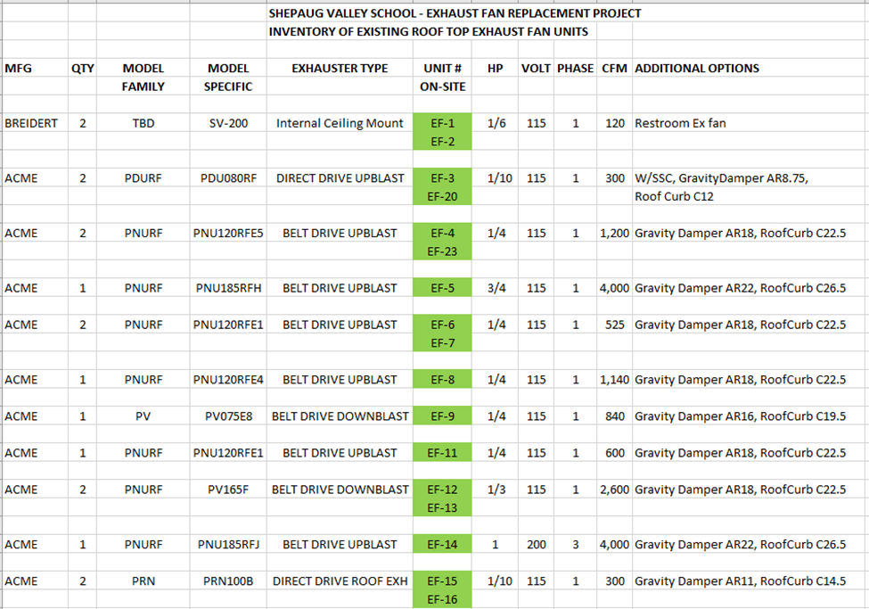

EXHAUST UNIT INFORMATION - continued
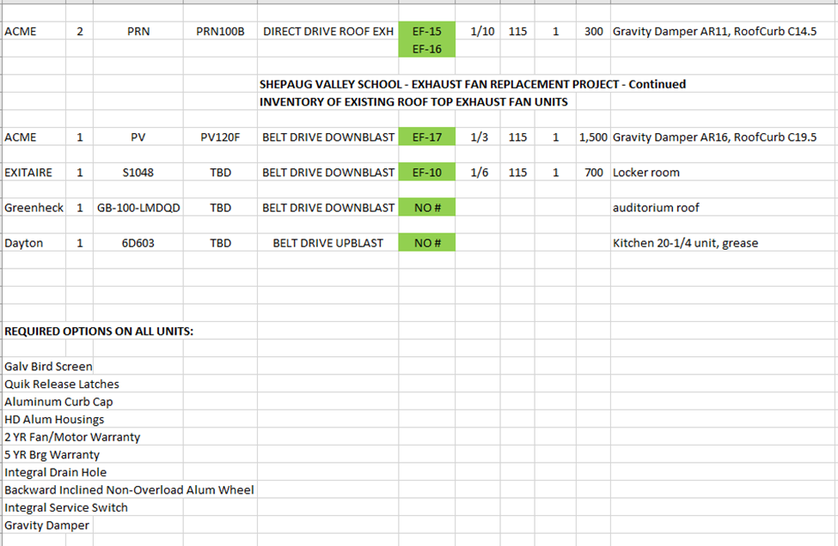

Exhibit E

REGIONAL SCHOOL DISTRICT NO. 12

INVITATION TO SUBMIT PROPOSALS

The Board of Education of Regional School District 12 of the State of Connecticut hereby invites the submission of Proposals for the following projects. The Proposals will be received at Central Office, 11A School Street, Washington, CT 06794. Proposals will be opened and read aloud on April 30, 2026 at the times set forth below. All interested parties are invited to attend.

AHU Replacement at Washington Primary School, 11 School Street, Washington, CT 06794 - 10:00am
AHU Replacement at Burnham School, 80 Main Street South, Bridgewater, CT 06752 - 10:30am
Front Office RTU Replacement at Washington Primary School, 11 School Street, Washington, CT 06794 - 11:00am
Exhaust Fans and HVAC Renovations at Shepaug Valley School, 159 South Street, Washington, CT 06793 - 11:30am
Lawn and Landscaping Services for its District Schools at Shepaug Valley School (159 South Street, Washington, CT 06793), Washington Primary School (11 School Street, Washington, CT 06794), Booth Free School (14 South Street, Roxbury, CT 06783) and Burnham School (80 Main Street South, Bridgewater, CT 06752) - 1:00pm
Bituminous Concrete Driveway Paving at Shepaug Valley School, 159 South Street, Washington, CT 06793 - 1:30pm
Student Locker Replacement at Washington Primary School, 11 School Street, Washington, CT 06794 - 2:00pm
Classroom LED Replacements at Booth Free School, 14 South Street, Roxbury, CT 06783 - 2:30pm

All RFP documents may be obtained on the District website under Central Office/Bids & RFPS and may also be requested electronically from the Assistant to the Director of Facilities by submitting an email request to plattc@region-12.org. Please note: Mandatory site visit dates and times are noted on our website.

The Board of Education of Regional School District 12 reserves the right to reject any and all proposals.

Nicole E. Grant
Director of Finance
Regional School District 12
11A School Street
Washington, CT 06794

April 1, 2026

Exhibit F
Insurance Requirements

The successful Contractor shall purchase from and maintain in a company or companies with an A.M. Best rating of A- (VII) or better, the insurance described below:

1. Workers’ Compensation. Contractor shall provide workers’ compensation insurance required by law with employer’s liability limits for at least the amounts of liability for bodily injury by accident of $1,000,000 each accident and bodily injury by disease of $1,000,000, including a waiver of subrogation in favor of the BOE.

2. Commercial General Liability Insurance. Contractor shall provide commercial general liability insurance policy including products and completed operations. Limits shall be at least: Bodily injury & property damage with an occurrence limit of $1,000,000; Personal & advertising injury limit of $1,000,000 per occurrence: General aggregate limit of $2,000,000 (other than products and completed operations); Products and completed operations aggregate limit of $2,000,000 per project. Coverage will continue for three years after the substantial completion of the work.

- The policy shall name the BOE and the Regional School District No. 12 as an additional insured and include ISO Form CG 20 10 04 13 and CG 20 37 04 13.
- The coverage will be provided on an occurrence basis and will be primary and shall not contribute in any way to any insurance or self-insured retention carried by the BOE.
- The policy shall contain a waiver of subrogation in favor of the BOE.
- The coverage shall contain a broad form contractual liability endorsement or wording within the policy form to comply with the hold harmless and indemnity provision of the Contract.
- Deductible and self-insured retentions shall be declared and are subject to the approval of the BOE.

3. Commercial Automobile Insurance. Contractor shall maintain commercial automobile insurance for any owned autos (Symbol 1 or equivalent) in the amount of at least $1,000,000 each accident covering bodily injury and property damage on a combined single limit basis. Such coverage shall also include hired and non-owned automobile coverage. Policy shall name the BOE as an additional insured.

4. Contractor’s Pollution Liability Insurance. Contractor shall maintain commercial pollution liability insurance in the amount of at least $1,000,000 each claim or each occurrence. Policy shall name BOE as an additional insured.

5. Umbrella Liability Insurance. Contractor shall provide umbrella or excess liability policy in excess (following form and without restriction or limitation) of those limits and coverages for commercial general liability and automobile insurance described above. The policy shall contain limits of liability in the amount of $5,000,000 each occurrence and $5,000,000 in the aggregate.

Unless otherwise provided above, the foregoing insurance shall be in effect no later than the date of execution of the Contract and shall continue in effect until three years after substantial completion of the Project. The insurer(s) and/or their authorized agents shall provide the BOE certificates of insurance prior to execution of the Contract.
Exhibit G

EQUAL OPPORTUNITY

Regional School District No. 12 is committed to the principles of equal employment. We are committed to complying with all federal, state, and local laws providing equal employment opportunities, and all other employment laws and regulations. It is our intent to maintain a work environment free of harassment, discrimination, or retaliation because of age, race, color, national origin, ancestry, religion, sex (including transgender status, gender identity or expression, sexual orientation, or civil union status), pregnancy (including childbirth, lactation and related medical conditions), physical or mental disability, genetic information (including testing and characteristics), veteran status, uniformed service member status, or any other status protected by federal, state, or local laws.

STATEMENT OF POLICY

It is the employment policy of _____________________________[Name of Contractor] that there shall be no discrimination against anyone on the grounds of age, race, color, national origin, ancestry, religion, sex (including transgender status, gender identity or expression, sexual orientation, or civil union status), pregnancy (including childbirth, lactation and related medical conditions), physical or mental disability, genetic information (including testing and characteristics), veteran status, uniformed service member status, or any other status protected by federal, state, or local laws in the hiring, upgrading, demotions, recruitment, termination and selections for training.

Name of Contractor:

By:
Date: Name:
Title:

Telephone Number Street Address

Email City/State
Exhibit H

PROHIBITED ACTIVITIES AND BACKGROUND CHECK REQUIREMENTS

Prohibited Activities and Background Check Requirements
Contractor shall comply with all applicable law including, without limitation, Connecticut General Statutes Section 10-222c, as applicable, and with the requirements set forth in this Exhibit.

Interaction with School Community.
The scope of the Work does not, and will not under any circumstances, require any contact with students or any other minors physically present in the facilities of, or the grounds surrounding, the school where the Project is located (the “School Grounds”). None of the Contractor, Subcontractors, Sub-subcontractor, or any of their respective employees, agents or representatives shall, under any circumstances, converse or interact in any manner, with students or any minors physically present on the School Grounds. None of the Contractor, Subcontractors, Sub-subcontractor, or any of their respective employees, agents or representatives shall interact with any adult members of the school community (including, without limitation, employees, officials, or visitors, including parents of students enrolled in the District’s schools) with respect to the Project with the exception of the District’s Designated Representative as provided in the Contract. All of the Contractor, Subcontractors, Sub-subcontractors, and their respective employees, agents or representatives shall, while on the School Grounds, refrain from use of vulgar language, obscene gestures, or any other behavior inappropriate for a school environment and/or property on which minor children are or may be present.

Background and Employment History Checks.
To the extent permitted by law, the Contractor shall perform (or cause to be performed) as regards all of its employees, agents, and representatives (each, a “Contractor Employee”), and all of the employees, agents, and representatives of Subcontractors and Sub-subcontractors (each, a “Subcontractor Employee”), who will be physically present on the School Grounds in connection with the Project, appropriate background checks on all such Contractor Employees and Subcontractor Employees. Such background checks shall include, at a minimum and without limitation, a search of both the Connecticut Department of Emergency Services and Public Protection’s sexual offender registry and the Abuse and Neglect Registry of the Connecticut Department of Children and Families. For those Contractor Employees and Subcontractor Employees who are to be physically present on the School Grounds in connection with the Project and whose current or most recent employment occurred out of state, the out-of-state equivalent of the Connecticut Department of Emergency Services and Public Protection’s sexual offender registry and the Abuse and Neglect Registry of the Connecticut Department of Children and Families registry shall be checked. The Contractor shall complete (or cause to be completed) background checks as to each Contractor Employee and Subcontractor Employee prior to such Contractor Employee or Subcontractor Employee being permitted to be physically present on the School Grounds. If the Contractor receives any information indicating that any Contractor Employee or Subcontractor Employee may be registered as a sexual offender, may have a record of abuse or neglect, or is, in any other manner, unfit to perform services which could involve direct contact with minor children, or which may involve working in or near property on which minor children may be present, the Contractor shall immediately forward such information to the District, to the extent permitted by law, and shall immediately remove the individual from the School Grounds and from participation in the Project.

Contractor represents and warrants that, in its best professional judgment, each Contractor Employee and each Subcontractor Employee maintains the appropriate qualifications and is fit to perform services which could involve direct contact with minor children, or which may involve working in or near property on which minor children may be present. The Contractor shall immediately remove any Contractor Employee or Subcontractor Employee from the School Grounds and from the Project if requested to do so by the District (which request shall be made in the District’s sole discretion) or if it becomes known to the Contractor that such Contractor Employee or Subcontractor Employee may be a danger to the health, safety or well-being of the school community, its students, or any minor children. A request by the District to remove any Contractor Employee or Subcontractor Employee from the School Grounds and from the Project shall not constitute a breach of the Contract.

The Contractor shall include and shall require all Subcontractors to include this Exhibit in all subcontracts for the Project.

By execution of the Contract, the Contractor represents and warrants that it has fully complied with the requirements of this Exhibit. To the extent permitted by law, the Contractor agrees that upon the District’s request, Contractor shall promptly provide the District with any documentation related to such compliance, including, without limitation, the results of the background and employment history checks required by this Exhibit. Failure by the Contractor to comply with its obligations under this Exhibit shall constitute a material breach of the Contract.
Exhibit I

Wage Rates

The District will provide Project specific wages below.
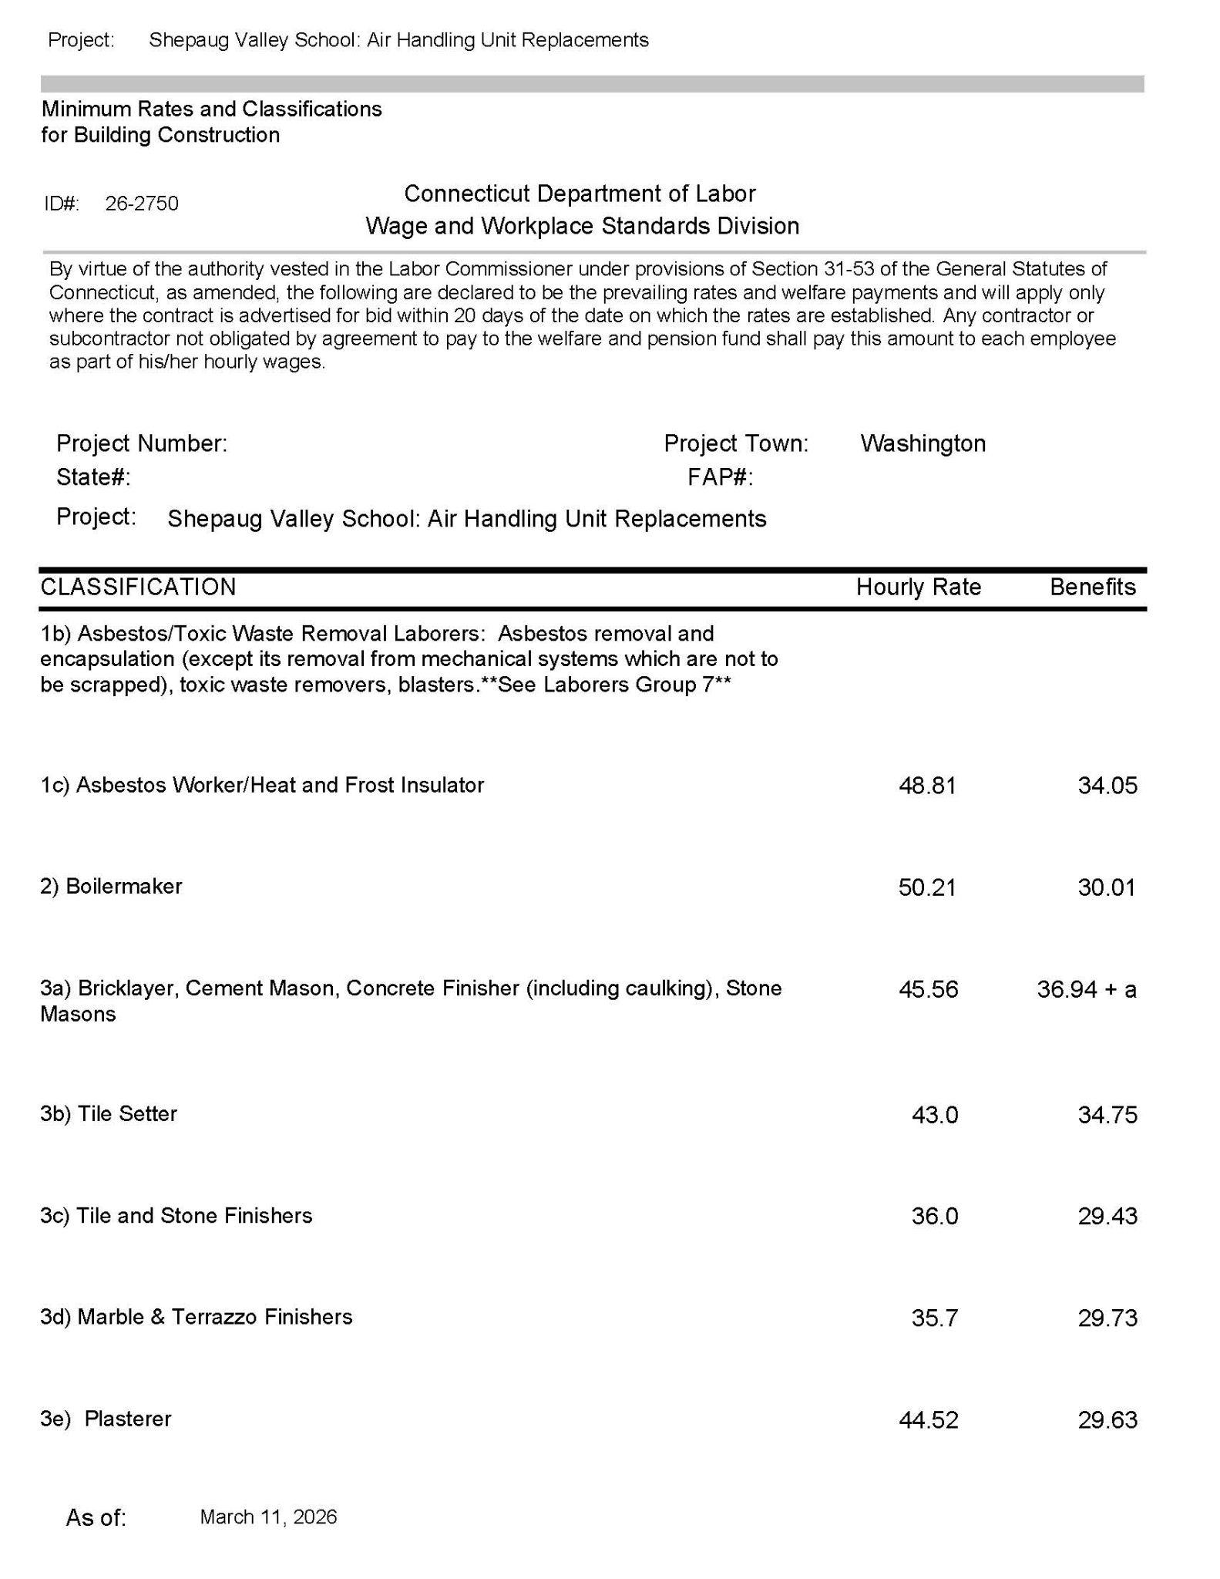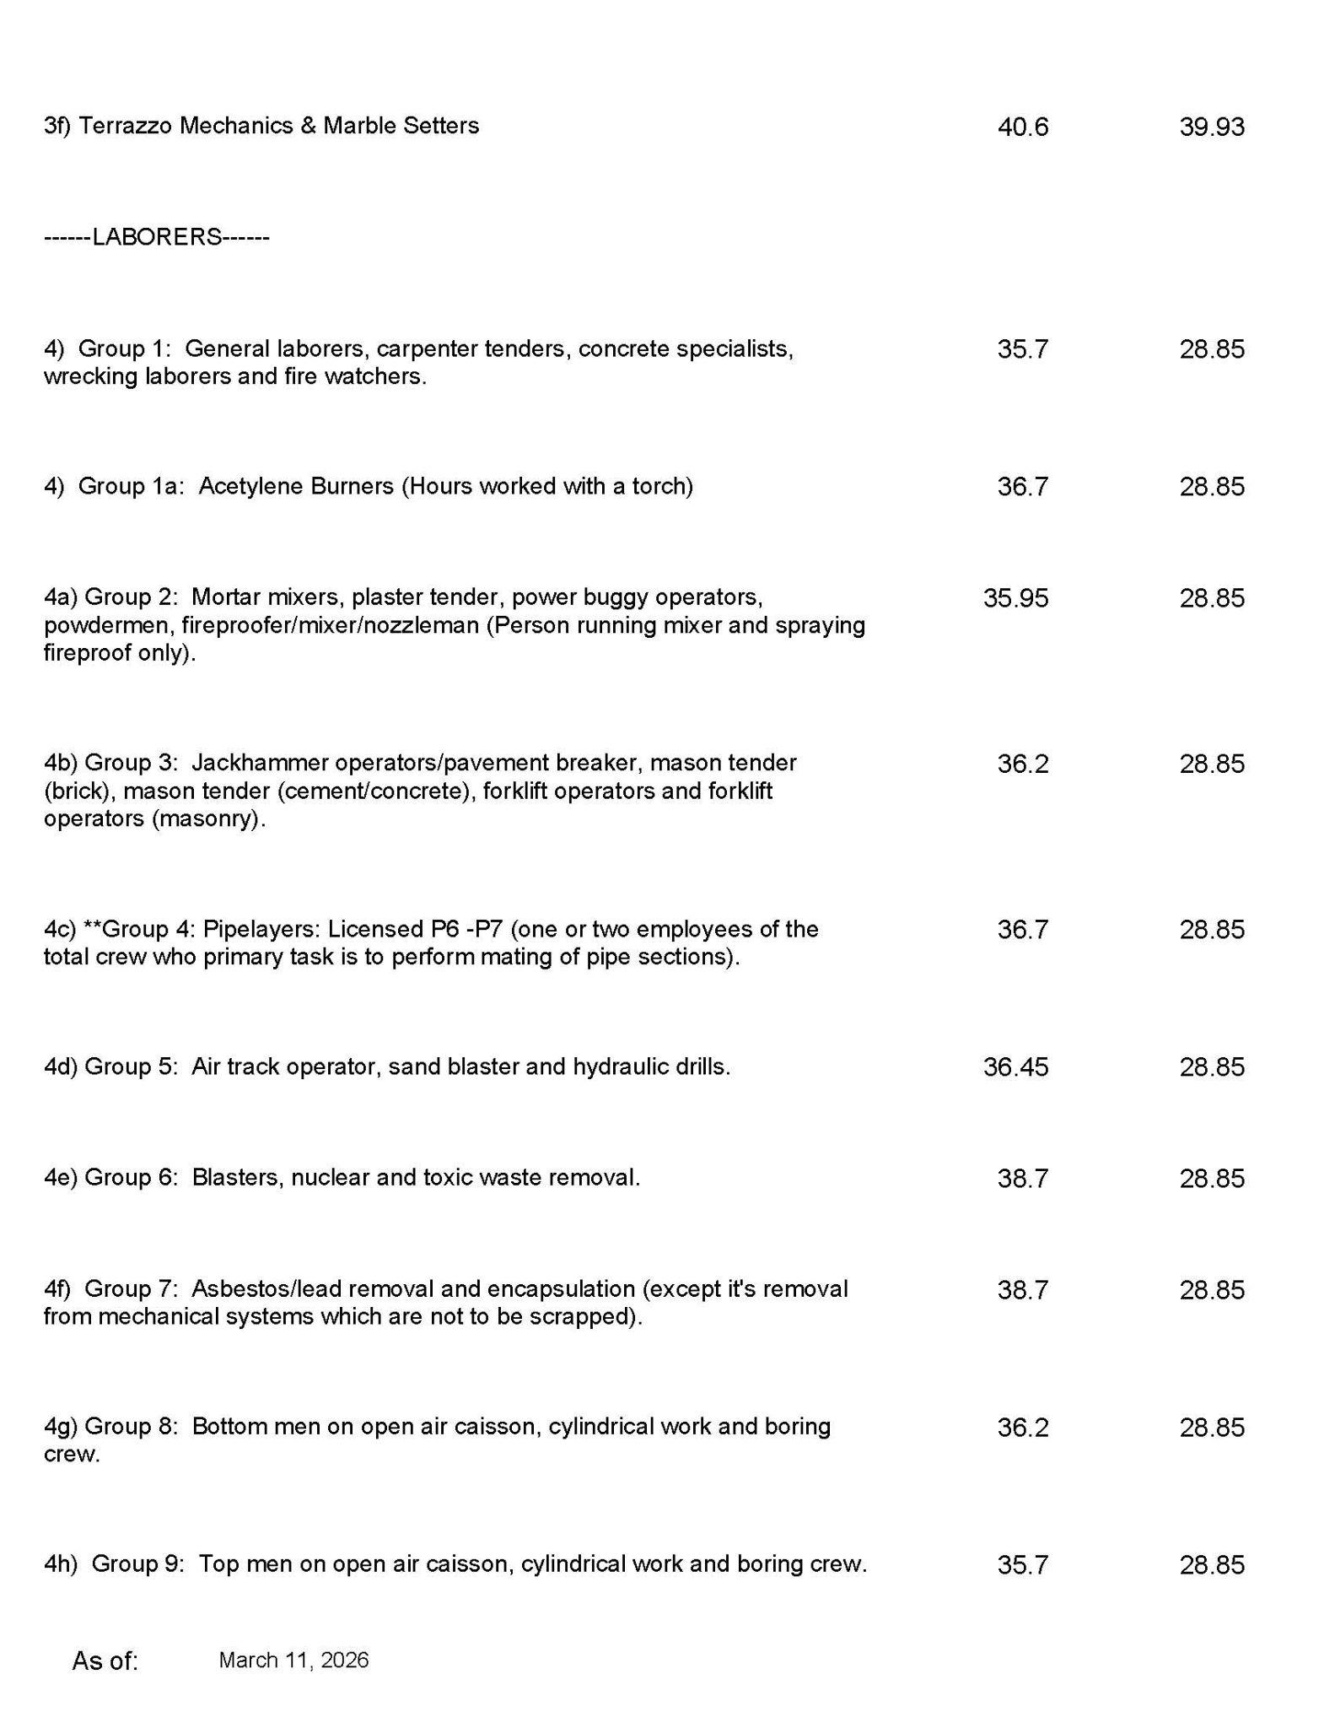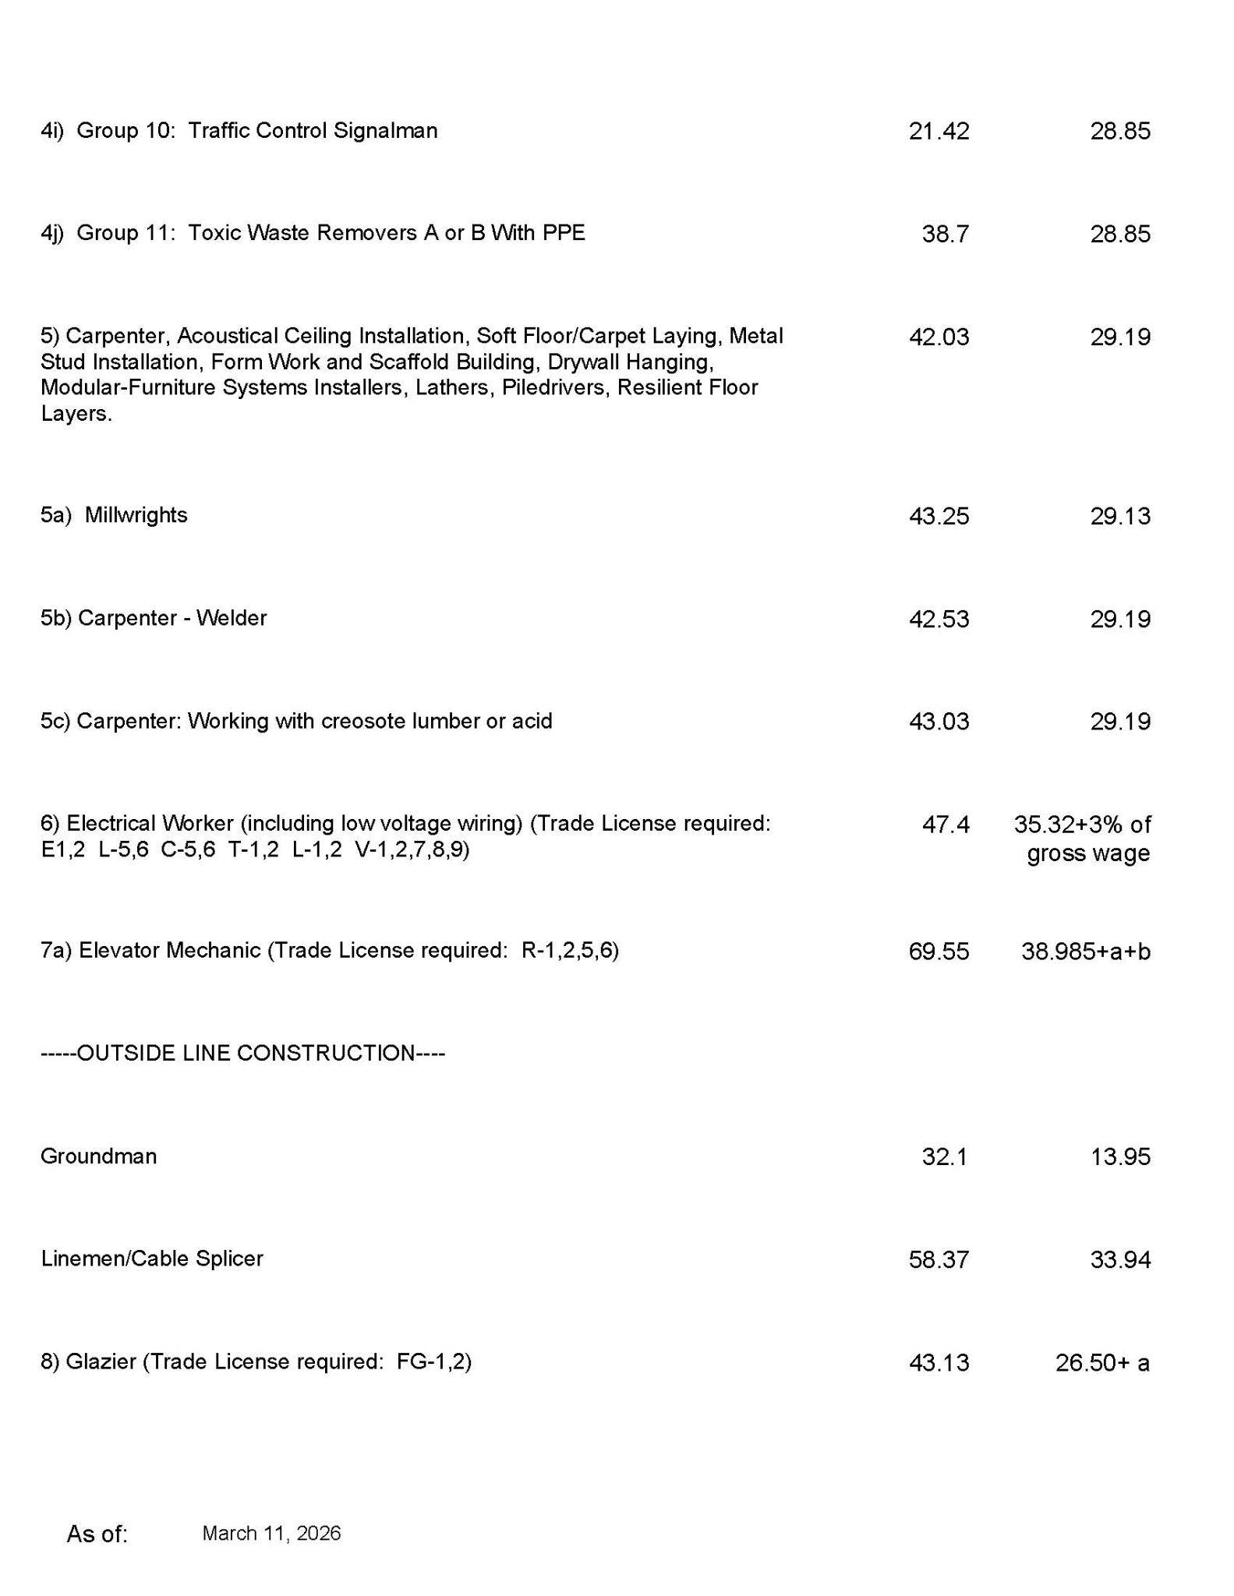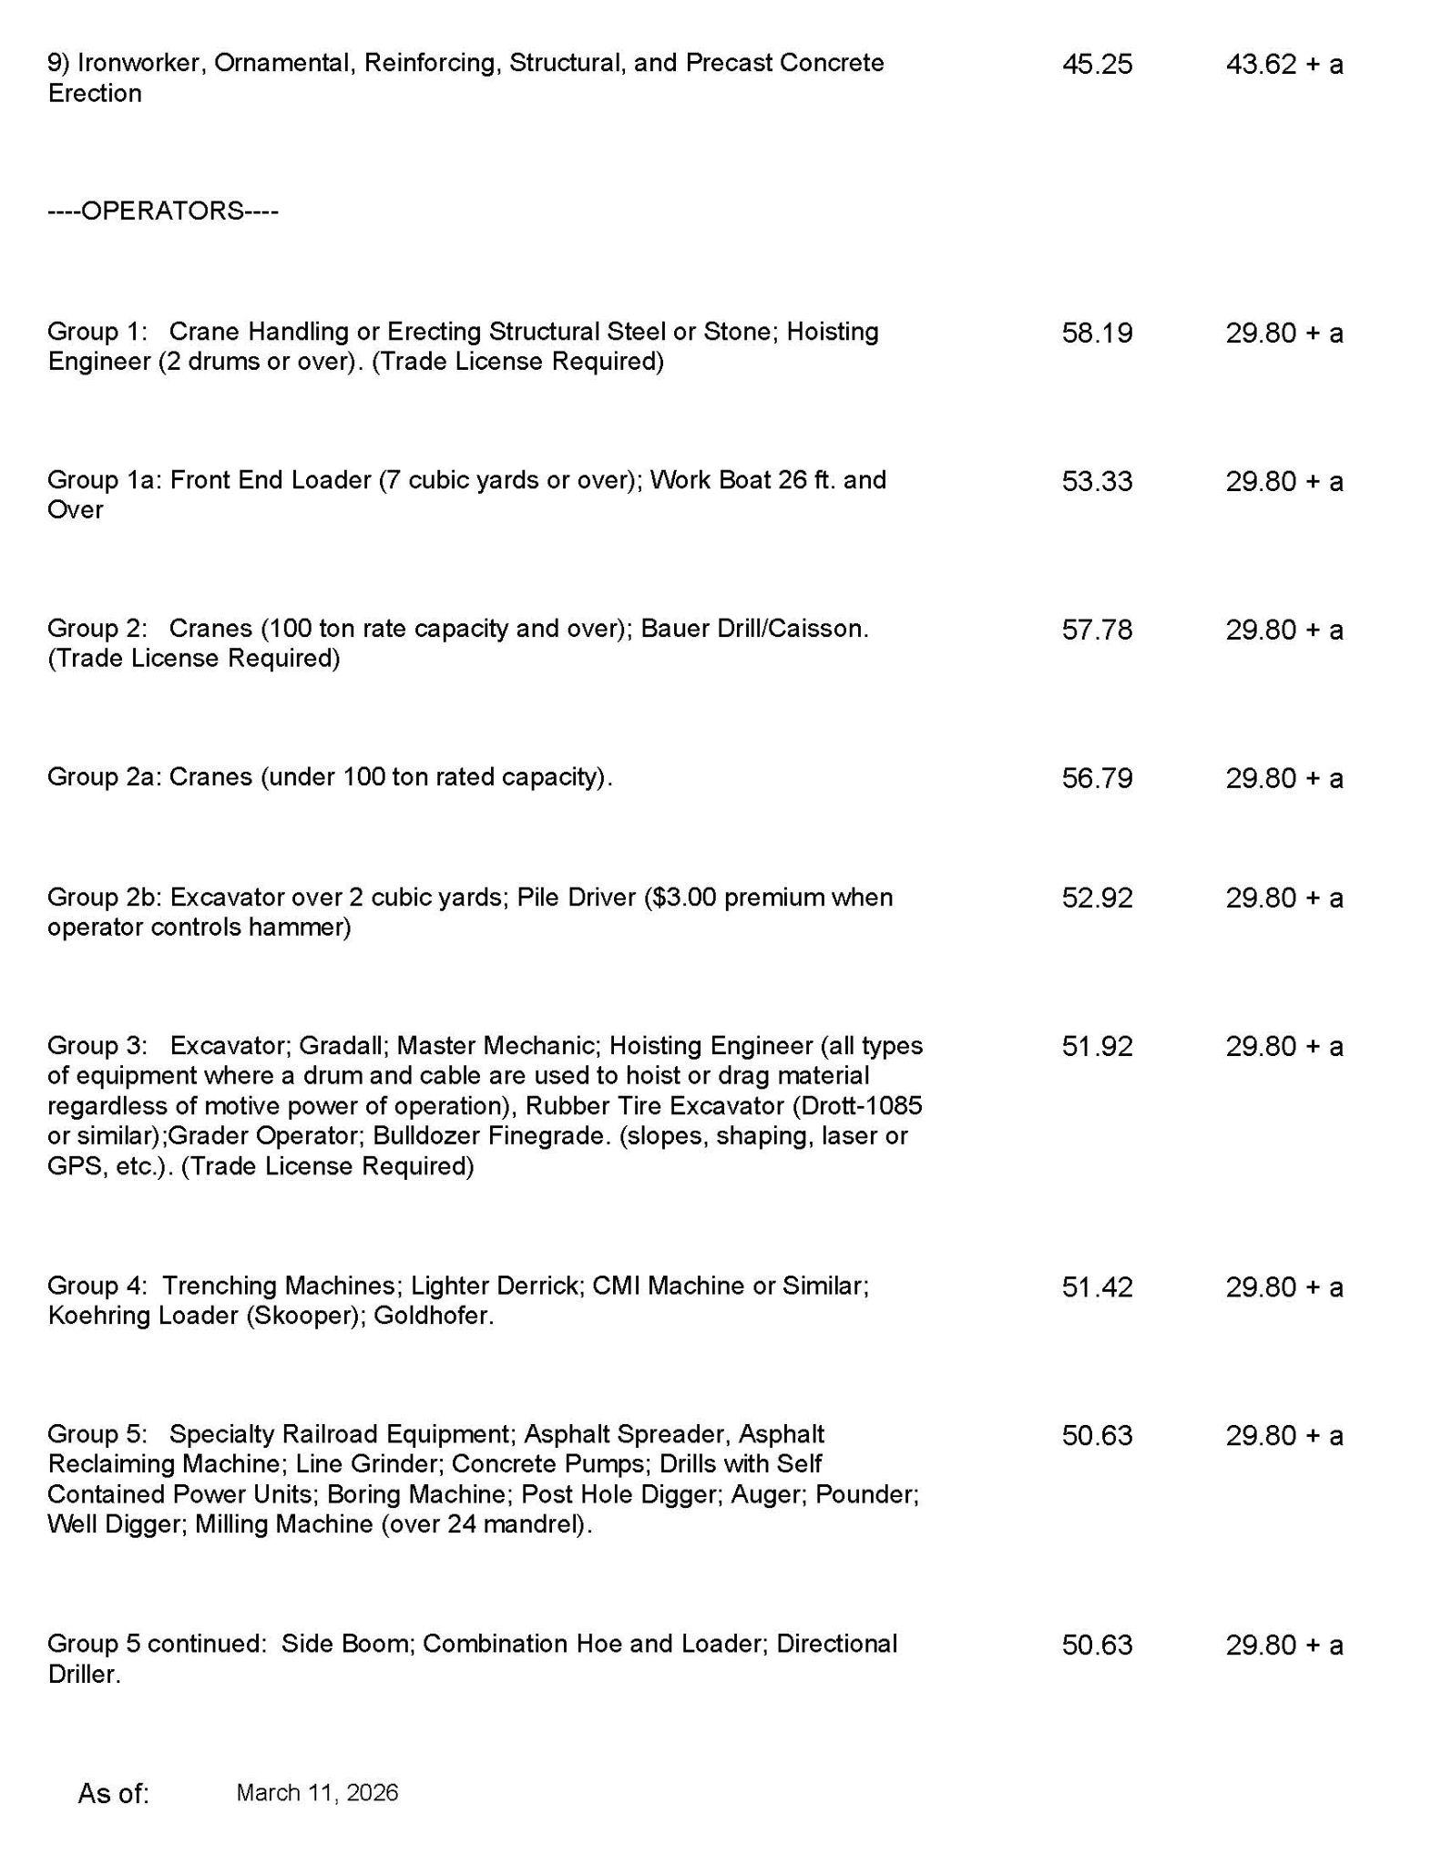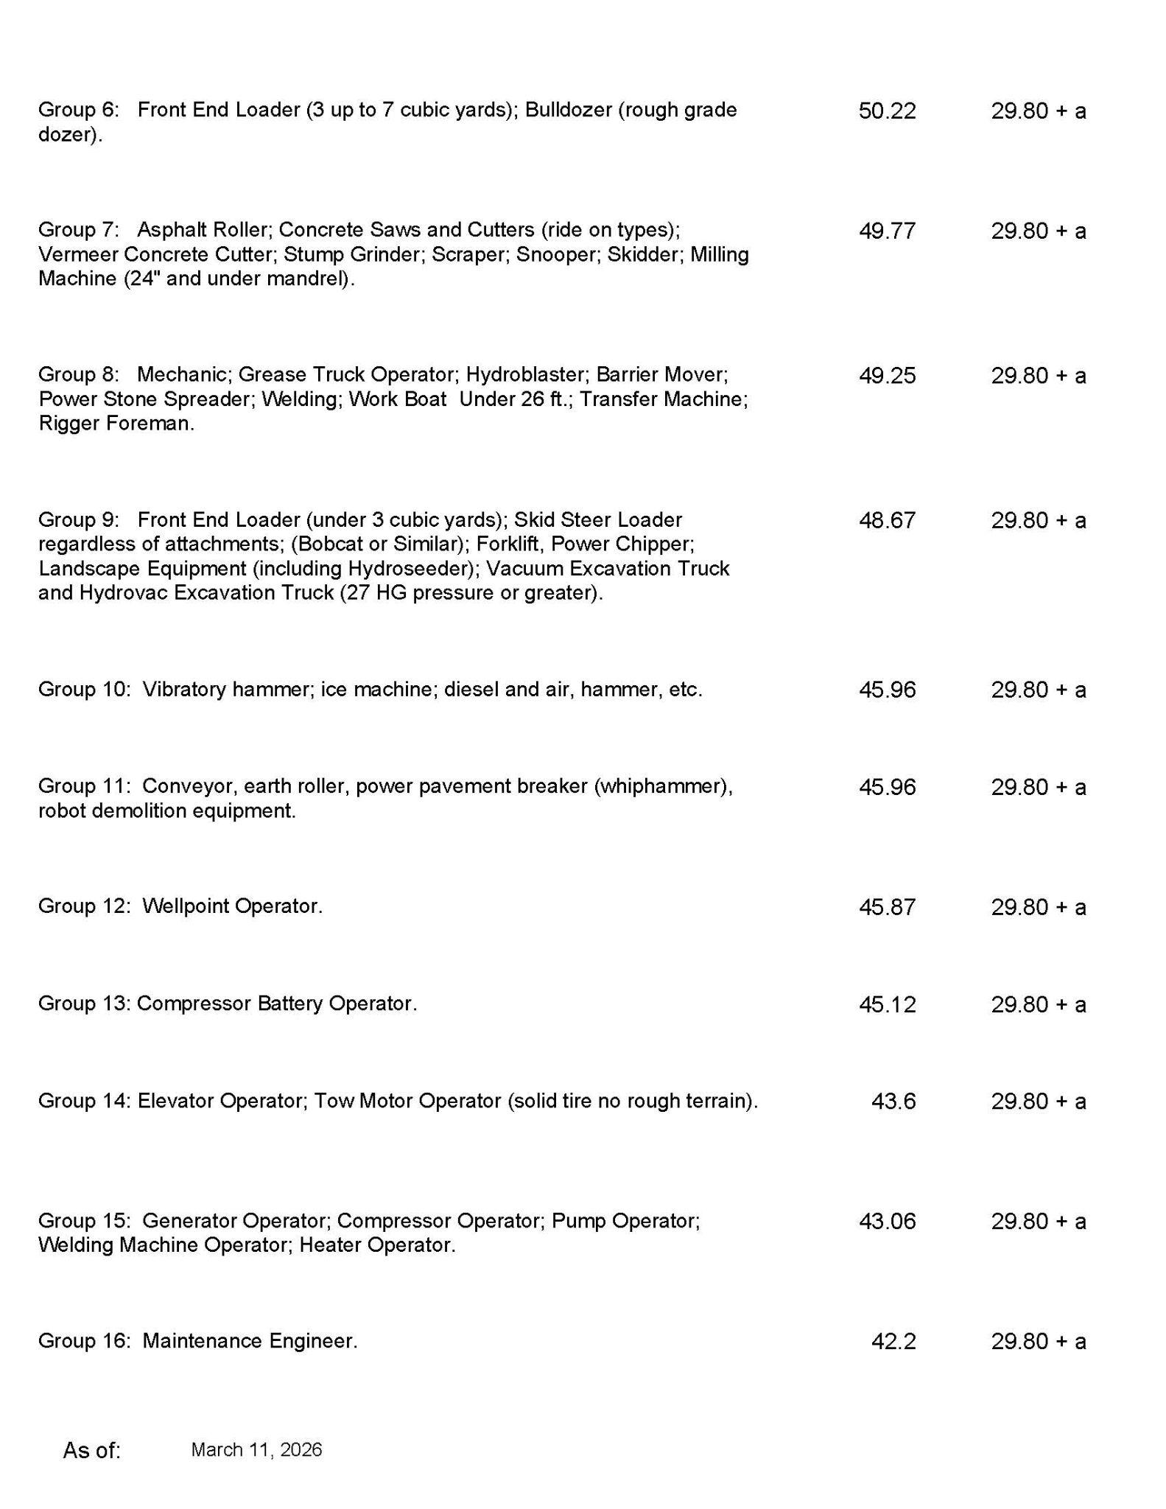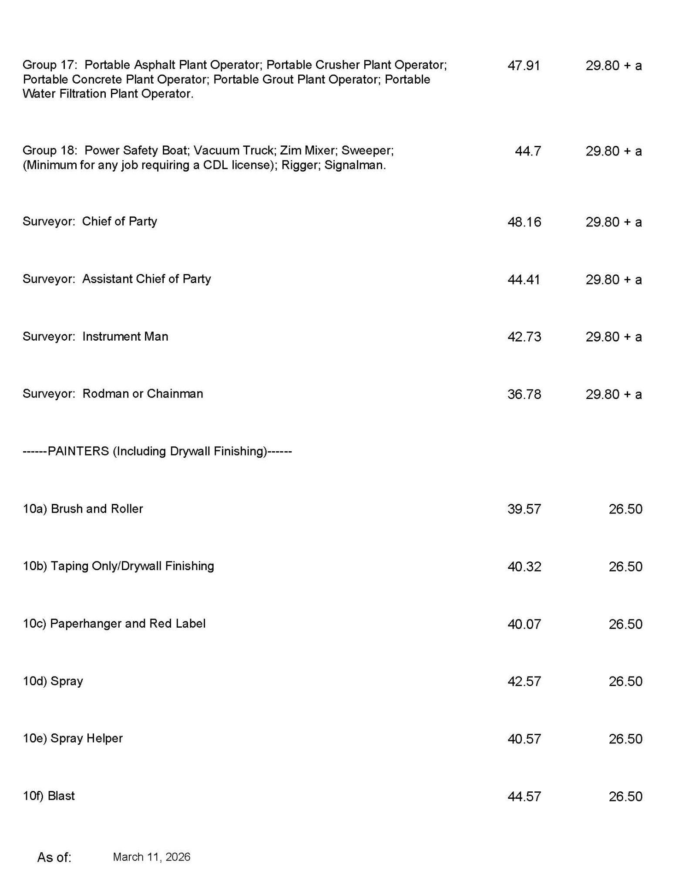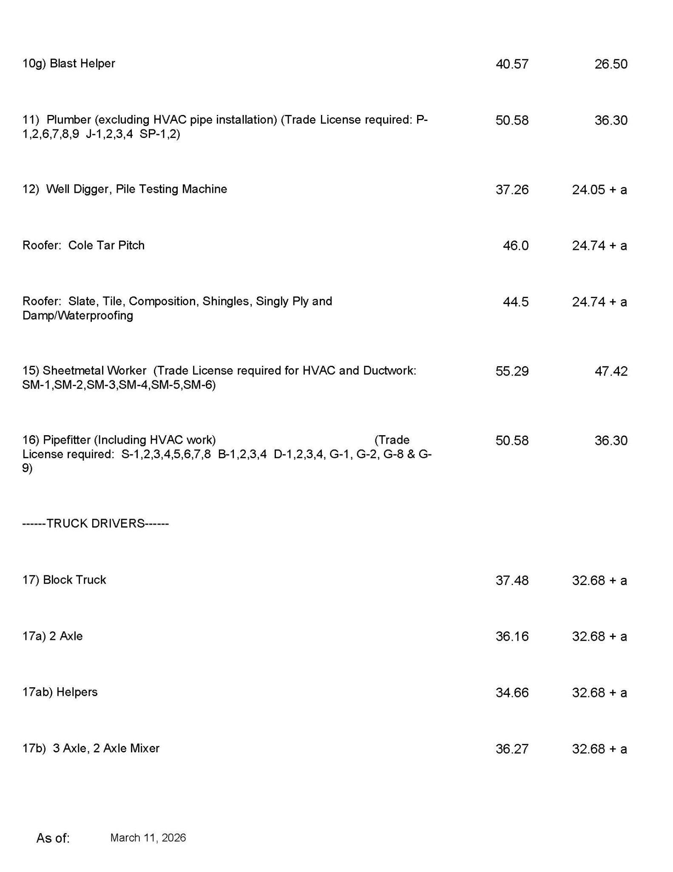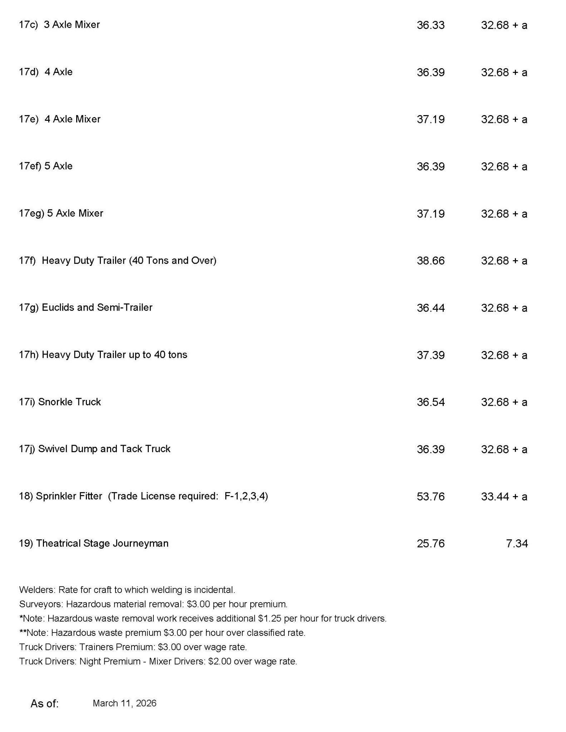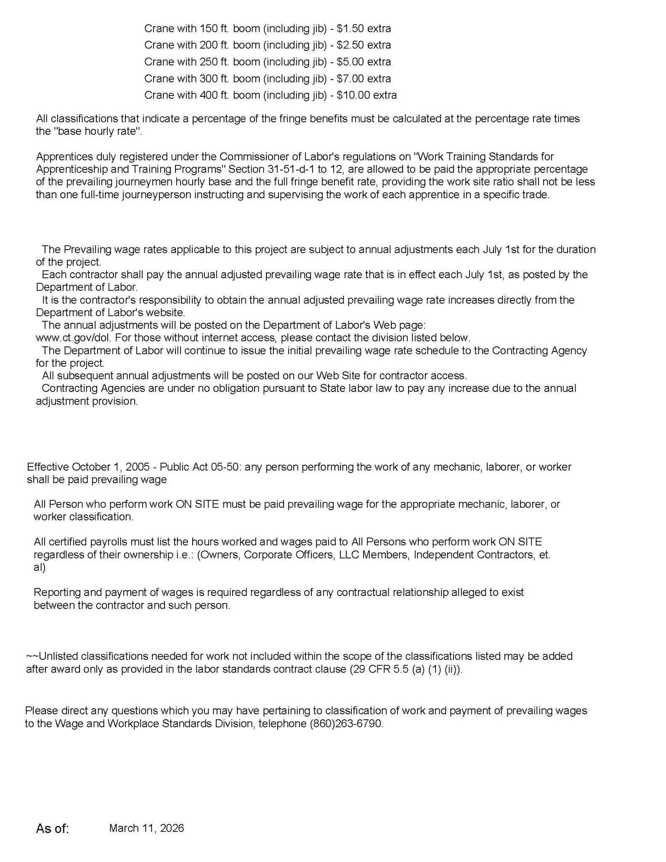
Exhibit J

STATEMENT ON NON-COLLUSION AND OTHER PRACTICES

The undersigned hereby declares to the Board of Education of Regional School District No. 12 (“BOE”) that:

1. This Proposal is made without any connection with any other person or entity making any proposal for the same services, that it has been prepared and submitted in good faith, that it is in all respects fair and without collusion or fraud and that no person acting for or employed by the BOE is directly or indirectly interested in the proposal or in the services to which it relates, or in any portion of the profits therefrom.

2. Contractor hereby declares that the only persons participating in the Proposal as Principals are named in its Proposal Submission and that no person other than those mentioned in its Proposal Submission has any participation in the Proposal or in any contract to be entered into with respect thereto. Additional persons may subsequently be included as participating Principals, but only if acceptable to the BOE.

3. The Contractor’s Proposal Submission is genuine and is not made in the interest of or on behalf of any undisclosed individual or entity and is not submitted in conformity with any collusive agreement or rules of any group, association, organization, or corporation.

4. Contractor has disclosed to the BOE, in writing pursuant to Section 10.05 of the Proposal Documents, any and all Principal(s) of Contractor who are members or employees of the BOE, or the immediate relative of BOE members or employees. For purposes of the above, “immediate relative” means a spouse, parent, stepparent, brother, sister, child, stepchild, direct-line aunt or uncle, grandparent, grandchild, and in-laws by reason of relation.

5. Contractor has not directly or indirectly induced or solicited any other prospective Contractors to submit a false or sham Proposal.

6. Contractor has not solicited or induced any individual or entity to refrain from submitting a Proposal.

7. Contractor has not engaged in corrupt, fraudulent, collusive, or coercive practices in competing for the Contract. For the purposes of this paragraph:
      - “corrupt practice” means the offering, giving, receiving, or soliciting of anything of value likely to influence the action of the procurement process, except as otherwise disclosed to the BOE in writing;
      - “fraudulent practice” means an intentional misrepresentation of facts made (a) to influence the procurement process to the detriment of the BOE, (b) to establish proposal prices at artificial non-competitive levels, or (c) to deprive the BOE of the benefits of free and open competition;
      - “collusive practice” means a scheme or arrangement between two or more Contractors, with or without the knowledge of the BOE, a purpose of which is to establish proposal prices at artificial, non-competitive levels; and
      - “coercive practice” means harming or threatening to harm, directly or indirectly, persons or their property to influence their participation in the procurement process or affect the Contract.

_______________________________
Contractor
By: _______________________________
Signature
_______________________________
Title
_______________________________
Date

STATE OF CONNECTICUT )
) ss.:
COUNTY OF )

Subscribed and Sworn to before me on this _____day of___________, 20__.

_________________________________
Notary Public

