IB CAREER-RELATED PROGRAM
COMMUNITY ENGAGEMENT GUIDE
Skyline High School

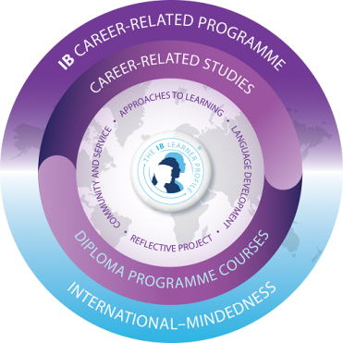

PURPOSE
“The link between service learning and experiential learning becomes evident when students ‘individually, and in association with others, engage in direct encounter, then purposefully reflect upon, validate, transform, give personal meaning to and seek to integrate their different ways of knowing” (McGill, Warner Weil 1898).

“The essence of service learning in the IBCP is experiential learning. Schools should base their service-learning activities on the three stages of the learning cycle.” (www.ibo.org/ibcc).

COMMUNITY ENGAGEMENT GOAL FOR JUNIOR YEAR
Students should complete half their CE requirements by June
- Describe activities thoughtfully with a 4-5 sentence proposal that speaks directly to a few (no more than 2-3) learner outcomes.
- Submit a balanced list of activities related to the students IBCP Career Track
- Complete well-developed reflections that directly address the learner outcomes. See length requirements for reflections on page ___
- Respond to Managebac messages from SL Advisors promptly.
RESPONSIBILITIES
The responsibilities of the school are:
- To liaise with the community to develop a network of Community Engagement contacts and partnerships
- To establish a core group of Community Engagement teachers-mentors
- To make presentations and provide information to students about Community Engagement
- To monitor the progress of students
- To provide feedback to students to help the students achieve their desired goals.

The responsibilities of the student are:
- To determine the nature of their own Community Engagement activities
- To set up an initial meeting with community contacts, after initial consultation with the school’s Community Engagement teacher-mentor
- To plan and manage their own Community Engagement
- To work with the community to achieve predetermined goals
- To reflect on the experience
ASSESSMENT
The nature of the assessment in the Community Engagement Strand of the IBCP core includes:
- Tracking of Community Engagement Hours with Managebac (One-time yearly fee – approximately $20)
- Reflection on Community Engagement experiences through the Managebac
- Presentation in PPS regarding Community Engagement Experiences
- Meetings scheduled with advisors

WHAT IS THE COMMUNITY ENGAGEMENT PROTOCOL?
Step One:
- Log onto Managebac: https://skyline.managebac.com/login
- Select the IB Manager tab and choose CE to begin.
- Your CE Worksheet organizes all your SL activity records in one place.
- Click on Add Engagement Activity.
- How many hours will you devote to your activity? You can estimate if you aren’t sure. You can go back and “Edit” later.
- When are the start and end dates?
- Who will be supervising your work? Remember that you must upload evidence in the form of photos, a log of hours, a website, or other artifacts to prove you did a parent supervised activity.
- Describe your activity and identify your goals in 4-5 sentences. Consider which 2-3 learning outcomes you want to meet in this activity as you set your goals.
Step Two:
- Participate in activity or project and collect evidence (photos, video, flyers, artifacts, etc.).
Step Three:
- Complete Activity or Project Reflection.
- Reflections for activities should be completed shortly after the completion of the activity.
- Reflections for ongoing activities and longer Engagement projects should be completed every two or three months or at the end of each semester.
- Reflections should be directly tied to Engagement Outcomes.
- From your CE Worksheet, click Add New Reflection to provide evidence of your activity. Reflections can encompass written journals and photos, websites, videos and other artifacts.
To guide your reflection, you may consider the following at different stages of an activity (prior to starting, during, and after completion):
- What do you perceive and notice?
- How do you feel being involved in this activity?
- What do you think and feel about the activity itself?
- What does the activity mean to you?
- What value does the activity have?
- What did you learn from this activity, and how might you extrapolate from this to your life more generally?
- What progress are you making towards the goals you set for yourself?
Reflection Requirements:
  - Activity of 9 hours or less: minimum 200 words, or 150 words plus other evidence
  - Activity of 10-50 hours: minimum 350 words, or 250 words plus other evidence
  - Activity of over 50 hours: two separate reflections of at least 250 words, spaced out in time (showing progress over time)
- Once you have completed your activity and submitted your reflections, you can click Request Supervisor Review. NOTE: If you click Request Supervisor Review before you have completed your reflections, the activity will be locked, and you will not be able to add reflections. Finish your reflections first, then request the supervisor review.
Ongoing: Messages between your advisor and you, take place in the Notes section of your CE Worksheet. You will get email notification when your CE Advisor writes you a note. Be sure to respond promptly!

