M.A. Jones Elementary School
Date: February 10, 2026
Time: 4:18pm-5:52pm
Location: Zoom & YouTube

- Call to Order: 4:18pm

- Roll Call
Role | Name | Present or Absent
Principal | Teruko Dobashi | Present
Parent/Guardian | Ayana Dunston | Present
Parent/Guardian | Kathryn Quintyne | Absent
Parent/Guardian | Shyretha Sheats | Present
Instructional Staff | Janni Buggs | Present
Instructional Staff | Cole Pryor | Present
Instructional Staff | Latoya Bostic | Present
Community Member | Melissa Waller | Absent
Community Member | Raquel Hudson | Present
Swing Seat | Krista Verdelotti | Present
**DUNSTON arrived at 4:51PM***
Quorum is met.

- Action Items
  - Approval for Agenda
    - MOTION: Buggs
    - SECOND: Verdelotti
    - RESULTS: Motion passed
  - Approval of Previous Minutes of December 11, 2026
    - MOTION: Bostic
    - SECOND: Hudson
    - RESULT: Motion passed

- Key Takeaways
  - The GO Team approved the FY27 draft budget of approximately $8 million, which aligns with the school's strategic priorities focusing on strengthening foundational instruction, staff capacity, and whole-child support.
  - The school is facing a $300,000 budget reduction compared to the previous year, resulting in staffing adjustments including reduced teacher support positions.
  - The school will maintain 23 K-5 teachers but will restructure some positions, including reducing from two instructional coaches to one and consolidating the STEAM lab from two teachers to one.
  - If enrollment targets are met, the school will receive an additional $100,000 in reserve funds, which would be used to hire two additional teacher tutors and allocate $20,000 for professional development travel.
  - Student attendance has improved by nearly a full percentage point, with kindergarten and 4th grade identified as attendance "hotspots" and Mondays/Fridays having the lowest attendance.

- Discussion Items
  - Budget Development Presentation

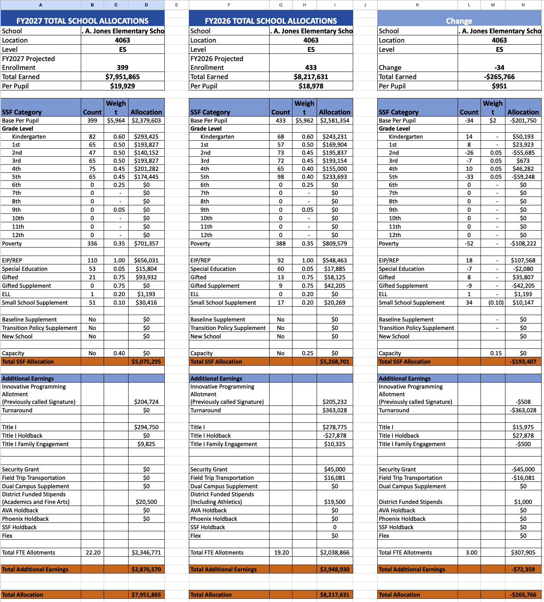
    - 2026-2027 Ranked Objectives
      - 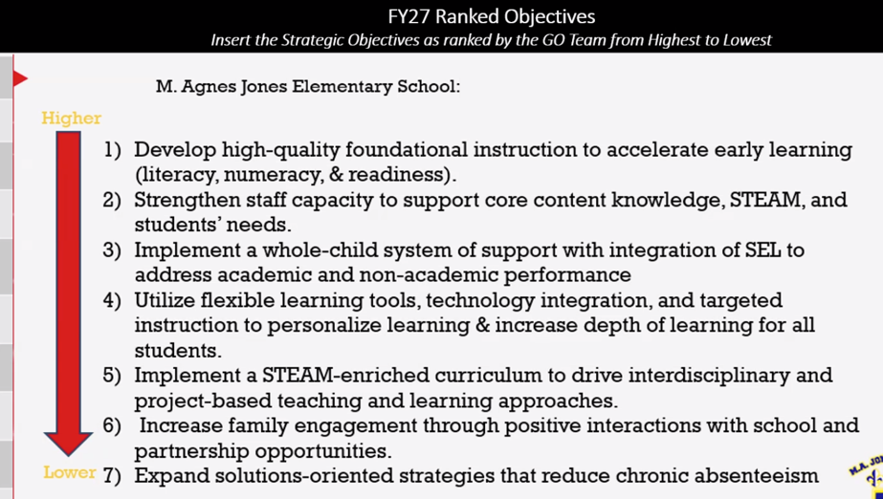
        - Dobashi: Outlined the school's mission to develop strong literacy and numeracy foundations through STEAM instruction and the four strategic goals focused on increasing ELA and math proficiency by 25% by 2030.
        - Dobashi: Presented the ranked strategic objectives, with "developing high-quality foundational instruction to accelerate early learning" as the top priority.
        - Dobashi: Explained that the budget ensures every kindergarten classroom will have a paraprofessional and includes a teacher tutor to support K-2 students.
    - Staffing Allocations: the team discussed the proposed staffing plan for FY27 and the adjustments from the district's baseline recommendations.
      - Dobashi: Explained that the school will maintain 23 teachers as recommended by the district baseline but will redistribute them based on grade-level needs.
      - Pryor: Asked for clarification about the allocation of second-grade teachers.
        - Dobashi: Clarified that while the numbers may look different in how teachers are classified (regular vs. EIP), the total number remains the same.
      - Hudson: Asked about the STEAM lab teacher position, which Dr. Dobashi confirmed would be maintained.
      - Pryor: Asked how the STEAM program would operate with one teacher instead of two.
        - Dobashi: Explained all grade levels would go to one classroom instead of being split into two, with an additional hourly technology lab position maintained.
    - Administrative and Support Positions: the team reviewed administrative and support staff allocations.
      - Dobashi: Explained the school will maintain two assistant principals despite the district baseline of one, with roles divided by grade levels (K-2 and 3-5) and content areas.
      - Verdelotti: Asked about the MTSS (Multi-Tiered System of Support) coordinator being reduced to half-time.
        - Dobashi: Explained that while not ideal, the position could be supported by other staff members to ensure the process continues effectively.
      - Bostic: Asked about the role of the SST interventionist.
        - Dobashi: Clarified that this is the same as the MTSS position, supporting Tier 2 and Tier 3 students.
      - Buggs: Asked for clarification about coaching positions.
        - Dobashi: Confirmed there would be one coach and one master teacher leader, down from two coaches and two master teacher leaders in the current year.
    - Non-Staffing Budget Allocations: Dobashi presented the non-staffing budget allocations and explained the rationale for adjustments.
      - Dobashi: Allocated $10,000 for teacher stipends to support clubs and summer planning, compared to $0 recommended by the district.
      - Dobashi: Increased teaching supplies from the recommended $19,000 to $52,000, noting that while less than the previous year's $80,000, it was necessary for basic operations.
      - Dobashi: Allocated $10,000 for signature program supplies to maintain the school's STEAM initiatives, including care for chickens and aquaponic systems.
      - Buggs: Asked about the number of clubs that could be supported with the stipend allocation.
        - Dobashi: Explained that there would likely be fewer clubs than the current year and that they would evaluate which clubs were actively functioning.
    - Media Specialist Position Discussion: the team discussed the role of the media specialist position in supporting literacy goals.
      - Buggs: Advocated for maintaining the media specialist position, citing district requirements and the importance of having certified staff supporting literacy initiatives.
      - Dobashi: Agreed with the importance of the position but noted it is considered a "flexible" role that could be restructured to better support foundational skills.
      - Verdelotti: Asked about how the gifted teacher and media specialist positions could be leveraged to support early literacy.
        - Teruko: Explained that these certified positions could be utilized differently to provide more direct support to early grades.
    - Reserve Funds Allocation: Dr. Dobashi presented the plan for utilizing the $100,000 in reserve funds if enrollment targets are met.
      - Dobashi: Proposed hiring two additional teacher tutors to expand intervention efforts.
      - Dobashi: Allocated $20,000 for professional development travel to allow teachers to attend conferences and bring back knowledge to share.

- Principals Report
  - Reported current K-5 enrollment at 422 students (459 total including Pre-K).
  - Highlighted improved attendance rates but noted kindergarten and 4th grade as areas of concern.
  - Identified bus safety as a major behavior concern and mentioned discussions about adding a fourth bus route.
  - Shared data from the AMIRA reading assessment showing that intervention efforts are working for beginning readers, but on-grade-level students are not accelerating as expected.
  - Announced that MAP testing would be expanded to include 3-5 grades in March to provide current data for the final weeks of instruction.
  - Shared that the school's basketball team won their recent game and that students had success at the Science and Technology Fair.

- Budget Vote
  - MOTION: Verdelotti
  - SECOND: Bostic
  - RESULT: Motion passed

- Challenges
  - Managing with a $300,000 budget reduction while maintaining essential services and strategic priorities.
  - Supporting the MTSS process effectively with a half-time position instead of full-time.
  - Addressing bus safety concerns and behavior issues, particularly among male students.
  - Accelerating academic growth for on-grade-level students who are not progressing as quickly as expected.
  - Improving attendance rates, particularly in kindergarten and 4th grade and on Mondays and Fridays.

- Action items
  - Dobashi: Present the approved draft budget to the Associate Superintendent and HR staffing conference.
  - Dobashi: Continue discussions with the district about adding a fourth bus route.
  - Pryor & Dobashi: Implement the boy mentoring group initiative to address behavior concerns among male students.
  - Buggs: Share the Georgia School Climate Survey on ClassDojo and initiate robocalls to increase participation.
  - Dobashi: Prepare for the budget finalization meeting on March 12, 2026.
  - ALL: Attend the budget finalization meeting on Thursday, March 12, 2026, at 4:15 PM.
  - ALL: Complete the Georgia School Climate Survey (staff version).

- Upcoming Events
  - February 11, 2026 @5-7pm: Valentine’s Family Formal
  - February 12, 2026 @5pm: MAJ vs Usher Collier Basketball game
  - February 16-20, 2026: Winter Break NO SCHOOL

- Adjournment
  - MOTIONED: Bostic
  - SECONDED: Hudson
  - RESULT: Motion passed

ADJOURNMENT at 5:52PM
--------------------------------------------------------------------------------------------------------------------------
Minutes Taken By: Krista Verdelotti in collaboration with ZOOM AI
Position: Secretary
Date Approved:

