Mission | 2026 STRATEGIC PLAN |  |  | Motto
Together, we cultivate an inclusive and caring community where every learner is supported, challenged, and prepared to thrive in a changing world. | 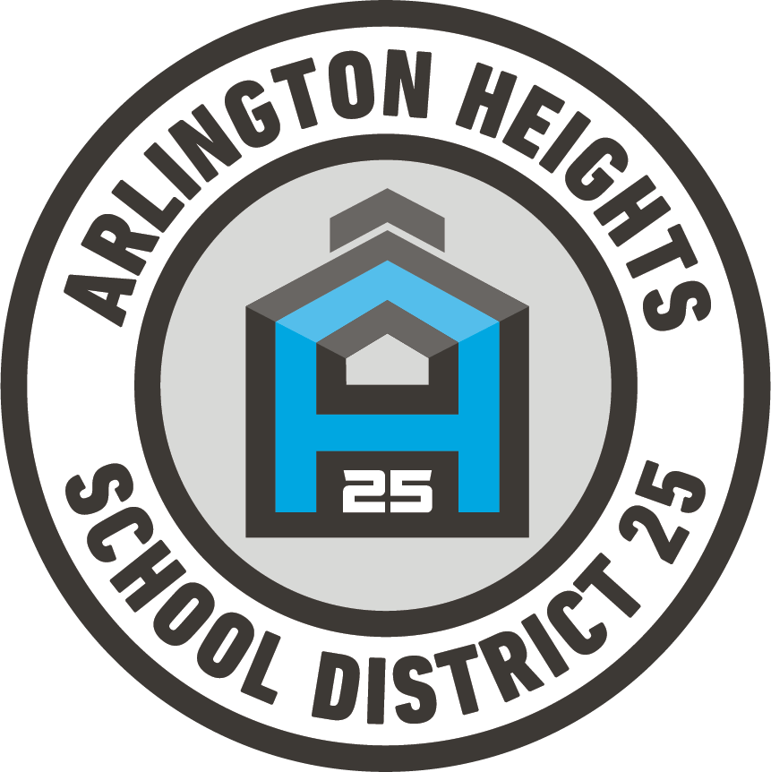 |  |  | Together Today  to  Transform Tomorrow
Vision
We envision a future in which every school ignites curiosity, fosters belonging, fuels joy, and equips every learner to lead with purpose, resilience, and compassion in a changing world. In this future:
- Students lead their learning. They set meaningful goals, think critically, apply knowledge to authentic challenges, and graduate prepared for high school, postsecondary success and engaged citizenship.
- Belonging is systemic, not incidental. Policies, practices, and structures ensure every learner feels seen, valued, and supported in a culturally responsive and inclusive environment.
- Learning reflects the future. Instruction prioritizes collaboration, innovation, adaptability, and real-world application aligned with emerging opportunities and workforce needs.
- Continuous improvement fuels excellence. Educators model curiosity, use evidence with purpose, and innovate relentlessly to ensure meaningful growth for every student, every year.
Core Values
Integrity: We act with honesty, transparency, and strong moral principles, and we take responsibility for our actions and their impact. |  |  | Student Version: I tell the truth, own my choices, and do the right thing, even when no one is watching.
Belonging: We create environments where every person feels valued, respected, and connected. |  |  | Student Version: I include others, embrace differences, and help everyone feel welcome.
Excellence: We pursue high standards, continuous growth, and meaningful achievement in everything we do |  |  | Student Version:  I set ambitious goals, keep improving, and do my best.
Innovation: We think creatively, embrace change, and seek better ways to learn and lead. |  |  | Student Version: I embrace new ideas, learn from mistakes, and look for better solutions.
Empowerment: We equip and trust individuals with the confidence, skills, and agency to lead and make a difference. |  |  | Student Version: I believe in myself and others, speak up, and take initiative.
Graduate Portrait
These competencies define the knowledge, skills, and mindsets every graduate will develop to succeed in school, career, and life.  THINKING SKILLS  - Critical & Creative Thinking - I can think deeply, ask thoughtful questions, and come up with new ideas.  - Problem Solving & Decision-Making - I can find solutions to challenges and make well-informed decisions.  COMMUNICATION & LITERACY  - Collaboration and Communication- I can work well with others, value different perspectives and ensure respectful communication.  - Literacy (Listening, Speaking, Reading, Writing) - I can listen carefully, speak clearly, read with understanding, and write to share my ideas. |  |  | SOCIAL EMOTIONAL SKILLS  - Empathy & Perseverance- I care about others and keep trying even when learning is difficult.  - Responsibility & Accountability I take responsibility for my actions, choices, and learning.  PERSONAL GROWTH  - Self-Awareness & Confidence - I understand my strengths, believe in myself, and continue to grow  - Flexibility & Agility - I can adapt to new situations and stay open to different ideas.
Goal One: Student Achievement
Inspire and prepare every student for a future of purpose, opportunity, and success.  Critical Strategies:  - Curriculum Rigor, Relevance, and Consistency: Implement a standards-aligned curriculum that challenges students while ensuring consistent expectations and real-world relevance across all classrooms. |  | - Personalized and Extended Learning Opportunities: Provide flexible learning pathways, enrichment, and support programs that adapt instruction to each student’s needs and interests.  - Special Education and Advanced Learning Systems: Strengthen systems that identify and support diverse learners by analyzing meaningful assessments and delivering targeted special education services and advanced academic opportunities.
Goal Two: Inclusive Learning Environment
Cultivate welcoming school communities where every student and staff member feels safe, valued, and inspired to thrive.  Critical Strategies:  - Enhance a Consistent, Healthy climate: Implement a clear, school-wide behavior system that promotes positive relationships, consistent expectations, and a safe learning environment for all students. |  | - Increase Student Engagement and Voice through Instructional Innovation & Enrichment: Enhance innovative teaching strategies and enrichment opportunities that actively involve students and deepen their learning experiences.  - Refine our Multi-Tiered Student Support System: Strengthen the MTSS framework to ensure students receive timely, tiered academic and social-emotional supports based on their individual needs
Goal Three: High Quality Staff
Build a culture where talented educators grow, lead, and inspire every learner.  Critical Strategies:  - Strengthen Staff Recruitment, Retention, Development, and Workforce Stability: Build a strong and stable workforce by attracting high-quality staff, supporting professional growth, and implementing strategies that improve retention. |  | - Promote Staff Voice, Climate, and Transparent Communication: Foster a positive workplace culture by encouraging staff input, maintaining open communication, and ensuring transparency in decision-making.  - Advance Staff Diversity, Well-Being, and Inclusive Workplace Culture: Cultivate a diverse, supportive, and inclusive work environment that prioritizes employee well-being and equitable opportunities for all staff.
Goal Four: Family and Community Partnerships
Unite families, schools, and the community to ensure every student thrives.  Critical Strategies:  - Strengthen Communication, Transparency, Education, and Trust with Families & Community. Strive for clear and open communication to assist families feel informed, valued, and connected. When trust is strong, families are better able to support their child’s learning and partner with schools. |  | - Expand and Deepen Family Engagement: Actively involve families in their child’s education. Creating flexible and inclusive ways to engage helps all families feel welcome and able to participate. Make expectation clear and provide tools and support.  - Strengthen Community Partnerships to Support Student Success: Strong community partnerships provide extra support and opportunities for students and families. Partnering helps support the whole child—academically, socially, and emotionally.
Goal Five: Resources
Build lasting stability through transparent, responsible stewardship.  Critical Strategies:  - Ensure Equitable Allocation of Resources and Support Services: Distribute resources and support services strategically to ensure all students and programs receive the support needed to succeed. |  | - Strengthen Financial Planning, Prioritization, and Sustainability: Implement strategic budgeting and long-term financial planning to align spending with district priorities and maintain fiscal stability.  - Strategically Integrate Technological Needs: Expand the thoughtful use of technology, including AI, while improving systems to support reliable, secure, and future-ready learning environments.

