
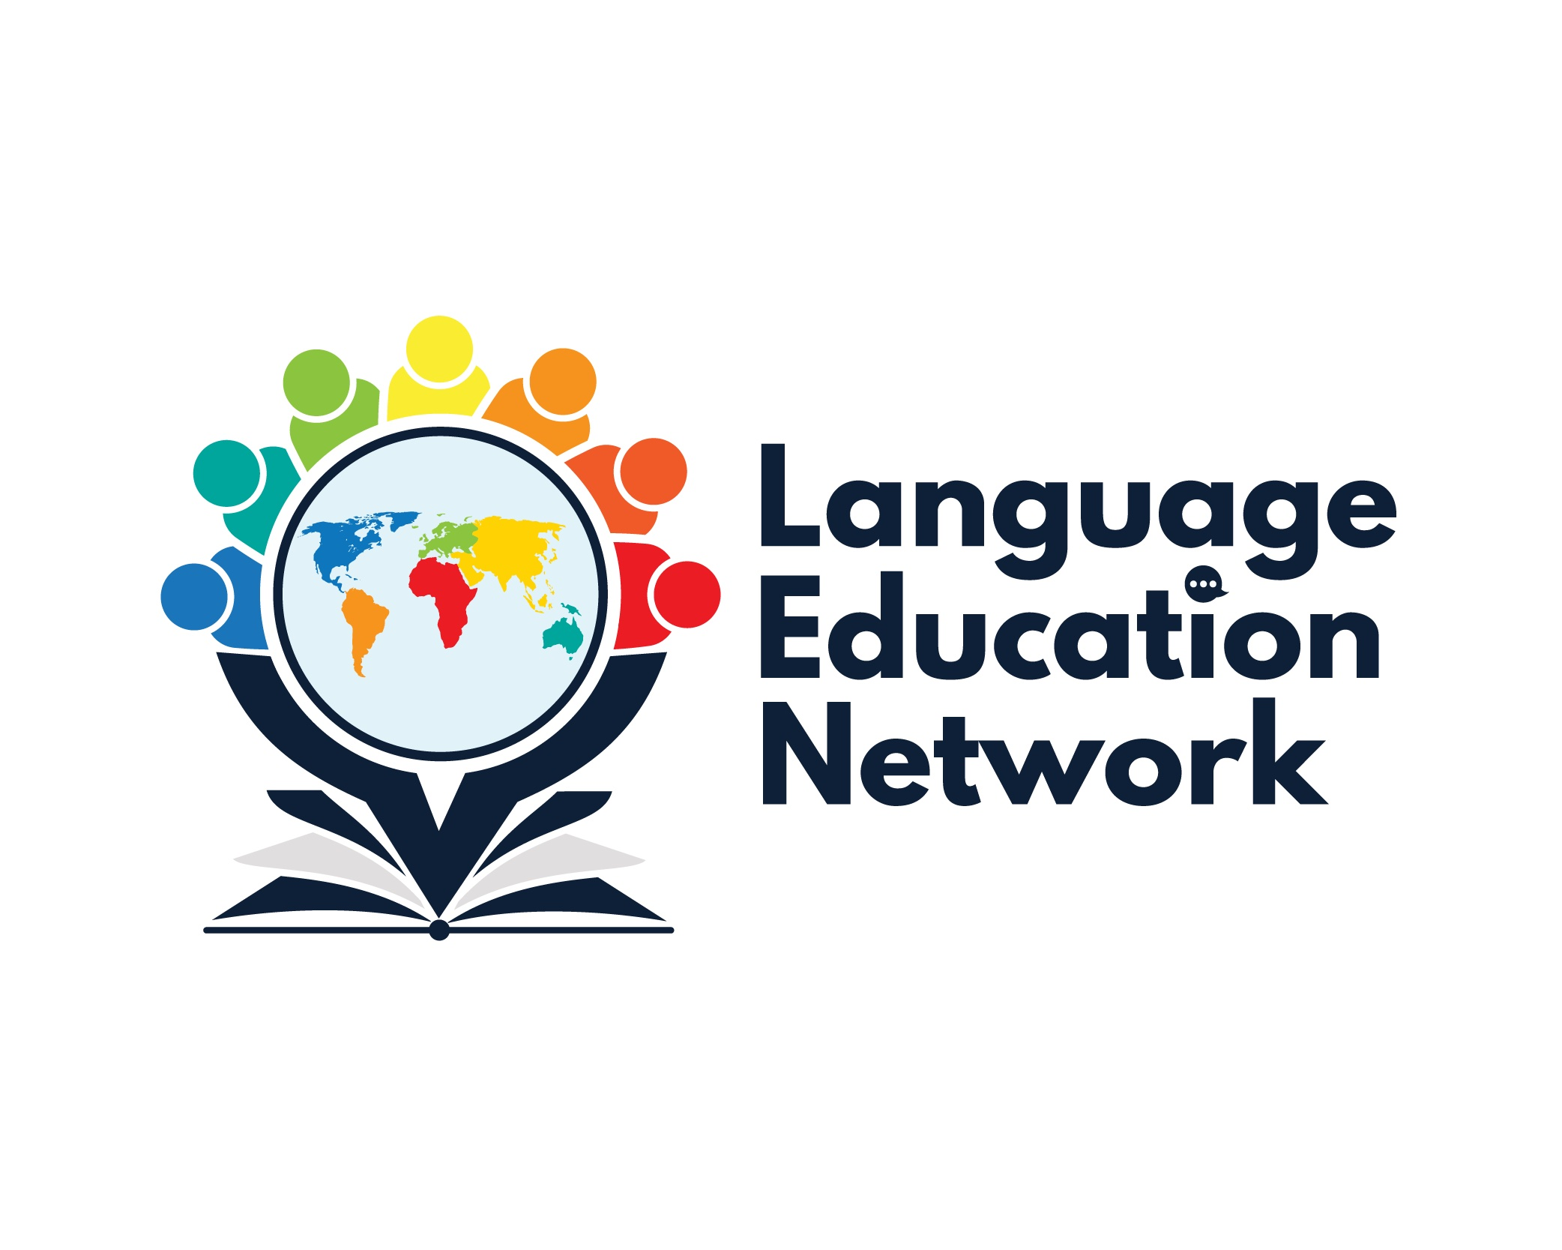
March 20, 2026
12:30 – 3:00 pm
AGENDA
PURPOSE: The purpose of our network is to come together to align current research and policy with the work that is required to prepare our English Learners and Multilingual Students for college and career.
¡BIENVENIDOS!  2025-2026 Meeting Dates | PRESENTATION SLIDES  Facilitators:  Carlos Pagán: cpagan@sbceo.org  Melissa Garcia: mgarcia@sbceo.org
  September 26, 2025  December 5, 2025 | March 20, 2026  May 8, 2026

SECTION | TOPIC | LINKS & RESOURCES
1: (12:30 – 12:45) | LUNCH (12:15-12:45)  Introductions & Activity | Language Education Network (LEN) Webpage
2: (12:45 – 1:15) | - Bilingual Authorization Program  - Program Evaluation  - Cohort III  - Accreditation Process (2026-2027)  - Advisory Committee | Bilingual Authorization Program (BAP) Information Sessions
3: (1:15-2:00) | - Summative ELPAC  - LEA Coordinator Checklist  - Site Coordinator Checklist  - California Literacy Content Blocks | CAASPP & ELPAC Website  LEA Coordinator Checklist  Site Coordinator Checklist  California Literacy Content Blocks
BREAK 2:00-2:10
4: (2:10– 2:40) | - BCN Updates  - P-3 Guide to Supporting Multilingual Learners Toolkit | P-3 Guide to Supporting Multilingual Learners Toolkit
5: (2:40-3:00) | - Professional Learning Opportunities  SAVE THE DATE  - DLI Institute (June 15-16, 2026; 8:00am-3:00pm- VCOE & SBCEO)  - Guided Language Acquisition Design (GLAD) in Spanish  Dates: April 6th, 8-10th, 13th, 2026  Locations: El Camino Elementary &  SBCEO  - AI & Language Development  ELPAC 101 for Teachers  Student Events in Spanish  - Batalla de los libros (May 14, 2026) | DLI Topics:  - GLAD (en español) Strategies – ALAS (VCOE)  - Dr. Tara Yosso – Cultural Wealth Model (DLI Pillar- Sociocultural Competence) (SBCEO)  Guided Language Acquisition Design (GLAD) in Spanish  AI & Language Development  ELPAC 101 for Teachers (K-5)  ELPAC 101 for Teachers (6-12)

2026-2027 LEN FIRM AND TENTATIVE DATES:

September 25, 2026 (firm)
December 4, 2026 (firm)
March 12 or 19, 2026
May 14, 2026 (tentative)

