

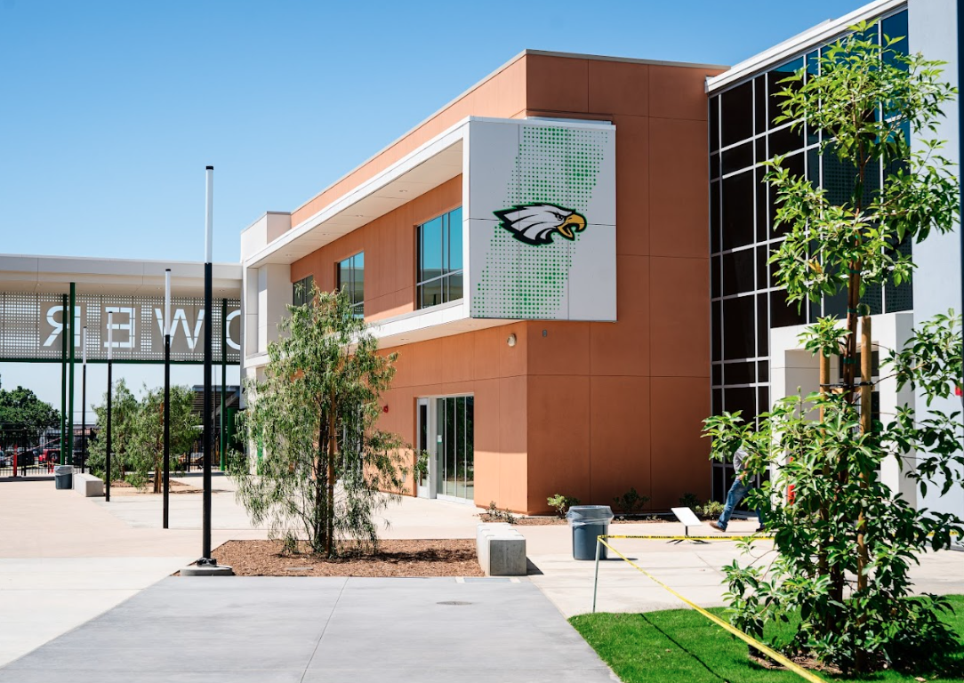
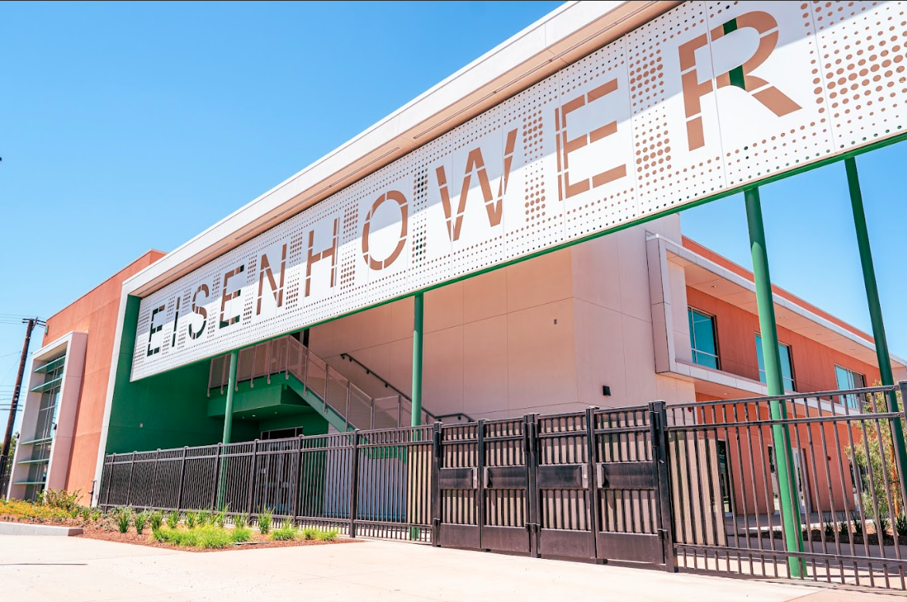
Y
2024-2025
Citizens’ Bond Oversight
Committee Annual Report
Measure Y & A

2020-2021 & 2021-2022
Citizens’ Bond Oversight Committee Annual Report
Measure Y

Committee Statement

The mission of the Rialto Unified School District, the bridge that connects students to their aspirations for the future, is to ensure each student achieves personal and career fulfillment within a global society, through a vital system distinguished by:
- High Expectations for student achievement
- Safe and engaging learning environments
- Effective family and community involvement
- Learning opportunities beyond the traditional school setting
- Appreciation of universal diversity

The Citizens’ Bond Oversight Committee continues to be committed to mission of the school district by ensuring the use of Measure Y and Measure A Bond proceeds have been spent in accordance with the scope of Measure Y approved in 2010 by the electorate and Measure A in 2022. This report covers Measure Y and Measure A expenditures and activities from July 1, 2024, through June 30, 2025.

The Measure Y and Measure A Citizens’ Bond Oversight Committee (Committee) is pleased to submit its annual report, as required by Section 15280 of the Education Code.

Your Citizens’ Bond Oversight Committee

Position | Category | Name
Member | Business Organization | Mr. Jack Carroll
Member | Senior Citizens' Organization | Mr. John Peukert
Vice Chair | Parent or guardian of a child enrolled in the school district | Ms. Paula Bailey
Member | Both a parent or guardian of a child enrolled in the school district and active in a parent teacher organization | Ms. Mirna Ruiz
Chair | Bona fide taxpayers' organization | Ms. Michelle Sanchez
Member | Member at Large | Ms. Brenda Asta
Member | Member at Large | Ms. Connie Buge
Member | Member at Large | Ms. Pauline Tidler
Member | Member at Large | Dr. Scott Sparks

Measure Y Background

On November 2, 2010, the Rialto community approved the Measure Y General Obligation Bond for $98 million to finance school facility construction, repair and improvement projects. The bond proceeds were to improve the quality of education and it authorized the District to acquire, construct and improve classrooms and support facilities, provide career and technical classrooms, including science labs, to enhance preparation for college and careers, replace portable facilities with permanent classrooms, and increase student access to modern technology, by issuing $98,000,000 in bonds. Measure Y required an independent Citizens' Oversight Committee, annual financial and performance audits, and a provision that no funds were to be used for administrators. The bonds were sold through four different series, Series A & B in 2011, Series C in 2015 and Series D in 2019.

Measure A Update

On November 8, 2022, the Rialto community approved the Measure A General Obligation Bond for $340 million to upgrade school fire/security/safety systems, science, engineering, math, arts, vocational classrooms; replace drinking water pipes, gas lines, leaky roofs, portable classrooms, electrical wiring, remove asbestos, lead paint, mold by issuing the $340 million in bonds. Measure A also requires an independent Citizens' Oversight Committee, annual financial and performance audits, and has a provision that no funds were to be used for administrators. The bonds will be sold over a series of issuance, the first being issued in July 2023.

The District will continue to use one Citizen Oversight Committee to monitor the activity of both Measure Y and Measure A.

Bond Expenditure Report

Measure Y and Measure A require an annual financial and performance audit. Eide Bailly, LLP conducted the 2024-25 audit and concluded that Rialto Unified School District complies with the requirements to expend bond proceeds on school facilities projects specified in Measure Y and Measure A.

On page 4 is a summary of expenditures for the 2024-2025 school year for General Obligation Bond Measure Y.

On page 6 is a summary of expenditures for the 2024-2025 school year for General Obligation Bond Measure A.

Bond Expenditure Report
Summary of Expenditure Report

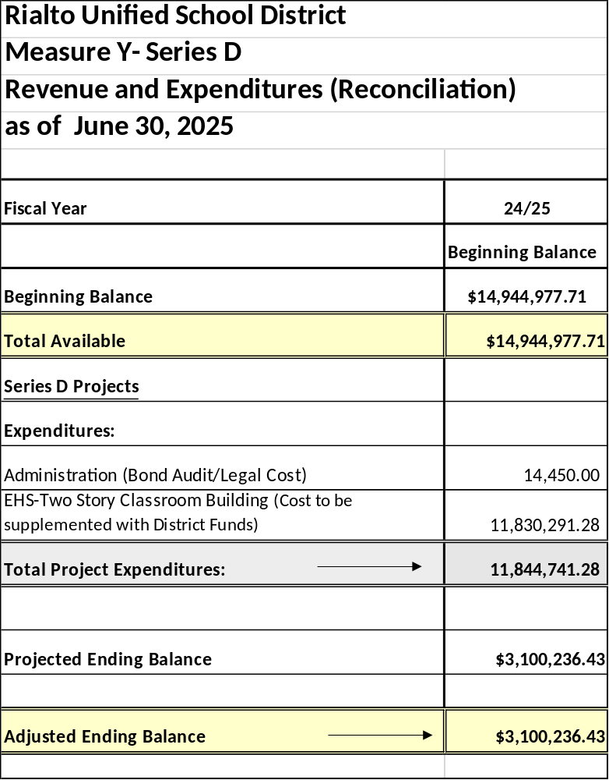
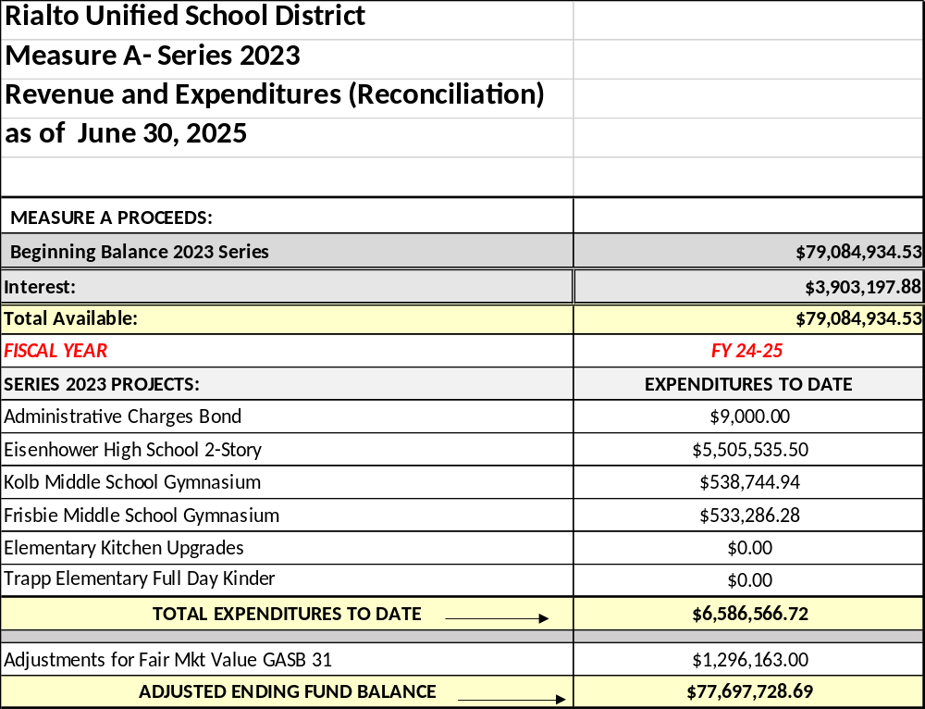

Highlights of 2024-2025 Projects

Completion of EHS Two2 Story Buildings/ Design of New Gyms at Kolb & Frisbie Middle School

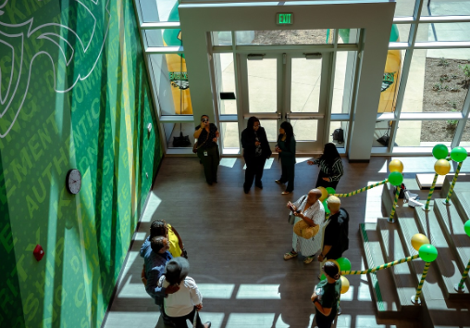

Highlights of Projects

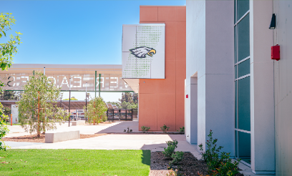

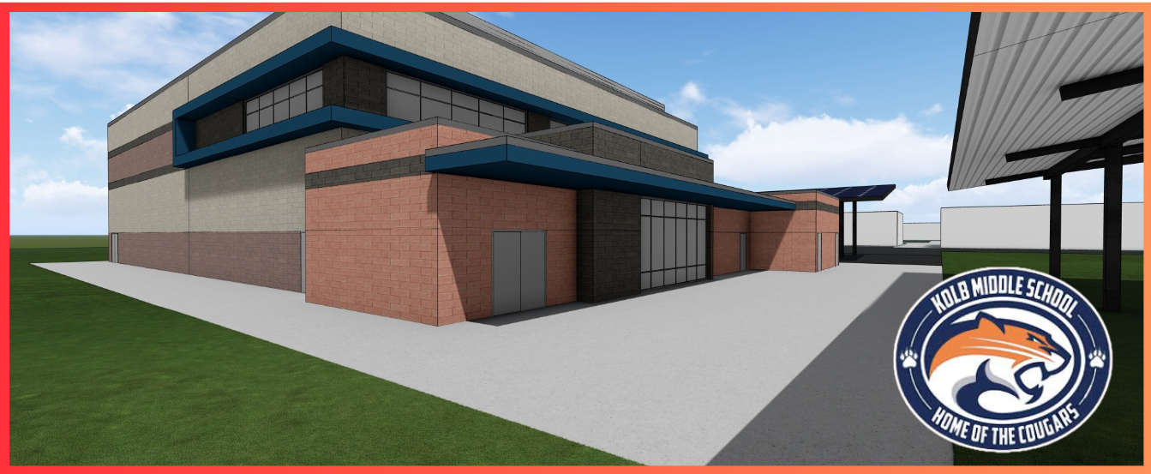

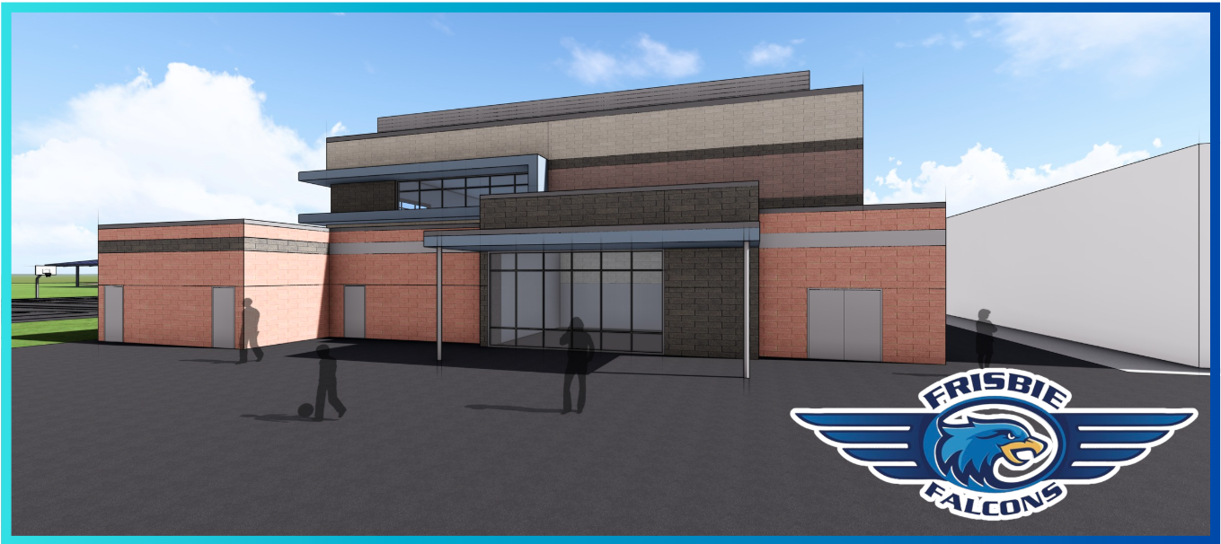
Frequently Asked Questions

What is a general obligation bond?

A General obligation (G.O.) bond is a type of municipal borrowing commonly used by school districts. G.O. bonds are financed through an increase in local property taxes and can be used for renovating, reconstructing, and building new facilities and for acquiring certain new equipment. Voters must approve the G.O. bond during an election with at least 55% approval. Under Rialto’s Measure Y G.O. Bond, the district can only levy taxes of up to $60 per $100,000 of all taxable property located within the District’s boundaries- residential, commercial, agricultural and industrial.

Why is the Citizens’ Bond Oversight Committee important?

Education Code Section 15278 requires the District to form a committee of local residents, whose main charge is to inform the public about how the bond dollars are being spent. The committee, known as the Citizens' Bond Oversight Committee, monitors the progress of projects and reviews report to ensure bond funds are spent in accordance with the Bond language. The committee is comprised of volunteers who represent specific constituencies, such as senior citizens, parents, businesses, or the community-at-large. This additional oversight is important because the community approved the additional property taxes to be reinvested in their local schools.

Does the Citizens’ Bond Oversight Committee review each expenditure?

No, a summary of expenditures is presented to them at each reporting period. However, each year the fund must have a performance and financial audit, through which over 70% of the transactions are reviewed. The audit verifies expenditures are allowed by bond language and that the financial status of the funds is presented accurately. The Citizens’ Bond Committee is responsible for reviewing the audit and present this information in its annual report.

Does the Citizens’ Bond Oversight Committee review the actual projects?

The committee can request to visit the projects to appreciate firsthand the improvements at the schools. It is the responsibility of District’s Facilities service area to monitor the progress and completion of projects.

Do Bond proceeds pay for the salaries in the Facilities service area?

No, bond proceeds cannot be used to pay for any salaries, pensions or benefits in the Rialto Unified School District.

How much does a bond issue cost a Rialto Unified School District community member?

Each bond issuance generates a tax based on the property value. Rialto Unified has two outstanding bond issuances. Under the 2010 Measure Y a taxable property owner may pay up to $63.98 per $100,000 of property value and under the 2022 Measure A a taxable property owner may pay up to $11.29 per $100,000 of property value. An example is provided to illustrate the additional property tax. On the sample provided, the Total Assessed Value is $256,110, which would be reduced by the Homeowner’s Exemption of $7000 to $249,110.

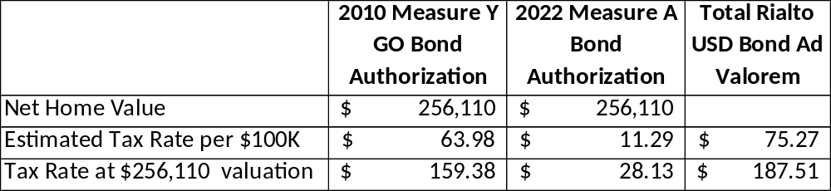

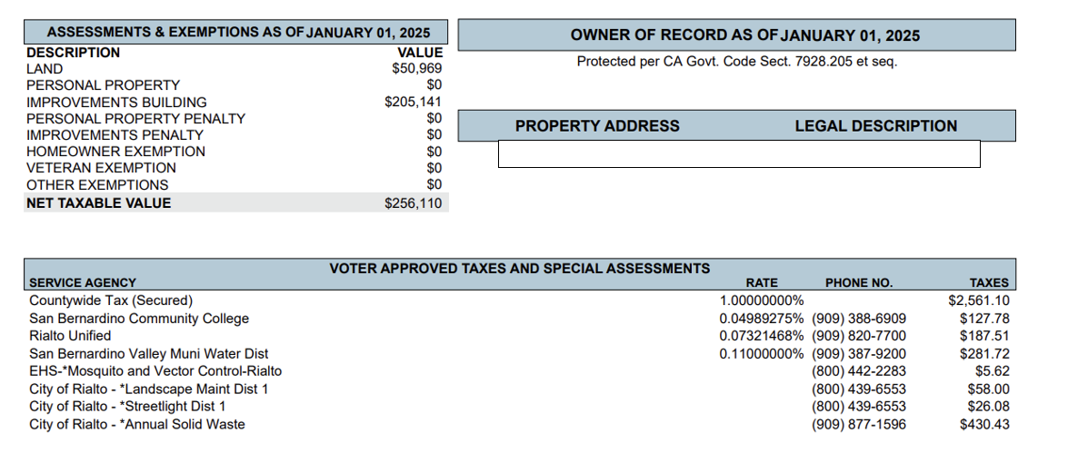

If you would like more detailed information, you can request a secured tax bill detail from the Tax Collector’s Office.

I don’t have children in the school; how does the bond measure benefit me?

A bond measure gives the school district the ability to construct new facilities, improve classroom and building, bringing 21st Century learning into the classroom. Improved facilities has an immediate positive impact on the quality of education but it also helps the local economy, local property values, traffic flow and safety. An improved quality of education will lead to a better-skilled workforce in the future.

When does the Citizens’ Bond Oversight Committee meet and can members of the public attend?

The Citizens’ Bond Oversight Committee meets quarterly. The meeting schedules, agenda, meeting minutes and reports are posted on the Rialto Unified School District’s website.

How can I get additional information?

Additional information and project updates can be found on the CBOC webpage at https://kec.rialto.k12.ca.us/Page/4787 . You may also contact Facilities Planning at (909) 421-7555.

