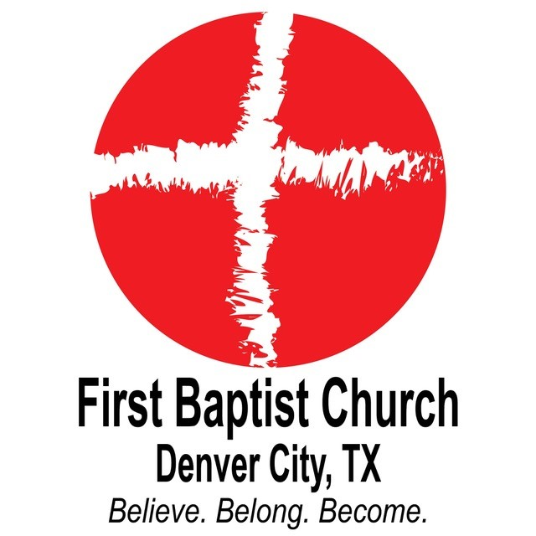
Educational Scholarship Application from
First Baptist Church – Denver City

Guidelines for Eligibility
and Awards

- Graduating senior of Denver City High School.
- Applicant should be an active member of a local church. (not necessarily FBC)
- Applicants will be considered on the basis of service in their church (50%), financial need (30%), and community service/extracurricular activities (20%).
- Applications must be thoroughly completed to be considered.
- Applications must be received by First Baptist Church no later than April 30, 2019.
- Applicants must consent to a personal interview by members of the committee if requested to do so.
- Scholarship recipients are responsible for notifying First Baptist Church immediately if changes affecting information in the application occur prior to the beginning of the academic year in which the scholarship will be applied.
- Scholarship funds will be paid directly to the awardees with proof of enrollment.
- All information in the application will be maintained as personal and confidential except for the non-financial information that may be shared during awards presentations.
- You may refer any questions regarding the program to Sandy Poe or any other member of the Scholarship committee listed below:

  - Youth Pastor – John Michael Alvarado

  - Stephen Benningfield
  - Melisa Dorsett

Application for
First Baptist Church Educational Scholarship
(For High School Seniors)

Part 1: General Information
(Please print clearly or type)

Name in Full:

Home Address:

Home Phone Number:

Name of High School currently
attending:

What college/university will
you be attending?

When will you begin to
attend this institution?

Part II Church Service:

- When did you first begin attending your church?
- Please list ALL church activities in which you have participated. Include all activities you were associated with at any age, e.g. drama, music, teaching/assisting in Sunday school/nursery programs, youth group, mission trips, boards you have served on, etc.
Activity | Dates | Comments
- Do you attend church services and/or activities on a regular basis? (This will be validated with your Youth pastor)
Yes No
Please elaborate:

- Share with us significant steps of Christian growth that you have experienced. (You may continue on a separate sheet if necessary OR attach a typed response if preferred)

Part III: Outside Activities

Please attach a copy of your resume OR complete the table below by listing any non-church related activities in which you participate (e.g. clubs, National Honor Society, after school employment, athletics, volunteer work, etc.) Please list the number of hours (on average) you spend each week at these activities in the years in which you have participated.

Name of Activity | Time spent per week | Comments | Dates of Participation

Part IV: In 250 words or less, write an essay telling the scholarship committee how this scholarship would benefit you and your college career.

Part V: Financial Overview
** The Scholarship Committee will keep the following information strictly confidential.**

- Sibling Information:
Sibling Name | Age | School Attending | Year in School

- Family Annual Income: Please have your parents check the range that is appropriate.
Under $50,000
$50,000 - $75,000
$75,000 - $100,000
$100,000 - $150,000
Over $150,000

- What scholarships/grants/financial aid have you been awarded?
Name of Scholarship/Sponsor | Amount of Award | Is this a continuing award or a one-time award?

- What OTHER scholarships have you applied for?
Name of Scholarship/Sponsor | Amount of Award | Is this a continuing award or a one-time award?

- What are your anticipated total expenses for the next academic year, including tuition, room & board, books, etc.

- How much will your family contribute to your tuition?

- How much will you contribute to your tuition/books/etc?

Part VI:
List any factors – financial or otherwise – that you feel should be taken into account by the committee reviewing this request. Attach a separate document if necessary.

I have read and understand the guidelines for eligibility and receiving an award. To the best of my knowledge the information I have provided is true and accurate. I authorize the release of this information to the members of the Scholarship Committee.

Signature:

Print Name:

Date:

The entire completed scholarship application must be received by:

Please turn in applications to
Stacie Robles at the high school
or to the FBC Office no later than:
Wednesday, April 30th, 2026

First Baptist Church
Scholarship Committee
519 W. 4th Street
Denver City, TX 79323

If you have any questions, please contact Sandy Poe at (806) 592-3130.
LATE APPLICATIONS MAY NOT BE CONSIDERED.

