AIA- Concussion Acknowledgement Form

Arizona Interscholastic Association, Inc. Mild Traumatic Brain Injury (MTBI) / Concussion Annual Statement and Acknowledgement Form

I, ____________________________ (student), acknowledge that I have to be an active participant in my own health and have the direct responsibility for reporting all of my injuries and illnesses to the school staff (e.g., coaches, team physicians, athletic training staff). I further recognize that my physical condition is dependent upon providing an accurate medical history and a full disclosure of any symptoms, complaints, prior injuries and/or disabilities experienced before, during or after athletic activities.

By signing below, I acknowledge:
• My institution has provided me with specific educational materials including the CDC Concussion fact sheet (http://www.cdc.gov/concussion/HeadsUp/youth.html) on what a concussion is and has given me an opportunity to ask questions.
• I have fully disclosed to the staff any prior medical conditions and will also disclose any future conditions.
• There is a possibility that participation in my sport may result in a head injury and/or concussion. In rare cases, these concussions can cause permanent brain damage, and even death.
• A concussion is a brain injury, which I am responsible for reporting to the team physician or athletic trainer.
• A concussion can affect my ability to perform everyday activities, and affect my reaction time, balance, sleep, and classroom performance.
• Some of the symptoms of concussion may be noticed right away while other symptoms can show up hours or days after the injury.
• If I suspect a teammate has a concussion, I am responsible for reporting the injury to the school staff.
• I will not return to play in a game or practice if I have received a blow to the head or body that results in concussion related symptoms.
• I will not return to play in a game or practice until my symptoms have resolved AND I have written clearance to do so by a qualified health care professional.
• Following concussion the brain needs time to heal and you are much more likely to have a repeat concussion or further damage if you return to play before your symptoms resolve.

Based on the incidence of concussion as published by the CDC the following sports have been identified as high risk for concussion; baseball, basketball, diving, football, pole vaulting, soccer, softball, spiritline and wrestling.

I represent and certify that I and my parent/guardian have read the entirety of this document and fully understand the contents, consequences and implications of signing this document and that I agree to be bound by this document.

Student Athlete:
Print Name: ____________________________ Signature: ______________________________ Date: ___________ Parent or legal guardian must print and sign name below and indicate date signed:

Print Name: ____________________________ Signature: ______________________________ Date: __________
FORM 15.7-C 06/2015

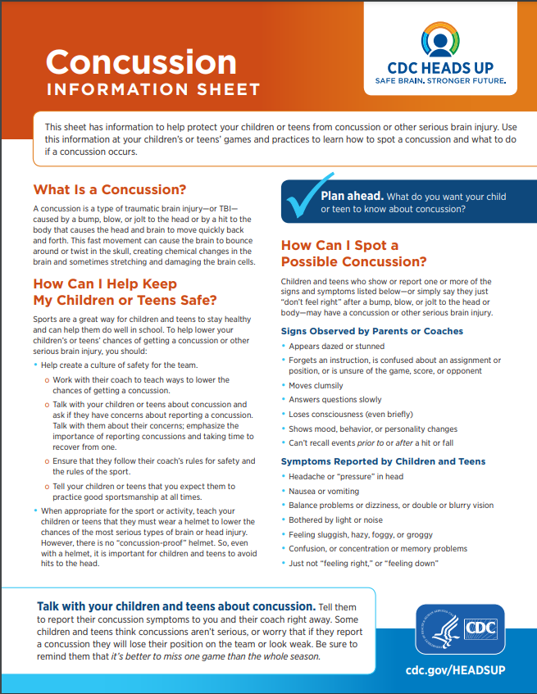
CDC Heads Up Information Sheet - English

