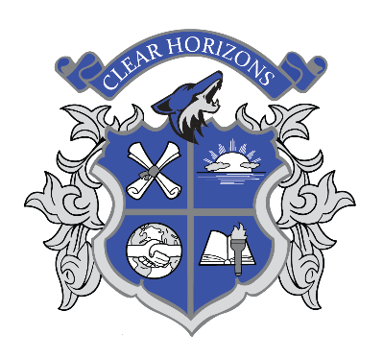

Clear Horizons
Early College
High School
Clear Creek Independent School District

Class Schedule

Time | A Day  (M, W) | B Day  (T, Th)
8:00 – 8:25 | Advisory
8:35 – 10:00 | Period 1 | Period 5
10:10 – 11:35 | Period 2 | Period 6
11:45 – 1:10 | Period 3 | Period 7
1:15 – 1:50 | Lunch
1:55 – 3:20 | Period 4 | Period 8

A/B Early Release  (Fridays) |  |  | Friday A Day Early Release |  |  | Friday B Day Early Release
Time | Class |  | Time | Class |  | Time | Class
8:00 – 8:15 | Advisory |  | 8:00 – 8:15 | Advisory |  | 8:00 – 8:15 | Advisory
8:20 – 8:50 | Period 1 |  | 8:20 – 9:25 | Period 1 |  | 8:20 – 9:25 | Period 5
8:55 – 9:25 | Period 2
9:30 – 10:00 | Period 3 |  | 9:30 – 10:35 | Period 2 |  | 9:30 – 10:35 | Period 6
10:05 – 10:35 | Period 4
10:40 – 11:10 | Period 5 |  | 10:40 – 11:45 | Period 3 |  | 10:40 – 11:45 | Period 7
11:15 – 11:45 | Period 6
11:50 – 12:20 | Period 7 |  | 11:50 – 12:55 | Period 4 |  | 11:50 – 12:55 | Period 8
12:25 – 12:55 | Period 8
1:00 – 1:25 | Lunch |  | 1:00 – 1:25 | Lunch |  | 1:00 – 1:25 | Lunch

