
419 FM 3168, Raymondville, Texas 78580
Phone: (956) 689-8175 ● FAX: (956) 689-8180 – Business Office

January 10, 2024

RFP 22-028 – ADDENDUM #2

Consulting Services-Pertaining to Child Nutrition

This addendum modifies the original document as listed below and is hereby incorporated to the bid documents. Acknowledge receipt of this addendum by returning the completed and signed form with the solicitation response. Failure to submit the addendum may be used as an evaluated factor.

CHANGE:

Raymondville ISD awarded Walker Quality Services to their current RFP# 22-028 Consulting Services-Pertaining to Child Nutrition with an extension clause for up to (2) two additional years.
The current term expires on December 12, 2023

Raymondville ISD and Walker Quality Services have agreed to extend RFP# 22-028 Consulting Services-Pertaining to Child Nutrition for (1) one additional year. New term date ends on December 10th, 2024.

Raymondville ISD and Walker Quality Services have agreed to extend RFP# 22-028 Consulting Services-Pertaining to Child Nutrition for (1) one additional year. New term date ends December 9th, 2025.

The RFP extension is meant to extend the submission term date for 1 additional year. This extension will help ensure that our bid remains active for the new term date.

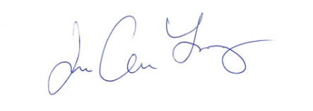

________________________
Joe A. Lopez
Purchasing Coordinator

Vendor Acknowledgement:

_____________________________________
Company Name

_____________________________________
Address

_____________________________________
City State Zip

_____________________________________
Signature

_____________________________________
Title

