
419 FM 3168, Raymondville, Texas 78580
Phone: (956) 689-8175 ● FAX: (956) 689-8180 – Business Office

February 11, 2025

RFP 23-027 – ADDENDUM #1

Property & Casualty Insurance

This addendum modifies the original document as listed below and is hereby incorporated to the bid documents. Acknowledge receipt of this addendum by returning the completed and signed form with the solicitation response. Failure to submit the addendum may be used as an evaluated factor.

CHANGE:

Raymondville ISD awarded Carlisle Insurance to their current RFP# 23-027 Property & Casualty Insurance with an extension clause for up to (2) two additional years. The current term expires Feb
11, 2025

Raymondville ISD and Carlisle Insurance to their current RFP# 23-027 Property & Casualty Insurance for (1) one additional year. The new term date ends February 10, 2026.

The RFP extension is meant to extend the submission term date for 1 additional year. This extension will help ensure that our bid remains active for the new term date.

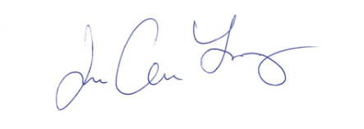

________________________
Joe A. Lopez
Purchasing Coordinator

Vendor Acknowledgement:

_____________________________________
Company Name

_____________________________________
Address

_____________________________________
City State Zip

_____________________________________
Signature

_____________________________________
Title

