Steps to View 2026-27 Course Requests

All change requests must be made before
11:59 PM on Wednesday, March 11th, 2026.

- Login to Classlink or the Parent Portal.
- Click on Infinite Campus – Student
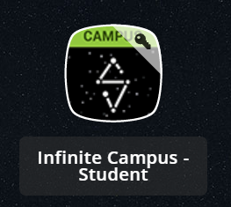
- Scroll down all the way on the left side menu and click on “Academic Plan.”
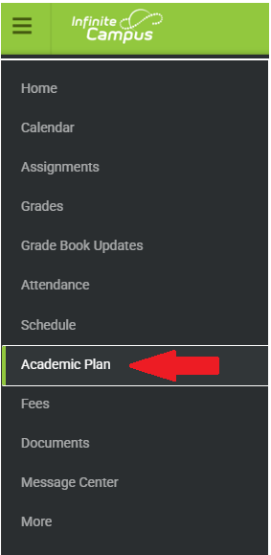
- Then click on “Next.” You can leave the “Post Grad Location” and “Post Grad Plans” blank.
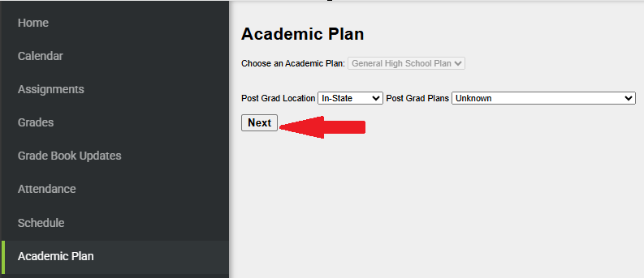

- Look in your upcoming grade level column. There, you will see your courses for “A” Semester (1st Semester) and “B” Semester (2nd Semester) for next school year (2026-27).
  - You should see at least 8 classes (16 for A and B semesters together). If you do not have a total of 8 classes, please contact your counselor.
  - This is not a schedule. These are the courses that will be used to build the 26-27 SY schedule. Courses are anticipated courses and will be scheduled based on staff and course availability.
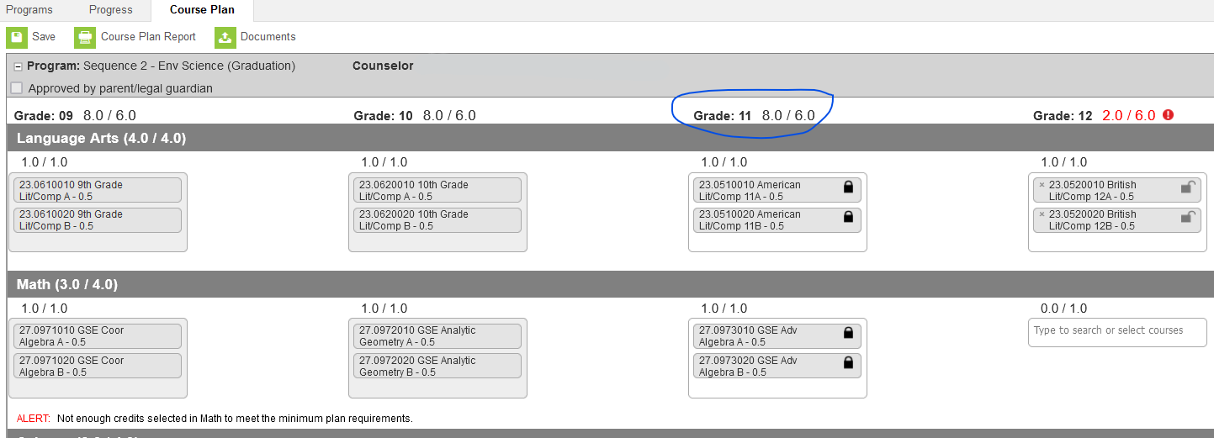
Criteria for Change Request Approval

We will only make changes based on the following reasons:
- Student has not successfully completed a prerequisite course (the level prior; for instance, you are scheduled for Spanish II, but you have not successfully completed Spanish I).
- Student is in a class he/she has already passed and received credit for.
- Student wishes to take a class at a different level of rigor (for instance, you are in a regular class, and you wish to take an Advanced Placement class or vice versa).

If your student wishes to take a different elective. Please understand that elective changes are subject to course availability. Therefore, if space does not permit, we will not be able to make the change.

For elective change requests select the link below for your home school. Links will not be available until Friday, March 6th, 2026.

Heritage High School Rising 9th Course Change Request

Heritage High School Rising 10-12th Course Change Request

Rockdale County High School Rising 9th – 12th Course Change Request

Rockdale Magnet School Rising 9th – 12th Course Change Request

Salem High School Rising 9th – 12th Course Change Request

RVC Course Change Request – please email the RVC Counselor Ms. Shonnon Buggs – sbuggs@rockdale.k12.ga.us

All change requests must be made before 11:59 PM on
Wednesday, March 11th, 2026.

There will be no change requests accepted after March 11th, 2026.

