Wood Technology
Iroquois Senior High School
Barker

This 20-week Wood Technology course is designed to introduce high school students to the fundamentals of woodworking, providing a hands-on experience in a well-equipped shop environment. The course aims to develop students' skills in wood craftsmanship, machine operation, and project design while emphasizing safety and problem-solving.

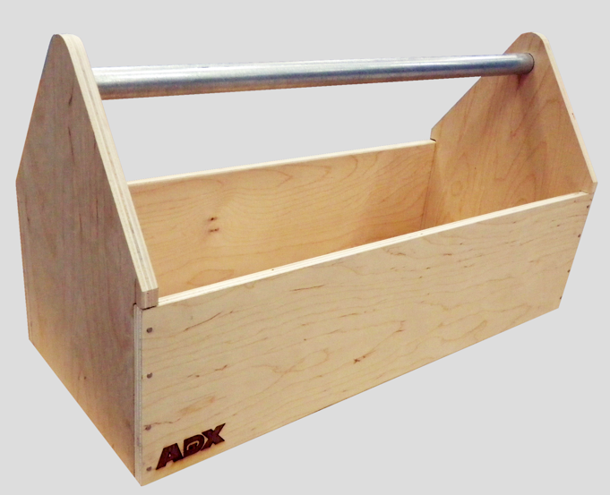
Project 1: Toolbox (Plywood)
- Mitersaw, Table Saw, Scroll Saw, Band Saw, Sander
- Plywood, Dowels, Wood Glue, Screws/Nails
- Hand Saw finger joints (extra)

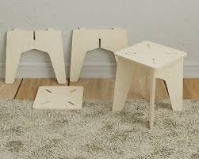
Project 2: Small Stool (For Kids) (Plywood)
- Jig Saw, Scroll Saw, Drills, Sanders
- Poly finish

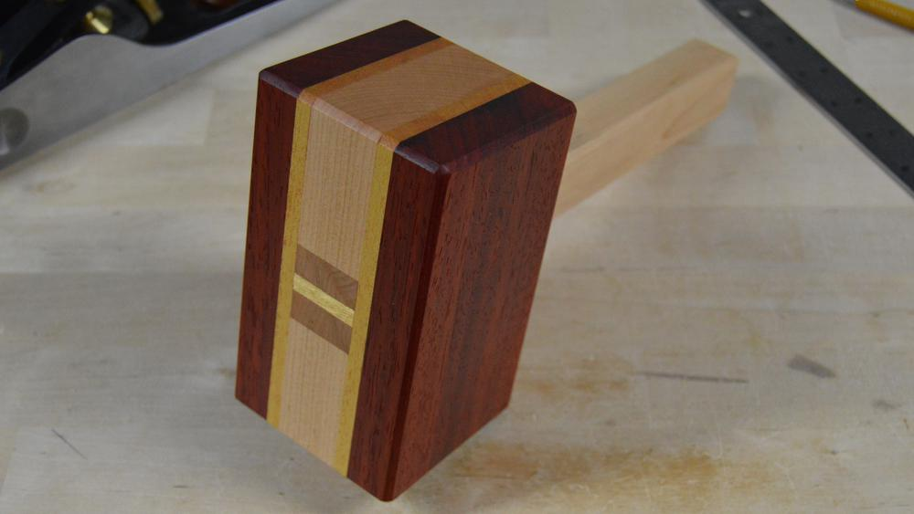
Project 3: Wooden Mallets (Hard Woods)
- Miter Saw, Bandsaw, Sanders
- Hard Woods
- Splints, Mortise/Tenon
- Oil and Wax

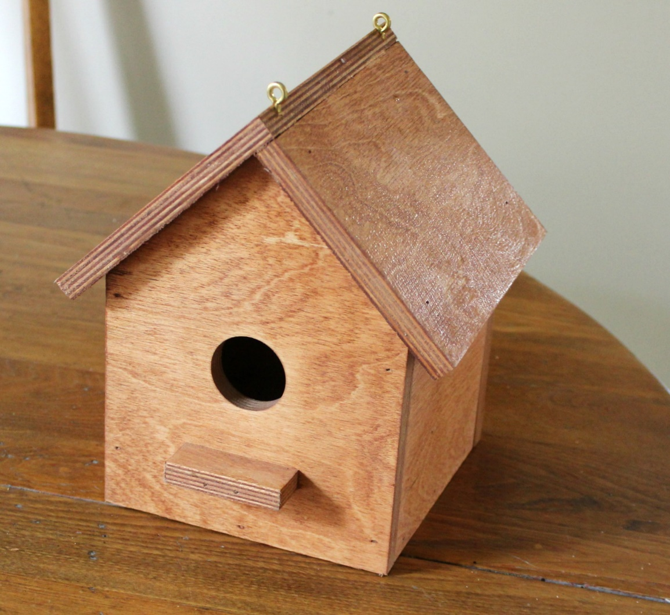
Project 4: Birdhouses (Birch Plywood)
- Miter Saw, Drill Press, Sanders
- Plywood, Wood Glue
- Miter Joints, Lap Joints

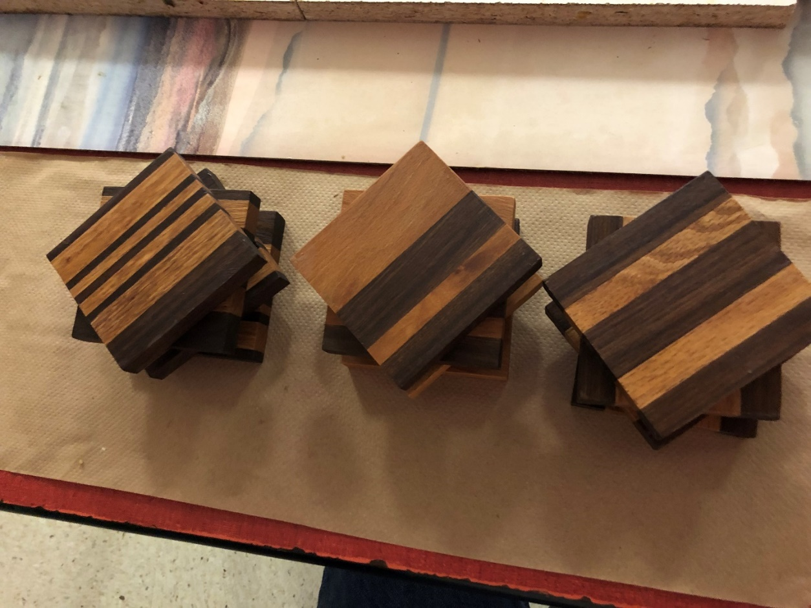
Project 5: Coaster Set w/ Holder (Hard Woods)
- Table Saw, Planer, Miter Saw, sander
- Hard Woods
- Oil and Wax
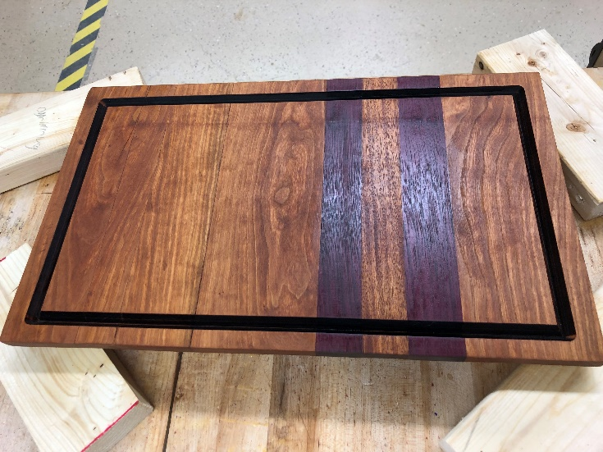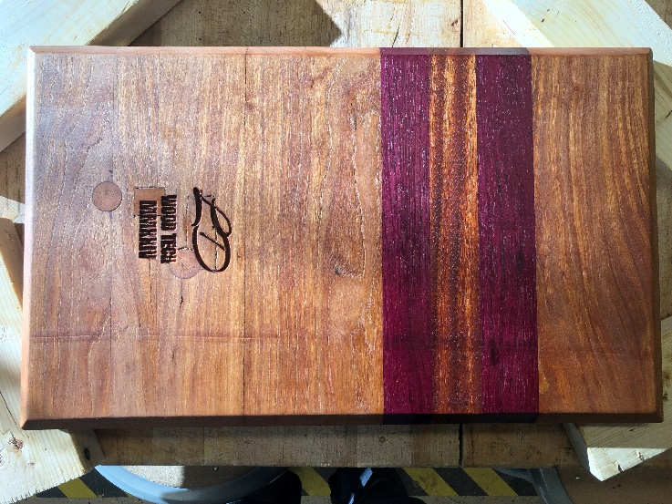
Project 6: Cutting Boards w/ CNC Engraving (Hard Woods)
- Tablesaw, Planer, Miter Saw, sander, CNC
- Hard Woods
- Food safe finish/conditioner

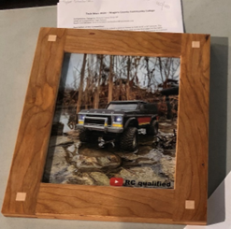
Project 7: Picture Frames 5x7 (Hard Woods, Plexiglass)
- Table Saw, Planer, Mitersaw, Bandsaw, sander
- Lap Joints, Miter Joints, Dado Joints, Mortise/Tenon
- Oil and Wax

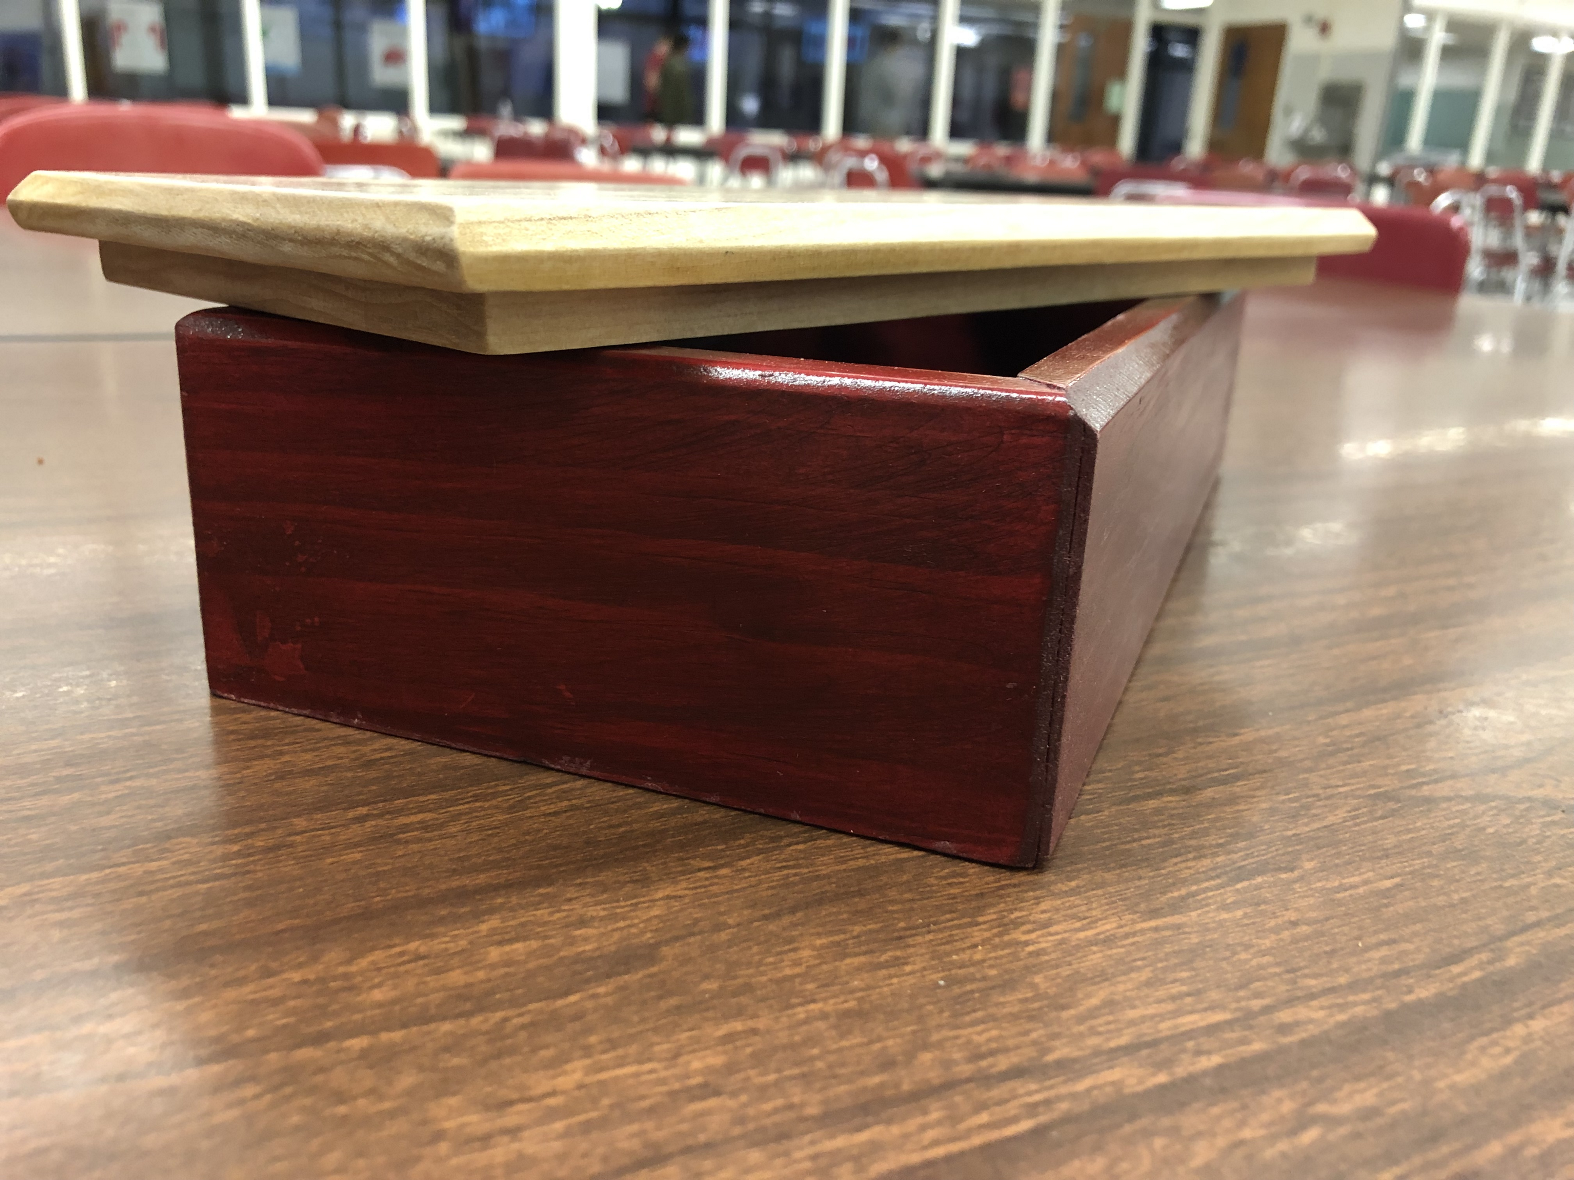
Project 8: Jewelry Box (Hard Woods)
- Tablesaw, Planer, Miter Saw, sander
- Hard Woods
- Lap Joints, Dado Joints, Mortise/Tenon
- Oil and wax

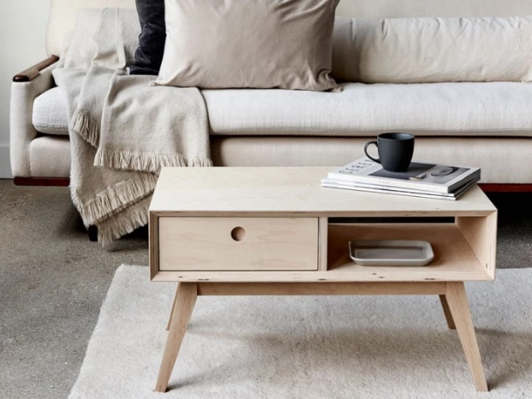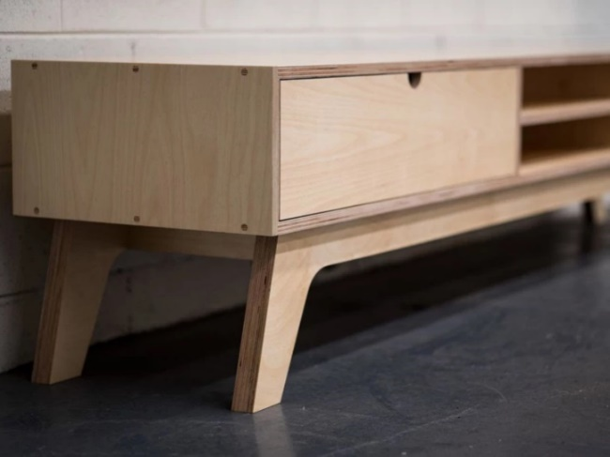
Project 9: Coffee Table w/ Drawer (Plywood)
- Tablesaw, Planer, Miter Saw, sander
- Hard Woods
- Lap Joints, Miter Joints, Dado Joints, Mortise/Tenon
- Oil and wax

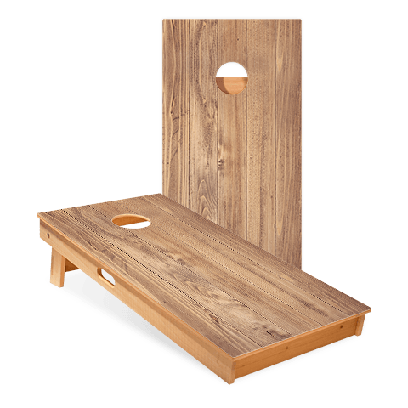
Project 10: Cornhole Boards (Plywood & Studs)
- Tablesaw, Planer, Miter Saw, sander
- Lap Joints, Miter Joints, Dado Joints, Mortise/Tenon

Grading: Based upon a Point Scale of 400 total points per project
- Project Planning/Material Selection: 100pts
- Equipment Management and Safety: 100pts
- Production in accordance with the project’s needs and specifications: 100pts
- Proper Product Finishing, Presentation, and End-of-Project cleanup/maintenance: 100pts

