Principles of Engineering
Iroquois Senior High School
Barker
Course Description
Principles of Engineering introduces students to fundamental engineering concepts through hands-on projects, research, and design challenges. Students explore various engineering disciplines, develop problem-solving skills, and gain practical experience in designing, building, and testing engineering solutions. Throughout the semester, students maintain an Engineering Notebook to document their progress, ideas, and reflections. The course culminates in participation at the NCCC Tech Wars competition, where students showcase projects or compete in challenges.
Course Units
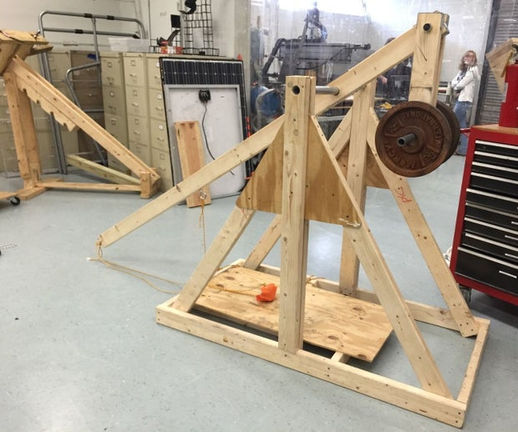
Unit 1: Trebuchet Design Challenge (5 weeks)
Students work in teams to design, build, and test a functional trebuchet, applying principles of physics and engineering.
Key Topics:
- Potential & Kinetic Energy
- Conservation of Energy
- Compound Machines
- Projectile Motion
- Catapult materials and principles
- Team management and leadership skills
- Construction and manufacturing techniques
- Testing and evaluation methods
Project: Design, build, and optimize a trebuchet for maximum throwing distance and accuracy.
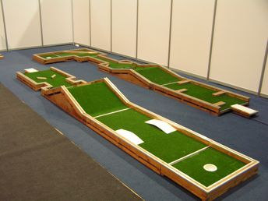
Unit 2: Mini-Golf Course (5 weeks)
Students work in teams to design, build, and test a mini-golf hole, applying principles of physics and engineering. They must incorporate mechanical components, as well as 3D Printed components that all showcase the Tech Program.
Key Topics:
- Potential & Kinetic Energy
- Manufacturing and Production
- Compound Machines
- Team management and leadership skills
- Construction and manufacturing techniques
- Testing and evaluation methods
Project: Design, build, and present a Mini-Golf Hole with your group with approved Materials.

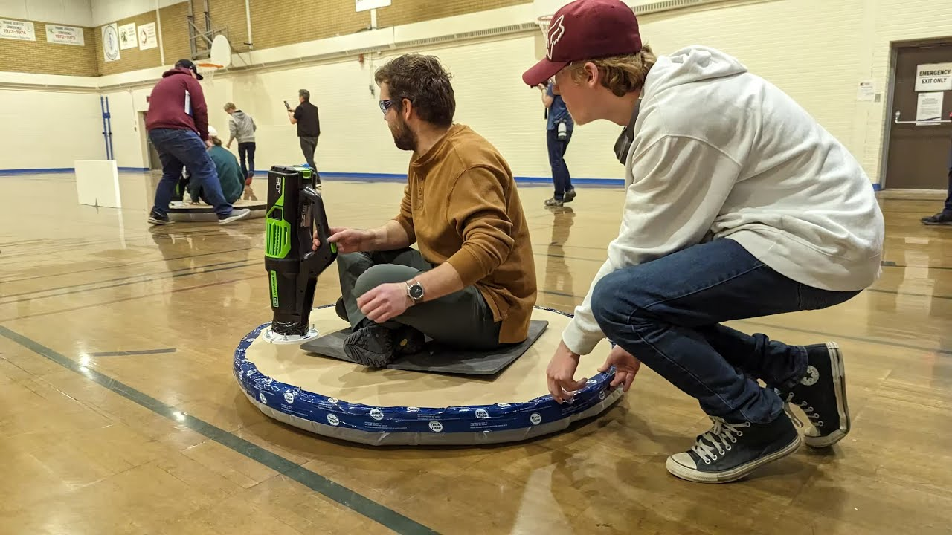
Unit 3: Hover Board Design/Production
Students work in teams to design and build Hover Boards that they can then ride around on. They will 3D print components, and manufacture the boards utilizing Plywood/OSB, tarps, and tape.
Key Topics:
- Manufacturing & Production
- Gravitational Force/Resistance
- Structural Protection
- Stress Reduction
- Surface Area
- Weight Disbursement

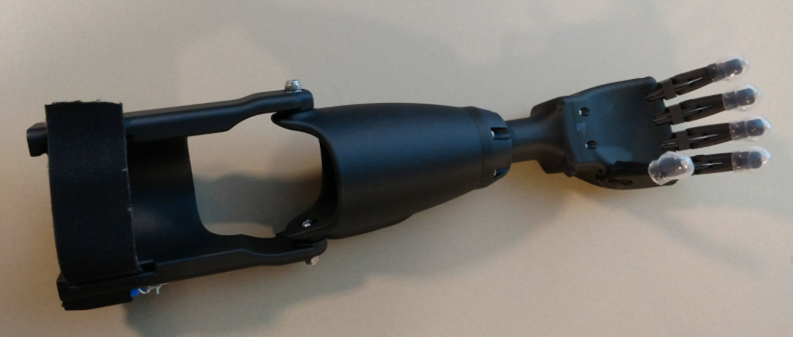
Unit 3: Prosthetic Arm Design (4 weeks)
This unit focuses on the design and development of prosthetic arms, incorporating historical context, anatomy, and modern design techniques.
Key Topics:
- Historical evolution of prosthetics
- Anatomy and functionality of prosthetic arms
- SolidWorks and 3D design principles
- Additive Manufacturing
- Mechanical Function (Bio-Mechanics, Joints)
- Force, Torque, Momentum under stress
- 3D printing prototypes
Project: Design and create a 3D-printed below-elbow prosthetic arm with articulated fingers and thumb.
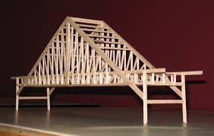
Unit 4: Large Bridge Design/Construction (4 weeks)
This unit explores the physics and civil engineering concepts behind Large Bridge design/construction, culminating in the design and construction of a scaled bridge.
Key Topics:
- Load Bearing Capacity
- Force Distribution
- Material Selection
- Environmental Factors
- Efficiency & Aesthetics
- Structural Integrity
- Openings, Dampers, & Bumpers
- Concept sketching and design iteration
- Bridge building and testing
Project: Design and construct a model of a bridge that can hold weight at the ratio appropriate to its scale.
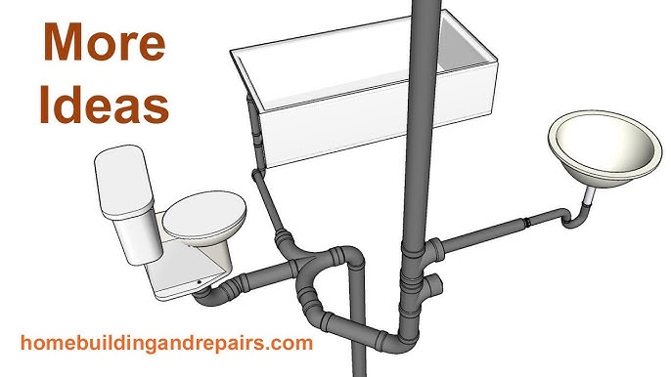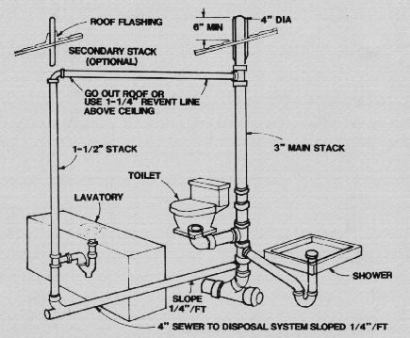
Unit 5: Water Distribution Systems (Bathroom Piping System) (4 weeks)
Students research and model a closed conduit system within a bathroom, connecting Sink/Toilet/Shower, while maintaining adequate pressure and staying up-to-code (Local)

Key Topics:
- Fluid Mechanics/Dynamics
- Piping Systems (Closed Conduit Systems)
- Pressure
- Aerodynamics
- Plumbing Code
- SolidWorks Modeling & Simulation of Pipes
Unit 5: Tech Wars Competition Projects (2 weeks)
Students prepare for and participate in the NCCC Tech Wars competition, applying skills learned throughout the course.
Key Topics:
- Tech Wars challenge requirements
- Project fine-tuning and optimization
- Competition strategies and teamwork
Project: Prepare and compete in selected Tech Wars challenges.
Unit 5: Wind Turbine Research, Design, and Presentation (4 weeks)
Students research, design, and present an improved wind turbine model, focusing on renewable energy applications.
Key Topics:
- Wind turbine technology and design principles
- SolidWorks for turbine modeling
- Renewable energy applications
- Technical writing and presentation skills
Project: Design an improved wind turbine model and write a detailed paper on its enhancements and potential impact on renewable energy.
Unit 6: LightSaber Flashlights (2 weeks, optional)
An extra unit for additional engineering practice and creativity.
Project: Design and build a functional flashlight inspired by lightsaber technology.
Grading Rubric
Component | Percentage
Engineering Notebook | 30%
Project Design and Documentation | 40%
Weekly Progress Reports | 10%
Participation and Collaboration | 20%
Grading Scale:
- A: 90-100
- B: 80-89
- C: 70-79
- D: 60-69
- F: Below 60
Assessment Criteria
Engineering Notebook (30%):
- Completeness and organization
- Quality of sketches and diagrams
- Depth of reflections and analysis
Project Design and Documentation (40%):
- Adherence to design specifications
- Creativity and innovation
- Quality of final product
- Thoroughness of documentation
Weekly Progress Reports (10%):
- Timeliness of submissions
- Clarity and completeness of reports
- Evidence of progress and problem-solving
Participation and Collaboration (20%):
- Active engagement in class discussions
- Effective teamwork and communication
- Contribution to group projects

