Iroquois Senior High School
Drawing & Design for Production
Syllabus


Instructors: Barker/Pignatora
Grades: 9-12

Course Description
This year-long course focuses on developing students' drawing skills, design thinking, and hands-on production techniques. Students will engage in various projects that encompass woodworking, 3D modeling, CAD design, and more, while fostering critical problem-solving skills and creativity. The course emphasizes conceptualization, planning, execution, and presentation of designed objects.
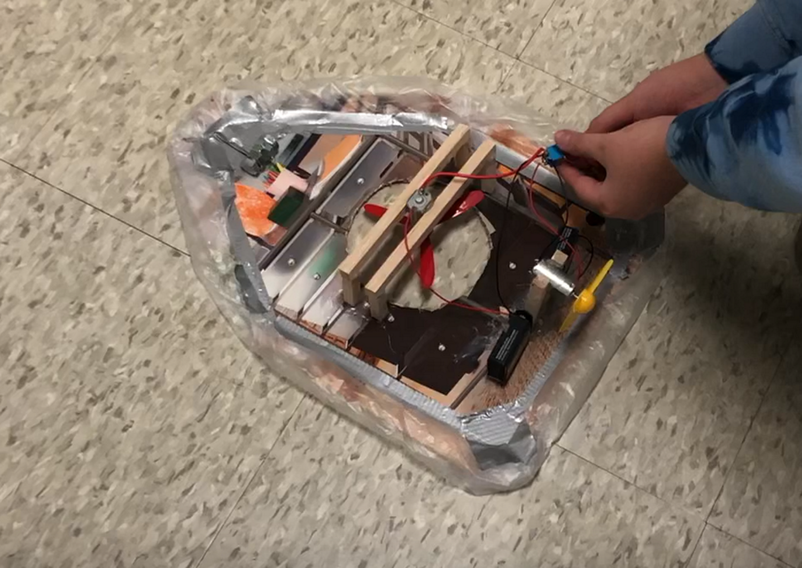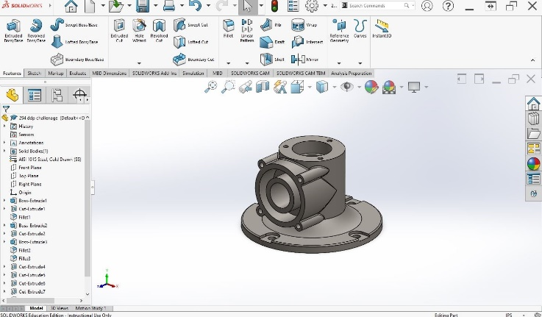
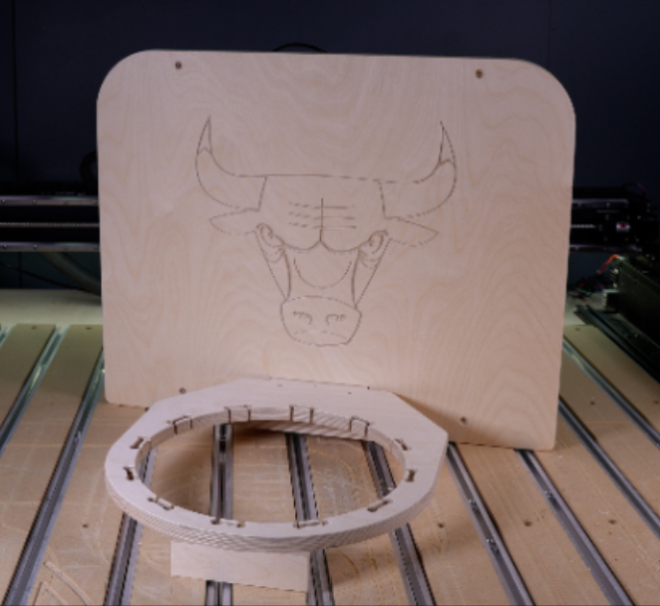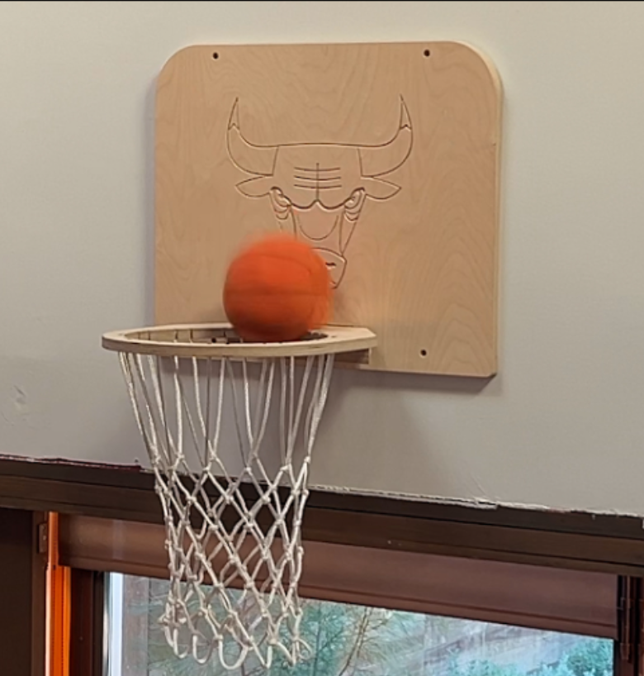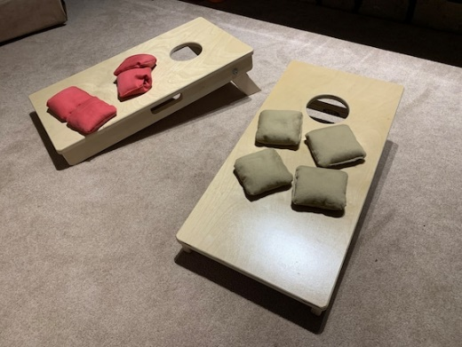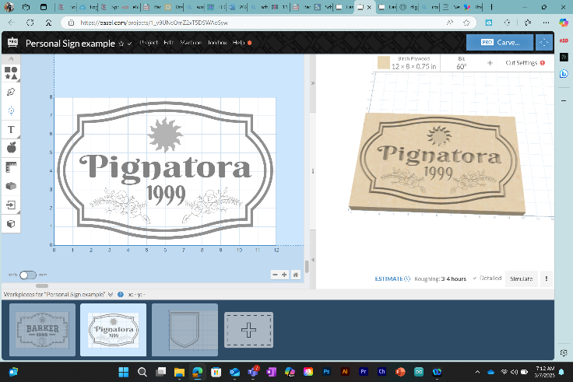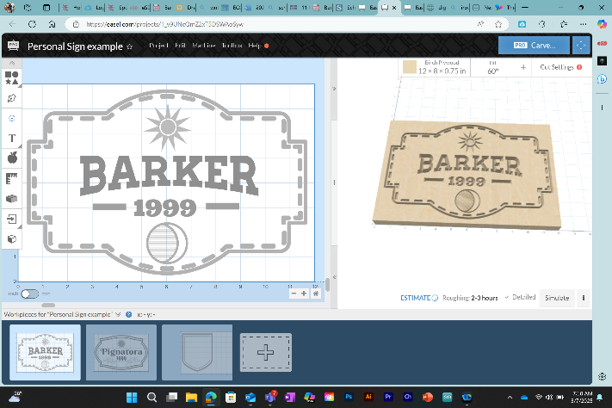
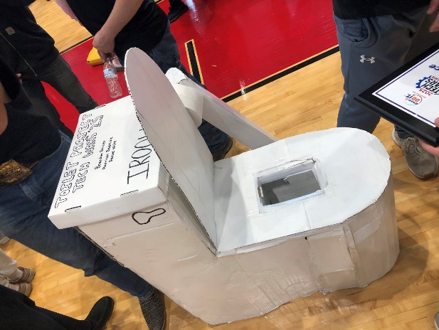

Course Outline (Project order varies year to year)
Unit 1: Catapults
- Research historical catapult designs.
- Sketch concepts and build functional models using woodshop tools.
- Test, refine, and present results using the engineering design process.
Unit 2: Intro to SolidWorks CAD (Part Designs)
- Introduction to SolidWorks CAD software.
- Create basic part designs using sketch tools (extruded, revolved, and swept features).
- Save and share CAD files.
Unit 3: CAD Cannon (Assembly)
- Learn assembly design in SolidWorks.
- Create part and assembly drawings.
- Build a cannon assembly and document the process.
Unit 4: Architecture (Mini House)
- Research architectural styles and basics of house framing.
- Design and build a scale-model house.
- Present architectural choices with documentation.
Unit 5: Suspension Bridge Model (New)
- Connections: Architectural framing (Unit 4), load-bearing simulations.
- CAD Phase: Design trusses in SolidWorks; perform stress analysis simulations. (2D)
- Build Phase: Construct a balsa wood bridge; compete for maximum load capacity.
Unit 6: CAD Reverse-Engineering and Design
- Analyze existing products for demographics and materials.
- Redesign a product with improved features using SolidWorks.
- Create marketing materials for the redesigned product.
Unit 7: Interlocking Wooden Puzzle Box (New)
- Connections: Reverse-engineering (Unit 6), precision joints.
- CAD Phase: Design sliding/rotating parts with tolerance calculations in SolidWorks.
- Build Phase: Use CNC/laser-cut templates; finish with traditional tools.
Unit 8: Hover-Craft (Teams of 2)
- Research hovercraft principles and sketch concepts.
- Build hovercrafts using circuits, woodshop tools, and approved materials.
- Test stability and refine designs.
Unit 9: Cell Phone Amplifier
- CAD Phase: Design a Cell-Phone Amp in multiple parts in SolidWorks & Assemble.
- Build Phase: Construct in the Wood Shop with provided Materials.
Unit 10: 3D Train CAD
- Model multiple train components in SolidWorks.
- Assemble parts into a functional 3D train model.
Unit 11: Interior Design Challenge
- Collaborate on room layouts using CAD software.
- Present detailed 3D models with material/furniture selections.
Unit 12: CAM Mini-Basketball Hoop Design
- Learn CAM workflows using Easel software.
- Produce personalized signs using CNC routers.
Unit 13: 3D CO2 Car Competition
- Design CO2 Car on SolidWorks (additive manufacturing)
- Race to test (aerodynamics, speed)
Unit 14: Adirondack Chair Production
- Design chair parts in SolidWorks; generate CNC-ready .dxf files.
- Construct a full-scale chair in the woodshop.
Unit 15: Miniature Cornhole Boards
- Model boards in SolidWorks; create parts lists for production.
- Build and finish boards with custom graphics.
Unit 16: Final Projects (Bike Parts & Assemblies)
Bike Parts Project:
- Draft five bike components in SolidWorks.
- Assemble the components into one complete bike assembly.
Vise/Jack Assemblies Project:
- Complete technical drawings of all parts and assemblies in SolidWorks.
- Submit final portfolios as part of the end-of-year review.

Assessment & Grading
Students will be assessed based on their ability to complete projects successfully while demonstrating creativity, technical accuracy, craftsmanship, adherence to the engineering design process, participation, and engagement in class activities.
Grade | Percentage Range
A | 90–100%
B | 80–89%
C | 70–79%
D | 60–69%
F | Below 60%
Materials & Supplies
Students will have access to woodworking tools, SolidWorks software licenses, CAM equipment (e.g., CNC routers), circuitry kits, and other necessary materials for each project. If students wish to use additional or personal materials/tools not required by the course, they are responsible for sourcing them independently.
Open Hours & Check-ins
Biweekly progress reviews will provide opportunities for students to discuss their work, ask questions, and receive feedback from instructors. Students are encouraged to reach out at any time with concerns or requests for additional support.
Important Notes
This syllabus serves as a guideline but may be adjusted as needed based on student progress or unforeseen circumstances. Updates will be communicated promptly to ensure clarity and alignment with course goals.

