TECHNOLOGY

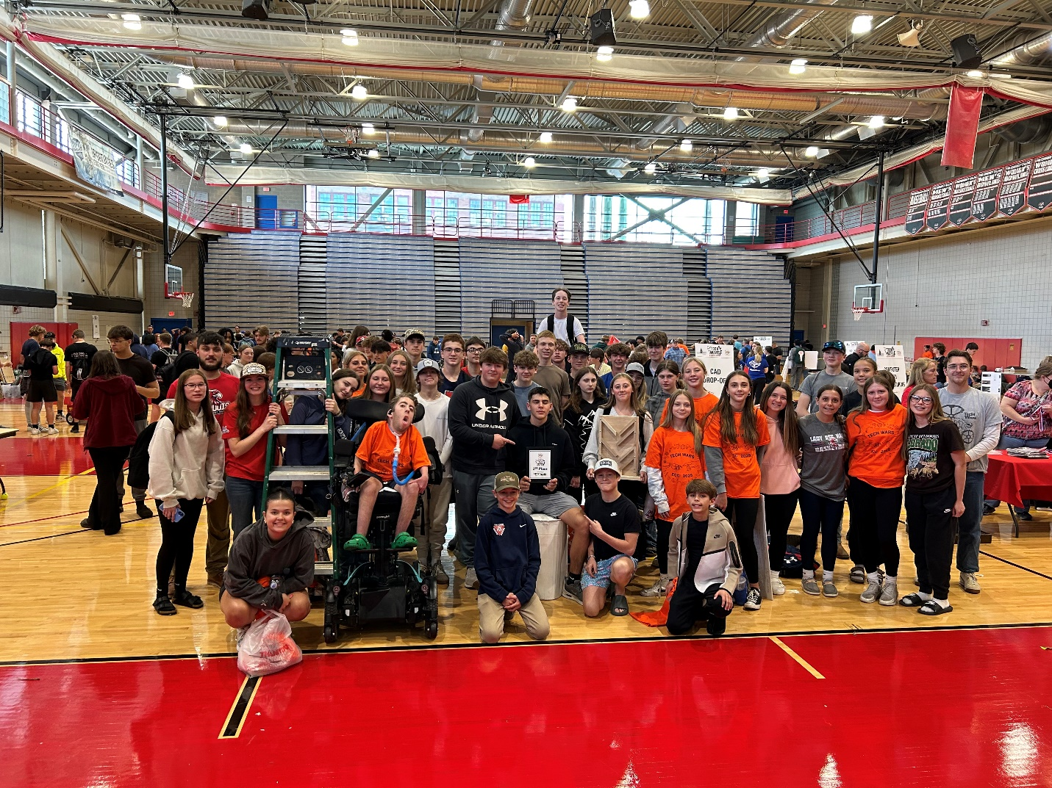

“I know the price of success: dedication, hard work, and an unremitting devotion to the things you want to see happen.”

Frank Lloyd Wright

DDP (Design and Drawing for Production) (9141) Open to Grades 9, 10, 11, 12
40 weeks – 1 credit (Art or Tech credit) (currently not NCAA approved)

Design and Drawing for Production is an entry level course. In DDP, students will be learning and using similar processes that they will not only see in future Engineering Technology courses, but in their future academic and professional careers. Through a variety of different processes and projects the students will utilize every step of the Design Process from addressing a problem, all the way through testing and evaluation. Students will utilize industry-standard 3D modelling software in a laboratory, then produce the final designs in the workshop.

DDP can replace the REQUIRED Art Credit.
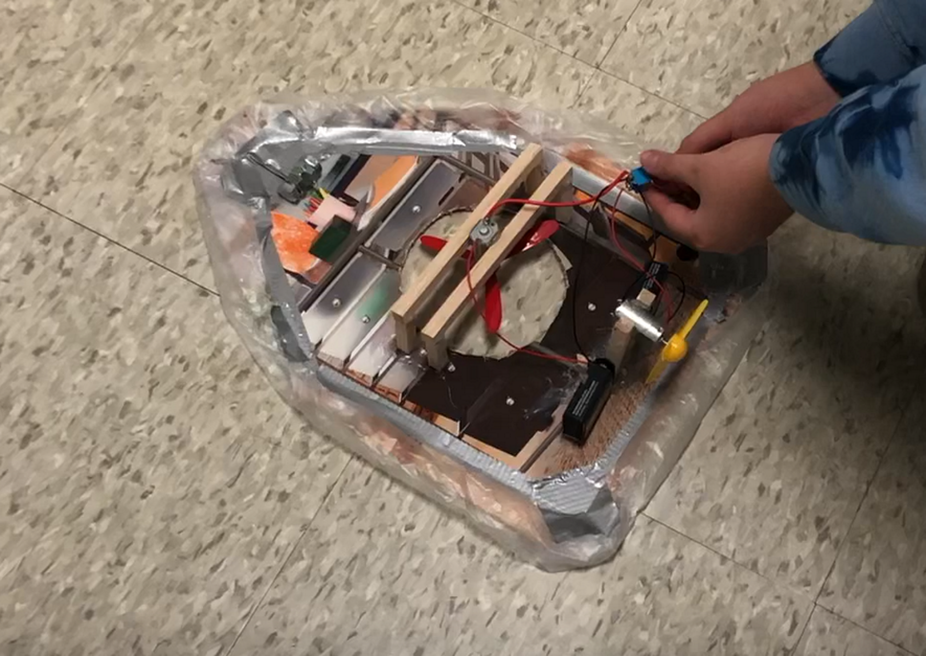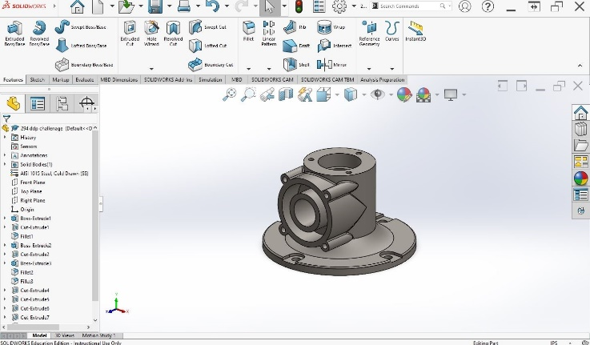
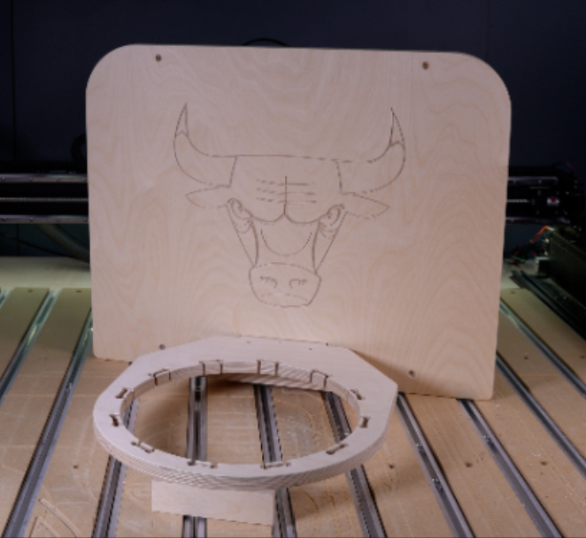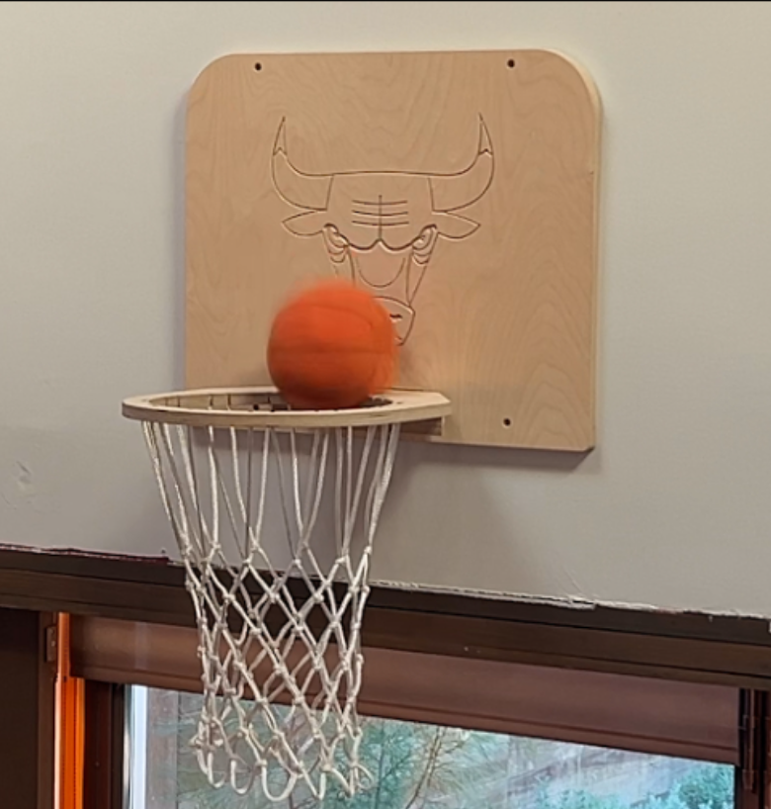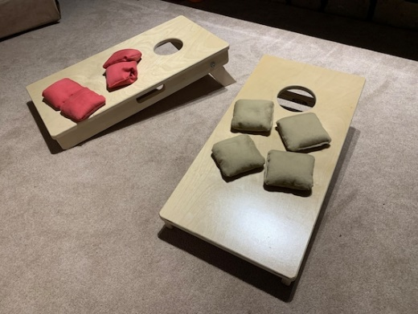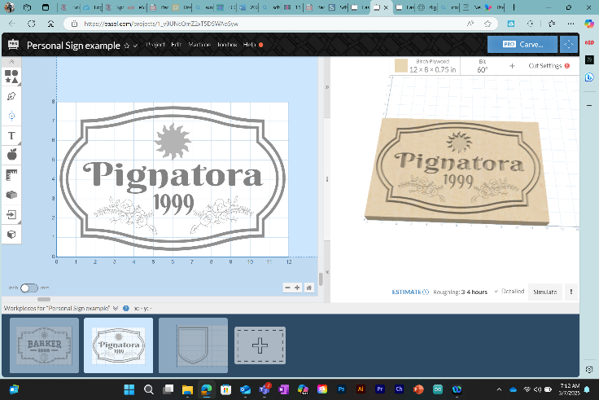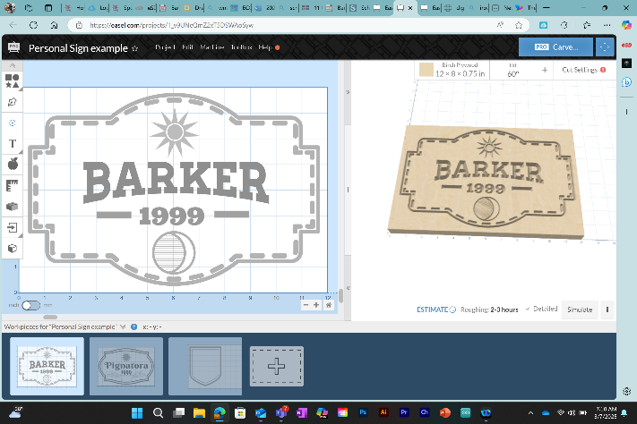
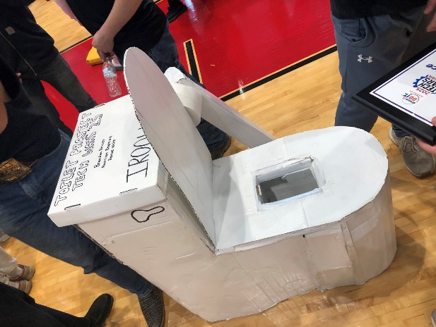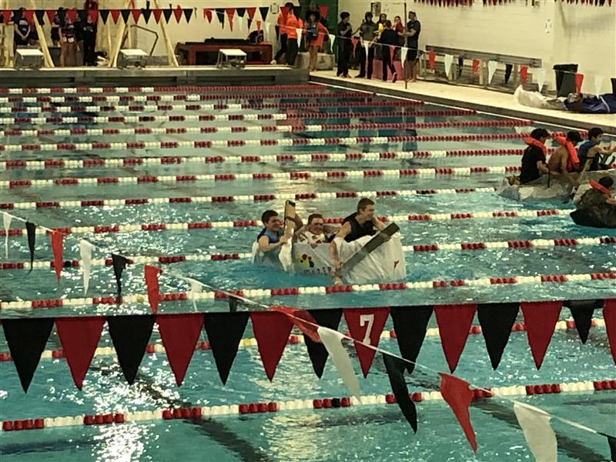

PRINCIPLES OF ENGINEERING (9142) Open to Grades 10, 11, 12
20 weeks – 1/2 credit (currently not NCAA approved)

Prerequisite: DDP

This is an integrative, hands-on, laboratory-based course which introduces students to concepts of engineering (ethics, design, modeling, optimization systems, and technology/society interactions). These concepts are applied to solving problems contained in “real world” case studies. Case study abstracts relate to mechanical foundations, and control energy, communications, structural design, designing technology for people with disabilities, and so much more.

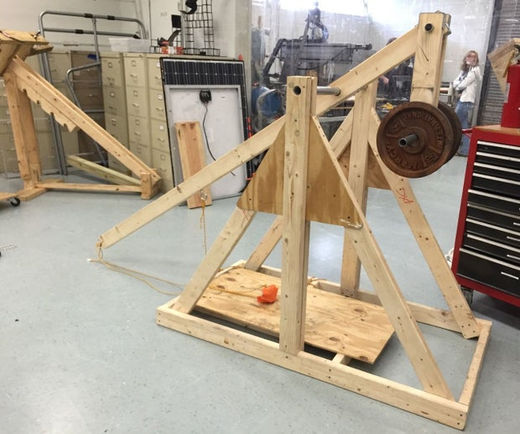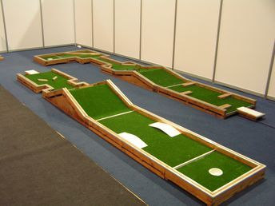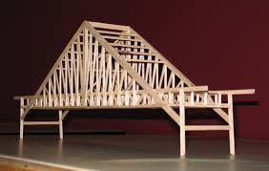
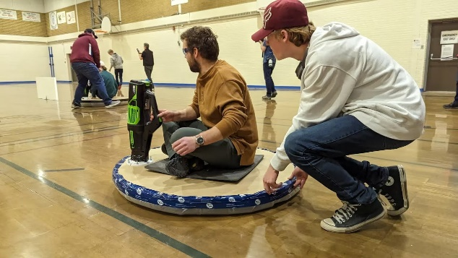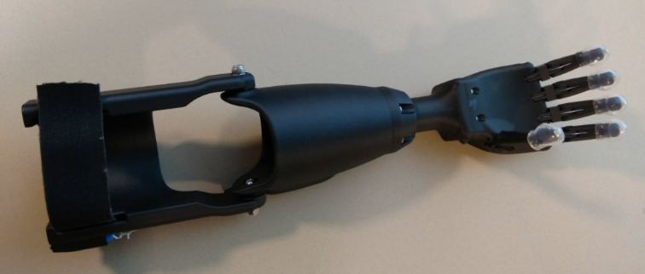

STEM ROBOTICS (9140) Open to Grades 10, 11, 12
20 weeks – 1/2 credit (currently not NCAA approved)

Prerequisite: DDP

In this course, students will be learning the inner workings of automation and robotics which are becoming more and more common in industries around the world. From cars to factories, robotics is something that students will encounter at some point in their lives; be it professional or personal. Students will manufacture, code, operate, test, and evaluate their designs. Ultimately providing students with first-hand knowledge/experience with automation and robotics to set them up for their future academic/professional endeavors.
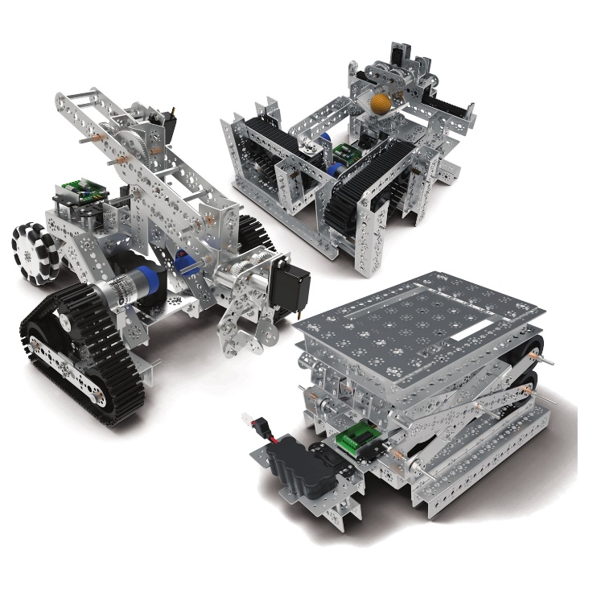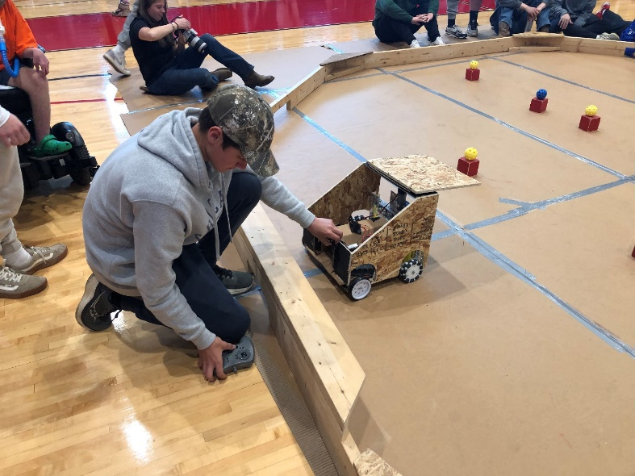

PRODUCTION SYSTEMS (9126) *NEW Open to Grades 10, 11, 12
20 weeks – 1/2 credit (currently not NCAA approved)

Prerequisite: DDP

This is a half year course where we delve into the Design and Production of Products that emphasize Aesthetic Design, Functionality, Ease of Assembly, and Mass Production Capabilities.

This course provides a hands-on approach to learning intricate systems driving production, construction methods, and quality assurance protocols. Uncovering the profound societal, economic, and environmental impacts of these industries. Join us to discover the pulse of innovation and sustainability shaping our future.

Careers this relates to: Manufacturing Engineer, Construction Manager, Quality Assurance Specialist, Environmental Compliance Officer, Supply Chain Analyst, Sustainable Design Consultant, Operations Manager,
Project Engineer, and more.
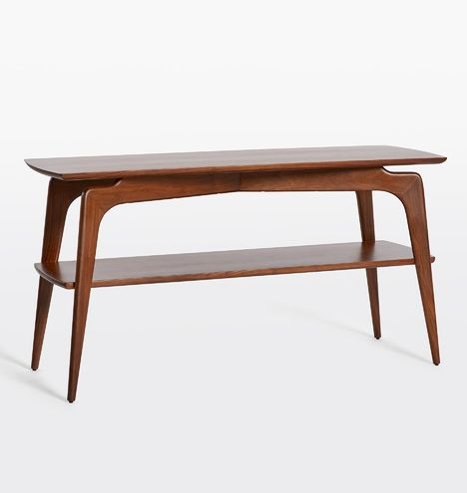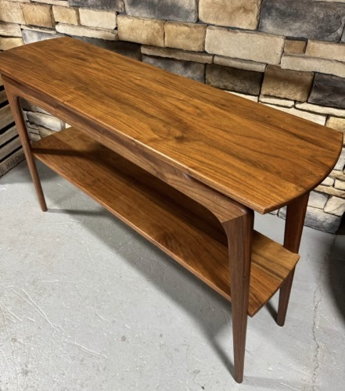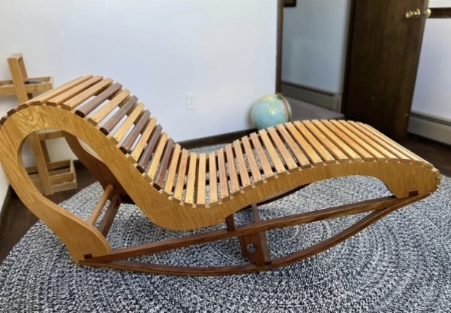
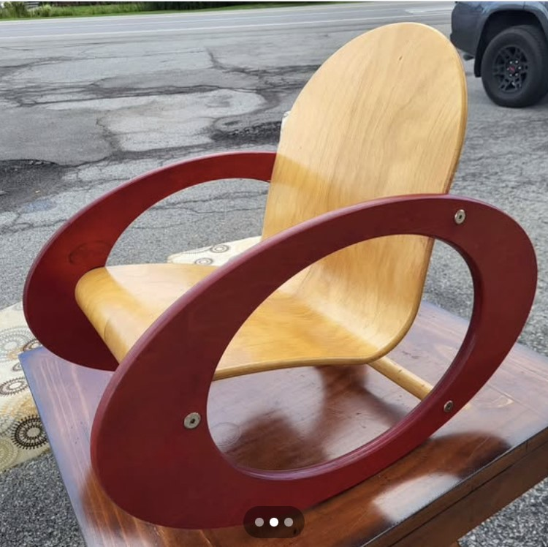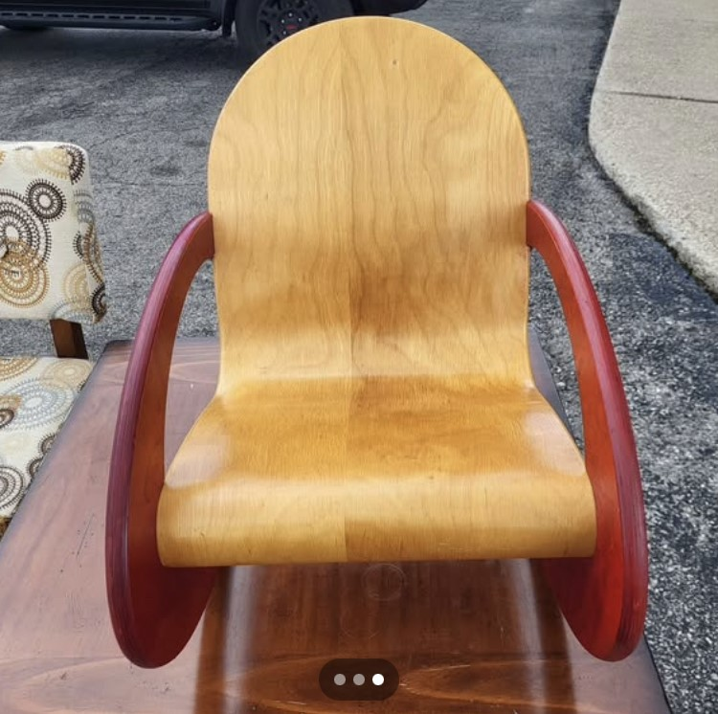
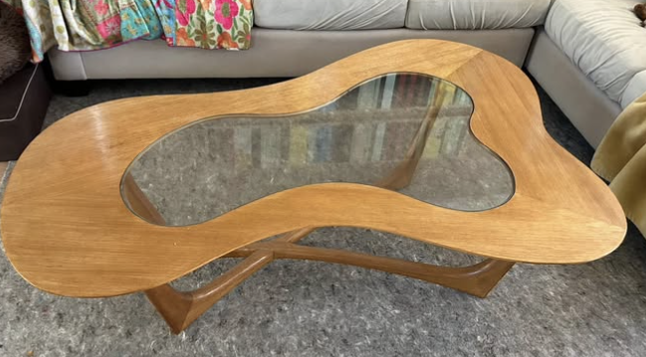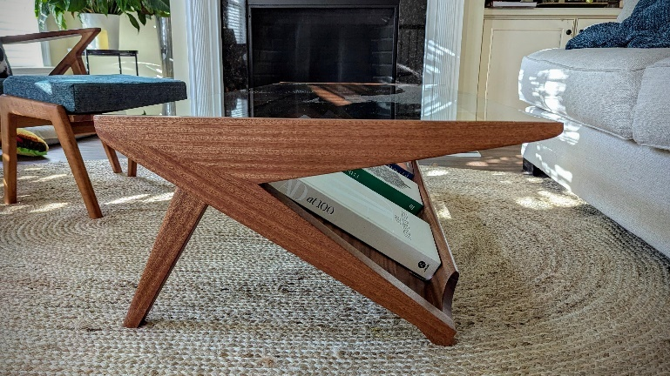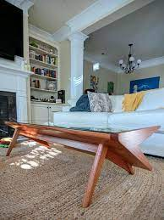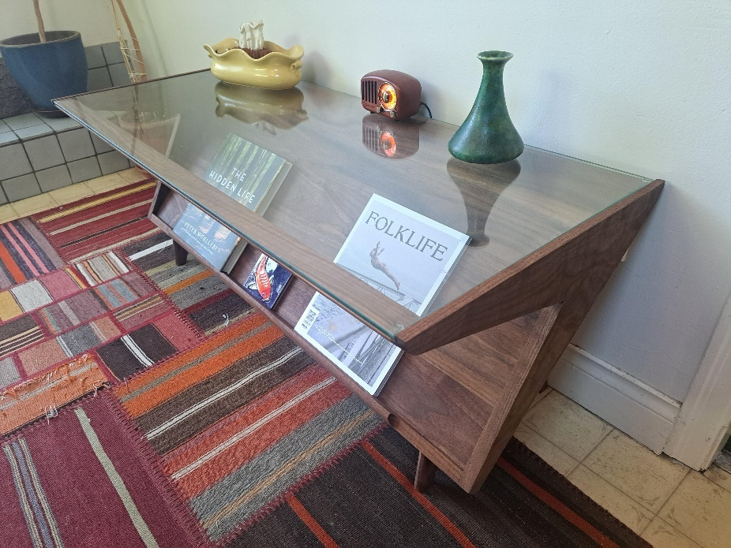

WOOD TECHNOLOGY (9148) Open to Grades 10, 11, 12
20 weeks – 1/2 credit (currently not NCAA approved)

Prerequisite: DDP

This course provides students with the skills of producing/manufacturing that are highly sought after in Engineering and all Technical Fields. The students will utilize a variety of different manufacturing and production methods akin to professional manufacturing companies. Working primarily with wood, the students will design and build a variety of different products to meet a myriad of different needs and/or requirements.
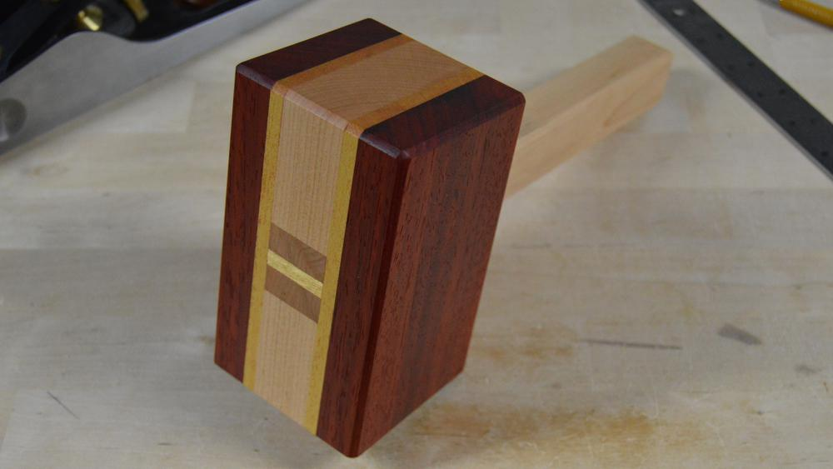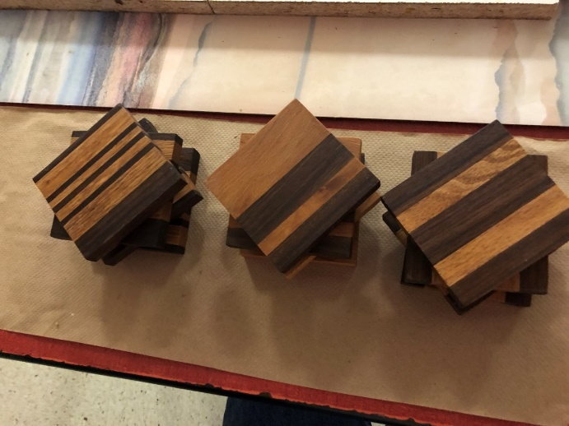
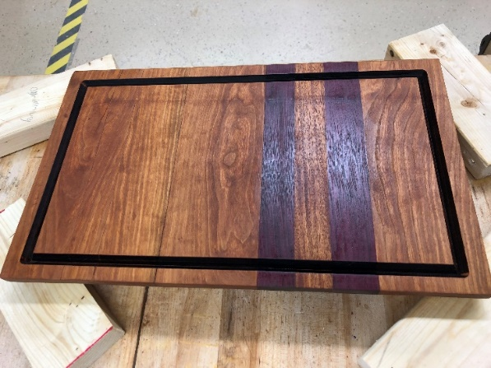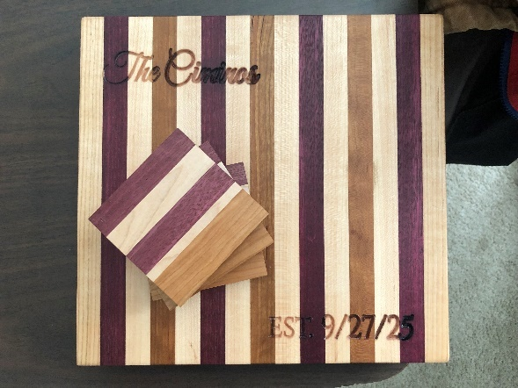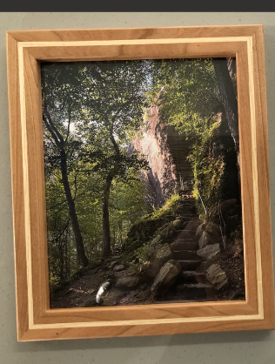
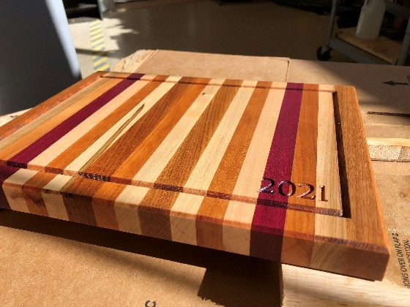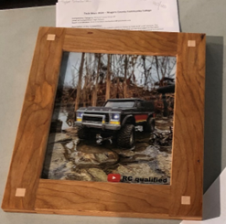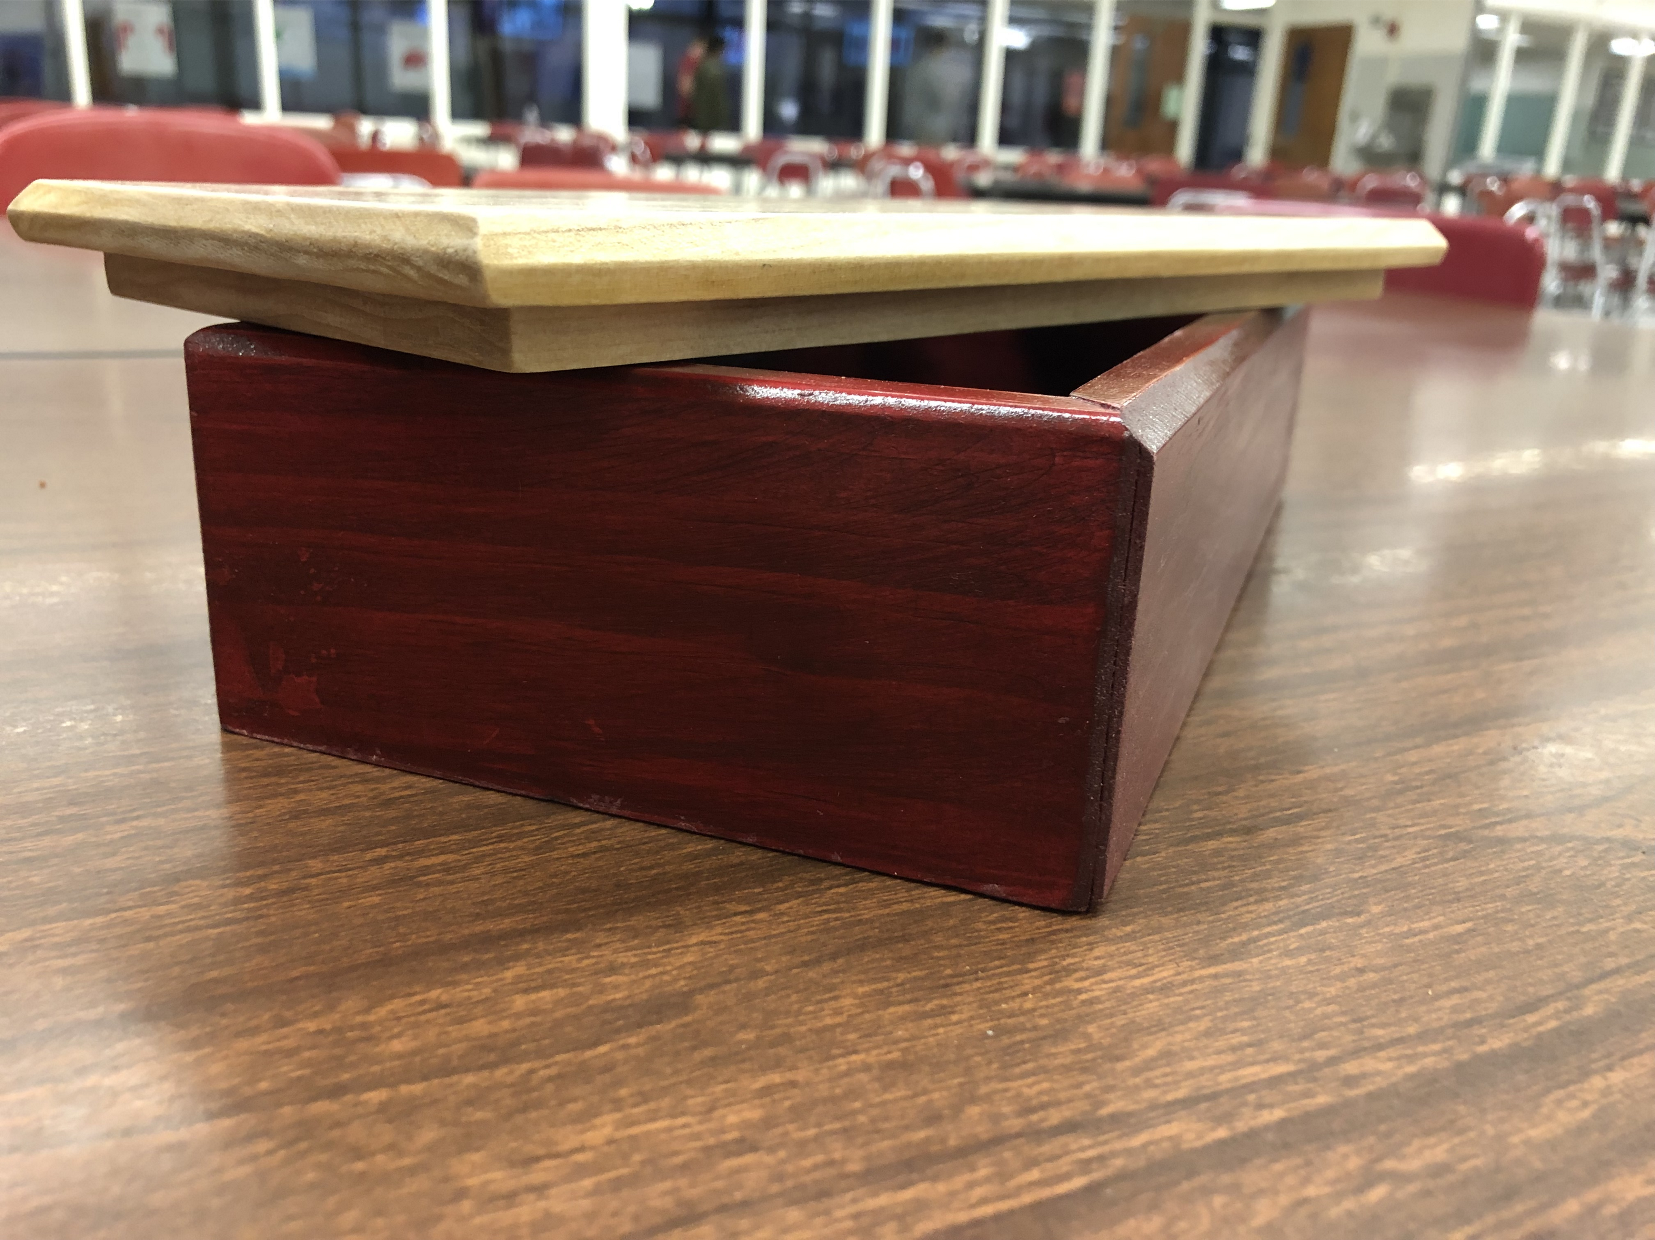

Architecture Open to Grades 10, 11, 12
20 weeks – 1/2 credit (currently not NCAA approved)

Prerequisite: DDP

This half-year course encapsulates everything Architecture: Building Design, Construction Techniques, Blueprinting, Codes, and so much more. This course is a hands-on approach to Architecture that will benefit any and all students interested in Architecture, Interior Design, Civil/Structural Engineering, Construction, Engineering Design, and beyond!
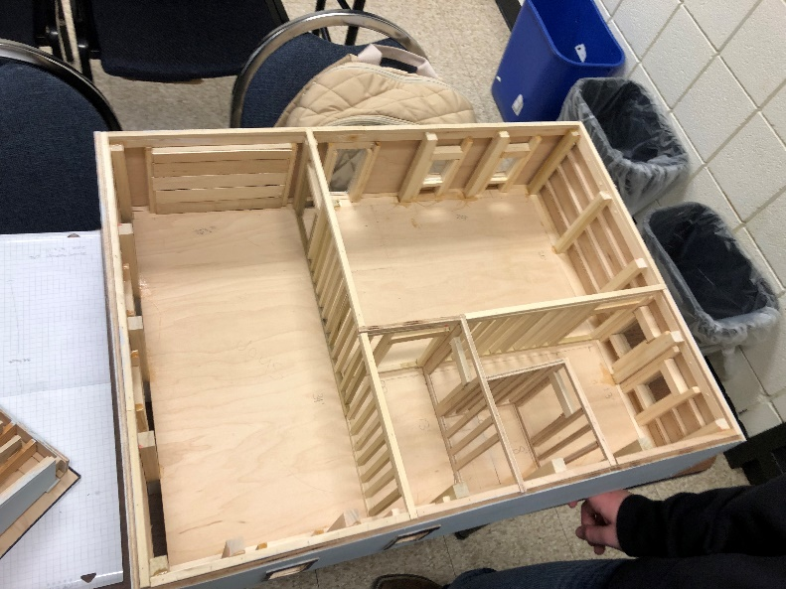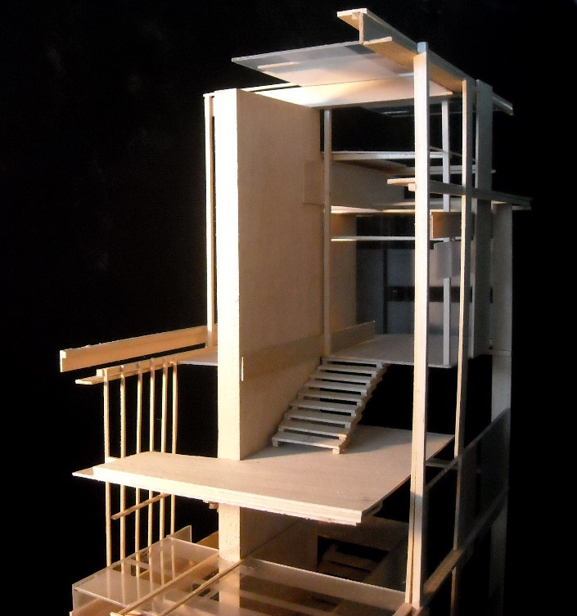
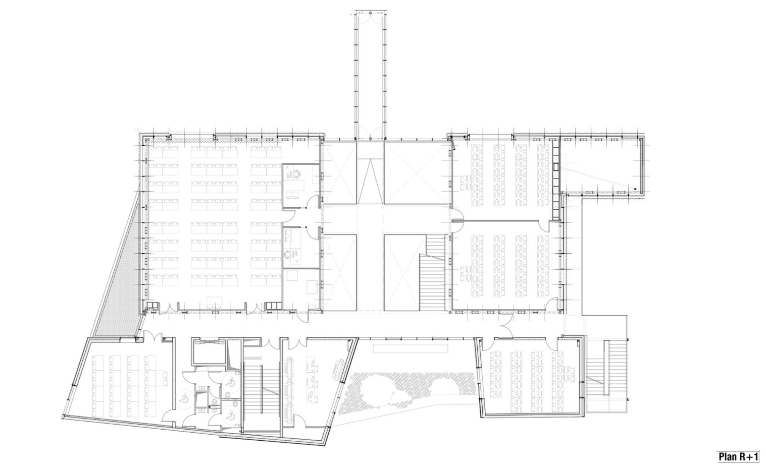
DIGITAL MEDIA PRODUCTION A (9081) Open to Grades 10, 11, 12
20 weeks - 1/2 credit (currently not NCAA approved)

Prerequisite: none

This is a half-year course that provides students with communications experience that correlate with modern production methods. Students will gain firsthand experience working in front of the camera, as well as behind the scenes (producing/editing). From News Broadcasting to short films to promotional ads, students will utilize a variety of different production skills found in all forms of media. Students will learn production methods (equipment needs, prop/outfit requirements, location scouting, proper equipment handling), filming methods (using equipment respectfully/accurately), editing (using Adobe Premiere Pro; an industry-standard editing software). This is a course designed to provide students with the skills necessary to excel in media production at every level.

DIGITAL MEDIA PRODUCTION B (9082) Open to Grades 10, 11, 12
20 weeks - 1/2 credit (NUSTEP)

Prerequisite: Media Production A

This semester-length course is designed for high school students with prior experience in video production. The course focuses on advanced techniques and skills necessary for producing professional-grade media. Students will work in groups and operate as production companies, creating various types of media such as news segments, commercials, advertisements, and entertainment content. The course aligns with the New York State (NYS) Math, Science, and Technology (MST) and Career Development and Occupational Studies (CDOS) standards.

NUSTEP (College Credit): This course is a part of the NUSTEP Program, through Niagara University. Which allows any 11th and 12th graders taking the opportunity to gain 3 credits through Niagara University for the course CMS 215-Video Production.

