MECHS SIT AGENDA Feb 16, 2026— 3:30 p.m.
In attendance: Sawicki, Young, Long, Sluder, Buckner, Teague, Irby, Applegate
Not in attendance:

New Business:
Action Item: We need your help on these items
- Improving attendance.
  - 8 unexcused absences/ tardies = attendance issues but discipline referrals/ after school make up.
  - How do we boost student morale and motivate students to attend school?
    - Growing mindset that school is “optional” which got exacerbated by COVID
    - Maybe link student parking spaces to attendance (show up on time or lose your spot)?
  - HUGE THANKS to Builder’s Express (Cassandra Buckner) for the Ingle’s cards for perfect attendance.
- May 4 - 8 Staff Appreciation Week–we like to do things daily for our staff.
  - Ideas: Donut & Coffee Day, Ice Cream Sundaes Day, Acts of Kindness/ Gifts of Service, keep it going….
    - Maybe donations from Krispy Kreme/Dunkin Donuts?
  - Sponsors/ business donations–gift cards, food, keep it going…
  - Notes/ art from students, parents, etc.
    - Eliza–can you get ABT students to do this?
    - Club Sponsors–can you start a thank you/ service campaign?

PD/ PLCs
- Vertical Alignment (Math and English) (MECHS/ MHS/ MMS PLCs) At MHS
  - New Date: 3/3 (now a Teacher Work Day)
  - Long & Young to lead the Writing PD
- WNC Resilience Cohort Year 1– OpenWay Learning (Wes)
  - $1000 Micro-Grant Winners
    - Local Field Trips (Johnston)
    - Beacon of Hope Thrift for Hope Fashion Show (Young & Long)
- Global Leaders Cohort Year 1– Gear Up (Bruce Murray), Participate Learning (Jamie) School Focus: Self-Awareness and Critical Thinking
  - Admin Team – Caldwell, Bryson, McGuire, Irby, Young, Jacob Morgan
  - Congratulations Fall Staff Members–Earned badges & a stipend!
    - Admin Team, Johnston, Long, Cutshall, Sawicki, Wilde, Moylan, Fox
  - Congrats on gift cards for Global Leader posts:: Johnston & Young
  - Global Leaders Bulletin Board/ Student Stories Displays (Johnston): Global Challenges Brainstorm results
  - Thank you, Teachers and Staff! Using Global Leaders posters, I can statements, surveys done, reflection, and more. Keep going!

Community Involvement, Clubs, SGA:
- Thrift for Hope Beacon of Hope Fashion Show (Date TBD)--Analize and Leigh’s ENG 232 Global Leaders Project Group*
  - BOH Jessi Koontz and Anna Ofsa-Anderson, Community Partners
  - $1000 Resilience grant awarded
  - Need everyone’s support
  - Maybe do it again next year before Prom w/ Prom Closet & My Sister’s Place?
- Community Housing Coalition (CHC)–Matthew L. & Jacob E’s group
  - CHC Sarah Pike and Anna Gibeau, Community Partners + MECHS Interact, NHS, SGA + PAGE + Teens of Mad Co
  - YAC–Youth Advisory Council meetings every 2nd Monday; transportation provided with permission slip. All are welcome.
    - Oral History Crew (TMC–Aine)
    - Neighbors Helping Neighbors Crew (learning the trades while helping elderly/ disabled with home repairs)
    - Advertising Crew
    - Little Free Library/ Dolly Parton Imagination Library Crew (MECHS NHS & SGA)
    - Pen Pal Crew (Interact and General Volunteers)--NHN outreach–many elderly community members are lonely. Even if ppl can’t come to meetings, this one can be done at home/ school. See Young.
- *Check out the students’ ENG class proposals for these community projects from Dec 2025*:
  - Copy of Final Presentation.MOV(CHC) 
  - Thrift for Hope (BOH)
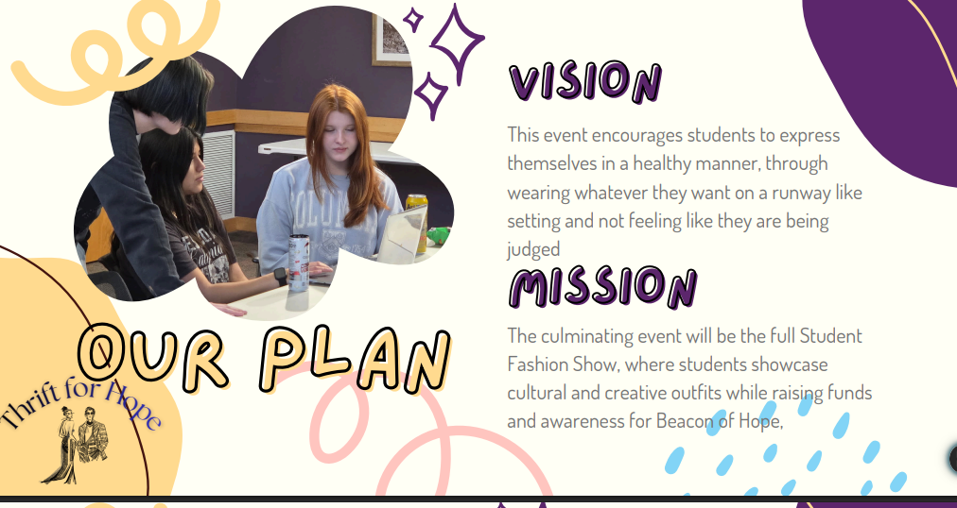

Trailblazers: Thanks to Johnston and crew for doing Adopt A Hwy on 2/13. Possible canoeing/kayaking trip in the works 4-28
NHS Initiation: March 6th, 10:00 AM
Graduation: May 29th @ football field, weather permitting (gym otherwise)
Yearbook: You can still buy them! Picture submissions are done, though. Get orders in by March 16th!
Costa Rica Trip: 19 people so far; no concrete date until Spring Break for next year is solidified. Last day to sign up is in September 2026!

Calendar:
Spring 2026
See Updated MCS Calendar due to Inclement Weather

February
2/25 ACT for Juniors–remote day for all other grades at MECHS
FCA Pizza Party afterwards for all Juniors
2/17 World Kindness Day
Perfect chance for all clubs and teachers to be Global Leaders
2/19 8th Graders Visit MECHS
Thank you, Student Tour Guides!
Teachers, great chance to showcase a Resilience or Global Leader engaging lesson
March
3/3 Joint ELA and Math PLC (MECHS, MHS, MMS) @ MHS 9 - 10:30 a.m.
3/20 WCU Principals’ Fellows Tours MECHS (Irby)--School-Wide Walk-Throughs
3/26 Global Learning Walks–Wilkes & Ashe Co. Early Colleges, MHS Visit MECHS
3/30 SIT Meeting

April
4/17 Prom at Claxton Farm
Wonderland Theme/ SGA Leads
Prom Closet Date (?)
4/27 SIT Meeting
4/28 Canoeing with the Trailblazers

Meeting Adjourned at: 4:18pm

Next meetings are Mon, March 30 and April 27 3:30 pm

