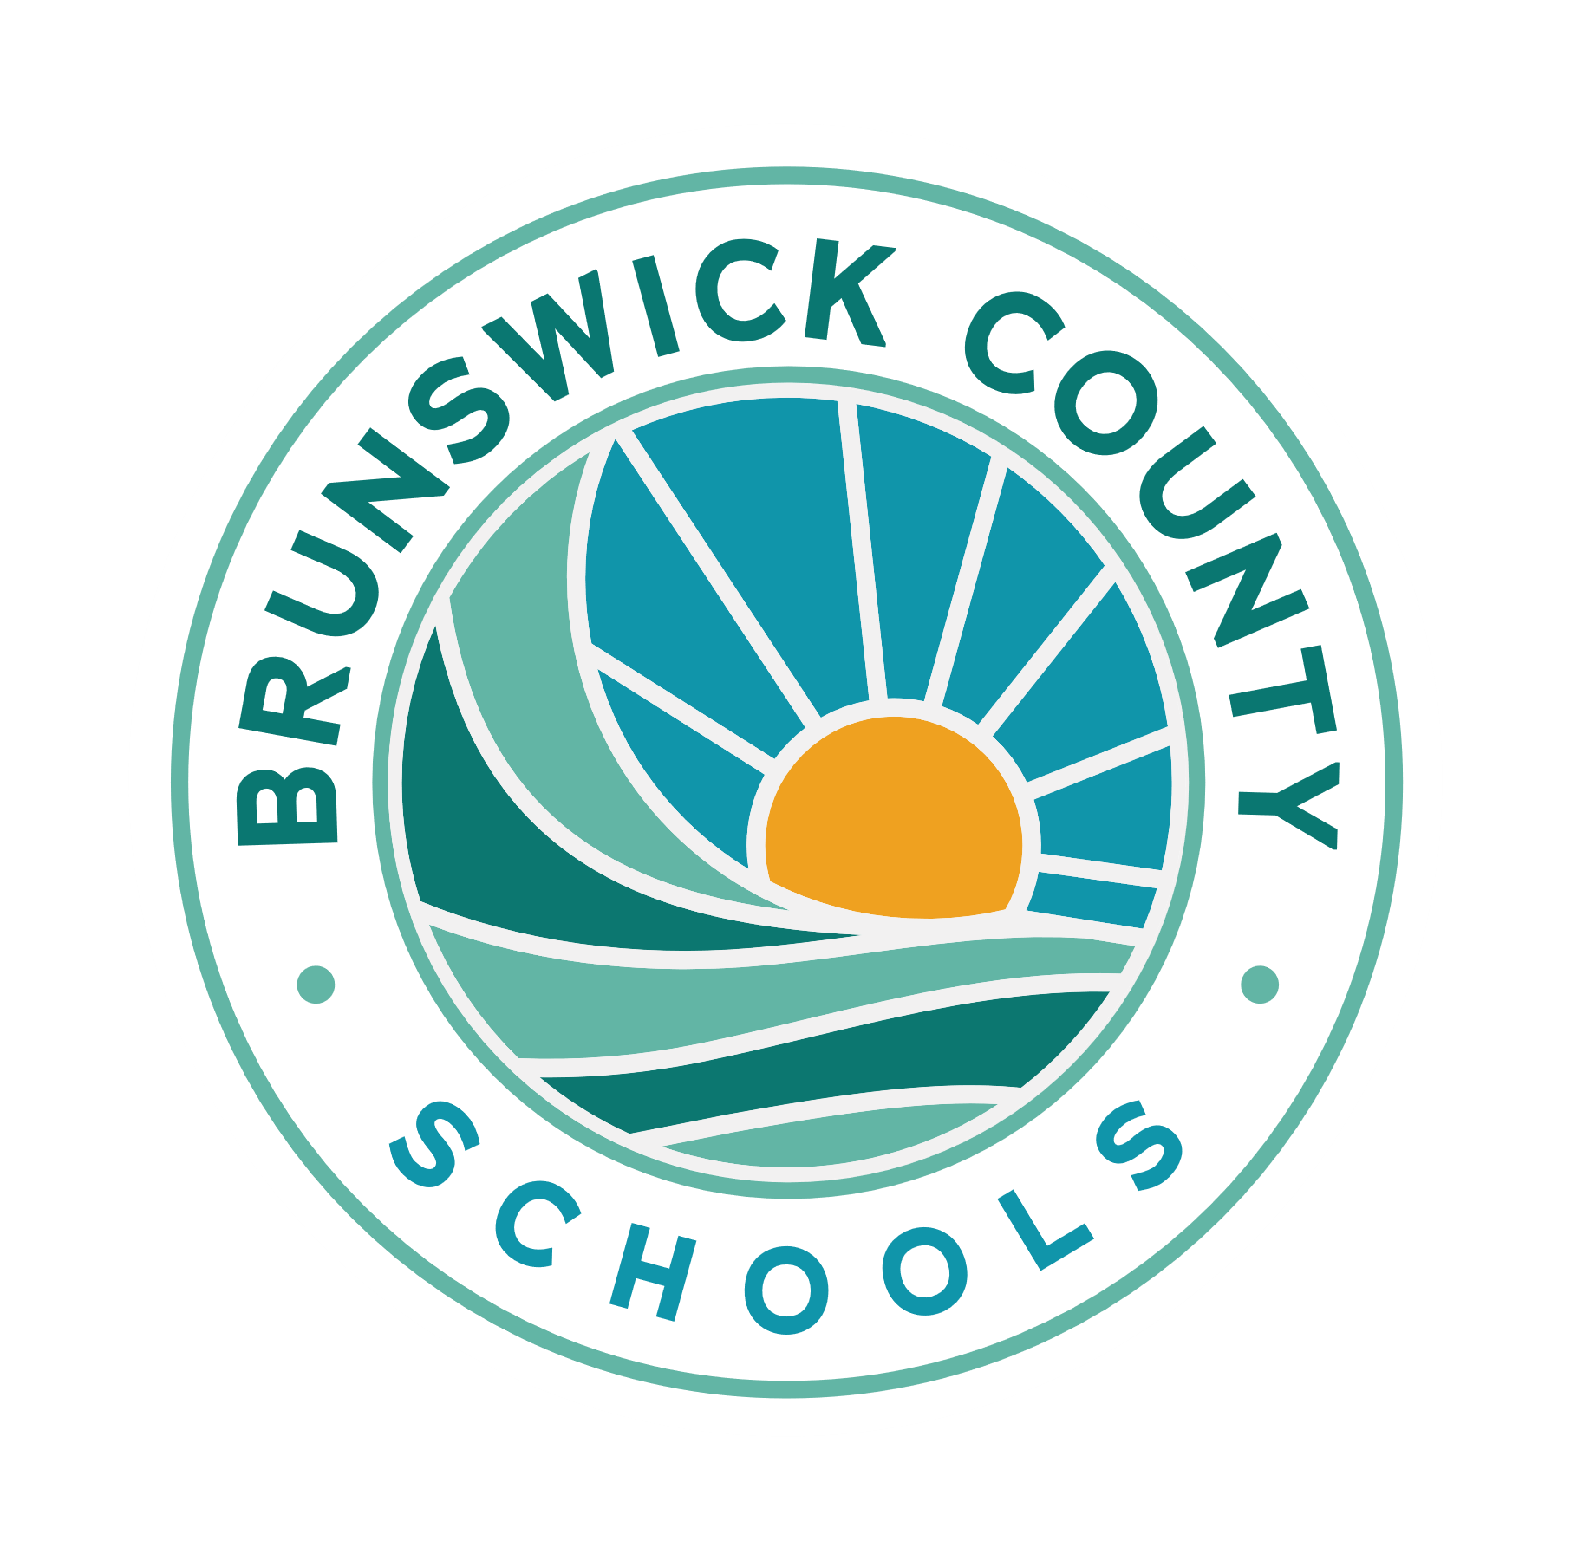
Brunswick County Schools
Child Nutrition Services
35 Referendum Drive, Bolivia, NC 28422
PH: 910-782-5090
Email: dleisinger@bcswan.net

Refund Request Form

To receive a refund for a balance remaining in a meal account, the student must no longer be enrolled in Brunswick County Schools or be able to provide hardship documentation. The following information is required in order for a refund to be issued. The refund check will be made payable to the parent (payee) and mailed to the address provided below. Mail completed form to the above address. Please allow four (4) weeks for processing.

- -
*Required in order for refund to be processed. Call 910-782-5090 if you have any questions.
Parent Name: Social Security #
(Payee)(Parent)

Student Name: Student NC Wise#
School:

Mailing Address
Street/ PO Box: _______________________________________________________________
City: ________________________________________________________________________
State/ Zip Code: Phone: __________________________________________________
For Office Use Only:
Transaction by Student or other form of account documentation must be attached.
DATE RECEIVED:
DATE PROCESSED:
PROCESSED BY:
REFUND AMOUNT:
DIRECTOR’S APPROVAL:

Revised: 5/6/2025

