Highfield Hall & Gardens Celebrates Black History Month

The African American Heritage Trail of Martha’s Vineyard
Past, Present and Future!

A Talk with Elaine Weintraub
Saturday, February 28, 2026 11:00 am – 12:00 pm
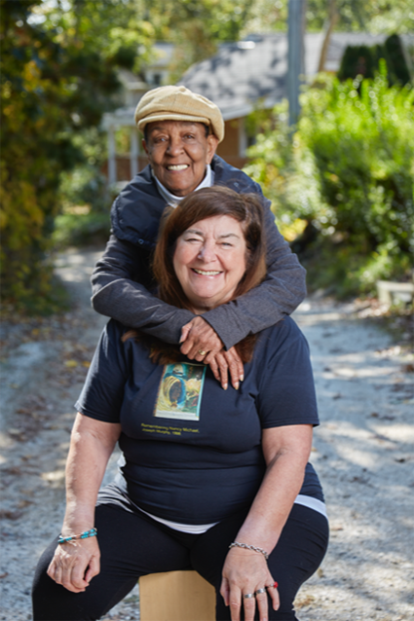
The African American Heritage Trail of Martha’s Vineyard (AAHTMV), is a pathway dedicated to the contributions of the people of African descent to the Island. Established in 1998, the AAHTMV celebrates the community, encourages student involvement, and advocates for inclusive history.
Co-founders, Carrie Camillo Tankard and Elaine Cawley Weintraub, met in 1989 and recognized a common mission to introduce the history of people of color into the Vineyard schools. Beginning with just four sites, the trail has grown to more than 42 plaques today and the expansion to Falmouth began last fall, with a commemoration of an African American scientist at the Marine Biological Laboratory.

Free to the public


Preregistration requested: highfieldhallandgardens.org
56 Highfield Drive, Falmouth, MA 02540

