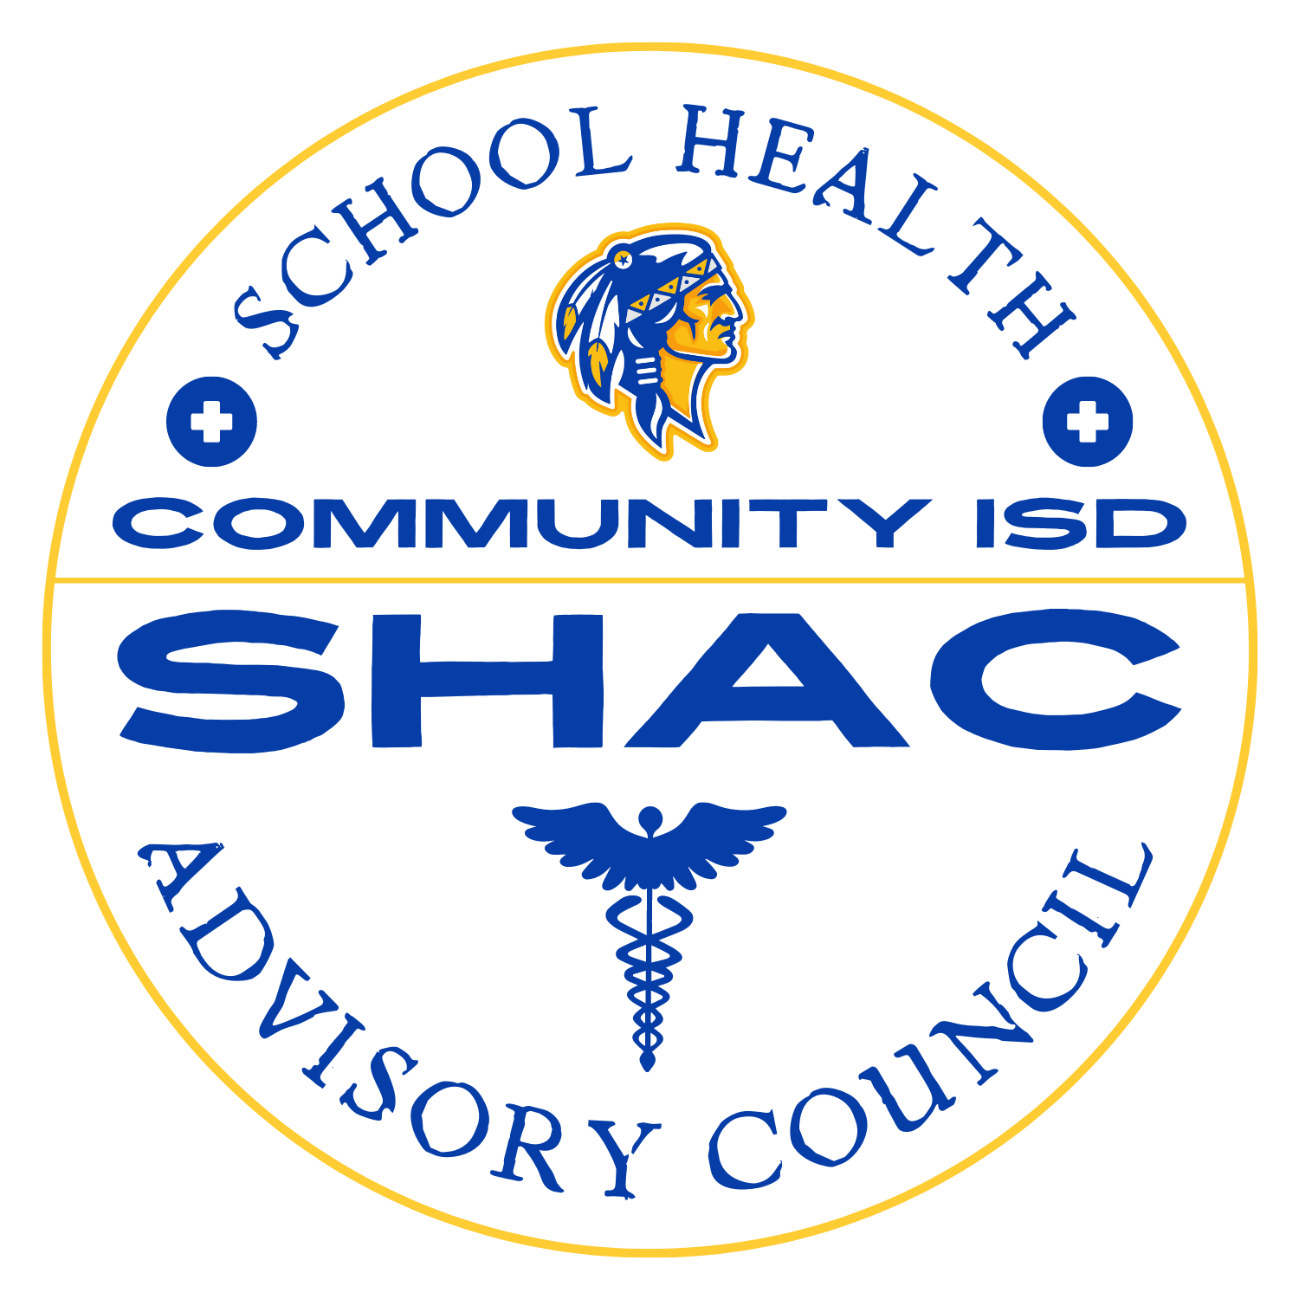

Community ISD SHAC
February 11, 2026 Meeting @ 6 pm
Terry Pope Administration Building
Minutes

Attendance:
Mallory Scott
NaTosha Lee
Amy Smith
April Sawyer (joined via Zoom later in the meeting)

1800 - Call to Order

- Approval of Previous Meeting Minutes
  - Review of December 3, 2025 SHAC meeting minutes
    - Proceeded with a motion and a second.

- Vaccination Policy and CDC Update
- CDC revisions to childhood immunization schedule from a directive by President Trump
  - Vaccines reorganized into 3 categories
  - Schools primarily impacted by category 1
- Potential changes to required vaccines
  - Possible removal of Hepatitis A (2 doses)
  - Possible removal of Hepatitis B (3 doses)
  - Possible removal of of Meningococcal (1 dose)
  - HPV vaccine doses reduced but remains non-mandatory
- Grade-level impact
  - Kindergarten and 7th grade
- District response
  - No immediate policy changes - awaiting official CDC publication
  - Will monitor vaccine to affidavit ratios across the district

3. District of Lifesavers Initiative
- Progress toward American Heart Association District of Lifesavers recognition
  - Annual CERT drill requirement in all campuses
  - Implementation of Kids Heart Challenge in all elementary campuses and American Heart Challenge in all the intermediate campuses.
- Kids Heart Challenge is embedded in PE programs during this month of February
- Secondary implementation needs
  - Student led American Heart Challenge required
  - Participation gaps at Edge Middle School and Community High School
    - Took suggestions from SHAC members for contacts at Edge Middle School
- Timeline
  - Targeting week prior to spring break
  - Goal of District recognition next school year

4. 2024-2025 School Climate Survey Review
- Strengths identified
  - Family involvement and engagement averaged 3.5 out of 4
  - Strong staff-student relationships
  - Positive academic culture district-wide
- Area of concern
  - Bullying and peer conflict averaged a 2.3
    - Lowest-rated category District wide
- Interventions and follow - up
  - Counselors updated grievance procedures
  - Increased encouragement of incident reporting
  - Ambassador programs supporting new students
  - 2025-2026 survey results to be reviewed at next meeting

5. Special Olympics District Event
- April 7, 2026 Track and Field Event
  - First District-hosted Special Olympics event
  - Approximately 200 special education students expected
- Participation structure
  - One track and one field event per student
  - Wheelchair participants eligible for two track events
  - Awards presented immediately after each heat
- Event logistics
  - 8:00 am - 3:00 pm at Braves football stadium
  - Lavon Fire Department providing two EMTs and one EMS vehicle
  - District directors to be invited

6. Committee Membership and Attendance
- Attendance concerns
  - Three parent members have not attended meetings this school year
  - Bylaws require attendance at two meetings annually.
- Governance considerations
  - No automatic dismissal language in bylaws
  - Importance of maintaining parent majority representation
- Next steps
  - Consider recruitment of additional parent members
  - Follow-up discussion scheduled for April meeting
7. Future Meeting
- Last SHAC meeting for the school year
  - April 8, 2026 6:00pm - 7:00 pm room 603 Terry Pope Administration Building and link for Zoom
1828 - Meeting Adjourned

