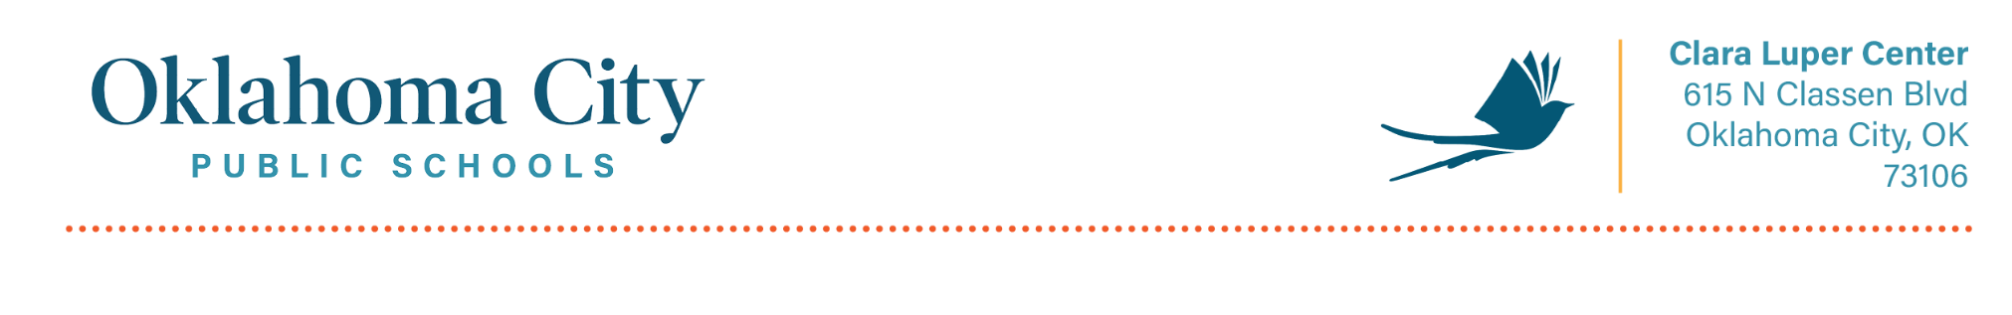

Missing Receipt Aﬃdavit
(For P-Card purchases without a receipt)

State of: Oklahoma
County of: Oklahoma
Affidavit of Claim
The undersigned (employee of Oklahoma City Public Schools) of lawful age, being first duly sworn, on oath says that this claim is true and correct. Affiant further states that the charges as shown below are for the goods / services listed below for the benefit of Oklahoma City Public School District, and were in accordance with all District Policies and Procedures.
The undersigned also understands that if the charge was for anything otherwise, the undersigned may receive disciplinary action up to and including termination.

Statement Reference Number

Statement Date: Amount of Charge

Description of Charge: ___________________________________________________________

______________________________________________________________________________

_________________________________ _______________ _
Card Number & Site Cardholder Signature

________________________________________
Signature of OKCPS CFO

