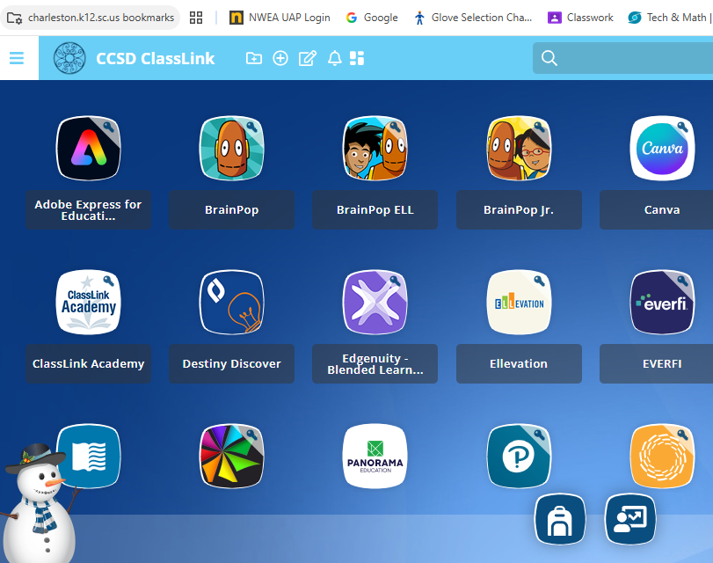
Log into ClassLink.
Click on the plus sign to add Apps.

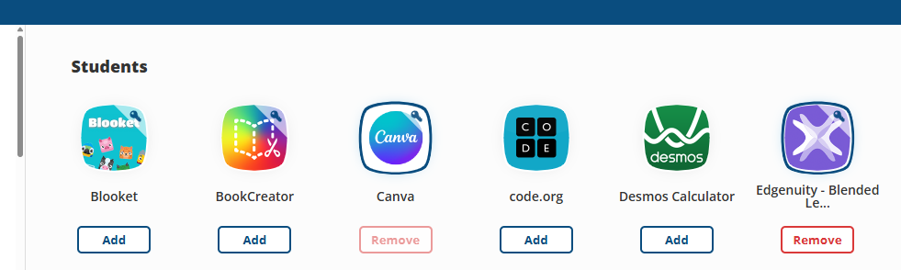
Select Edgenuity Blended App to add to ClassLink. There are 2 Edgenuity Apps. You want the Blended Learning App. You will not be able to log into the other App because this is only for students taking online courses.

