FEBRUARY
VOL . 14 | ISSUE 6 | FEBRUARY 2 , 2026

LINCOLN ELEMENTARY NEWSLETTER

PRINCIPAL: Audrey McKell | 435.245.6442 | audrey.mckell@ccsdut.org
PTA PRES.: BriAnne Thomson | lincoln.elementary.pta.ut@gmail.com

A MESSAGE FROM OUR PRINCIPAL
Hello Lincoln Families!
The energy at Lincoln Elementary has been absolutely electric lately! It’s been such a joy seeing our classrooms buzzing with life. Thank you for the “morning hustle” it takes to get your kiddos here on time — we see you, and we appreciate you!
We’re on a mission to keep our momentum going. Did you know that missing just two days a month adds up to 10% of the school year? That’s considered “chronic absence,” and it can make it tricky for students to stay on track. Let’s keep working together to make sure every student is here for the magic!
We are thrilled to kick off our Annual Read-a-Thon! This year, our entire school is diving into the same book: Malcolm at Midnight.
- The Goods: A copy of the book will be sent home with your youngest child on February 23.
- The Fun: Keep those thinking caps on for daily trivia and weekly prize drawings!
- The Grand Finale: Mark your calendars for Literacy Night on March 9. We’ll celebrate finishing the book together - it’s going to be a fun night for the whole family!
This month, our theme is LOVE. Beyond the candy hearts, we’re focusing on the power of real connection. Whether it’s a tech-
free dinner or a quick family walk, those “unplugged” moments do wonders for a child’s world. Let’s take some time this month to recharge our relationships and strengthen our wonderful community.
Thank you for being the heart of Lincoln Elementary. This school is a special place because of you.
Stay kind and take care, Audrey McKell



UPCOMING EVENTS

FEB 5 – PTA Meeting
12:25 - 1:05 – Mrs. Frenzel’s Room

FEB 12 – Valentine’s Class Parties

FEB 13 – Professional Development Day, No School

FEB 14 – Happy Valentine’s Day!

FEB 16 – Presidents’ Day, No School

FEB 27 – End of Trimester, No School

MAR 5 – Parent Teacher Conferences, Early Out: 1:00 PM

MAR 6 – Parent Teacher Conferences, No School

MAR 14 – Pi Day

MAR 17 – St. Patrick’s Day MAR 19 – Science Fair: 7:00 PM MAR 30 - APR 3 – Spring
Break, No School

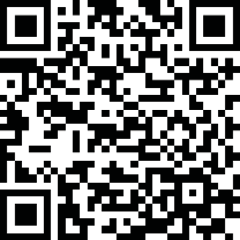
JOIN THE LINCOLN ELEMENTARY PTA!
Did you know there is no time commitment needed to be a member of the Lincoln PTA? Members can volunteer to help as little or as much as they would like. Scan the QR code or email lincoln.elementary.pta.ut@gmail.com to get involved!

SAVE THE DATE – LINCOLN SCIENCE FAIR
Save the date for our 2026 Science Fair! It will be held on March 19th at 7:00 PM. More information coming soon.

VOLUNTEERING
Interested in helping out at Lincoln? We’d love to have you as a room parent! Please contact our room parent coordinator, Tessa Thornley at lincoln.elementary.pta.ut@gmail.com. Class Valentine’s parties will be held on February 12th. It’s a great time to join the room parents and help out!

 STUDENT SPOT

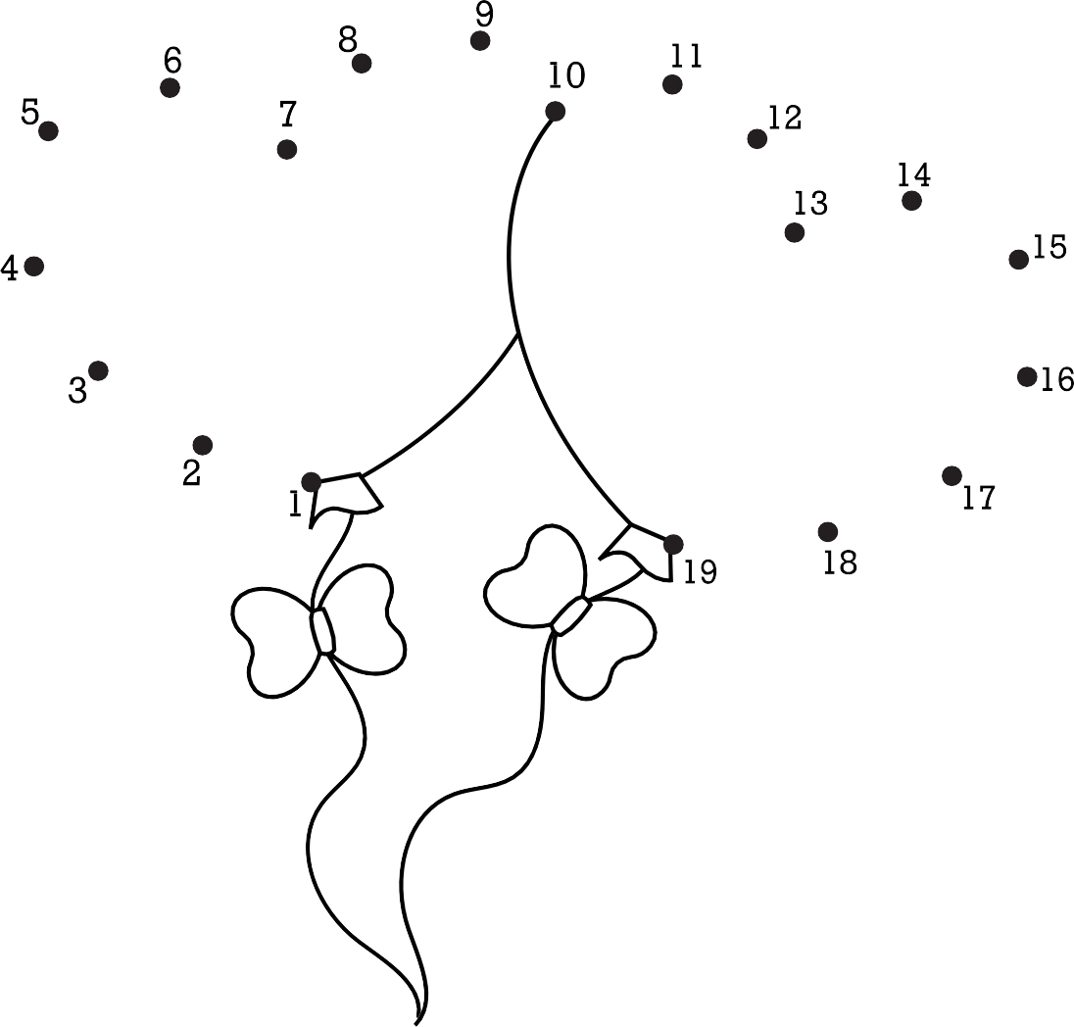

If you’d like to submit information for this newsletter, please email Elise Egbert at elisecreates@gmail.com by the 27th of the month.

